Demo Guideline

- Download and Install Visual Studio 2022

You can download from official website and choose the community 2022 edition ( Community edition is free to use for many scenarios. But you are expected to login to unlock the IDE.).

Link: https://visualstudio.microsoft.com/downloads/?cid=learn-navbar-download-cta

After downloading the installer, double click to run it and you can see a page similar to the following picture. Then choose the relevant packages to install (Here we tick all the items with a C++).

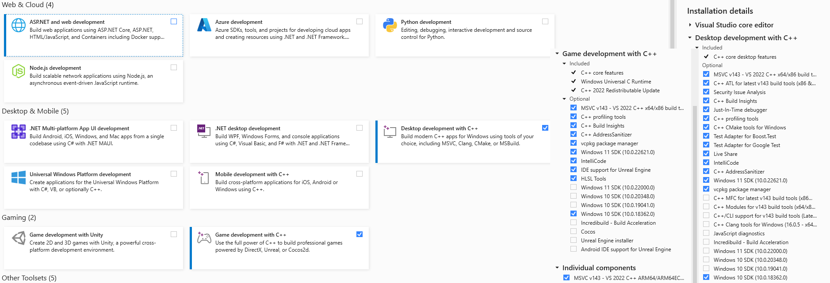

- Download OpenCV
Installation by Using the Pre-built Libraries
https://sourceforge.net/projects/opencvlibrary/files/opencv-win/2.4.13/opencv-2.4.13.6-vc14.exe/download
Download opencv-2.4.13.6-vc14.exe and Double Click to install OpenCV.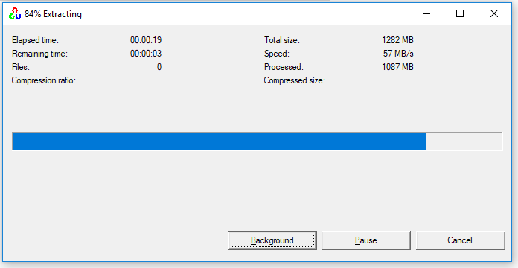

After installation, enter into your OpenCV folder, you will see the Pre-build folder, we will use it directly. 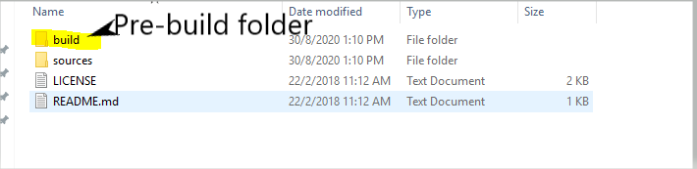

- set the environment variables OPENCV
Right Click Computer -> Properties
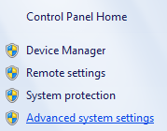
Add new system variable “OPENCV”, the directory is where you have your OpenCV pre-build folder.
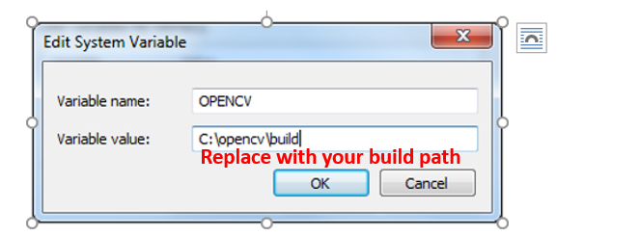
Next, you need to add %OPENCV%\x64\vc14\bin; to the system PATH variable:
Up to now, you can download the Demo program, and open it with VS2022. It is expected that you could build and run the demo successfully. Make sure that you complete the step 1-3 correctly.
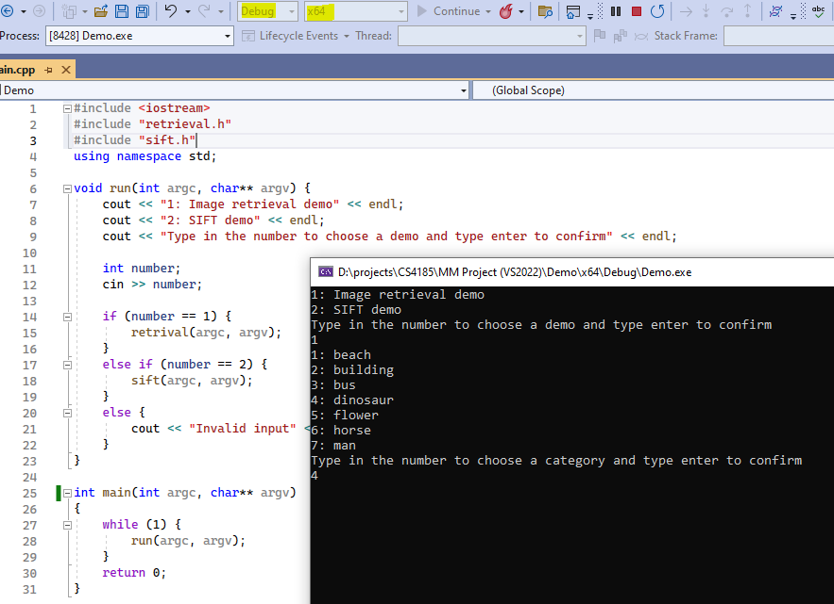
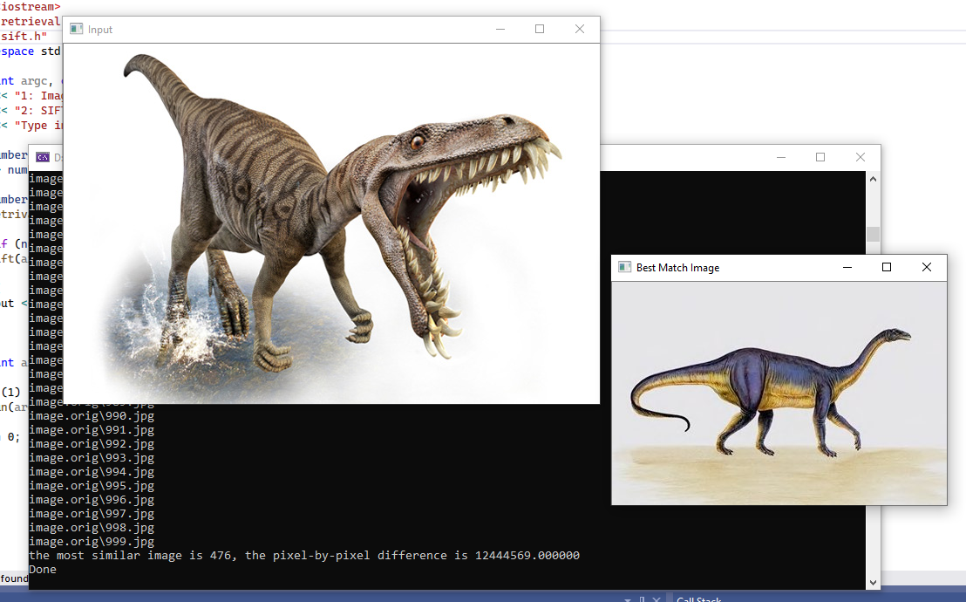
Just in case that you encounter some unexpected problems in your PC or you want to create a new project/solution, follow the following steps to setup your VS2022. And I recommend that all of you could have a look at the following steps, since it may help you keep from some problems.

- Using OpenCV in Visual Studio
First, create a new project in Visual Studio 2022
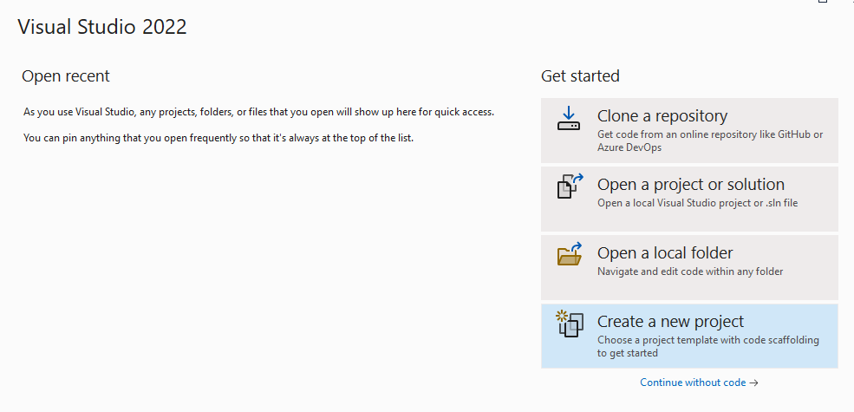

Choose “Console App” and name your project.
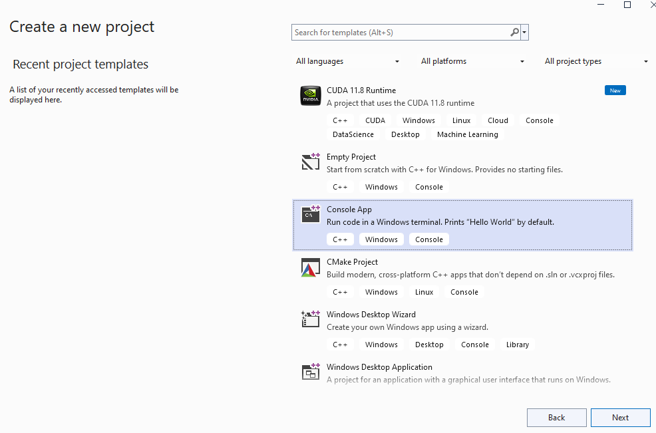

Next, copy the demo code (e.g. Demo/sift.cpp OR Demo/retrieval.cpp) to the new project, and add a main function at the end to call sift function:
int main(int argc, char** argv)
{
sift(argc, argv);
return 0;
}
The full SIFT demo code in one cpp file is as follow:
/**
* CS4185/CS5185 Multimedia Technologies and Applications
* Course Assignment
// ********* ********* ********* *********
// sift demo
// ********* ********* ********* *********
*/

#include <iostream>
#include <stdio.h>
#include <algorithm>
#include "opencv2/highgui/highgui.hpp"
#include "opencv2/imgproc/imgproc.hpp"
#include "opencv2/nonfree/nonfree.hpp"
#include "opencv2/features2d/features2d.hpp"

using namespace std;
using namespace cv;

#define IMAGE_LIST_FILE "inputimage.txt" // NOTE: this is relative to current file

int sift(int argc, char** argv)
{

Mat img_1 = imread("../image.query/flower.jpg", CV_LOAD_IMAGE_GRAYSCALE);
Mat img_2 = imread("../image.orig/685.jpg", CV_LOAD_IMAGE_GRAYSCALE);

if (!img_1.data || !img_2.data)
{
printf("Error loading images\n"); return -1;
}

//-- Step 1: Detect the keypoints using SURF Detector
int minHessian = 400;

SurfFeatureDetector detector(minHessian);

std::vector<KeyPoint> keypoints_1, keypoints_2;

detector.detect(img_1, keypoints_1);
detector.detect(img_2, keypoints_2);

//-- Step 2: Calculate descriptors (feature vectors)
SurfDescriptorExtractor extractor;

Mat descriptors_1, descriptors_2;

extractor.compute(img_1, keypoints_1, descriptors_1);
extractor.compute(img_2, keypoints_2, descriptors_2);

//-- Step 3: Matching descriptor vectors with a brute force matcher
BFMatcher matcher(NORM_L2);
std::vector< DMatch > matches;
matcher.match(descriptors_1, descriptors_2, matches);

//-- Draw matches
Mat img_matches;
drawMatches(img_1, keypoints_1, img_2, keypoints_2, matches, img_matches);

//-- Show detected matches
imshow("Matches", img_matches);

printf("Done \n");
// Wait for the user to press a key in the GUI window.
//Press ESC to quit
int keyValue = 0;
while (keyValue >= 0)
{
keyValue = cvWaitKey(0);

switch (keyValue)
{
case 27:keyValue = -1;
break;
}
}

return 0;
}

int main(int argc, char** argv)
{
sift(argc, argv);
return 0;
}
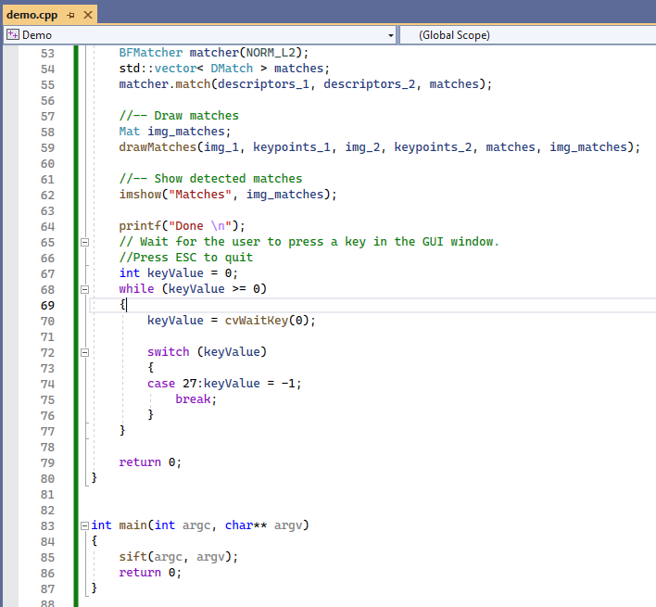

Next, for using the OpenCV, you need to tell your project where to find OpenCV.
- Add any .c/.cpp file of OpenCV and Additional Library Directories to the project
Select Project->Properties
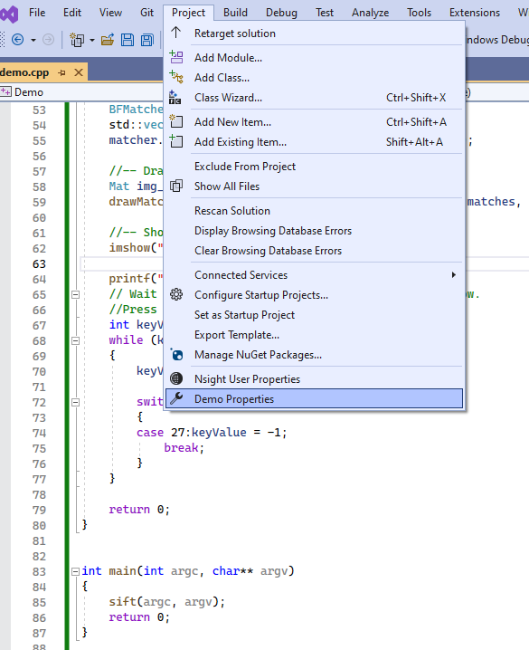

In Property Page, choose Configuration Properties -> VC++ Directories
In “Include Directories”, you should edit it by adding $(OPENCV)\include.
In “Library Directories”, you should edit it by adding $(OPENCV)\x64\vc14\lib.
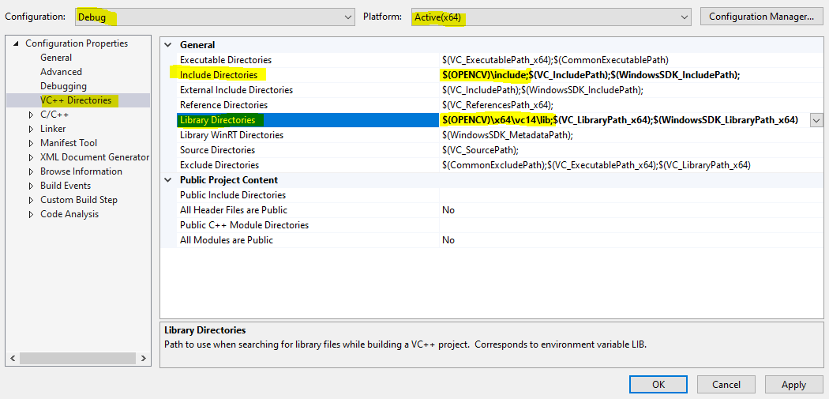

- Add the name of all modules which you want to use in OpenCV.
In Property Page, choose Configuration Properties->Linker->Input
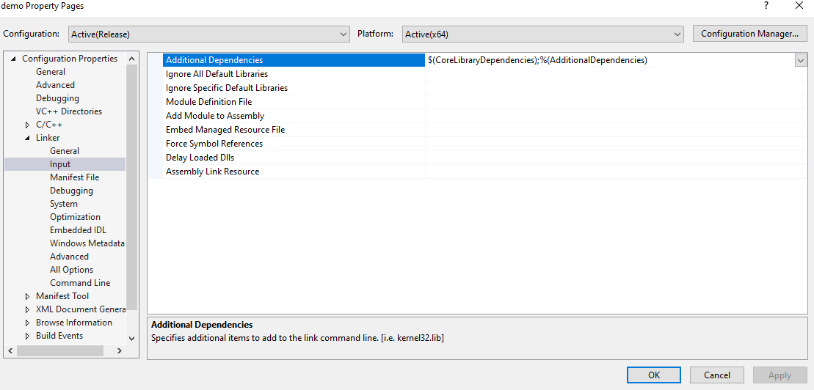

In “Additional Dependencies”, you should edit it by adding the related .lib. The names of the libraries are as follow:
opencv_(The Name of the module)(The version Number of the library you use)d.lib.
The letter d at the end just indicates that these are the libraries required for the debug.
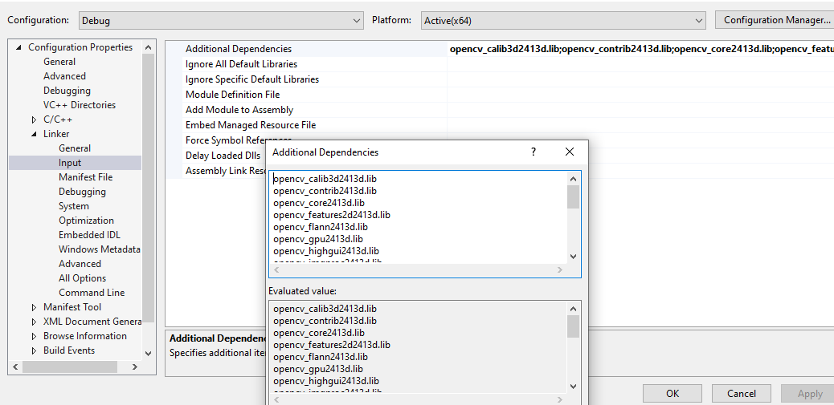
opencv_calib3d2413d.lib
opencv_contrib2413d.lib
opencv_core2413d.lib
opencv_features2d2413d.lib
opencv_flann2413d.lib
opencv_gpu2413d.lib
opencv_highgui2413d.lib
opencv_imgproc2413d.lib
opencv_legacy2413d.lib
opencv_ts2413d.lib
opencv_video2413d.lib
opencv_videostab2413d.lib
opencv_superres2413d.lib
opencv_stitching2413d.lib
opencv_photo2413d.lib
opencv_ocl2413d.lib
opencv_objdetect2413d.lib
opencv_nonfree2413d.lib
opencv_ml2413d.lib

Finally, save and reopen the project, and you should compile it successfully!
To run the demo, you need to prepare the images for the program. Copy the “image.query” and the “image.orig” folders to the project root (the directory containing the solution file).
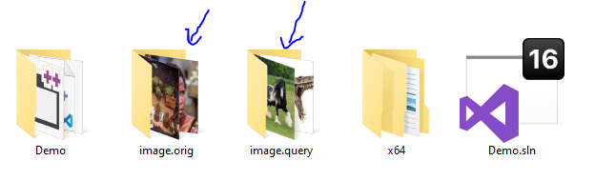
Run the program:
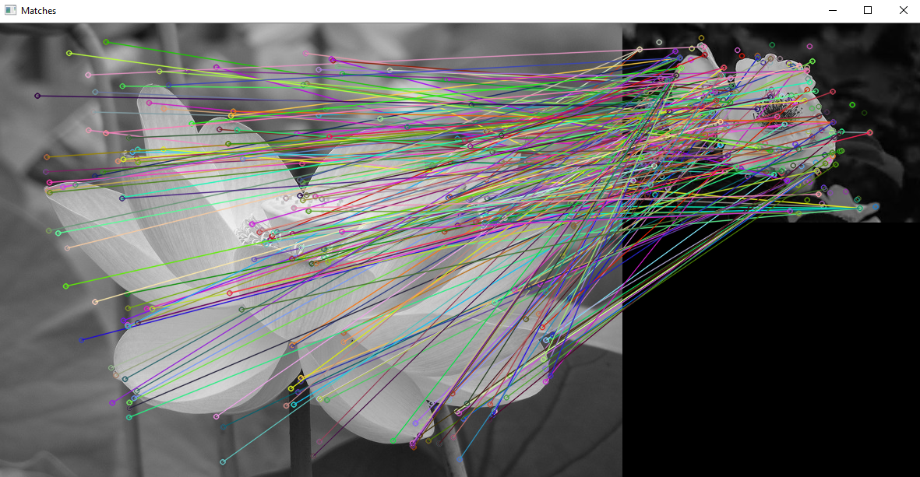

List of modules without letter ‘d’ (debug) at the end: (for release mode)
opencv_calib3d2413.lib
opencv_contrib2413.lib
opencv_core2413.lib
opencv_features2d2413.lib
opencv_flann2413.lib
opencv_gpu2413.lib
opencv_highgui2413.lib
opencv_imgproc2413.lib
opencv_legacy2413.lib
opencv_ml2413.lib
opencv_nonfree2413.lib
opencv_objdetect2413.lib
opencv_ocl2413.lib
opencv_photo2413.lib
opencv_stitching2413.lib
opencv_superres2413.lib
opencv_ts2413.lib
opencv_video2413.lib
opencv_videostab2413.lib

