

Tree Risk Management Portfolio (MR4005)
Author: Tammy, WC SUM
Introduction
Benefits generated from trees are uncountable. They contribute to a healthier and more sustainable environment in urban areas. Here are some of the key benefits of trees in urban areas.

- Tree is an air purifier which help to improve air quality and reduce pollution. They absorb carbon dioxide and release oxygen through photosynthesis, helping to improve air quality and reduce pollution.
- Tree also provides shade and help to cool the surrounding environment through evapotranspiration. This can help reduce the urban heat island effect (Wang & Hashem ,2016).
- Urban trees provide habitats for birds, insects, and other wildlife, promoting biodiversity in urban areas. They can create important green corridors and connect fragmented ecosystems.
- Trees enhance the visual appeal of urban areas, making them more attractive and inviting. Being around trees has been shown to reduce stress, improve mood, and promote overall mental well-being.

However, there's no needle with both ends pointed. As trees mature and grow in size, their likelihood of shedding branches or developing decay and other conditions that can lead to failure increases. Therefore, when evaluating and overseeing trees, it is important to find a middle ground between the potential risks they present and the advantages they offer to individuals and communities. By doing so, we can ensure a balanced approach to tree risk assessment and management.

This portfolio aims to examine and compare three cases of different tree defects and two contrasting cases of fungal decay in trees in the Arboriculture industry of Hong Kong. Additionally, it will introduce two tree defect detection systems, namely the Resistograph and Sonic tomography. The portfolio will discuss the pros and cons of these methods and provide suggestions for potential improvements.

Tree Risk Cases

The significance of tree conflicts or failures varies depending on their location. In areas where the impact of tree failure would have minimal result such as non-urban or undeveloped areas, the need for tree inspections may be less critical. However, in urban and development zones where there is a higher risk of harm to people, property, and activities, the consequences of tree conflicts or failures can be significant or severe. Therefore, decisions regarding whether tree inspections are necessary, and the level of assessment required should be made by considering what is reasonable and proportionate to the specific condition and situation at hand. These considerations are crucial aspects of tree risk management. There are three cases will be discussed as coming page.

Tree Risk case – Case 1
In Case 1, we have a Casuarina equisetifolia (T1) planted in a tree pit measuring 2m x 2m. T1 has a diameter at breast height (DBH) of approximately 400mm and stands at a height of 14m. Its crown spread extends to about 6m.

T1 is situated in a significant location, adjacent to a public footpath and in close proximity to a high school entrance, a taxi stand, and a traffic road. This means that various vehicles, students, and residents frequently pass by or gather around T1. Due to its location, removing the target is not an option.

To provide a visual representation, a location map and a photo of T1 are included below.
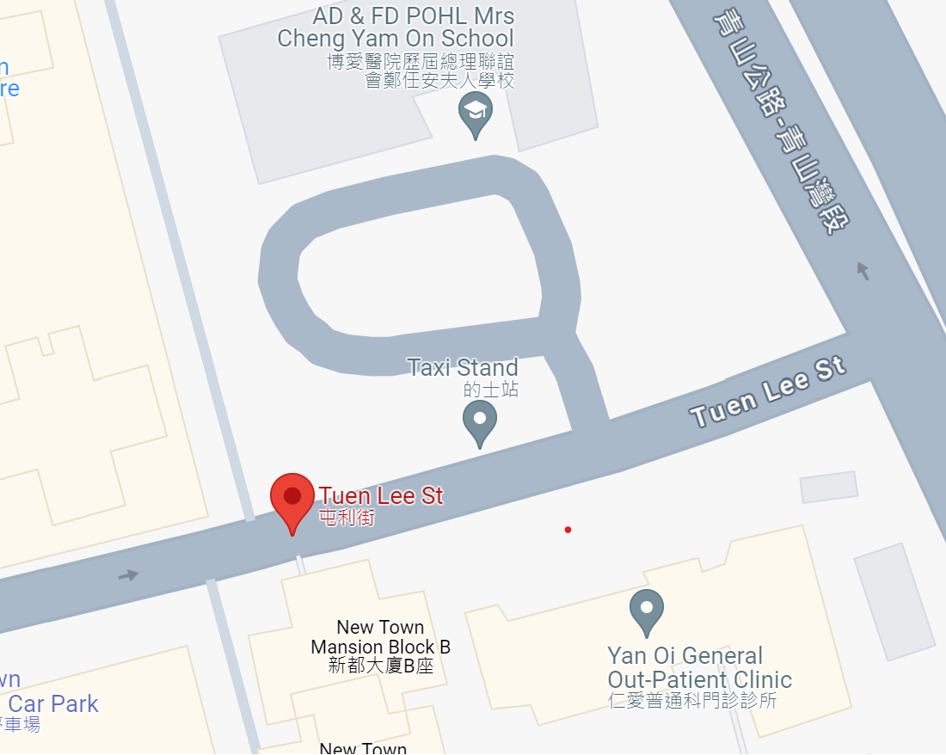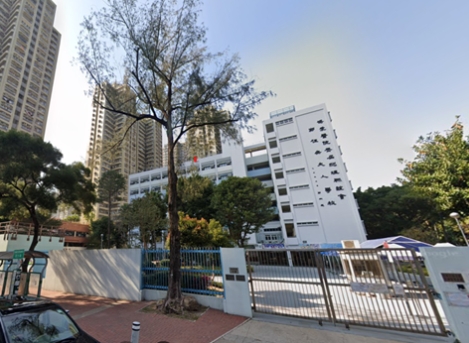
T1 Location

Considering the high traffic and potential risks associated with the area, it is crucial to conduct a tree inspection and risk assessment of T1.

Crown Condition: The comparative yellowing and smaller size of the foliage, along with a foliage density of around 75%, and the presence of died-back twigs, which indicate T1 is facing potential stress or health issues. These symptoms could be attributed to various factors, such as nutrient deficiencies, drought stress, pest infestation, disease, or root problems.

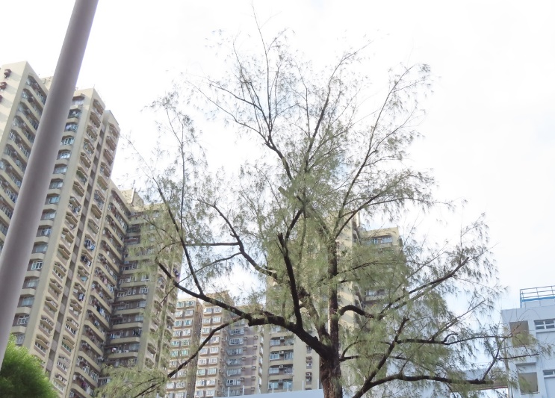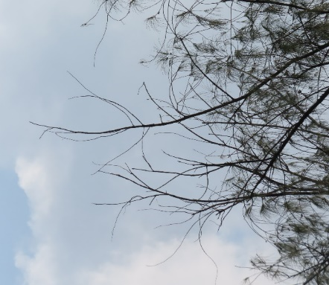

Trunk Condition: The presence of exposed dead wood and signs of termites at an old pruning wound on the upper trunk at 4m height, along with the discovery of a termite cavity measuring 120mm (height) x 30mm (width) x 300mm (depth) on the lower trunk at 1.3m height, indicates potential structural concerns and the possibility of decay or damage within the tree.

Photo of the upper trunk and the old wound
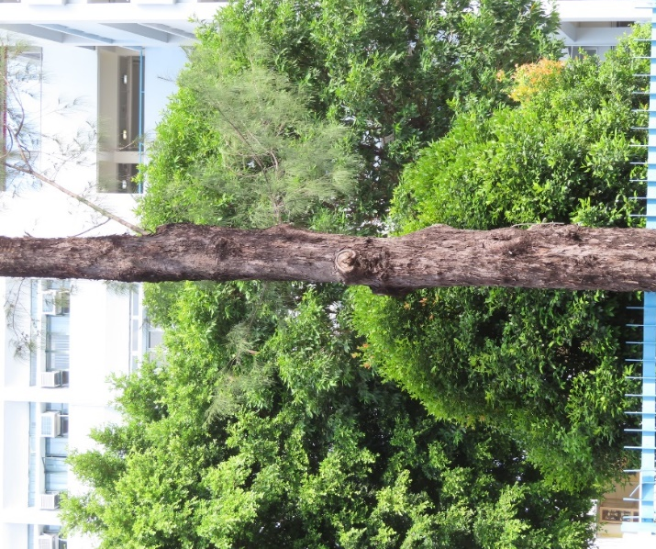 | 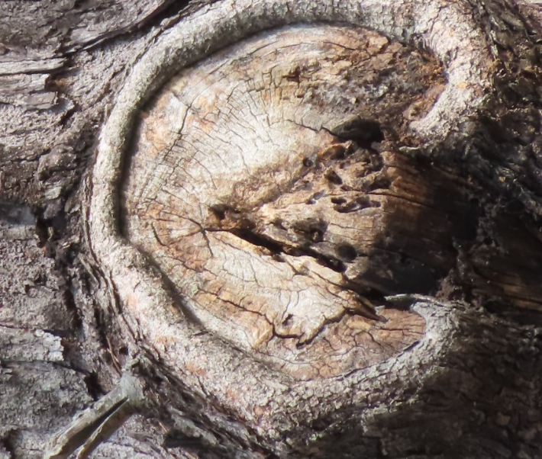

Photo of lower trunk and signs of termites
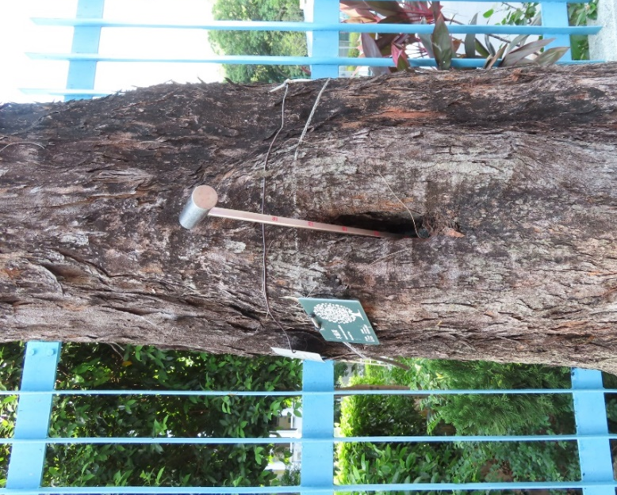 | 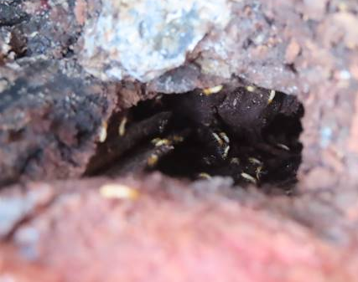

Exposed dead wood create entry points for pests (termites) which is increasing the risk of decay and compromising the structural integrity of the tree. The presence of termites is a cause for concern as they can further contribute to the decay and weakening of T1. Termites feed on wood, including dead wood, and can cause significant damage if left unchecked.

The presence of a termite cavity indicates that termites have created a void within the tree, potentially resulting in a loss of structural integrity. The size of the cavity suggests a significant amount of wood has been affected.

The results of the Sonic Tomography inspection as below indicate that the internal decay in the lower trunk is progressing and becoming more severe. The cross-sections inspection taken at various heights (170cm, 100cm, and 60cm from the ground) reveal a decreasing percentage of solid wood, ranging from 83% to 50%. This deterioration in the amount of solid wood suggests that the structural integrity of the tree is being compromised.

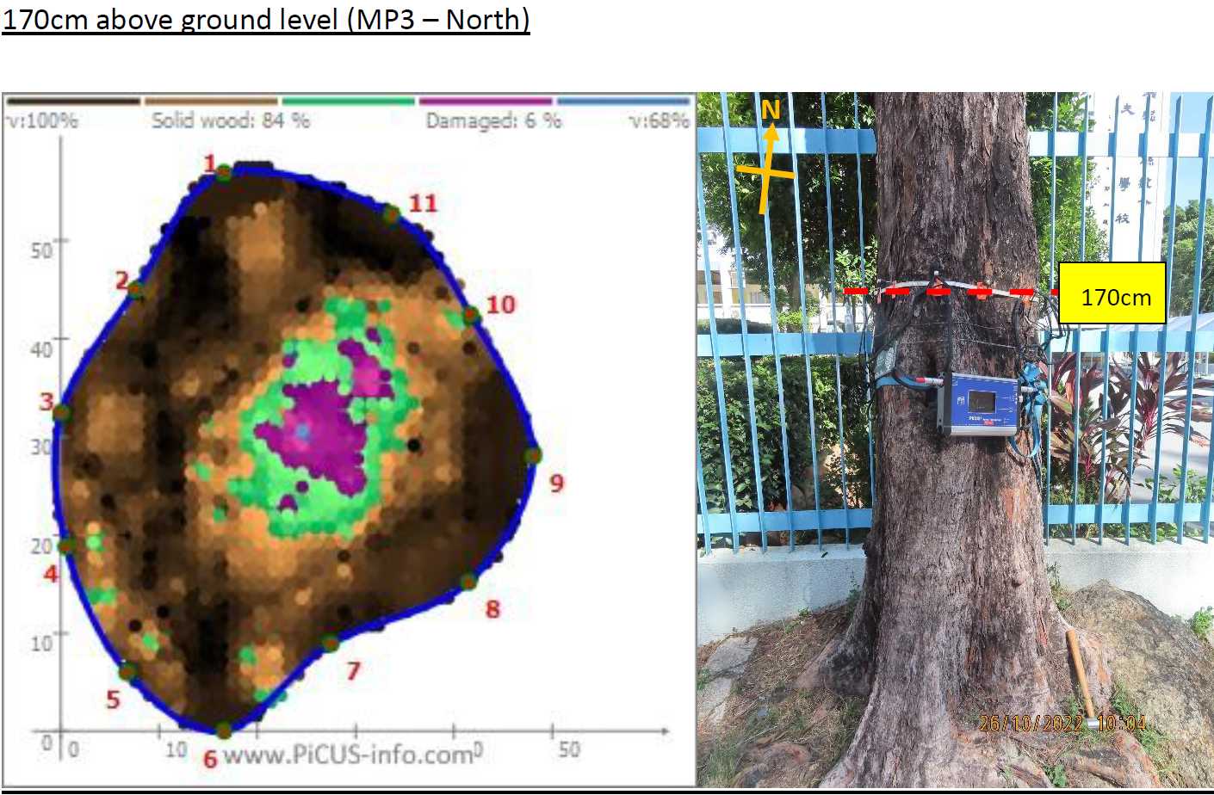
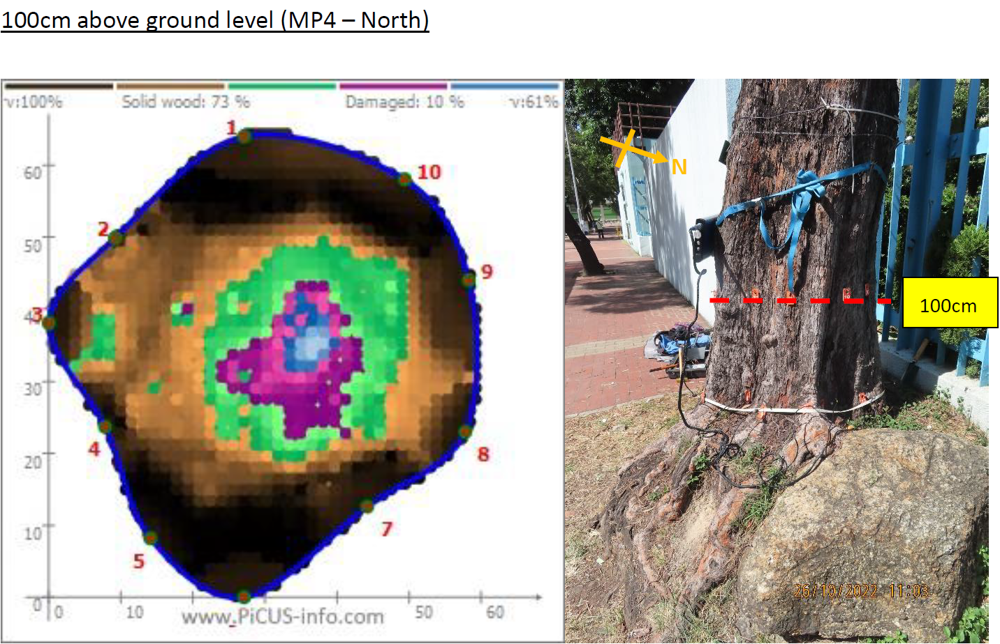
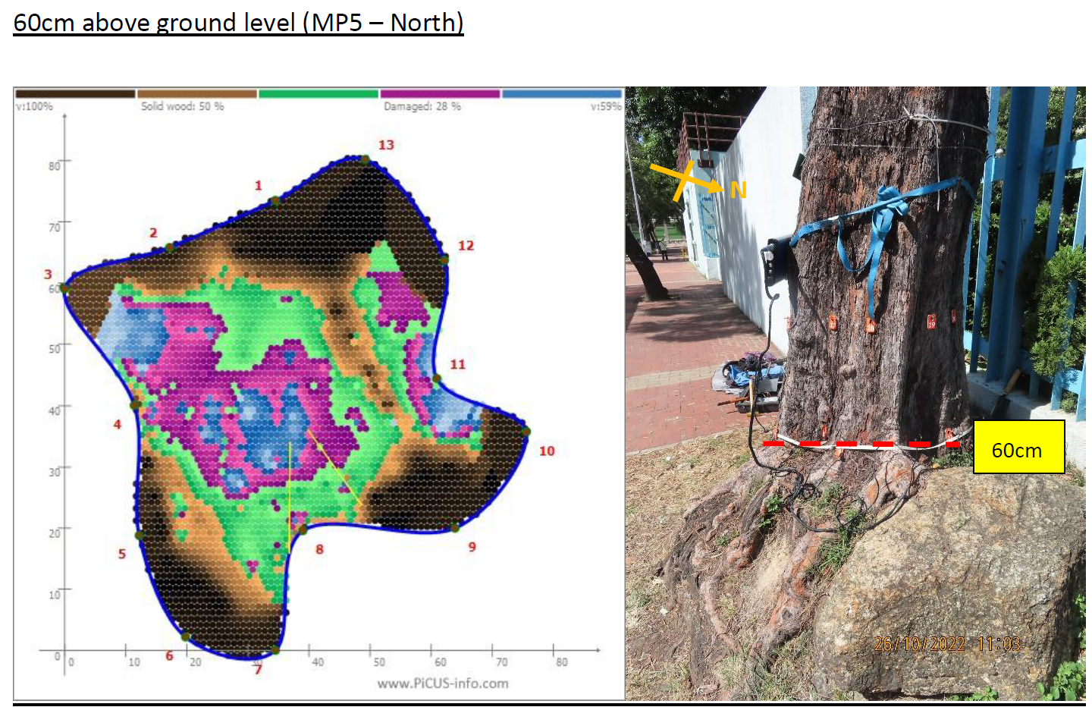

Root condition: The root development of the tree being restricted by the tree pit and structure wall, along with the presence of girdling roots, root cuts, and fungal fruiting bodies, indicates significant challenges and potential health issues for the tree.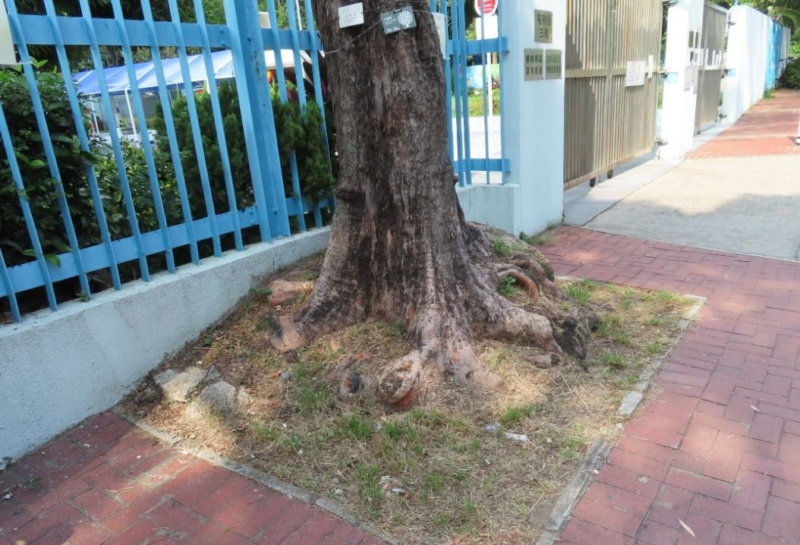

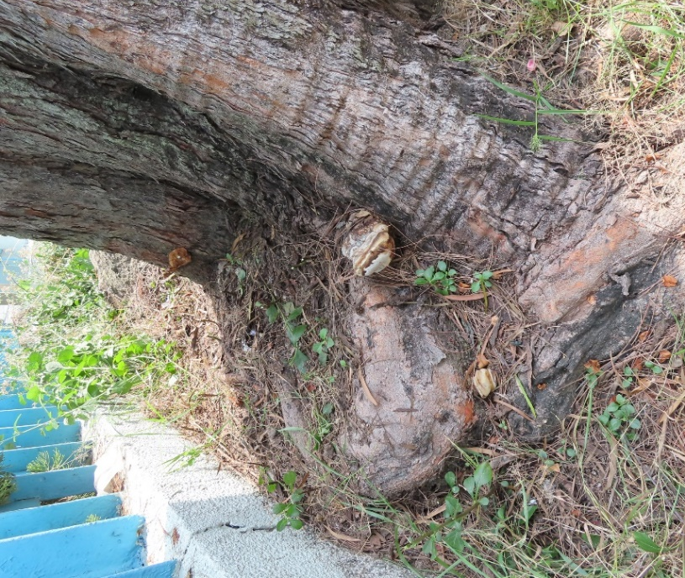  Girdling roots | 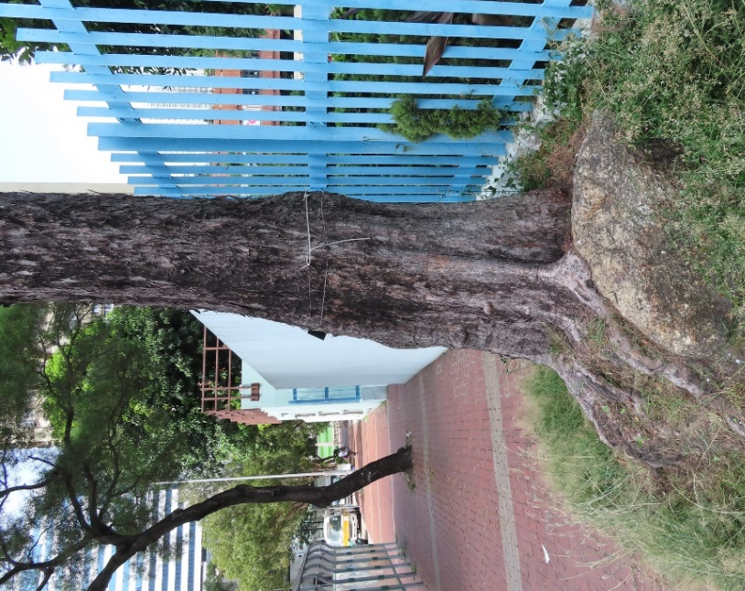  Rock
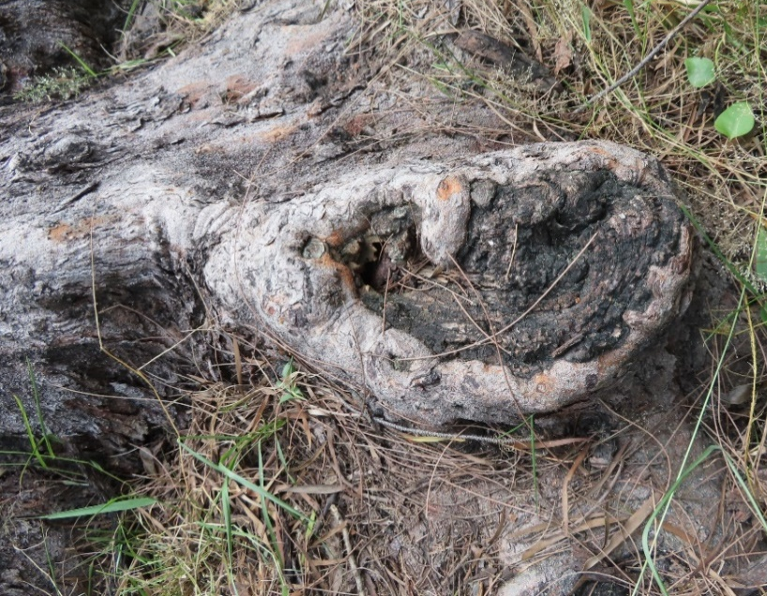  Root cut | 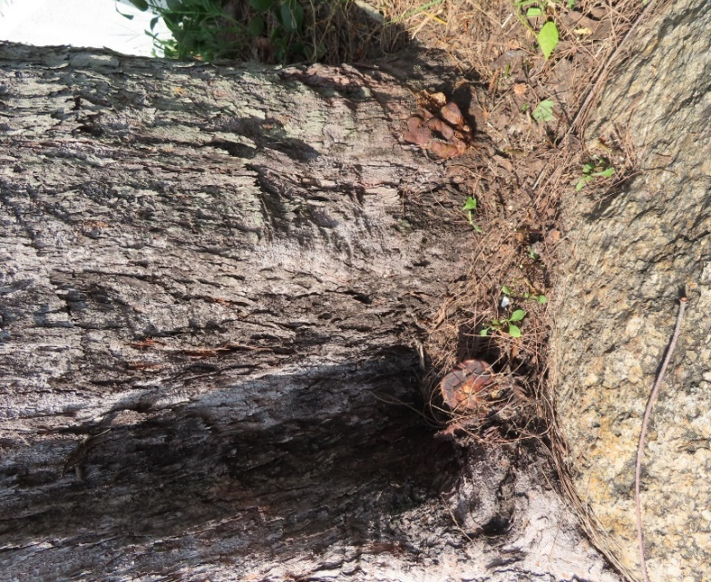  fungal fruiting bodies

Remedial measure: To summarize, The overall condition of T1 is moderate.

- Remove dead twigs and branches to improve the tree's appearance and reduce potential hazards.
- Implement appropriate treatments to control and eliminate termites, preventing further damage.
- Treat fungal infections with fungicide application or targeted removal of infected wood.
- Inspect the tree one month after treatment to assess the effectiveness of pest and fungal control measures.
- Conduct routine tree risk assessments every six months to evaluate health, stability, and potential risks.
Tree Risk case – Case 2
In Case 2, a Dimocarpus longan (T2) planted in a narrow amenity area measuring 1.5m(width) x 2m. T2 has a diameter at breast height (DBH) of approximately 600mm and stands at a height of 9m. Its crown spread extends to about 8m.

T2 is situated in a significant location, adjacent to a public footpath and in close proximity to a vehicle maintenance depot and pet garden and a traffic road. This means that various vehicles, residents, garden users with their pets frequently pass by or gather around T2. Due to its location, removing the target is not an option.

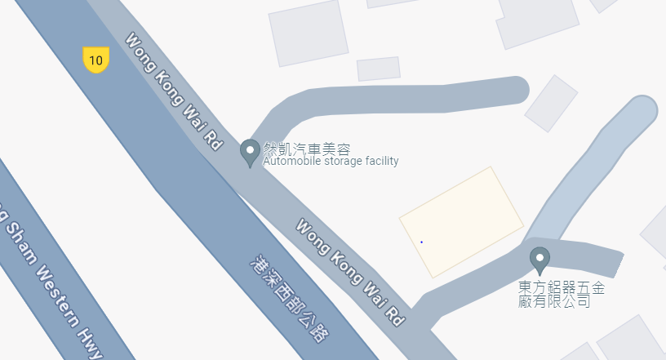
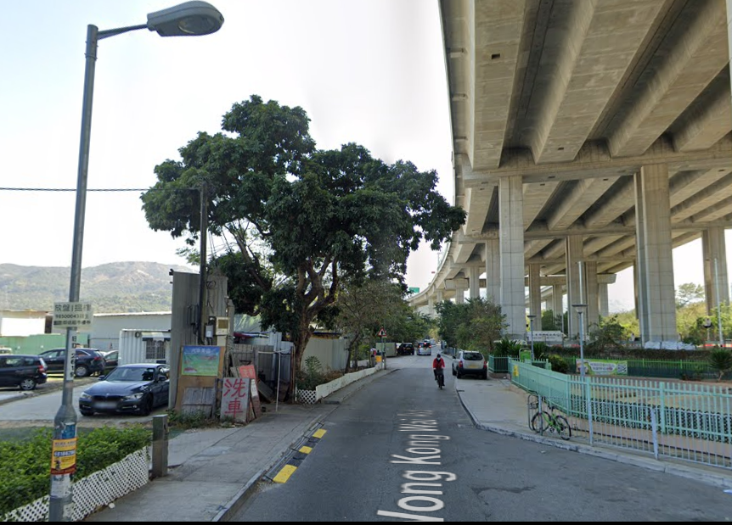
T2 Location

Crown Condition: While the color and density of the foliage appear normal, there is a noticeable difference in the size of the foliage, which is relatively smaller. Additionally, one of the branches has been broken due to inclement weather, and there is visible exposed dead wood.

Although the foliage color and density seem fine, the smaller foliage size could indicate possible issues such as nutrient deficiency, disease, insect infestation, or environmental stress. Furthermore, the broken branch and exposed dead wood pose potential risks, as they can weaken the tree's structure and potentially lead to further branch breakage or decay.

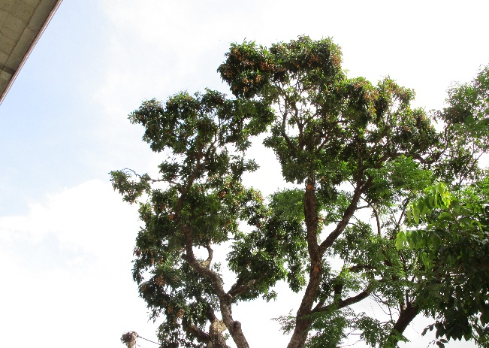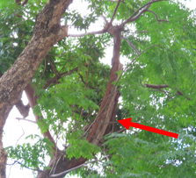

Trunk Condition: An extensive tearing wound, measuring 150mm wide and 600mm long, has been observed. Furthermore, there is a substantial opening wound on the broken stem, resulting in a single cavity that exceeds a depth of 500mm. Additionally, the lower trunk exhibits two cavities, both exceeding a depth of 500mm.
Photo of the upper trunk and the old wound
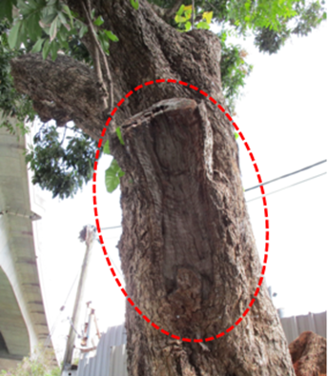  Tearing wound | 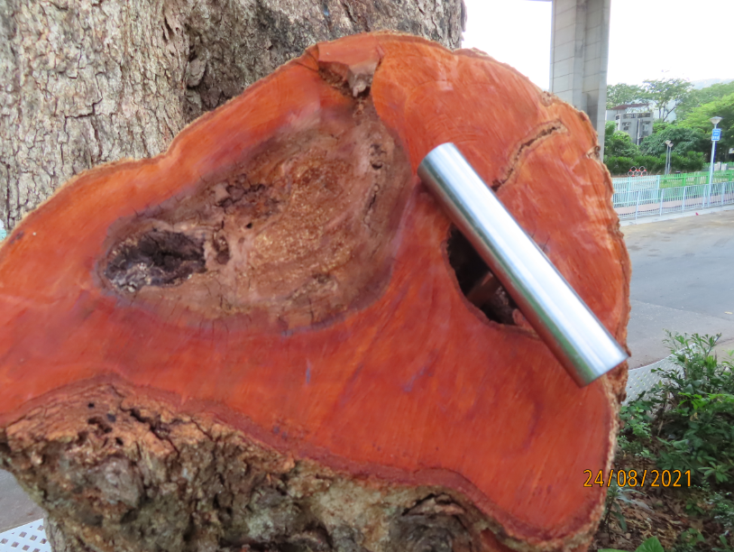  Cavrity
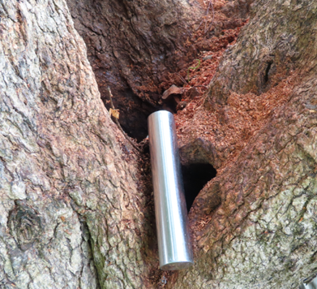  Cavrity | 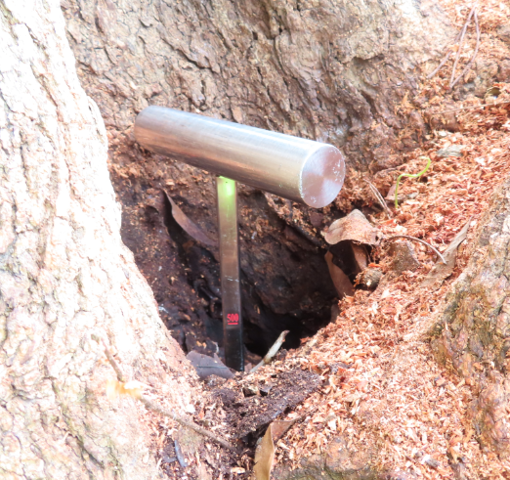  Cavrity

The tearing wound can compromise the tree's ability to heal and seal off the damaged area, making it more vulnerable to decay, disease, and insect infestation. The opening wound on the broken stem, along with the deep cavity, creates an entry point for pathogens and further weakens the structural stability of the tree.

The presence of cavities in the lower trunk suggests advanced decay or structural damage. These cavities can weaken the tree's support system, making it susceptible to branch failures or even complete failure of the tree itself.

The results of the Sonic Tomography inspection reveal that there is severe and progressing internal decay in the trunk of the tree. The cross-section inspections conducted at different heights, specifically 200cm and 140cm from the ground, indicate that the percentage of solid wood is only 20% and 22% respectively.
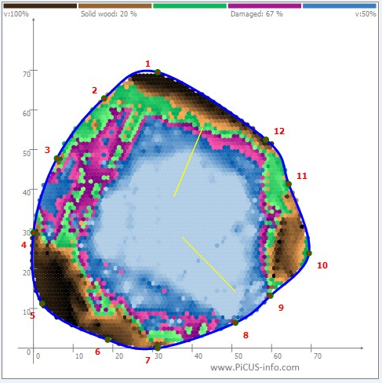  140cm above ground level | 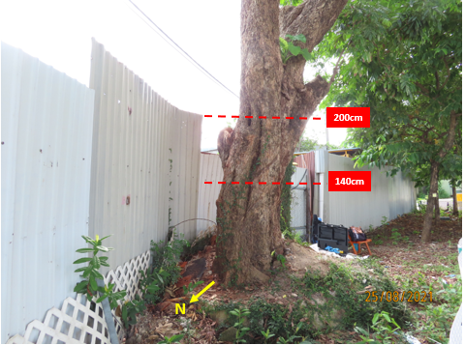  T2
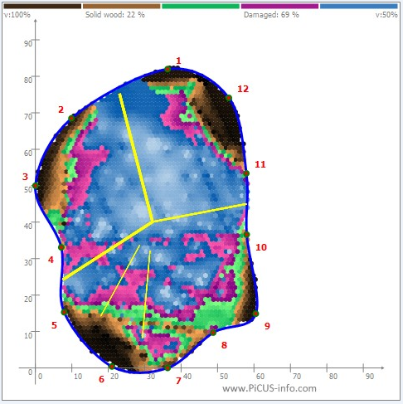
200cm above ground level

With a low percentage of solid wood in the cross-sections, the tree's ability to support its weight and withstand external forces is compromised. This increases the risk of branch or stem failures, which can pose a significant safety hazard to people and property in the vicinity.

Root condition: The root flare of the tree is not clearly visible, and the root zone is constrained by a metal plate and an old tree pit kerb.
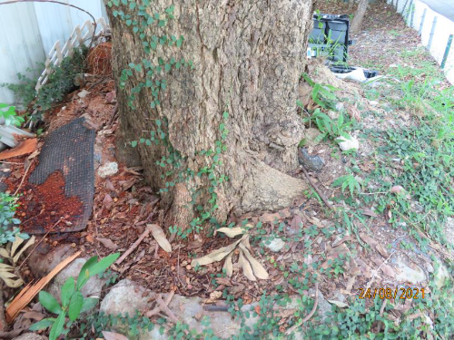
The lack of a noticeable root flare indicates that the base of the tree may be covered or obscured, potentially due to soil accumulation or other factors. The root flare is an important feature as it marks the transition between the trunk and the root system, allowing for proper nutrient absorption and stability.

The presence of a metal plate and an old tree pit kerb restricts the expansion and growth of the tree's root zone. This limitation can impede the tree's ability to access sufficient water, nutrients, and oxygen from the surrounding soil. It may also result in stunted root development and compromised stability.

Remedial measure: Based on the Sonic Tomography inspection results, the trunk of the tree exhibits a low percentage of solid wood, measuring only 20%. This indicates a significant decrease in trunk stability, which in turn affects the support provided to T2 (presumably a reference to a structure or object). The high risk of trunk failure or collapse is particularly concerning, especially during inclement weather conditions.

The potential consequences of such a failure are severe, including significant property damage and the risk of injuries. The presence of this problematic tree poses a direct threat to the safety of individuals and property within the tree canopy area.

Considering the above factors, it is highly recommended to remove T2. This course of action prioritizes public safety and mitigates the risk of accidents or damages caused by potential tree failure.

Tree Risk case – Case 3
In Case 3, an Aleurites moluccana (T3) planted at the comer of the amenity area measuring at Tuen Mun Park. T3 has a diameter at breast height (DBH) of approximately 400mm and stands at a height of 10m. Its crown spread extends to about 8m.

T3 is situated at adjacent to a path and in close proximity to the large pavilion at a Majoy Park in Hong Kong. This means that various activities and amply of park users, visitors and residents nearby frequently pass by or gather around T3 Due to its location, removing the target is not an option.

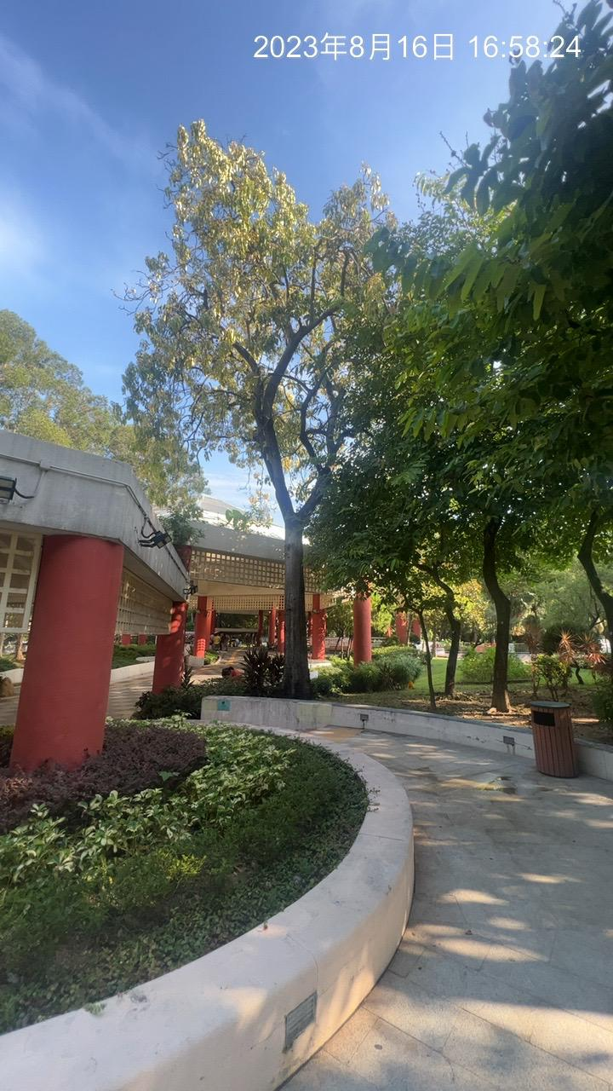
T3
T3 Location

Crown Condition: T3, the specific tree in question, is exhibiting notable signs of potential stress or health issues. These signs include a comparative yellowing of the foliage, smaller foliage size, and the presence of died-back twigs.

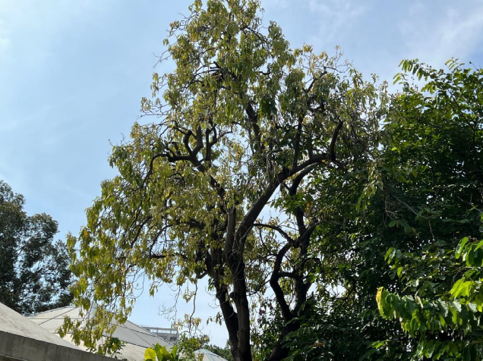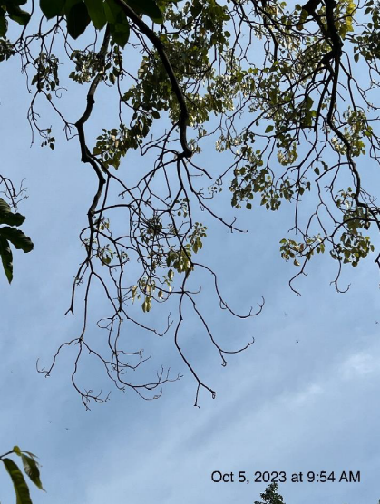

The yellowing foliage and smaller size suggest that T3 may be experiencing stress or health issues. These issues could be caused by a range of factors, including nutrient deficiencies, drought stress, pest infestation, disease, or root problems. Each of these factors can have a detrimental effect on the overall health and vitality of the tree.

Additionally, the presence of died-back twigs further indicates potential stress or health concerns. This occurrence may be a result of insufficient nutrient uptake or the impact of pests or diseases.

Trunk Condition: The tree in question displays abnormal bark peeling off, with dimensions of 600mm in width and 1900mm in length. Additionally, decay has been observed in the affected area. Furthermore, there are several vertical cracks present around the trunk, with the longest crack measuring 1.5m in length.

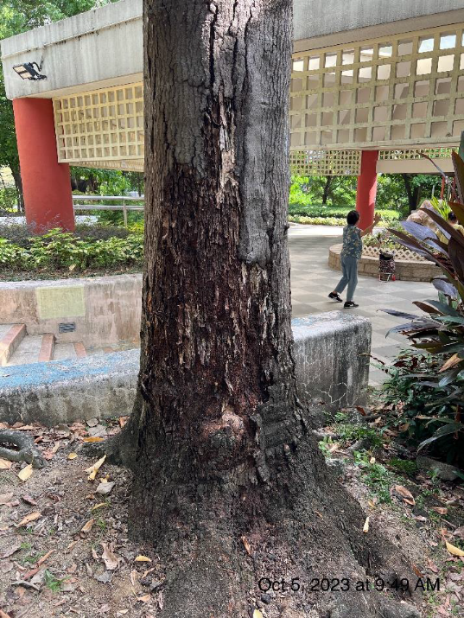  abnormal bark peeling | 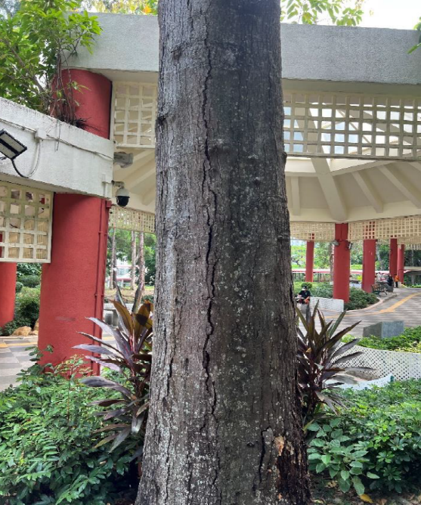  Crack
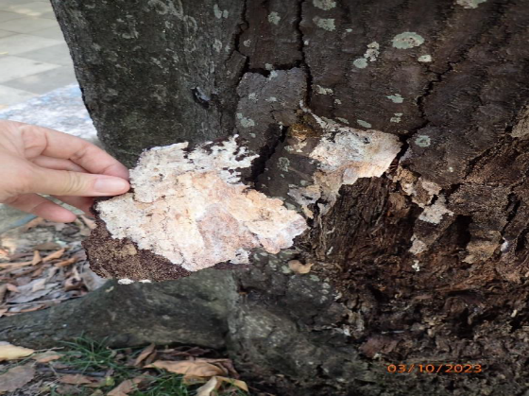
abnormal bark peeling

The abnormal bark peeling off and decay indicate significant damage to the tree's outer protective layer. This can leave the underlying wood exposed to the elements, increasing the risk of further decay, disease, and insect infestation.

The presence of vertical cracks, particularly the longest one measuring 1.5m, suggests structural instability in the trunk. These cracks weaken the tree's integrity and can potentially lead to trunk failures, especially during periods of inclement weather or other external force.
Root condition: T3 exhibits signs of root plate movement, with the roots showing decay and exposed dead wood. Additionally, the root zone is restricted by the nearby planter wall.

Root plate movement refers to the shifting or instability of the root system, which can occur due to various factors such as soil compaction or inadequate anchorage. In this case, the root plate movement was observed after the Typhoon Signal No. 8. This movement can weaken the tree's stability and increase the risk of uprooting
.
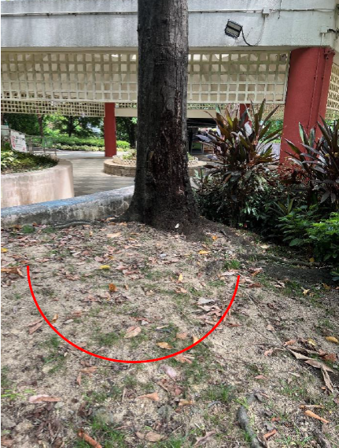  Root plate movement | 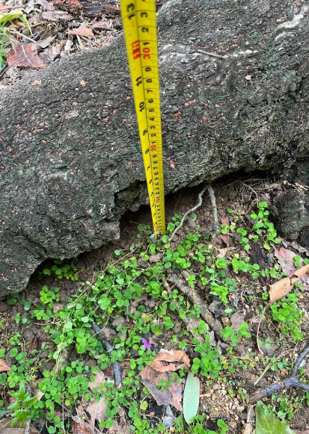  Root plate movement
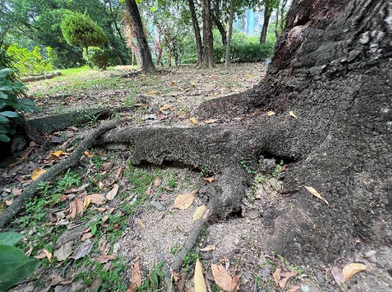  Roots decay and exposed dead wood | 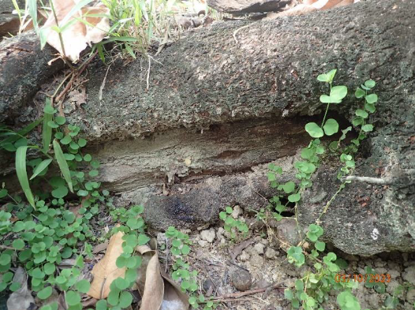  Roots decay and exposed dead wood

Remedial measure: Root plate movement has significantly compromised the stability of T3. Additionally, the trunk of the tree exhibits several vertical cracks, indicating structural damage.

The combination of root plate movement and trunk damage poses a severe risk. The potential consequences of a failure in this condition could result in substantial property damage and pose a significant risk of injuries. The presence of this problematic tree directly threatens the safety of individuals and property within the tree canopy area, especially at inclement weather.

Considering the above factors, it is highly recommended to remove T3. This course of action prioritizes public safety and mitigates the risk of accidents or damages caused by potential tree failure.

Fungal decay in Tree

Fungal decay occurs when specific fungi colonize and break down the structural components of a tree, such as the wood. This can weaken the tree, making it more susceptible to failure, especially during severe weather events or other stressors.

Identifying the types of fungi involved is crucial in understanding the risks associated with fungal decay. Different fungal species have varying abilities to degrade wood and cause structural damage. Researchers have studied and identified various decay-causing fungi, including white rot, brown rot, and soft rot fungi.

To assess and detect fungal decay in living trees, various methods have been developed. These methods include visual inspections, specialized tools like resistographs or sonic tomography, and laboratory analysis of wood samples. These techniques help arborists and professionals determine the extent of decay and make informed decisions regarding tree management and safety.
Fungal decay in Tree – Case 4
Phellinus noxius on Delonix regia

T4, a Delonix regia tree infected with Phellinus noxius, is located adjacent to a public road in a busy Industrial Zone. The tree stands at a height of 11m.

Several concerning issues have been observed with this tree. Abnormally small foliage, dieback of twigs and branches, and signs of termites on the trunk are evident. Additionally, decay with the presence of Phellinus noxius fungal fruiting bodies has been clearly identified at the root flare.

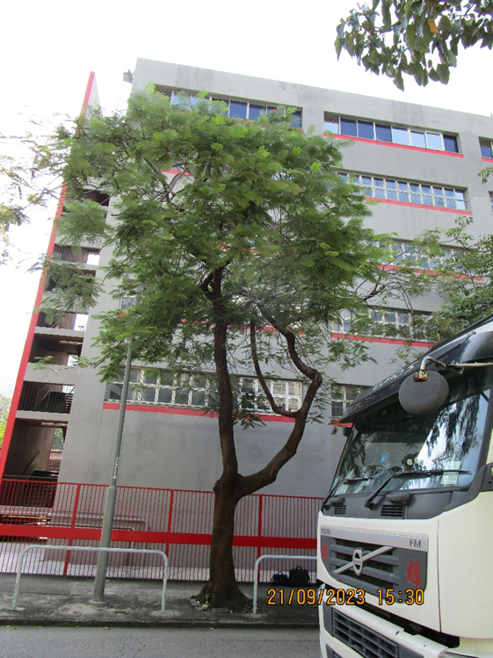

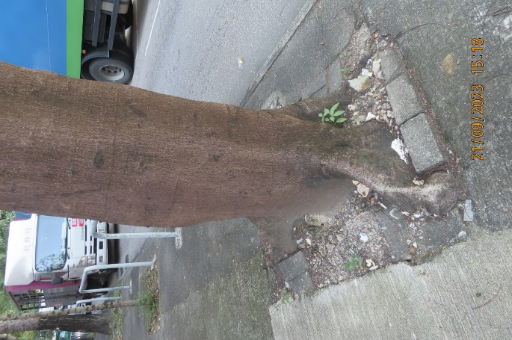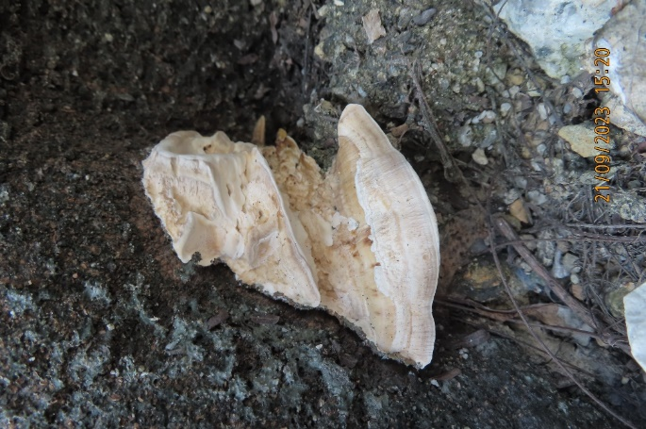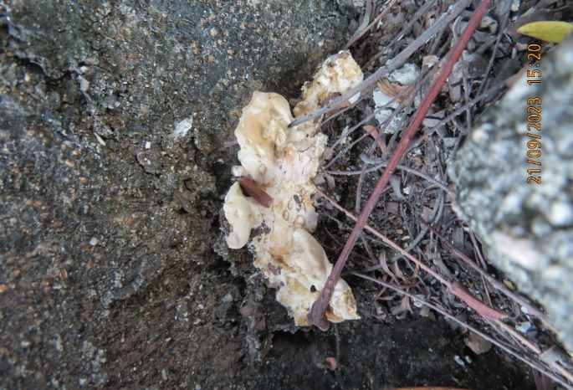
Phellinus noxius is a highly virulent pathogenic fungus that primarily causes simultaneous white rot on the roots and root collars of infected trees. Unlike many other fungi, wounds are not necessary for P. noxius infection, as it can actively infect living trees. Infection can occur through root-to-root contact or via the dissemination of basidiospores from mature fruiting bodies.

The presence of this fungus leads to the development of Brown Root Rot disease (BRRD) in trees. BRRD is characterized by a gradual thinning out of the crown, yellowing of the foliage, and a reduction in foliage size. These symptoms occur due to the impaired water transportation function of the tree's vascular system.

Given the severity of the fungal infection and the presence of irreparable defects, the structural integrity of the tree is compromised. As a result, there is a high likelihood of future tree failure. Considering the tree's low sustainability and its high-risk rating, it is recommended to remove the tree. This action is necessary to eliminate the risk it poses to public safety, especially due to its proximity to a busy road with heavy traffic and minimize the chance of spreading of BRRD.

Fungal decay in Tree – Case 5
Ganoderma lucidum on Delonix regia

T5, a Delonix regia tree, is infected with Ganoderma lucidum and situated at the edge of a slope near a traffic road. There is an electric box (grey in the photo) located underneath the tree. The tree has a height of 5m.

The tree exhibits a significant lean of 24 degrees on the compression side. An old wound is present, showing signs of decay and borer infestation. The root system is restricted on the tension side of the tree. The foliage appears abnormally colored and small in size. There is also dieback of twigs and branches.
Furthermore, decay with the presence of Ganoderma lucidum fungal fruiting bodies has been clearly identified at the root. This indicates a severe fungal infection and decay within the tree's root system.
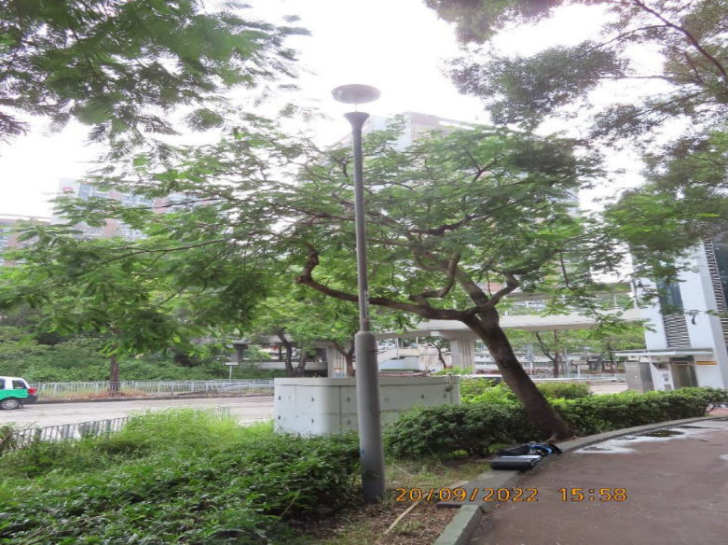
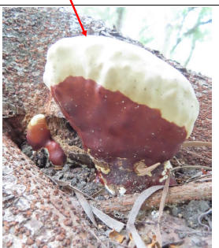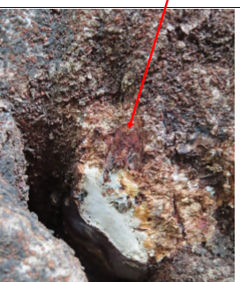

Ganoderma lucidum is a pathogenic fungus that causes white rot decay on the trunks and roots of trees. This fungal infection can eventually lead to the death of the tree within a few years after initial infection.

In this particular case, it is important to regularly monitor T5, preferably by a certified arborist or tree specialist. The tree exhibits a leaning posture that compromises its stability, compounded by the infection of Ganoderma lucidum, which leads to decay in both the trunk and root system. Over time, this decay will gradually damage the tree's structural integrity.

By conducting regular inspections, the condition of T5 can be consistently assessed, allowing for timely updates on its health and structural stability. This proactive approach ensures that appropriate measures can be taken promptly if the situation worsens.

Tree Defect Detection system
In recent years, the arboriculture and forestry industry has witnessed the introduction of several tools aimed at aiding in the evaluation of tree defects. These tools encompass a range of essential equipment, including a mallet for conducting sounding tests, diameter tape and logger's tape for measuring tree dimensions, an increment borer for extracting core samples, a portable drill for various purposes, a calculator for data analysis, a telescope for visual inspections, and soil excavation tools for assessing root conditions.

Moreover, more advanced decay detection devices such as the Resistograph and Sonic Tomography Assessment have gained popularity and are now commonly employed. These tools provide additional capabilities for identifying and evaluating internal decay and structural integrity issues within trees.

Resistograph Assessment
Resistograph inspection is a method used to assess the internal condition of trees. It involves drilling into the tree trunk with a specialized device called a Resistograph, which measures the resistance encountered. The resistance profile obtained helps identify internal defects like decay or cracks. Arborists use the resistogram, a graphical representation of the resistance measurements, to make informed decisions about tree management and safety. Resistograph inspections are typically performed by trained professionals and are used in combination with other assessment methods for a comprehensive evaluation of tree health.

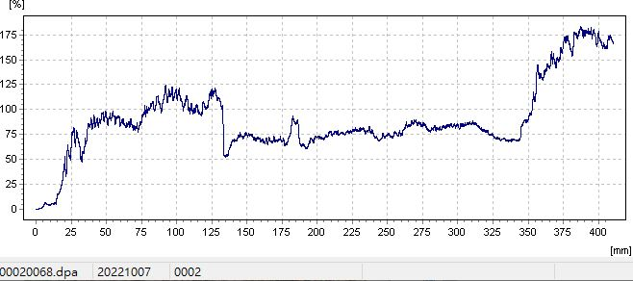

The pros and cons of Resistograph Assessment is as below:

Pros:
- The resistograph generates quantitative data in the form of resistance measurements, allowing for objective analysis and comparison.

- The resistograph can be used on a wide range of tree species and sizes, making it a versatile tool for tree inspections.

- Resistograph inspection complements other assessment techniques, such as visual inspections or sonic tomography, providing a more comprehensive understanding of a tree's condition. brief

Cons:

- The drilling process involved in resistograph inspection can cause surface damage to the tree trunk. While the damage is generally minor, it can affect the aesthetic appearance of the tree.
- Interpreting resistograph data requires expertise and experience. Without proper training, there is a risk of misinterpreting the results, leading to incorrect assessments.

- Resistograph inspection provides information only about the specific area where drilling takes place. It does not provide a comprehensive assessment of the entire tree.

Sonic Tomography Assessment

Sonic Tomography Assessment is a non-invasive method used to evaluate the internal condition and structural integrity of trees. It involves the use of sound waves to create a visual representation of the internal wood density and potential areas of decay within the tree trunk. The methodology includes equipment setup with specialized sensors, transmitting sound waves by striking the trunk, recording the travel times of the waves between sensors, analyzing the data using software, and generating a visual representation known as a tomogram. This tomogram provides a cross-sectional view of the tree trunk, highlighting areas of potential decay or structural weakness. Sonic Tomography Assessment is a valuable tool for arborists, allowing them to assess internal tree conditions without causing damage and make informed decisions regarding tree management and safety measures.

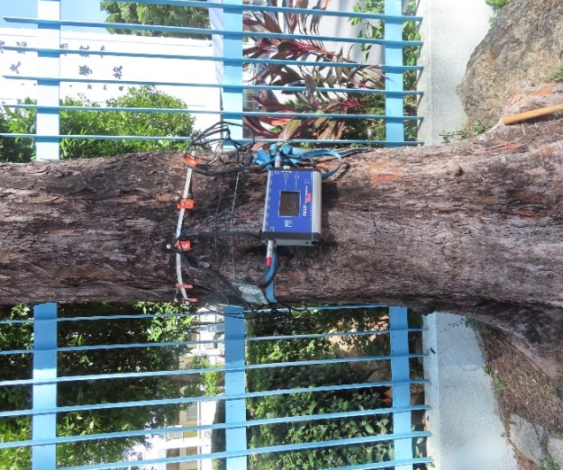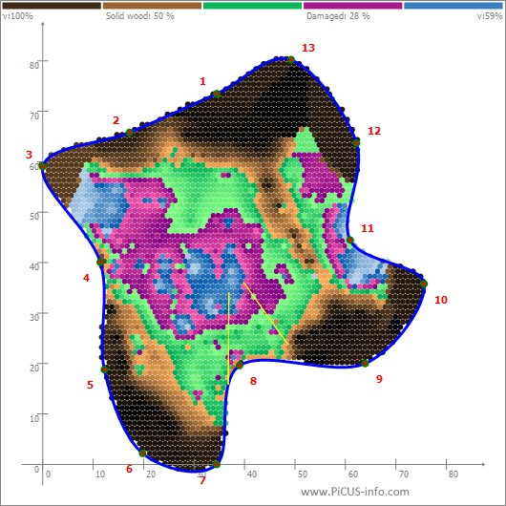

The pros and cons of Sonic Tomography Assessment is as below:

Pros:
- Non-invasive method for evaluating internal tree conditions without causing damage.
- Provides accurate visualization of internal wood density and areas of decay through tomograms.
- Offers objective data for informed decision-making regarding tree management and safety.
- Time-efficient assessment process.
- Suitable for various tree species.

Cons:

- Effective results limited to trees with a minimum trunk diameter.
- Less effective for hollow trees or extensive decay.
- Environmental factors can affect assessment accuracy.
- Requires expertise for proper sensor placement and data interpretation.
- Additional equipment and software requirements may incur costs.

In summary, Sonic Tomography Assessment is a valuable tool for non-destructively evaluating internal tree conditions. It provides accurate visualization and objective data, but has limitations related to tree size, hollow trees, environmental factors, user expertise, and additional equipment requirements.

Now, there are several innovative tree defect detection systems that have emerged in recent years. These include hyperspectral imaging, LiDAR, acoustic monitoring, drone-based inspections, and AI applications. Hyperspectral imaging analyzes spectral signatures to identify subtle changes associated with tree defects. LiDAR creates 3D models to accurately measure tree structure and identify defects. Acoustic monitoring detects changes in sound patterns to indicate internal defects. Drones equipped with various sensors enable efficient and detailed inspections. AI applications analyze data from multiple sources to automatically detect and classify tree defects. These innovative systems provide advanced capabilities for assessing tree health and structural integrity.

Conclusion

Hong Kong is a densely populated urban area with limited green spaces. Trees often grow in urban environments, including parks, roadside plantings, and private gardens. The urban setting presents challenges such as limited planting spaces, competition for resources, and exposure to pollution and urban heat island effects.

The portfolio cases presented here highlight the challenges faced by arboriculture industry in Hong Kong. Many trees are planted in confined spaces such as planters or tree pits, obstructing root system development. This is a common and significant issue that tree inspection officers, arborists, and tree workers deal with on a daily basis.

Enhancing knowledge on urban forestry in the public and tree management sectors is crucial for promoting effective tree care and sustainable urban green spaces. When there is a better understanding of urban forestry and its principles, tree planting can be approached in a more balanced and thoughtful manner, taking into consideration both the needs of trees and humans.

Innovative tree decay detection equipment is essential for tree inspection officers to accurately assess the extent of decay and provide appropriate instructions to tree surgeons. This ensures public safety within the community and serves as evidence to support the preservation of trees. With the use of updated decay detection equipment, trees with low risk and minor defects can be preserved by confirming the extent of internal decay.

Word Count: 4021

