F.2 Computer Literacy
Answer Sheet for Assignment 4
Name: _Alyssa Pang____________ Class___2G_____(25 )

Refer to the question paper
Part 1:
The purpose of the algorithm is
It will get the sum from 1 to target number defined by M.
i.e. when user input 5 into M input box
the algorithm will do 1 + 2 + 3 + 4 + 5 and hence shown 15 on the result (s)

Part 2:
The purpose of the algorithm is
It will get the sum of the list
i.e. when user define [0,1,2,3,-1,-2,-3,3,10,1] into the list
the algorithm will output 14 in “s” input box. ( 0 + 1 + 2 + 3 + -1 + -2 + -3 + 3 + 10 + 1 = 14)

Challenge 1: (Paste a screen capture of your blocks here)

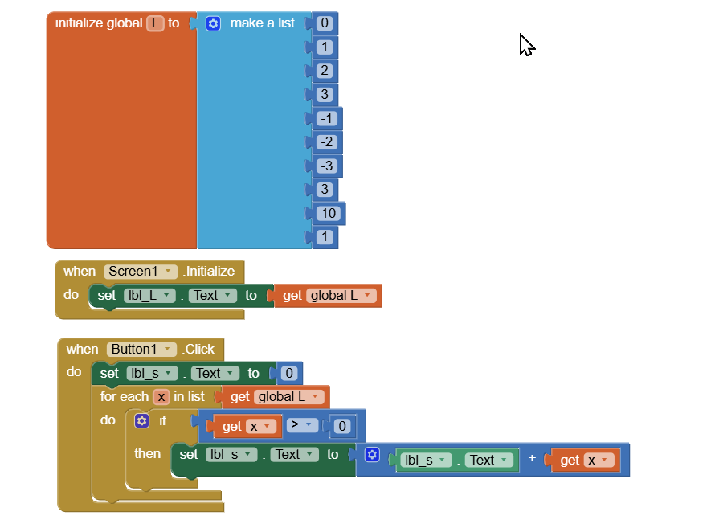
Challenge 2: (Paste a screen capture of your blocks here)
