ISOM 2600 - Assignment 2

In this assignment, you are given a dataset about bodyfat measure collected from a clinic. As a nutritionist, you want to use regression model to check whether your patients are in danger of high bodyfat. The data contains physical measurements of patients:
- explantory variables: Age (in year), Weight (in pounds), Height (in inches), and BMI.
- response variable: bodyfat (in %)

Complete the tasks. (Notice each of the missing code to be filled is a single line command, more than one command line will be downgraded)

Task 1: Compute the correlation matrix; which variable has the strongest correlation with bodyfat? [5pts]

Task 2: Split the data into train and test set by random (use 25 as the random seed/state) [5pts]

Task 3: Using the train set, fit a simple regression model for bodyfat by the variable from Task1 (the one with max correlation) [5pts]

Task 4: Using the train set, fit a multiple regression model for bodyfat by all of the explanatory variables (i.e. age, weight, height and bmi) [5pts]

Task 5: Multicollinearity is reflected from above. Does bmi cause the problem? Briefly explain using your understanding about bmi. [5pts]

Task 6: Using the train set, fit a multiple regression model for bodyfat by all of the explanatory variables except bmi. [5pts]

Task 7: Compute the RMSE for MLR. [5pts]

Task 8: Refit the better model from Task7 using the full dataset. [5pts]

Task 9: Predict the body fat for a new patient (using the final model from Task 8): age=35, weight=170 pounds. Height=72 inches, BMI=23. [5pts]

Task 10: by using residuals (from final model) outlier analysis, report those patients are in danger (i.e. % of fat is much higher than what we expected from the final model) [5pts]
After completion of all task and questions,
- For Jupyter Notebook/Jupyter lab user: Once you finish implementing all the codes (Please DO NOT clear the outputs), please export the notebook as HTML (see instruction in next page) and submit both your notebook and HTML to Canvas.
- For Google Colab user: Once you finish implementing all the codes (Please DO NOT clear the outputs), use the link below to convert the ipynb file to HTML and submit both your notebook and HTML to Canvas.
- https://colab.research.google.com/github/Mostafa-MR/Convert_ipynb_to_HTML_in_Colab/blob/main/Convert_ipynb_to_HTML_in_Colab.ipynb
For Jupyter Notebook/Jupyter lab user
Export the code and output as HTML:
Jupyter Notebook: Go “File” > “Download as” > Choose “HTML”
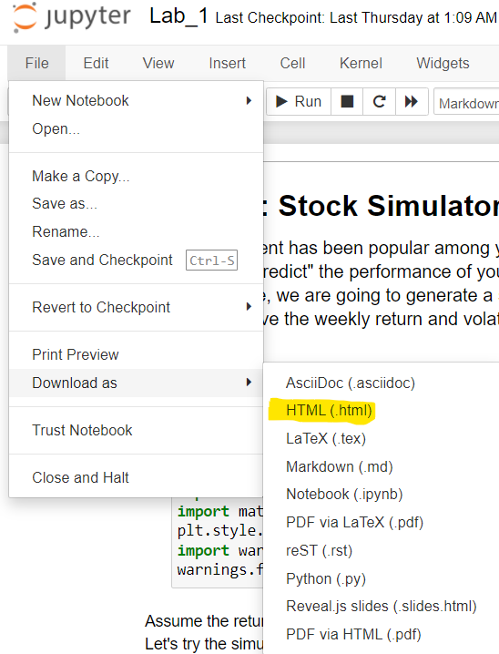
Jupyter lab: Go “File” > “Save and Export Notebook As” > Choose “HTML”
