Topic
Heart Disease Detection
Source of dataset
https://www.kaggle.com/datasets/johnsmith88/heart-disease-dataset

Main Variables
Patient info - may affect the diagnosis as previously mentioned data (Higher death rate for certain age group/sex)
1. age: The age of a person
2. sex: The person’s gender(1 = male, 0 = female)

Severity of chest pain, which is highly associated with heart disease
3. cp: The types of chest pain experienced (Value 1: typical angina, Value 2: atypical angina, Value 3: non-anginal pain, Value 4: asymptomatic)

Characteristic for classifying disease in the model
4. trestbps: Resting blood pressure (mm Hg on admission to the hospital)
5. chol: Cholesterol measurement in mg/dl
6. fbs: Fasting blood sugar (if > 120 mg/dl, 1 = true; 0 = false)
7. restecg: Resting electrocardiographic measurement (0 = normal, 1 = having ST-T wave abnormality, 2 = showing probable or definite left ventricular hypertrophy by Estes’ criteria)
8. thalach: Maximum heart rate achieved
9. exang: Exercise-induced angina (1 = yes; 0 = no)
10.oldpeak: ST depression induced by exercise relative to rest (‘ST’ relates to positions on the ECG plot)
11.slope: the slope of the peak exercise ST segment (Value 1: upsloping, Value 2: flat, Value 3: downsloping)
12.ca: The number of major vessels (0–3)
13.thal: A blood disorder called thalassemia (1 = normal; 2 = fixed defect; 3 = reversable defect)

Result from the dataset for training
14.target: Heart disease (0 = no, 1 = yes)

Proposed Methodology
Data Visualization
- Provide an overview of the dataset, e.g. Male and Female proportion, The types of chest pain experienced among the patients, showing the correlation between cp and target
Confusion Matrix
- Decision Tree
- Logistic Regression
  - Construct a model to predict whether a patient has heart disease

- Introduction and motivation
- Data frame and Variables [source, type of variable, objectives, etc]
- Data Cleaning (checking n/a, missing value, structure of data [summary of stat])
- Methods intro
- why these methods, and how can they benefit your research?

- Data Visualisation (700 words)
  - Correlation of independent variables
- Decision tree
  - Classification tree -> binary output
  - Construct a decision tree with minimum classification errors
  - Identify whether the issue of overfitting exists, why important…
  - Simplify the tree if necessary (additional research required: other possible enhancements to the model’s efficiency?)
- Logistic regression
  - Construct a simple/full model first
https://libres.uncg.edu/ir/ecsu/f/Brandon_Simmons_Thesis-Final.pdf (Interpretation P54)
Example
Model Equation: Log(odds of Heart Disease) = 1.6 + 0.024 · thalach − 0.74 · oldpeak − 2.11 · cp(level4)
Interpretations:
• In average, the expected odds value (or average odds value) of getting ’Heart Disease’ is quite high (e 1.6 ∼ 5 i.e., a 5 to 1 odds ratio). Thus, the average probability is e 1.6 1 + e 1.6 × 100% ∼ 49.5% of getting ’Heart Disease’, according to the Cleveland Data. In other words, one in two people will likely become ’heart patient’.
• A unit change in thalach value increases the odds of getting ’Heart Disease’ by a factor of e 0.024 ∼ 1.02 above the average, holding the effect of the factors constant. In which case, the probability of getting ’Heart Disease’ increases by about (e 0.024 − 1) × 100% ∼ 2.4% compared to the average.
• Also, when compared to patients with typical angina (cp-level 1), the average odds of getting heart disease for individuals who experience no pain (cp-level 4 or asymptomatic) decreases by a factor of e −2.11 ∼ 0.12. In which case the probability of getting ’Heart Disease’ while showing no chest pain (cp-level 4) decreases about (1 − e −2.11) × 100% ∼ 88% compared to those who experience typical angina. Other pain levels (2-3) are not statistically significant.
  - Enhancement of the predictive power of the model by:
  - a) Introduction of interactive variables or the likes;
https://libres.uncg.edu/ir/ecsu/f/Brandon_Simmons_Thesis-Final.pdf

age -0.03545
ca0yes 2.30631
exp(age) exp(ca0yes)
0.9651713 10.0373376

Ca0yes = (e 2.30631 − 1) × 100% = 1000% / 10 times higher chance (double check)
Age = (1 − e -0.03545) × 100% = 3.5% lower chance
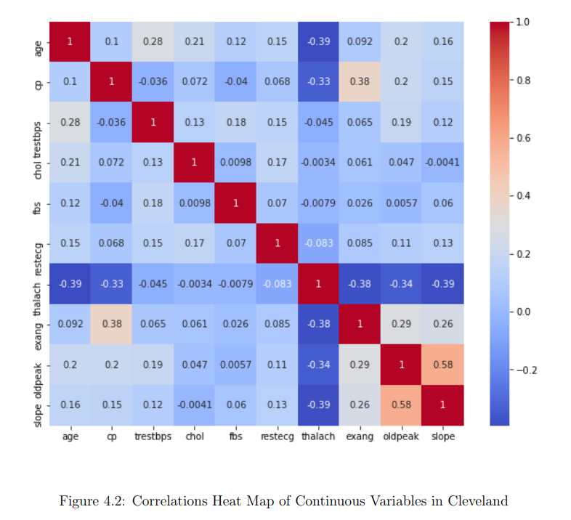
  - b) Stepwise regression to produce a model with a low p-value or high adjusted R-squared;
  - c) Adjustment of threshold to derive the preferred outcome (precision vs recall?)
Use confusion matrix https://libres.uncg.edu/ir/ecsu/f/Brandon_Simmons_Thesis-Final.pdf (P48)

- Other ML applications (without detailed explanations)
- SVM/Naive Bayes
  - Have info for supervised learning
- Random forest/NN -> ensemble learning
- Results [confusion matrix evaluation, ROC curve, implication]
- Threshold setting -> 0.25 initial screening to relieve the burden of the medical system, just to filter a small group of healthy ppl out. (balance the risk)
- Discussion [Conclusion]
- Models usage depends on diff. situations.
- Any potential correlation to the causation issue? cautions

CODE
EDA (DATA VISUALIZATION)
#Data Visualisation
library(ggplot2)
#data remap for data visualisation, easier for graph labelling
heart$sex[heart$sex == 0] <- "F"
heart$sex[heart$sex == 1] <- "M"
heart$cafac <- as.factor(heart$ca)

#percentage of male and female
ggplot(heart, aes(fill=targetfac, y=1, x=sex)) +
geom_bar(position="stack", stat="identity")+
ylab("Count of patient") +
ggtitle("Gender distribution")

#age distribution
hist(heart$age, 20)
boxplot(heart$age)
ggplot(heart, aes(fill=targetfac, y=1, x=age)) +
geom_bar(position="stack", stat = "identity")+
ggtitle("Relationship of age to heart disease")
ggplot(heart, aes(x=age, y=targetfac)) +
geom_boxplot()+
ggtitle("Relationship of age to heart disease")

#Relationship of healthy vessels to heart disease
ggplot(heart, aes(fill=cafac, y=1, x=targetfac)) +
geom_bar(position="fill", stat = "identity")+
ggtitle("Relationship of healthy vessels to heart disease")

#Relationship of heart rate and heart disease
ggplot(heart, aes(fill=targetfac, y=1, x=thalach)) +
geom_bar(position="stack", stat="identity") +
ylab("Number of patient") +
ggtitle("Max. heartrate and heart disease")
ggplot(heart, aes(x=thalach, y=targetfac)) +
geom_boxplot()+
ggtitle("Relationship of Max. heartrate and heart disease")

#Relationship of chest pain and heart disease
ggplot(heart, aes(fill=targetfac, y=1, x=cp)) +
geom_bar(position="stack", stat="identity")+
ylab("Number of patient") +
ggtitle("Type of chest pain")

#Relationship of exercise induced angina to heart disease
ggplot(heart, aes(fill=targetfac, y=1, x=exang)) +
geom_bar(position="stack", stat="identity")+
ylab("Number of patient") +
ggtitle("exang")

#Relationship of slope to heart disease
ggplot(heart, aes(fill=targetfac, y=1, x=slope)) +
geom_bar(position="stack", stat="identity")+
ylab("Number of patient") +
ggtitle("Relationship of slope to heart disease")

#Relationship of thalassemia to heart disease
ggplot(heart, aes(fill=targetfac, y=1, x=thal)) +
geom_bar(position="stack", stat="identity")+
ylab("Number of patient") +
ggtitle("Relationship of thalassemia to heart disease")

#Relationship of cholesterol to heart disease
ggplot(heart, aes(fill=targetfac, y=1, x=chol)) +
geom_bar(position="stack", stat="identity")+
ylab("Number of patient") +
ggtitle("Relationship of cholesterol to heart disease")
ggplot(heart, aes(x=chol, y=targetfac)) +
geom_boxplot()+
ggtitle("Relationship of cholesterol to heart disease")

#Relationship of blood sugar to heart disease
ggplot(heart, aes(fill=targetfac, y=1, x=fbs)) +
geom_bar(position="fill", stat="identity")+
ylab("Percentage of patient") +
ggtitle("Relationship of bloodsugar to heart disease")

LOGISTIC REGRESSION
Note: Logit4 and Logit7 are deleted as they are not contributing to our final model.

heart <- read.csv("C:/Users/JustinC/Downloads/heart.csv",stringsAsFactors = TRUE)
#check whether the dataset is imported properly
str(heart)
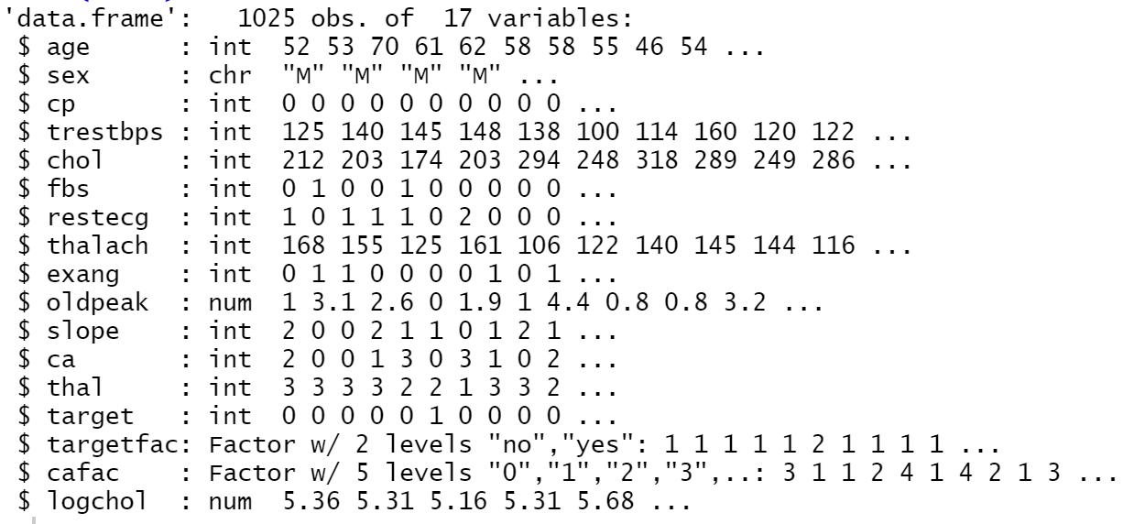
summary(heart)
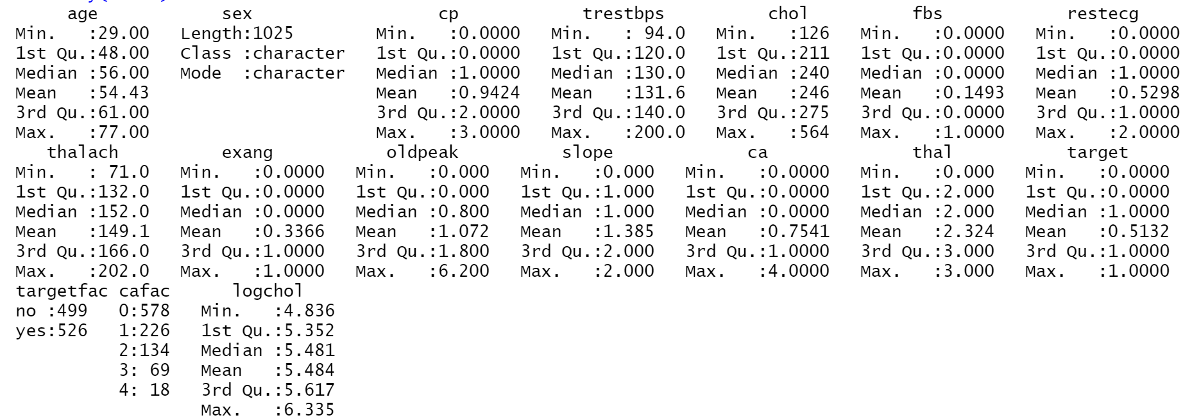
#test any NA within the dataset
any(is.na(heart))

#Data remap
heartTraining$sex[heartTraining$sex == 0] <- "F"
heartTraining$sex[heartTraining$sex == 1] <- "M"

#split 3 sets (holdout method) Code source: https://stackoverflow.com/questions/36068963/r-how-to-split-a-data-frame-into-training-validation-and-test-sets
fractionTraining <- 0.60
fractionValidation <- 0.20
fractionTest <- 0.20
# Compute sample sizes.
sampleSizeTraining <- floor(fractionTraining* nrow(heart))
sampleSizeValidation <- floor(fractionValidation* nrow(heart))
sampleSizeTest <- floor(fractionTest* nrow(heart))
# Create the randomly-sampled indices for the dataframe. Use setdiff() to avoid overlapping subsets of indices.
indicesTraining <- sort(sample(seq_len(nrow(heart)), size=sampleSizeTraining))
indicesNotTraining <- setdiff(seq_len(nrow(heart)), indicesTraining)
indicesValidation <- sort(sample(indicesNotTraining, size=sampleSizeValidation))
indicesTest <- setdiff(indicesNotTraining, indicesValidation)
# Finally, output the three dataframes for training, validation and test.
heartTraining <- heart[indicesTraining, ]
heartValidation <- heart[indicesValidation, ]
heartTest <- heart[indicesTest, ]

#Construction of initial logistic model
logit1 <- glm(target~.-targetfac, data=heartTraining, family=binomial(link="logit"))
summary(logit1)
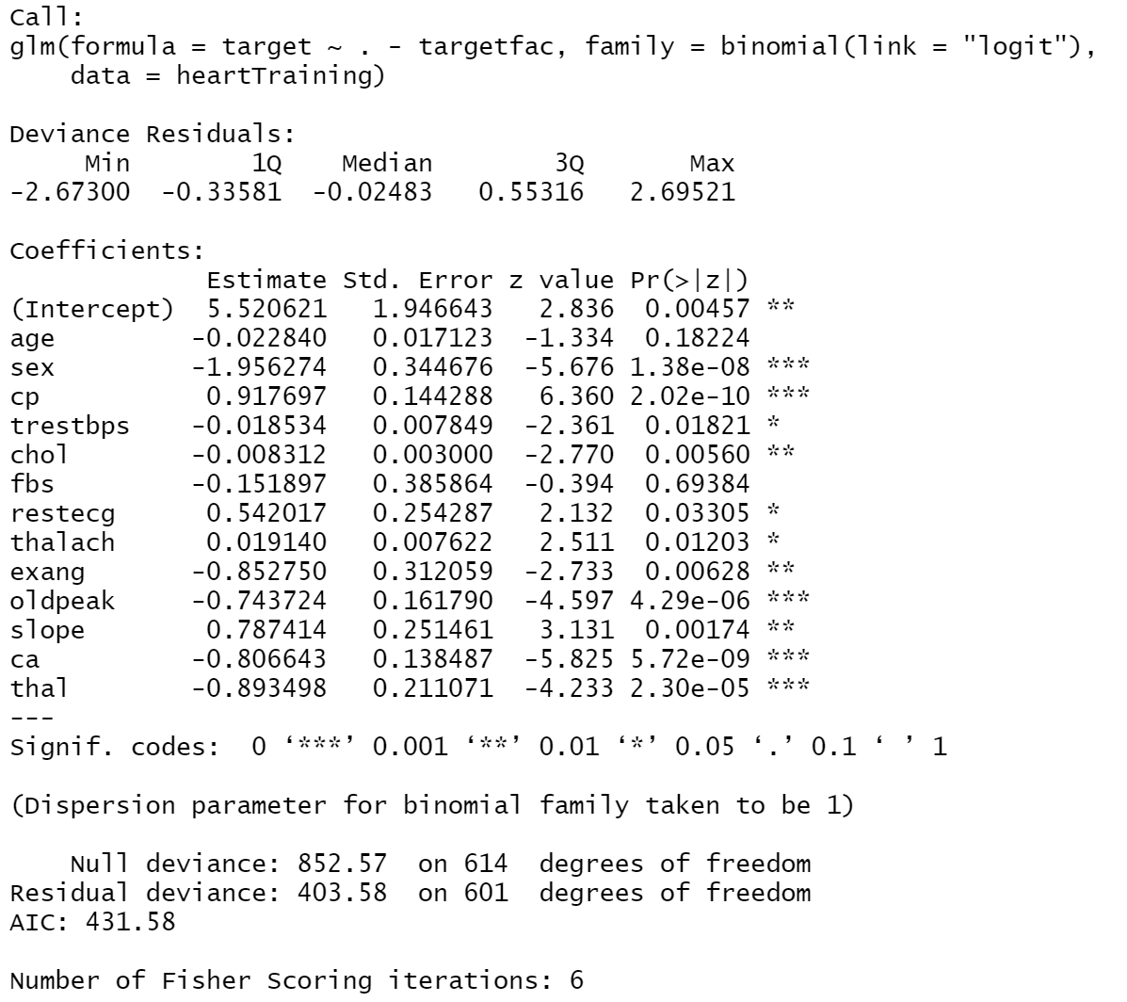
library(rcompanion)
nagelkerke(logit1) #0.527
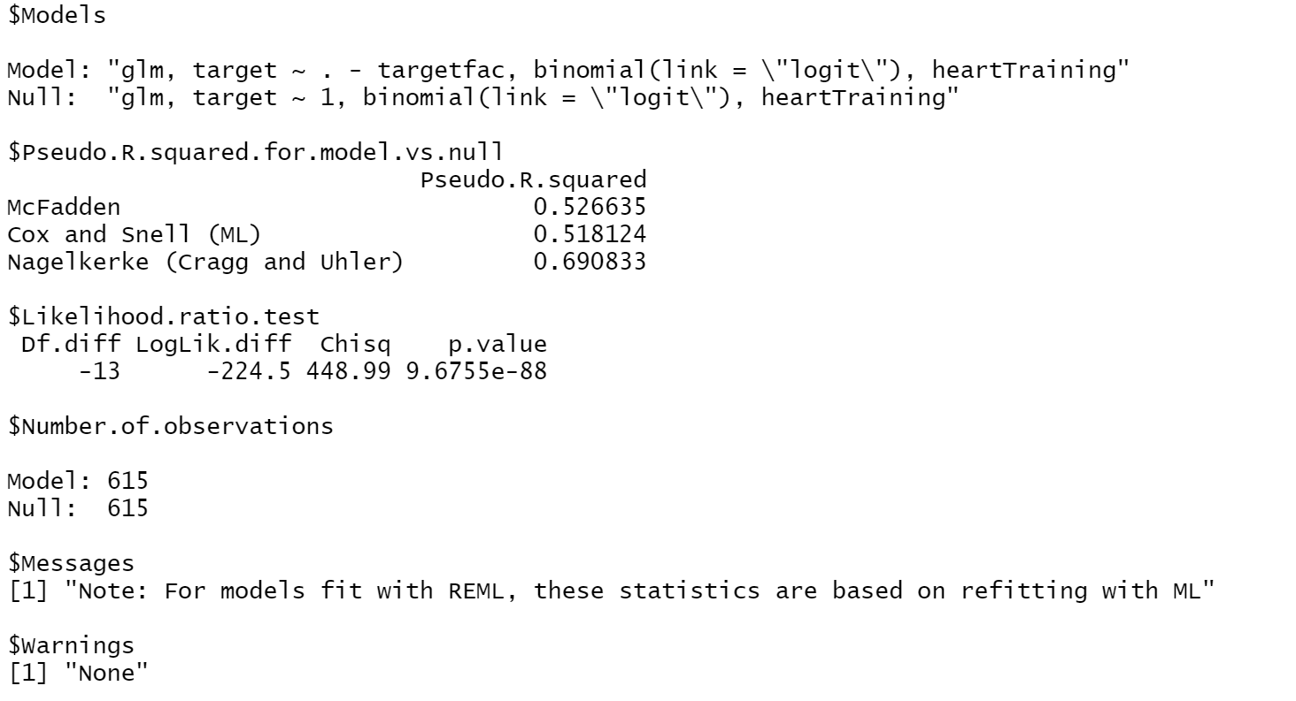
#BIC
base <- glm(target~1, data=heartTraining)
full <- glm(target~. -targetfac, data=heartTraining)
step(base,scope = list( upper=full, lower=~1 ), direction = "both", trace=TRUE, k=log(nobs(base)))
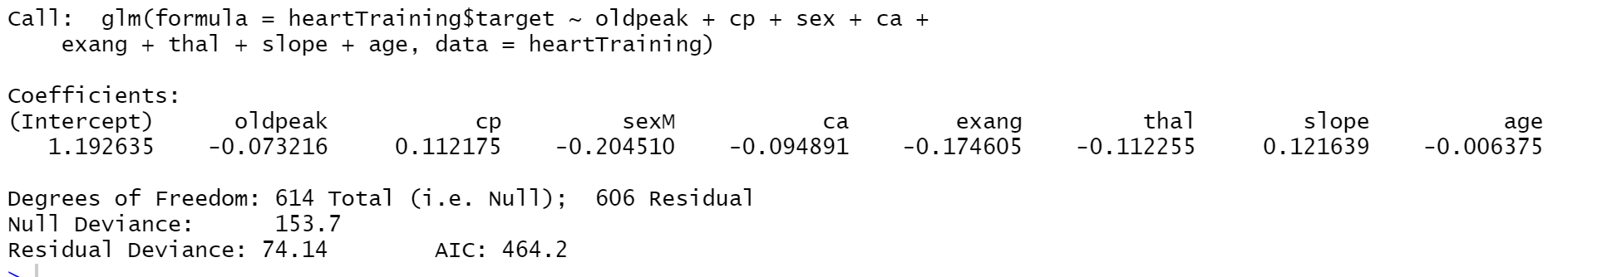
logit2 <- glm(formula = target ~ oldpeak + cp + sex + ca +
exang + thal + slope + age, data = heartTraining,family=binomial(link="logit"))
summary(logit2)
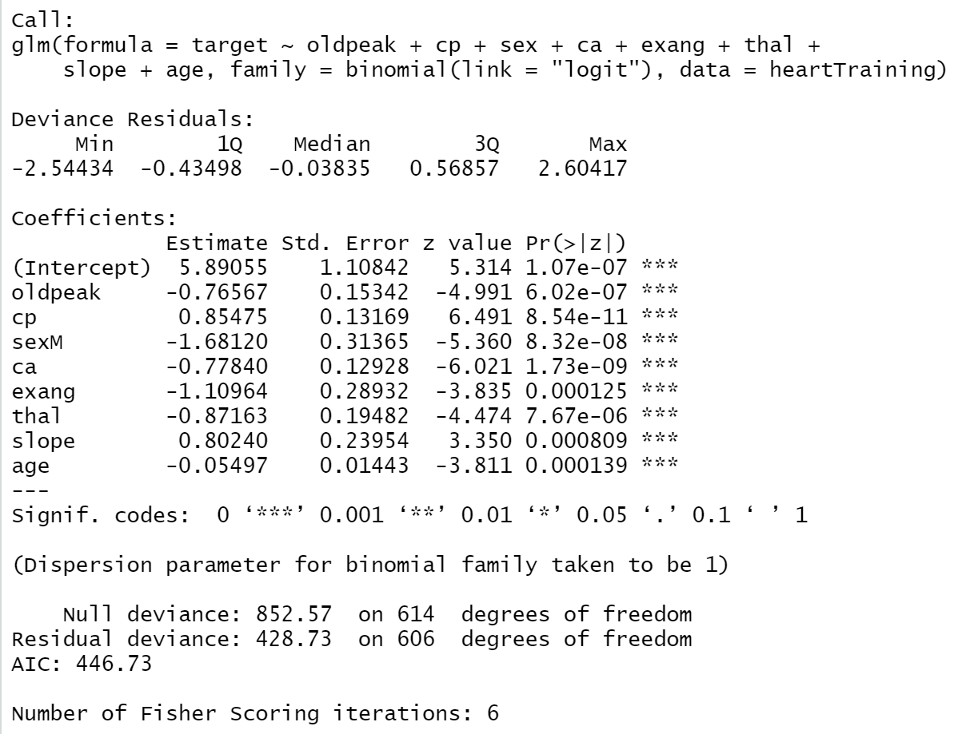
nagelkerke(logit2) #0.497
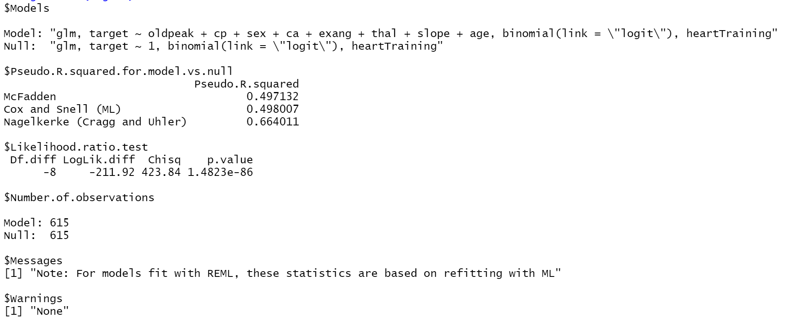

#try for logarithmic and exponential term
#1 number of major vessels (less vessels, higher chance for heart disease) (10 times more prob to have heart disease for ca=0)
heartTraining$ca0 <- ifelse(heartTraining$ca==0, "yes", "no")
logit3 <- glm(target ~ oldpeak + cp + sex + exang + thal + slope + age + ca0 , data = heartTraining,family=binomial(link="logit"))
summary(logit3)
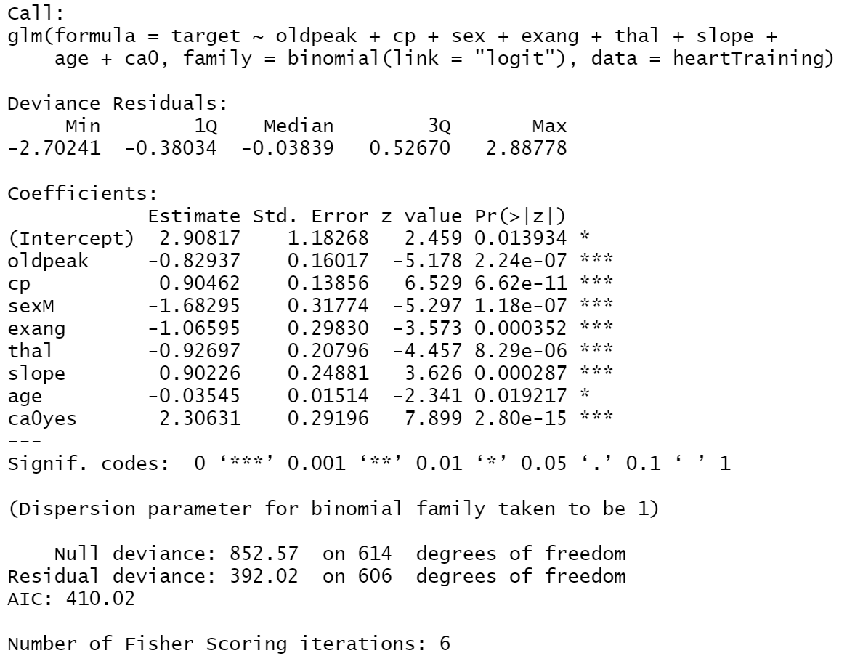
nagelkerke(logit3) #0.540
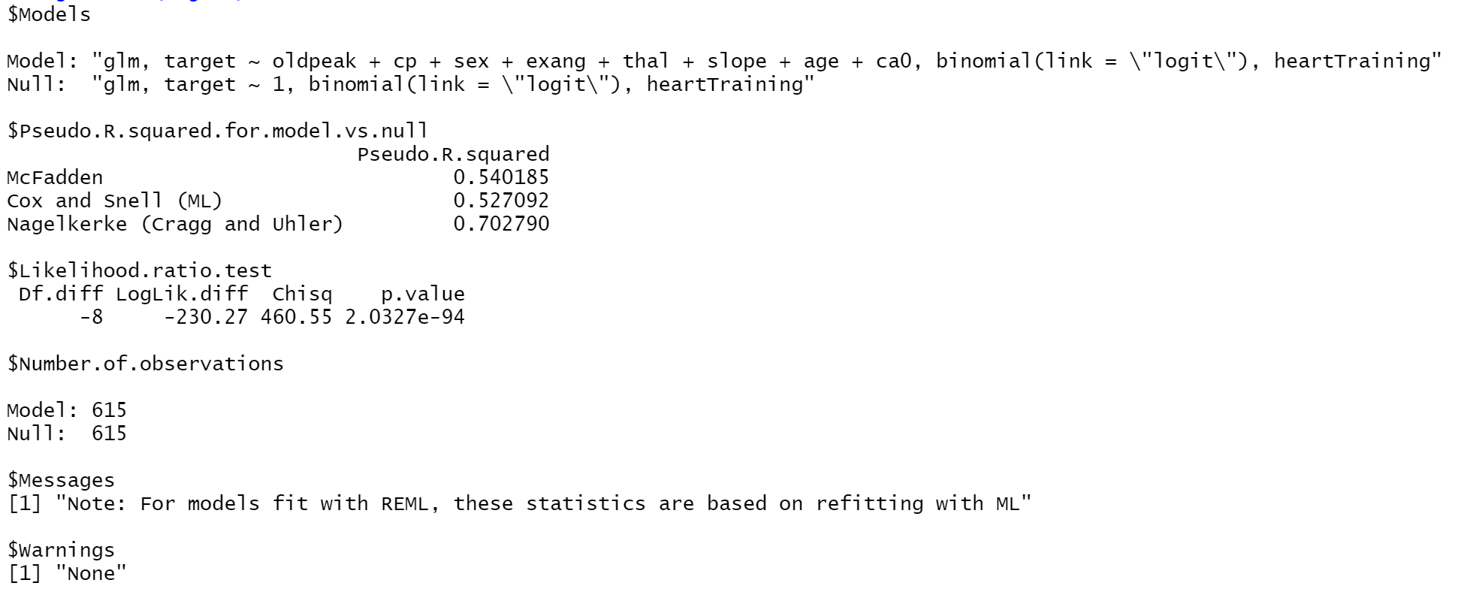
exp(coef(logit3))

#2 Max. heart rate (from data vis.) (X stat significant)
heartTraining$thalach2 <- heartTraining$thalach^2
logit5 <- glm(target ~ oldpeak + cp + sex + exang + thal + slope + age + ca0 + thalach2, data = heartTraining,family=binomial(link="logit"))
summary(logit5)
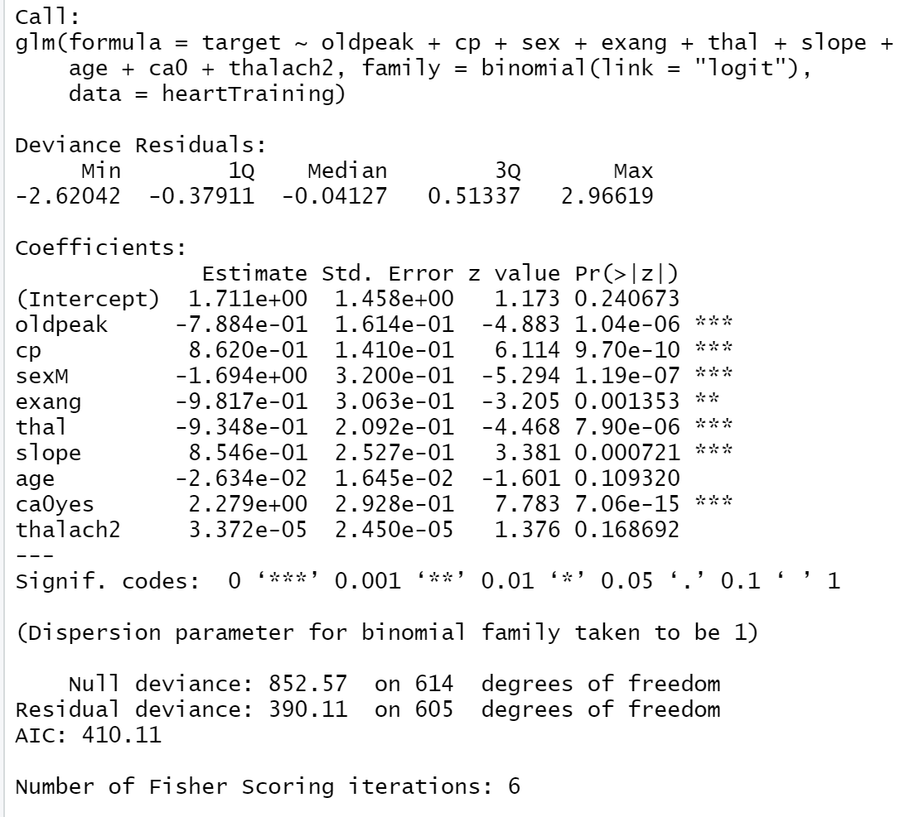

#3 Chest pain (0 = no chest pain, 1,2,3 = exp chest pain)
heartTraining$cp123 <- ifelse(heartTraining$cp==0, "no", "yes")
logit6 <- glm(target ~ oldpeak + sex +
exang + thal + slope + age + ca0 + cp123, data = heartTraining,family=binomial(link="logit"))
summary(logit6)
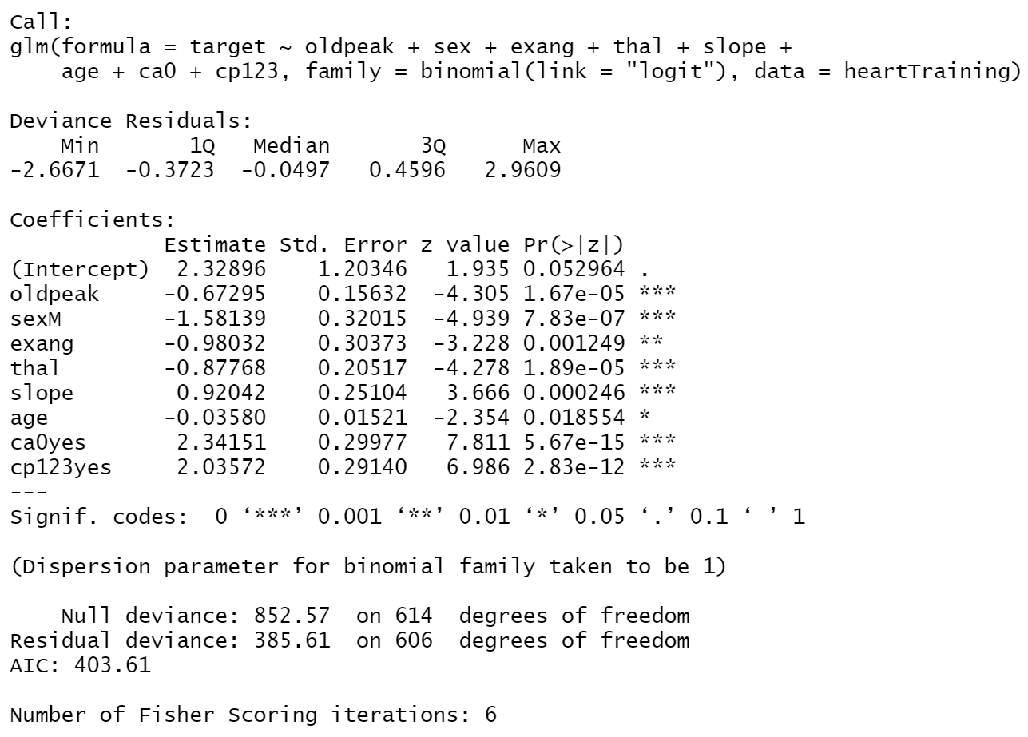
nagelkerke(logit6) #0.548
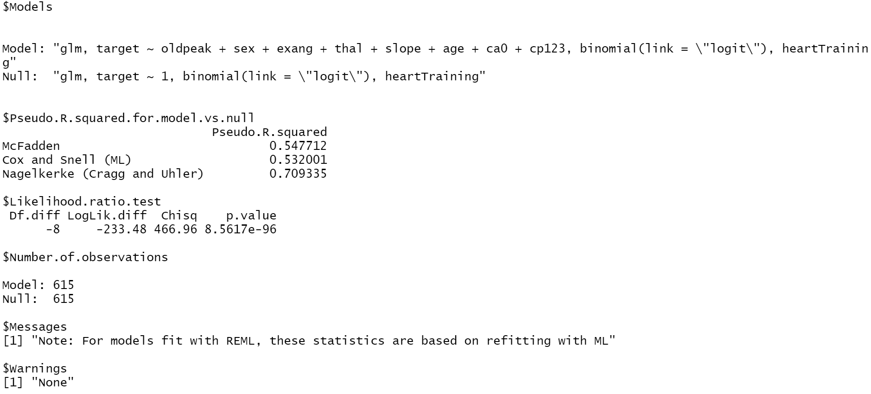
exp(coef(logit6))

#try for interactive terms
#1 male + flat slope (X stat significant)
heartTraining$sexMale <- ifelse(heartTraining$sex == 1, 1, 0)
heartTraining$slopeFlat <- ifelse(heartTraining$slope == 1, 1, 0)
logit4 <- glm(target ~ oldpeak + cp + sex + exang + thal + slope + age + ca2 + sex*slopeFlat , data = heartTraining,family=binomial(link="logit"))
summary(logit4)
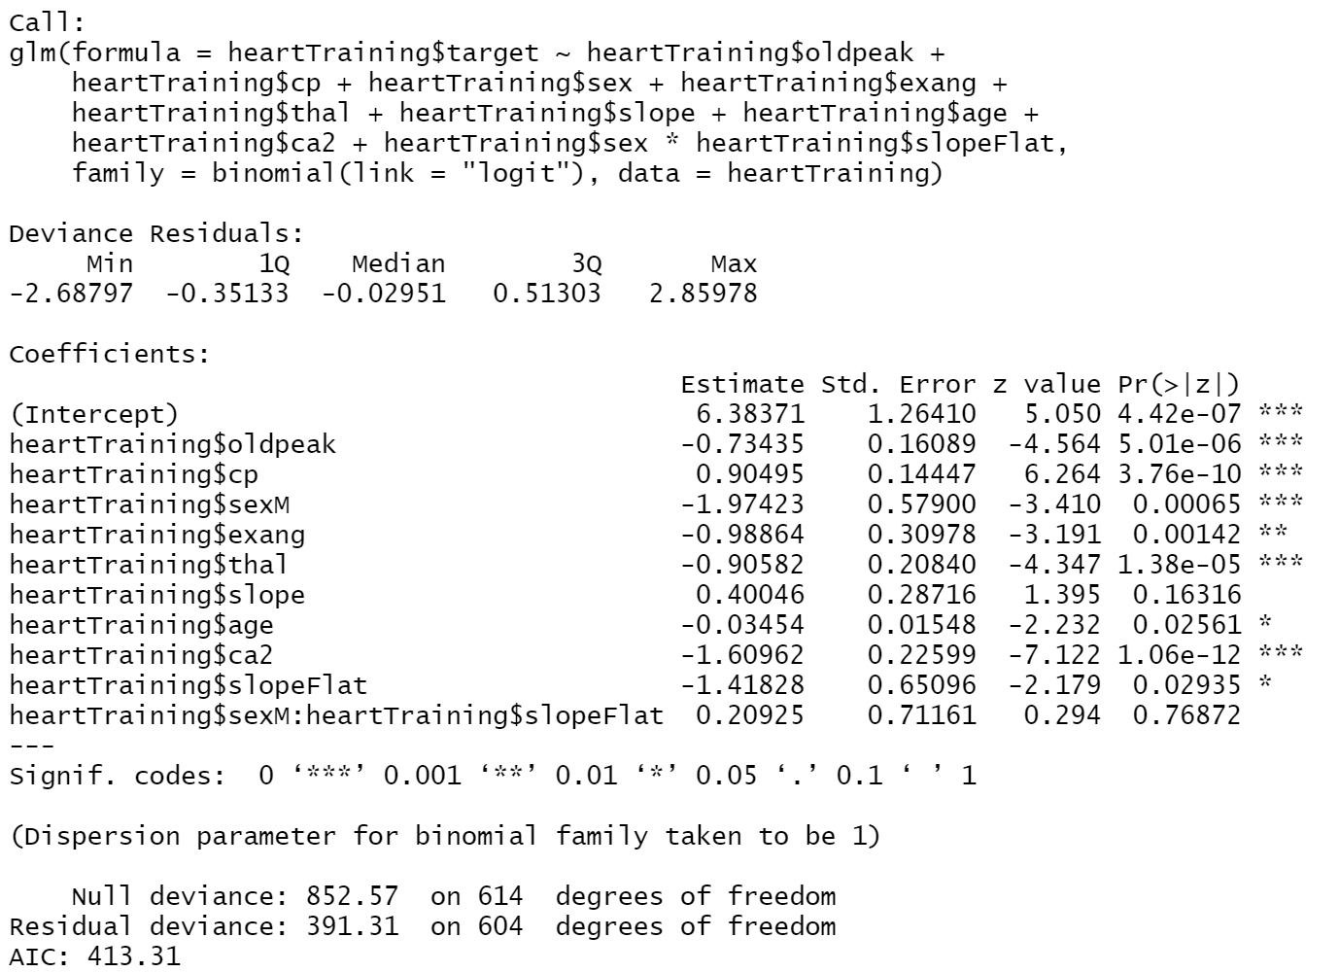

#2 Exang + cp123
logit8 <- glm(formula = target ~ oldpeak + sex +
exang + thal + slope + age + ca0 + cp123*exang, data = heartTraining,family=binomial(link="logit"))
summary(logit8)
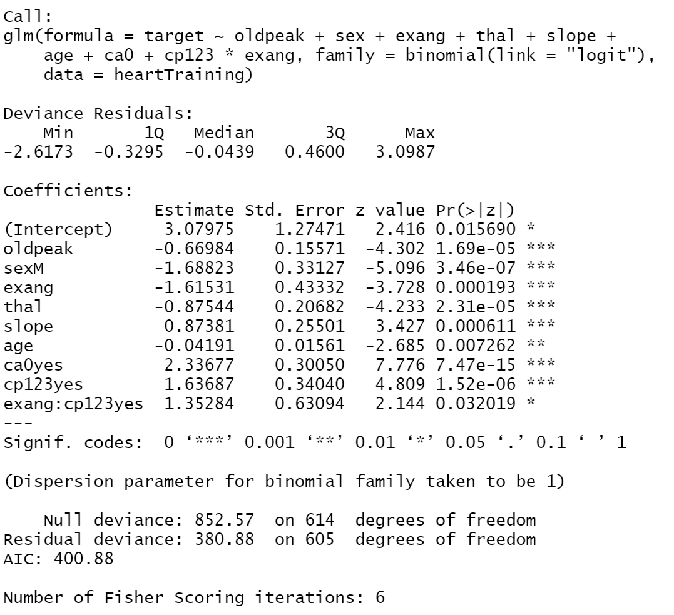
nagelkerke(logit8) #0.553
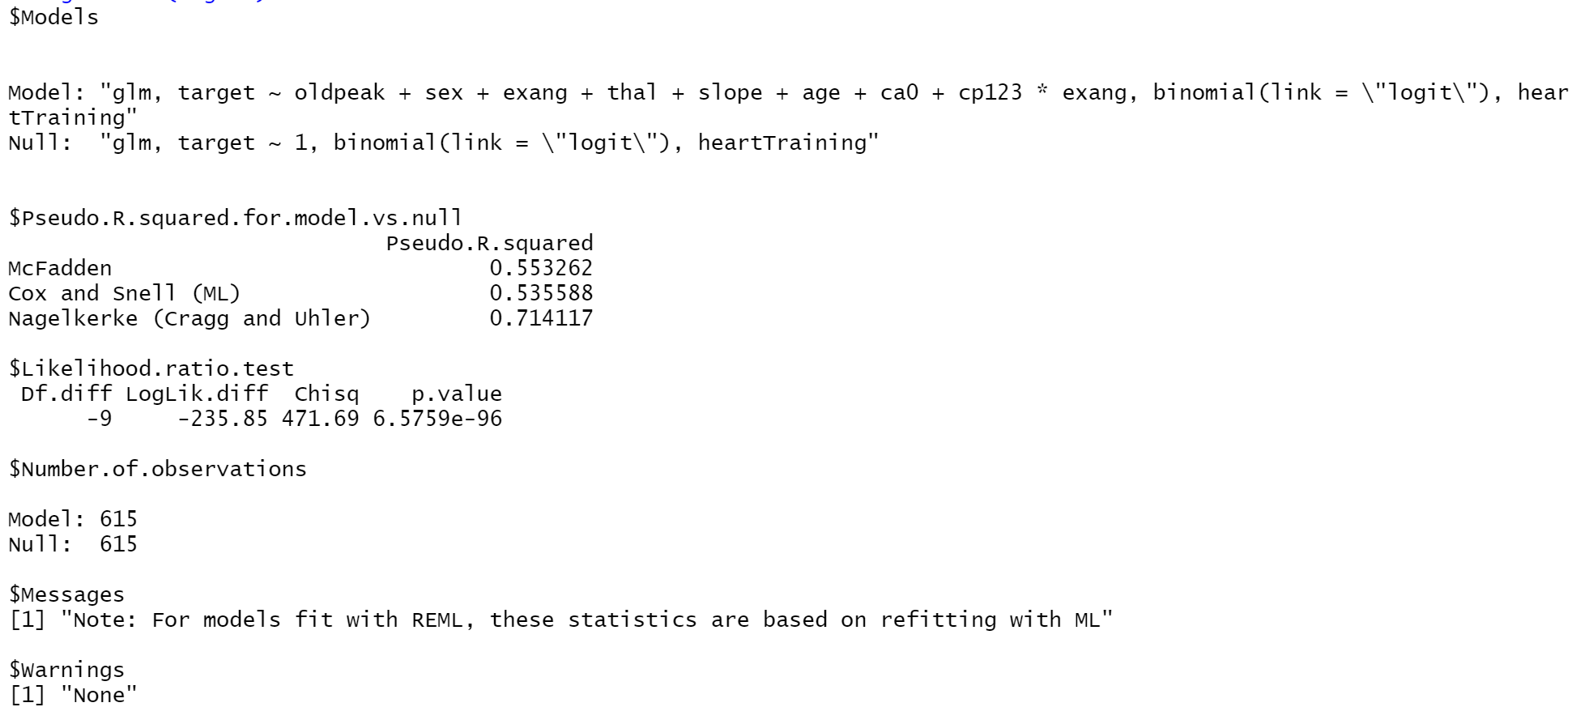
exp(coef(logit8))

#After Logit6 (2 additional variables), formulate a confusion matrix to evaluate the model
heart_pred <- predict(logit6, heartTraining)
library(gmodels)
CrossTable(heartTraining$target, heart_pred>0.25,
prop.chisq = FALSE, prop.c = FALSE, prop.r = FALSE,
dnn = c('actual disease', 'predicted disease'))
#Accuracy = 87.48%, FNR = 12.86%
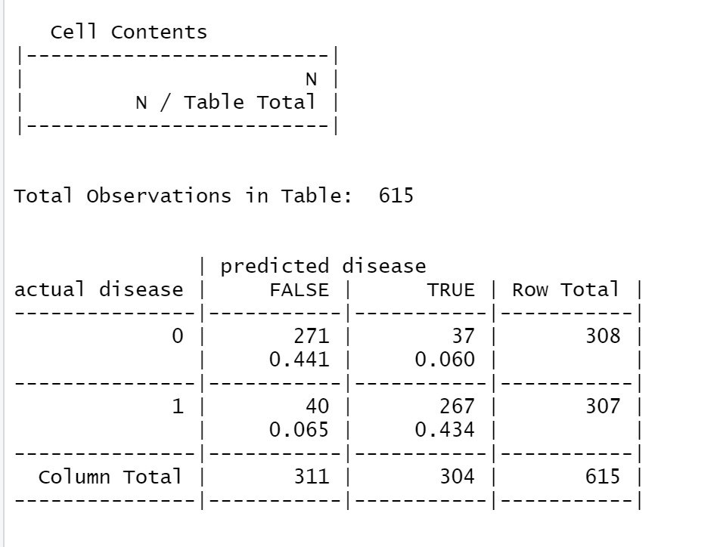

#After Logit6 (2 additional variables), use validation set to evaluate the training set first
heartValidation$sex[heartValidation$sex == 0] <- "F"
heartValidation$sex[heartValidation$sex == 1] <- "M"
heartValidation$ca0 <- ifelse(heartValidation$ca==0, "yes", "no")
heartValidation$cp123 <- ifelse(heartValidation$cp==0, "no", "yes")
heart_pred <- predict(logit6, heartValidation)
CrossTable(heartValidation$target, heart_pred>0.25,
prop.chisq = FALSE, prop.c = FALSE, prop.r = FALSE,
dnn = c('actual disease', 'predicted disease'))
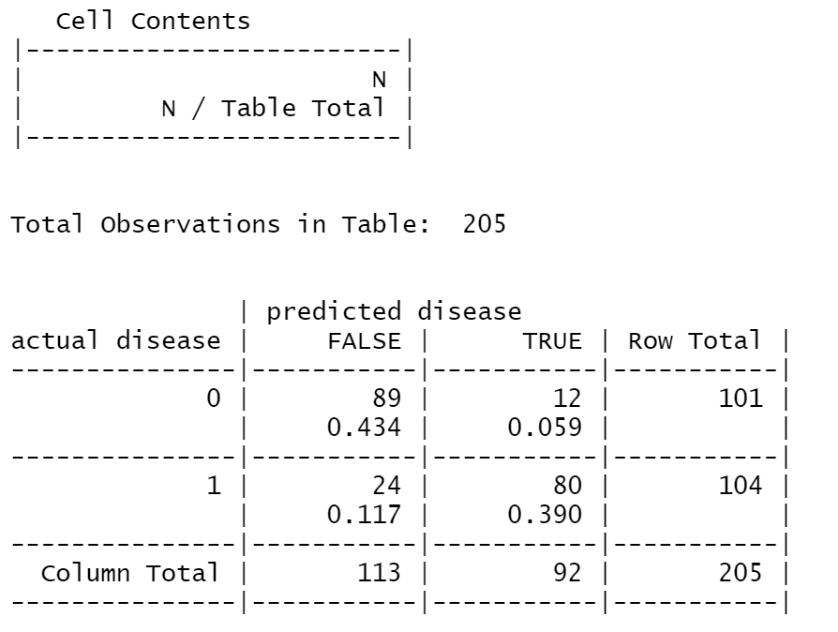
#Accuracy = 82.44%, FNR = 21.23%

#plot ROC curve 1
library(ROCR)
predTraining <- predict(logit6, newdata = heartTraining, type = "response")
predObjTraining=prediction(predTraining,heartTraining$target)
rocObjTraining=performance(predObjTraining, measure="tpr", x.measure="fpr")
aucObjTraining = performance(predObjTraining, measure="auc")
plot(rocObjTraining, main=paste("Area under the curve:", round(aucObjTraining@y.values[[1]],4)))
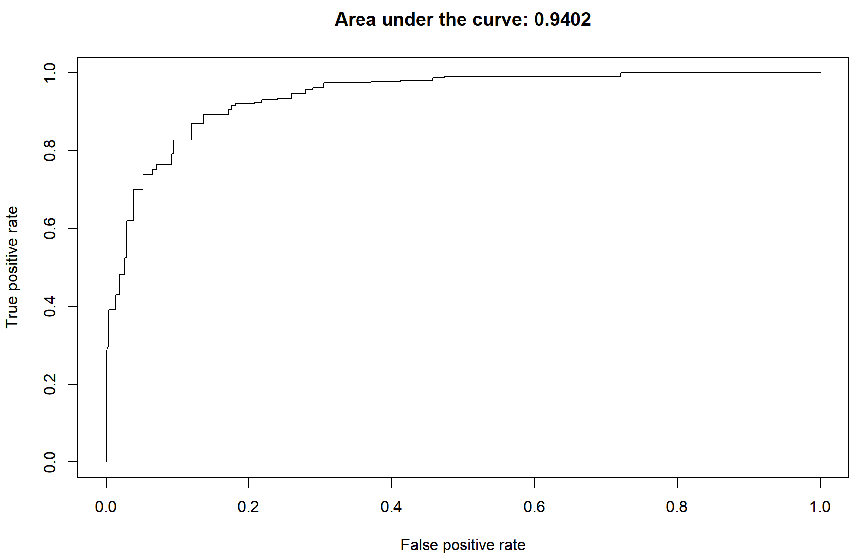
predValidation <- predict(logit6, newdata = heartValidation, type = "response")
predObjValidation=prediction(predValidation,heartValidation$target)
rocObjValidation=performance(predObjValidation, measure="tpr", x.measure="fpr")
aucObjValidation = performance(predObjValidation, measure="auc")
plot(rocObjValidation, main=paste("Area under the curve:", round(aucObjValidation@y.values[[1]],4)))
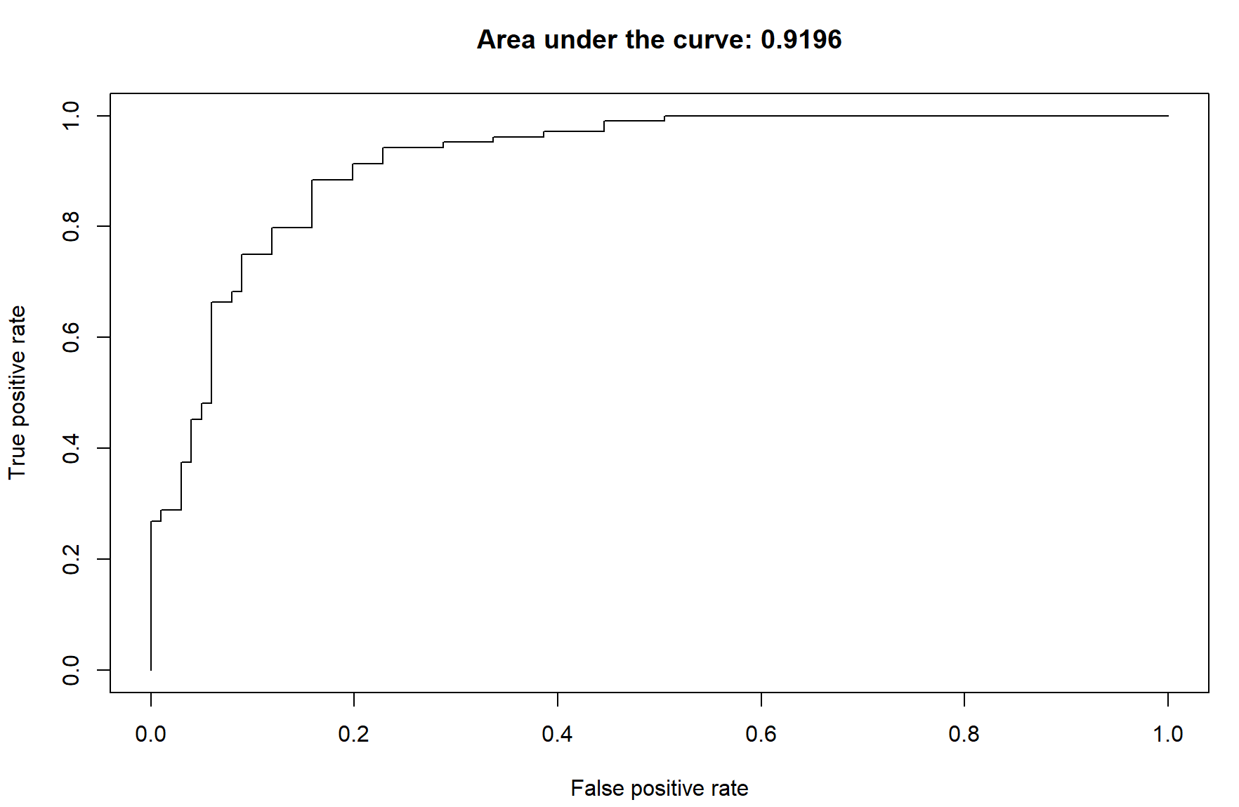
#After Logit8 (3 additional variables), formulate a confusion matrix to evaluate the model
heart_pred <- predict(logit8, heartTraining)
CrossTable(heartTraining$target, heart_pred>0.25,
prop.chisq = FALSE, prop.c = FALSE, prop.r = FALSE,
dnn = c('actual disease', 'predicted disease'))
#Accuracy = 87.31%, FNR = 11.67%
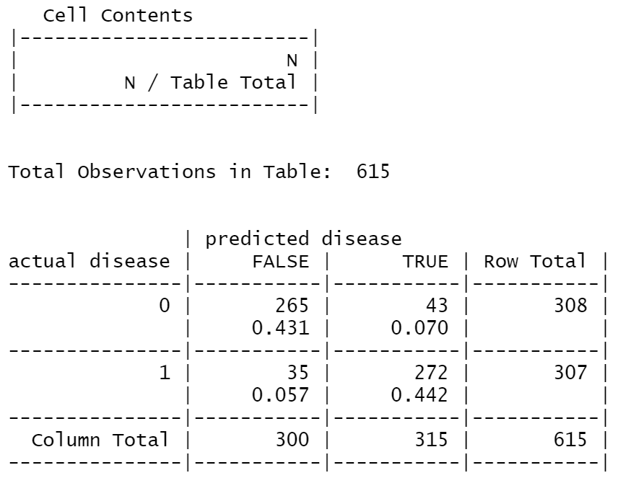
#After Logit8 (3 additional variables), use validation set to evaluate the training set first
heart_pred <- predict(logit8, heartValidation)
CrossTable(heartValidation$target, heart_pred>0.25,
prop.chisq = FALSE, prop.c = FALSE, prop.r = FALSE,
dnn = c('actual disease', 'predicted disease'))
#Accuracy = 88.29%, FNR =12.62%
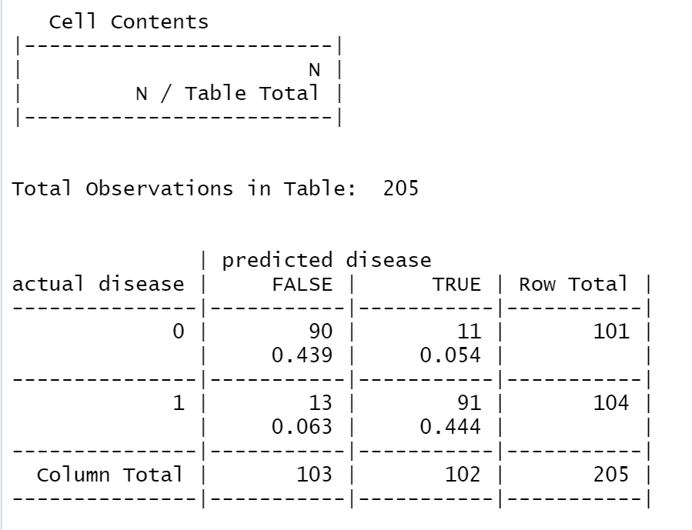

#plot ROC curve 2
predTraining <- predict(logit8, type = "response")
predObjTraining=prediction(predTraining,heartTraining$target)
rocObjTraining=performance(predObjTraining, measure="tpr", x.measure="fpr")
aucObjTraining = performance(predObjTraining, measure="auc")
plot(rocObjTraining, main=paste("Area under the curve:", round(aucObjTraining@y.values[[1]],4)))
#AUC = 0.9399
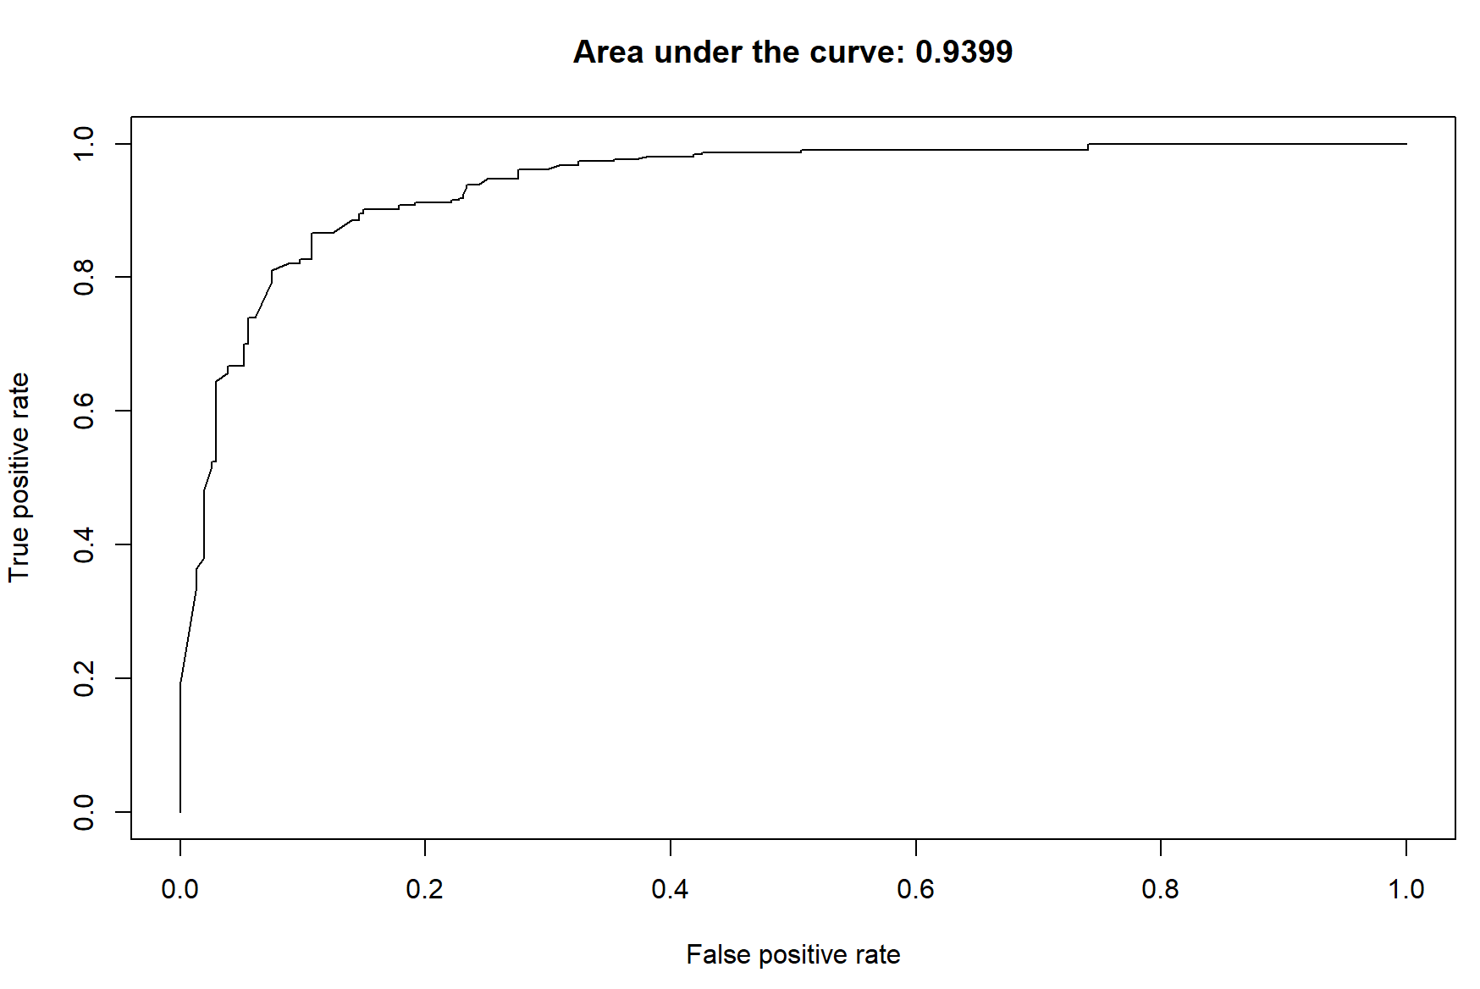
predValidation <- predict(logit8, newdata = heartValidation, type = "response")
predObjValidation=prediction(predValidation,heartValidation$target)
rocObjValidation=performance(predObjValidation, measure="tpr", x.measure="fpr")
aucObjValidation = performance(predObjValidation, measure="auc")
plot(rocObjValidation, main=paste("Area under the curve:", round(aucObjValidation@y.values[[1]],4)))
#AUC = 0.9269
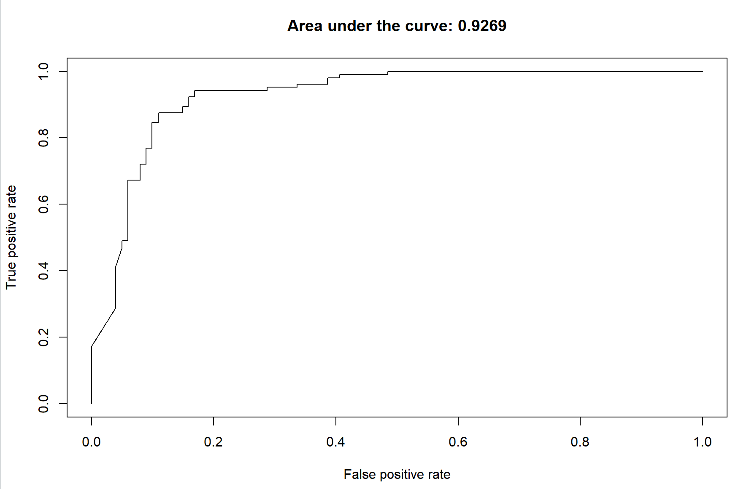

#Result of logistic regression
#Confusion matrix of testing set
heartTest$sex[heartTest$sex == 0] <- "F"
heartTest$sex[heartTest$sex == 1] <- "M"
heartTest$ca0 <- ifelse(heartTest$ca==0, "yes", "no")
heartTest$cp123 <- ifelse(heartTest$cp==0, "no", "yes")
heart_pred <- predict(logit8, heartTest)
CrossTable(heartTest$target, heart_pred>0.25,
prop.chisq = FALSE, prop.c = FALSE, prop.r = FALSE,
dnn = c('actual disease', 'predicted disease'))
#Accuracy = 80%, FNR = 24.21%
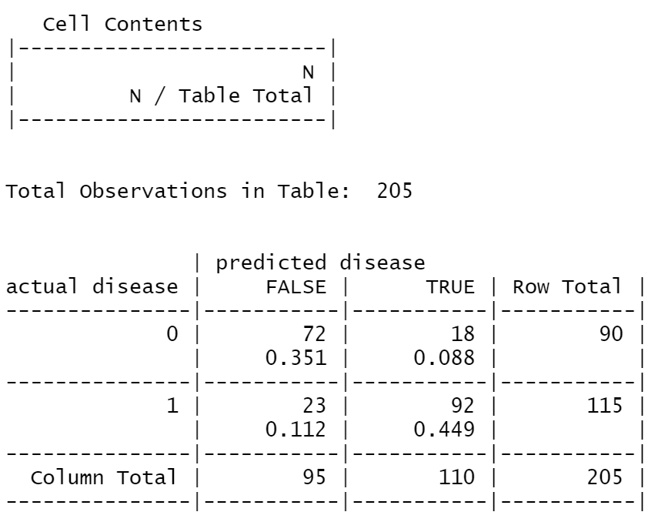
#ROC of testing set
predTest <- predict(logit8, newdata = heartTest, type = "response")
predObjTest=prediction(predTest,heartTest$target)
rocObjTest=performance(predObjTest, measure="tpr", x.measure="fpr")
aucObjTest = performance(predObjTest, measure="auc")
plot(rocObjTest, main=paste("Area under the curve:", round(aucObjTest@y.values[[1]],4)))
#AUC = 0.893
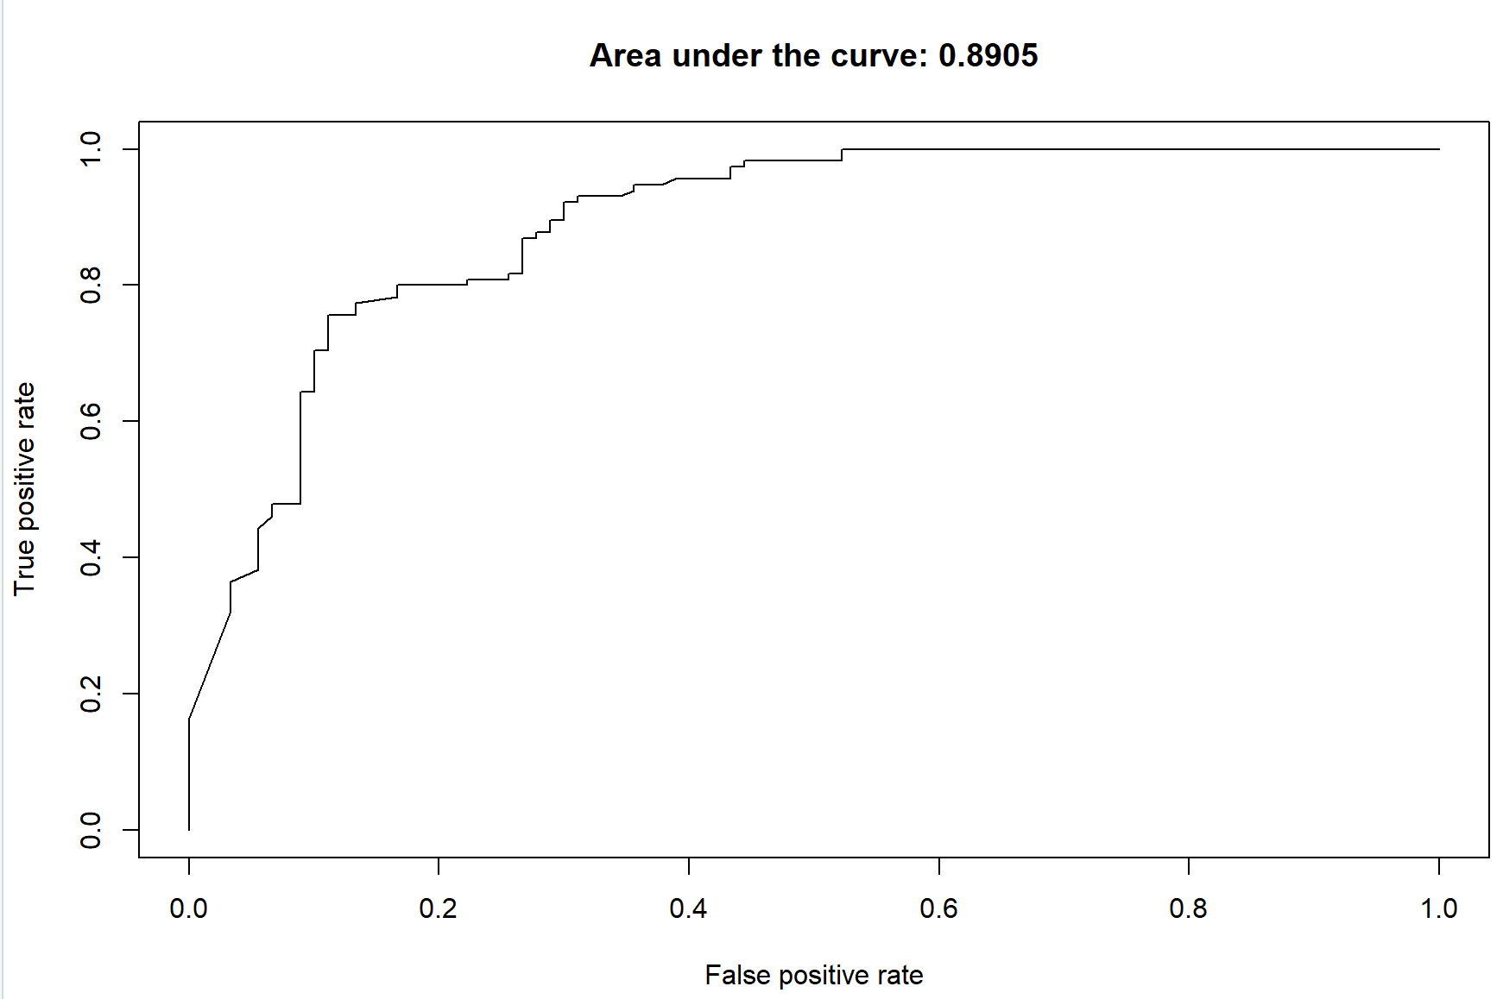

#Conclusion
#Comment on accuracy/other indicators
#Compare two models: +ve/-ve // target: initial screening -> lower FNR with reasonable accuracy
+ve of decision tree
- Very low FNR -> minimise the risk for the patient who actually has heart disease

-ve:
- Low accuracy -> cannot efficiently relieve the burden of the healthcare system (as we will have further assessments / treatments for patients with predicted disease)
+ve of Logistic regression model
Reversal of the above points

Final decision:
Depends on the situation
- If the current healthcare system is overloaded, use logit
- If we want to minimise the risk for the patient, use decision tree

#Caution
#1 age: weird distribution, may cause by the small amount of data (1000 rows of data only)
#2 overfitting: FNR doubled [logit]

Decision Tree Model

library("rpart")
library("rpart.plot")

#Change "Target" to factor for decision tree (Classification tree: Binary output)
heart$targetfac <- as.factor(ifelse(heart$target==0, "no", "yes"))

basemodel <- rpart(targetfac ~ age + sex + cp + trestbps + chol + fbs + restecg + thalach + exang + oldpeak + slope + ca +thal,
method="class", data=heartTraining,control=rpart.control(maxdepth = 10,cp=0),parms=list(split='information'))
rpart.plot(basemodel,type=4, extra=2, clip.right.labs=FALSE, varlen=0, faclen=3)

library(gmodels)
basemodel_pred <- predict(basemodel,heartTraining) [,2]
CrossTable(heartTraining$targetfac, basemodel_pred>0.25,
prop.chisq = FALSE, prop.c = FALSE, prop.r = FALSE,
dnn = c('actual disease', 'predicted disease'))

#Ranking the importance of variables
varimportance <- as.data.frame(basemodel$variable.importance)
plot(basemodel$variable.importance, xlab = "Variable", ylab = "Importance", xaxt ="n")
axis(1,at= 1:13, labels = row.names(varimportance))

#New Decision Tree base on Ranking of variables (Top 5 variables) (Not used)
newmodel <- rpart(heartTraining$targetfac ~ heartTraining$cp + heartTraining$thalach + heartTraining$oldpeak + heartTraining$age + heartTraining$exang,
method="class", data=heartTraining,control=rpart.control(maxdepth = 7,cp=0),parms=list(split='information'))
rpart.plot(newmodel,type=4, extra=2, clip.right.labs=FALSE, varlen=0, faclen=3)
#complexity of the new model
printcp(newmodel)
plotcp(newmodel)
#Accuracy of new model
newmodelpred <- predict(newmodel,heartTraining,type = "class")
newmodelaccuracy <- mean(newmodelpred == heartTraining$targetfac)
#Pruning of new model
newmodelprune <- prune(newmodel, cp=0.01)
newmodelprunepred <- predict(newmodelprune, heartTraining, type = "class")
postprune_accuracy <- mean(newmodelprunepred == heartTraining$targetfac)
data.frame(basemodelaccuracy,newmodelaccuracy,postprune_accuracy)
#How the pruned model looks like
rpart.plot(newmodelprune,type=4, extra=2, clip.right.labs=FALSE, varlen=0, faclen=3)
#Crosstable of newmodel prediction
newmodel_pred <- predict(newmodel,heartTraining) [,2]
CrossTable(heartTraining$targetfac, newmodel_pred>0.25,
prop.chisq = FALSE, prop.c = FALSE, prop.r = FALSE,
dnn = c('actual disease', 'predicted disease'))
#FNR = 0.0554 (17/307)

#New decision tree model (all variables with importance >50)
newmodel2 <- rpart(heartTraining$targetfac ~ heartTraining$cp + heartTraining$thalach + heartTraining$oldpeak + heartTraining$age + heartTraining$exang + heartTraining$thal,
method="class", data=heartTraining,control=rpart.control(maxdepth = 7,cp=0),parms=list(split='information'))
rpart.plot(newmodel2,type=4, extra=2, clip.right.labs=FALSE, varlen=0, faclen=3)
printcp(newmodel2)
plotcp(newmodel2)
#Accuracy of model 2 without pruning
newmodel2_predict <- predict(newmodel2,heartTraining,type = "class")
newmodel2_accuracy <- mean(newmodel2_predict == heartTraining$targetfac)
#confusion matrix
newmodel2_pred <- predict(newmodel2,heartTraining) [,2]
CrossTable(heartTraining$targetfac, newmodel2_pred>0.25,
prop.chisq = FALSE, prop.c = FALSE, prop.r = FALSE,
dnn = c('actual disease', 'predicted disease'))
#FNR = 0.0554 (17/307)

#Pruning of model 2
newmodel2prune <- prune(newmodel2, cp=0.0032573)
rpart.plot(newmodel2prune,type=4,extra=2,clip.right.labs=FALSE, varlen=0, faclen=3)
#Accuracy of model 2 with pruning
newmodel2prune_predict <- predict(newmodel2prune,heartTraining,type = "class")
newmodel2prune_accuracy <- mean(newmodel2prune_predict == heartTraining$targetfac)
data.frame(basemodelaccuracy,newmodelaccuracy,postprune_accuracy,newmodel2prune_accuracy)
#confusion matrix
newmodel2prune_pred <- predict(newmodel2prune,heartTraining) [,2]
CrossTable(heartTraining$targetfac, newmodel2prune_pred>0.25,
prop.chisq = FALSE, prop.c = FALSE, prop.r = FALSE,
dnn = c('actual disease', 'predicted disease'))
#FNR = 0.0554 (17/307)

#Model 2 second pruning
newmodel2prune2 <- prune(newmodel2, cp=0.0048860)
rpart.plot(newmodel2prune2,type=4,extra=2,clip.right.labs=FALSE, varlen=0, faclen=3)
#Accuracy after 2nd pruning
newmodel2prune_predict2 <- predict(newmodel2prune2,heartTraining,type = "class")
newmodel2prune_accuracy2 <- mean(newmodel2prune_predict2 == heartTraining$targetfac)
#Confusion matrix after second pruning
newmodel2prune2_pred <- predict(newmodel2prune2,heartTraining) [,2]
CrossTable(heartTraining$targetfac, newmodel2prune2_pred>0.25,
prop.chisq = FALSE, prop.c = FALSE, prop.r = FALSE,
dnn = c('actual disease', 'predicted disease'))
#FNR = 0.0456 (14/307)

#Model 2 third pruning
newmodel2prune3 <- prune(newmodel2, cp= 0.0065147)
rpart.plot(newmodel2prune3,type=4,extra=2,clip.right.labs=FALSE, varlen=0, faclen=3)
#Accuracy of third pruning
newmodel2prune_predict3 <- predict(newmodel2prune3, heartTraining, type = "class")
newmodel2prune_accuracy3 <- mean(newmodel2prune_predict3 == heartTraining$targetfac)
#Confusion matrix for third pruning
newmodel2prune3_pred <- predict(newmodel2prune3,heartTraining) [,2]
CrossTable(heartTraining$targetfac, newmodel2prune3_pred>0.25,
prop.chisq = FALSE, prop.c = FALSE, prop.r = FALSE,
dnn = c('actual disease', 'predicted disease'))
#FNR = 0.0814 (25/307)

#Accuracy Comparison
data.frame(newmodel2_accuracy,newmodel2prune_accuracy,newmodel2prune_accuracy2,newmodel2prune_accuracy3)

#Decision tree model (exclude exang and thal) (Not used)
newmodel3 <- rpart(heartTraining$targetfac ~ heartTraining$cp + heartTraining$thalach + heartTraining$oldpeak + heartTraining$age,
method="class", data=heartTraining,control=rpart.control(maxdepth = 7,cp=0),parms=list(split='information'))
rpart.plot(newmodel2,type=4, extra=2, clip.right.labs=FALSE, varlen=0, faclen=3)
printcp(newmodel3)
#Accuracy of model 3 without prune
newmodel3_predict <- predict(newmodel3,heartTraining$targetfac,type = "class")
newmodel3_accuracy <- mean(newmodel3_predict == heartTraining$targetfac)
#Confusion Matrix for model 3
newmodel3_pred <- predict(newmodel3,heartTraining) [,2]
CrossTable(heartTraining$targetfac, newmodel3_pred>0.25,
prop.chisq = FALSE, prop.c = FALSE, prop.r = FALSE,
dnn = c('actual disease', 'predicted disease'))
#FNR = 0.0684 (21/307)

#Final model (depth = 5)
finalmodel <- rpart(targetfac ~ cp + thalach + oldpeak + age + exang + thal,
method="class", data=heartTraining,control=rpart.control(maxdepth = 5,cp=0.0048860),parms=list(split='information'))
rpart.plot(finalmodel,type=4, extra=2, clip.right.labs=FALSE, varlen=0, faclen=3)

#Accuracy (against training dataset)
finalmodel_predict <- predict(finalmodel,heartTraining, type = "class")
finalmodel_accuracy <- mean(finalmodel_predict == heartTraining$targetfac)
#Confusion matrix
heart_pred <- predict(finalmodel, heartTraining)[,2]
CrossTable(heartTraining$targetfac, heart_pred>0.25,
prop.chisq = FALSE, prop.c = FALSE, prop.r = FALSE,
dnn = c('actual disease', 'predicted disease'))

#FNR = 0.011

#Final model (depth = 7)
finalmodel2 <- rpart(targetfac ~ cp + thalach + oldpeak + age + exang + thal,
method="class", data=heartTraining,control=rpart.control(maxdepth = 7,cp=0.0048860),parms=list(split='information'))
rpart.plot(finalmodel2,type=4, extra=2, clip.right.labs=FALSE, varlen=0, faclen=3)
#Accuracy (against training dataset)
finalmodel_predict2 <- predict(finalmodel2,heartTraining,type = "class")
finalmodel_accuracy2 <- mean(finalmodel_predict2 == heartTraining$targetfac)
#confusion matrix
heart_pred <- predict(finalmodel2, heartTraining)[,2]
CrossTable(heartTraining$targetfac, heart_pred>0.25,
prop.chisq = FALSE, prop.c = FALSE, prop.r = FALSE,
dnn = c('actual disease', 'predicted disease'))

#FNR = 0.023

#Evaluation of Finalmodel (d=5) with validation set (Use this)
heart_pred <- predict(finalmodel, heartValidation)[,2]
CrossTable(heartValidation$targetfac, heart_pred>0.25,
prop.chisq = FALSE, prop.c = FALSE, prop.r = FALSE,
dnn = c('actual disease', 'predicted disease'))
#Accuracy = 77.07% // FNR = 0.029

#ROC Curve Validation
library(ROCR)
predValidation1 <- predict(finalmodel, newdata = heartValidation, type = "prob")[,2]
predObjValidation1=prediction(predValidation1,heartValidation$targetfac)
rocObjValidation1=performance(predObjValidation1, measure="tpr", x.measure="fpr")
aucObjValidation1 = performance(predObjValidation1, measure="auc")
plot(rocObjValidation1, main=paste("Area under the curve:", round(aucObjValidation1@y.values[[1]],4)))
#AUC = 0.88

#Evaluation of Finalmodel (d=7) with validation set
heart_pred <- predict(finalmodel2, heartValidation)[,2]
CrossTable(heartValidation$targetfac, heart_pred>0.25,
prop.chisq = FALSE, prop.c = FALSE, prop.r = FALSE,
dnn = c('actual disease', 'predicted disease'))
#Accuracy = 78.54% // FNR = 0.059

#ROC Curve Validation
predValidation2 <- predict(finalmodel2, newdata = heartValidation, type = "prob")[,2]
predObjValidation2=prediction(predValidation2,heartValidation$target)
rocObjValidation2=performance(predObjValidation2, measure="tpr", x.measure="fpr")
aucObjValidation2 = performance(predObjValidation2, measure="auc")
plot(rocObjValidation2, main=paste("Area under the curve:", round(aucObjValidation2@y.values[[1]],4)))
#AUC = 0.8854

#Evaluation of Finalmodel (d=5) with test set (Use this)
heart_pred <- predict(finalmodel, heartTest)[,2]
CrossTable(heartTest$targetfac, heart_pred>0.25,
prop.chisq = FALSE, prop.c = FALSE, prop.r = FALSE,
dnn = c('actual disease', 'predicted disease'))
#Accuracy = 78.54% // FNR = 0.01

#ROC Curve Validation
predTest <- predict(finalmodel, newdata = heartTest, type = "prob")[,2]
predObjTest=prediction(predTest,heartTest$target)
rocObjTest=performance(predObjTest, measure="tpr", x.measure="fpr")
aucObjTest=performance(predObjTest, measure="auc")
plot(rocObjTest, main=paste("Area under the curve:", round(aucObjTest@y.values[[1]],4)))
#AUC = 0.8892

Outline for introduction

Introduction and motivation (400 words)
- Background information
- According to WHO, heart disease ranked as the top cause of death worldwide.
- According to the HK government database, the death rate of heart disease is very high, 70% for males and 50% for females.
- Motivation
- higher occurrence of heart disease in the younger age group
-> not an issue that only concerns elderly group
=> possible self-diagnosis with reference to symptoms or factors shown significantly correlated to probability of heart disease in the prediction models constructed below
- Objectives
- Identify signs and factors that are commonly attributable to heart disease
- Identify how other circumstances (e.g. other diseases) might also contribute to the occurrence of heart diseases
- Determine how the above factors might affect the probability of the occurrence
-> Early detection of heart disease in order to increase the possibility of survival
=> devise initial screening prediction model in aim of alleviating pressure of healthcare system (predict using the models (with varying accuracy rates and false positive rates/recall or precision trade-off) whether a patient has heart disease)

Data frame and Variables [source, type of variable] (400 words)
Source: https://www.kaggle.com/datasets/johnsmith88/heart-disease-dataset
4 Categories of variables:
a) Patient Information
1. age: The age of a person
2. sex: The person’s gender (1 = male, 0 = female)
b) Severity of chest pain
(separately categorized provided our expectation that chest pain will be closely associated with heart disease)
3. cp: The types of chest pain experienced (Value 1: typical angina, Value 2: atypical angina, Value 3: non-anginal pain, Value 4: asymptomatic)
- angina: a type of chest pain caused by reduced blood flow to the heart.
(source: https://www.mayoclinic.org/diseases-conditions/angina/symptoms-causes/syc-20369373)
c) Characteristics for classifying disease
4. trestbps: Resting blood pressure (mm Hg on admission to the hospital)
5. chol: Cholesterol measurement in mg/dl
6. fbs: Fasting blood sugar (if > 120 mg/dl, 1 = true; 0 = false)
7. restecg: Resting electrocardiographic measurement (0 = normal, 1 = having ST-T wave abnormality, 2 = showing probable or definite left ventricular hypertrophy by Estes’ criteria)
8. thalach: Maximum heart rate achieved
9. exang: Exercise-induced angina (1 = yes; 0 = no)
10. oldpeak: ST depression induced by exercise relative to rest (‘ST’ relates to positions on the ECG plot)
11. slope: the slope of the peak exercise ST segment (Value 1: upsloping, Value 2: flat, Value 3: downsloping)
12. ca: The number of major vessels (0–3)
13. thal: A blood disorder called thalassemia (1 = normal; 2 = fixed defect; 3 = reversable defect)
d) Result from the dataset for training
14.target: Heart disease (0 = no, 1 = yes)
[further explanation to specialized terminologies required]

Data Cleaning (… structure of data [summary of stat]) (100 words)
logistic model:
1. check n/a, missing values
2. change sex from 0/1 to male/female (factor):
to facilitate easier comparison on difference on proportion of male and female having heart disease-

decision tree:
binary output: changing “target” variable from categorical variable to factor
(for better presentation and comprehension of classification tree)

Methods introduction (300 words)
1. Data visualization
a) provides overview of dataset and possible correlation between dependent variables and independent variables (preliminarily identify independent variables that are likely related to occurrence of heart disease); and
b) between independent variables and independent variables (identify possible correlated predictor variables for issue of multicollinearity or for insights on interactive terms to be created later on during construction of model to enhance its predictive power.
2. Construction of prediction models
Holdout method:
ratio-> sample size (respective) -> extract rows -> create vector [explanation required]

Q: why logistic model and decision tree?
- binary result of dataset (additional research/info required)

Outline for logistic regression
Model 1 (Initial logistic model):
target = 5.520621 - 0.022840age - 1.956274sex + 0.917697cp - 0.018534trestbps - 0.008312chol - 0.151897fbs + 0.542017restecg + 0.019140thalach - 0.852750exang - 0.743724oldpeak +0.787414slope - 0.806643ca - 0.893498thal
McFadden pseudo R^2 = 0.526635

Model 2 (BIC, both directions):
target = 5.89055 - 0.76567oldpeak + 0.85475cp – 1.68120sexM - 0.77840ca - 1.10964exang – 0.87163thal + 0.80240slope – 0.05497age
McFadden pseudo R^2 = 0.497132
slightly lower adjusted R^2 compared to initial model à simpler à BIC model is preferred

Model 3 (ca -> ca0):
target = 2.90817 - 0.82937oldpeak + 0.90462cp - 1.68295sexM -1.06595exang - 0.92697thal + 0.90226slope - 0.03545age + 2.30631ca0
McFadden pseudo R^2 = 0.540185
e^2.30631 = 10.0373376 à individuals with 0 major vessels are 10 times more likely to have heart disease than those with 1-3

Model 5 (thalach -> thalach2):
target = 1.711e+00 - 7.884e-01oldpeak + 8.620e-01cp – 1.694e+00sexM – 9.817e-01exang - 9.348e-01thal + 8.546e-01slope – 2.634e-02age + 2.279e+00ca0 + 3.372e-05thalach2
statistically insignificant

Model 6 (cp -> cp123):
target = 2.32896 - 0.67295oldpeak – 1.58139sexM – 0.98032exang – 0.87768thal + 0.92042slope – 0.03580age + 2.34151ca0 + 2.03572cp123
McFadden pseudo R^2 = 0.547712
e^2.03572 = 7.6577840 -> individuals who have experienced chest pain are 7.66 times more likely to have heart disease than those who have not experienced chest pain

Model 8 (interactive variable: exang + cp123) (Final Model):
target = 3.07975 - 0.66984oldpeak – 1.68823sexM – 1.61531exang – 0.87544thal + 0.87381slope – 0.04191age + 2.33677ca0 + 1.63687cp123 + 1.35284cp123*exang
McFadden pseudo R^2 = 0.553262
e^1.35284 = 3.8684084 -> (doing research)
cp123yes decreases from 7.6577840 to 5.1390742

Adjustment of threshold:
0.25 (low threshold) -> higher recall, lower precision (trade-off)
Lower FN for initial screening purpose

Outline for Decision Tree

Base model
How do we choose our variables
What is the CP used when pruning the tree + Justification
What is the Depth used when pruning the tree + Justification
The Final model used for decision tree

Outline for result&conclusion
Analysis Results (700 words)
The regression analysis and decision tree analysis are done using R computing language.

A. Logistic regression
1. Regression Output of final model
After ensuring that each variable has the proper coding and structure, we run a logistic regression on the following variables against the target variable. The regression output is shown in Table .

2. Confusion matrix evaluation
- Threshold setting -> 0.25 -> initial screening, low threshold minimize FNR, to relieve the burden of the medical system, just to filter a small group of healthy ppl out. (balance the risk)
- Confusion matrix of testing set
#Accuracy = 80%, FNR = 24.21%

(a) Accuracy: This determines how often is the binary classifier correct–In which case we have Accuracy= (TP + TN)/ Total=0.80, i.e., 80% of the times. Consequently, its misclassification rate also known as error rate is 1-Accuracy which is about 20%.
(b) FNR: This shows what percent of positives the classifier marked as negatives. For this model, the false negative rate is 24.21%. (still high -> may have over-fitting problem)

3. ROC curve of testing set
#AUC = 0.893
This is a plot of the diagnostic ability of the classifier as we vary its discrimination threshold. Thus, a curve is obtained as we plot the true positive rate (TPR) against the false positive rate (FPR) at various threshold. In general, the closer the curve is to the top left corner in the plane, the better the classification.In order to check the performance of our classifier, we will rely on the AUC (Area Under Curve) of the ROC curve; this is a useful metric.
The AUC for our classifier is 0.893, it indicates that the possibility of correctness is 89.3%.

B. Decision tree

For this model, the threshold still equals 0.25.
Finalmodel (d=5) with test set
#Accuracy = 78.54% // FNR = 0.01
#AUC = 0.8892
(a)Accuracy: This determines how often is the decision tree classifier correct–In which case we have Accuracy = (TP + TN)/ Total= 0.7854, i.e., 78.54% of the times. Consequently, its misclassification rate also known as error rate is 1-Accuracy which is about 21.46%.
(b)FNR: This shows that 1 percent of positives the classifier marked as negatives using this classifier.
(c)The AUC for our classifier is 0.8892, it indicates that the possibility of correctness is 88.92%.

Discussion [Conclusion] (500 words)

1. Comment on accuracy/other indicators
l Indicator closely related with heart disease: Oldpeak, sex, exang, thal, slope, age, ca0, cp123*exang
l Suggestions for people and further research

2.Compare two models: +ve/-ve //
target: initial screening -> lower FNR with reasonable accuracy

+ve of decision tree
Very low FNR 1% -> healthy people diagnosed to have heart disease is low -> no need to asses again -> minimize the risk for the patient who actually has heart disease
-ve:
Low accuracy 78.54% -> cannot efficiently relieve the burden of the healthcare system (as we will have further assessments / treatments for patients with predicted disease)

+ve of Logistic regression model
Reversal of the above points
High accuracy 80%
Low FNR (24.21%, much lower)

3.Final decision:
Model usage Depends on the situation
If the current healthcare system is overloaded, use logit
If we want to minimise the risk for the patient, use decision tree

4. Caution
#1 age: weird distribution, may cause by the small amount of data (1000 rows of data only); median ages of people with heart disease and without heart disease
#2 overfitting: FNR [logit] from validation set to testing set-> doubled,
#3 decision tree:low accuracy. (-ve of decision tree?)

