Objects manipulation and utilisation (46 marks)

- Sufficient workbook manipulation: At least two workbooks for the source data sets, at least one workbook for the derived data sets, at least one workbook for the report, and one workbook for the programme code and Userform. Sufficiently utilized object variables, references, properties, and methods. (0-5)

- Sufficient worksheet manipulation: Sufficiently utilized object variables, references, properties, and methods. (0-4)

- Sufficient data manipulation: Generate at least one new data set in a new workbook by applying non-trivial manipulation on the source data sets. (0-8)

- Create at least two non-Pivot tables for character variables in the report workbook. At least one table includes summary statistics of a numeric variable for each level of the character variable. All elements of the tables, such as data range, variables, statistics, etc., must be appropriately coded in the application. (0-4)

- Create at least one non-Pivot frequency table for a numeric variable in the report workbook. All elements of the tables, such as data range, variables, statistics, etc., must be appropriately coded in the application. (0-3)

- Create at least two types of non-Pivot charts in the report workbook. All features of the charts, such as data range, type of chart, labels, etc. of the charts must be appropriately coded in the application. (0-4)

- Utilise OptionButton control. (0-2)
- Utilise CheckBox control. (0-2)
- Utilise RefEdit control. (0-1)
- Utilise ScrollBar or SpinButton controls. (0-2)
- Utilise ComboBox control. (0-3)
- Utilise Frame control. (0-2)
- Utilise ListBox control. (0-4)
- Utilise MultiPage control. (0-2)

Problem Description and background
CWC drinking shop is a shop is a shop selling drink like tea, coffee.
It also sells ice cream. It has three branches in Hong Kong Island, Kowloon and New Territories respectively.

- Member discount: Provide discounts to members based on their spending and the holiday. The source dataset includes two workbooks:
  - workbook_salesrecord and
  - workbook_memberInformation, which have the common column Member ID.
The sales record gives the spending of members, and
member information gives information such as
salaries,
marital status, and
birthdays in the month.

Customers who accumulate spending above a certain amount can receive a percentage discount.
Customers can also receive a 10% discount if they purchase items during their own birthday month. Additionally,
customers who are married can receive a 10% discount if they buy drinks between February 10 and February 14 to celebrate Valentine's Day.
Discounts can be used together by multiplying them. Memberships are usually upgraded at the end of the month, as sales reports for members are generated monthly. To achieve this objective, two workbooks need to be generated:
Workbook_salesreport and
Workbook_Membership&discount.
The latter will summarize the number of members in each tier and the discount given.

 | Accumulated Spending | Discount
Basic | $100 | 1%
Advanced | $250 | 5%
Platinum | $400 | 10%
Birthday | N/A | 8%
Valentine’s day(in 10-Feb to 14-Feb) | N/A | 12%

- Weekly sales report: Generate a sales report as a new workbook by extracting data from the workbook_salesrecord. This report will be generated at the end of each week to help the marketing department identify which products have the potential to generate more profit for the company.

- Monthly sales report: Generate a sales report as a new workbook by extracting data from the workbook_salesrecord. This report will be generated at the end of each month and will include the weekly sales report. The purpose of this report is to provide a comprehensive overview of sales trends over time.

Type of Product

Espresso | Price | Cost
Decaf Espresso | $32.50 | $15.20
Caffe Latte | $25.00 | $12.20
Caffe Mocha | $30.30 | $13.00
Regular Espresso | $22.00 | $14.20

Coffee | Price | Cost
Amaretto | $15.20 | $8.50
Decaf Irish Cream | $35.30 | $28.00
Columbian | $20.00 | $15.00

Herbal Tea | Price | Cost
Lemon | $18.50 | $5.50
Chamomile | $21.00 | $14.00
Mint | $18.32 | $8.90

Tea | Price | Cost
Green Tea | 17.50 | 7.00
Earl Grey | 22.00 | 14.00
Darjeeling | 25.00 | 15.00

Data source description

The workbook_MemberInformation have following column.
Member ID, Gender, Age, Salary, Martial Status, Living District and Birthday in Month
Pic 1:
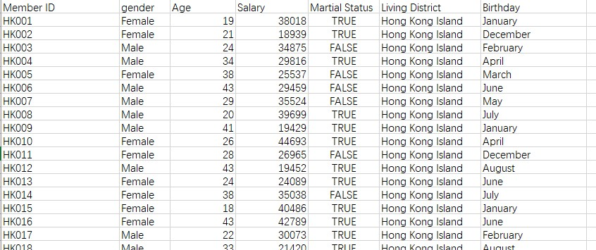
The Workbook_salesrecord have following columns.
Member ID, Order Date, Product Name, Product Category, Quantity, Price Per Unit, Total sales, Total revenue by member ID Pic 2:
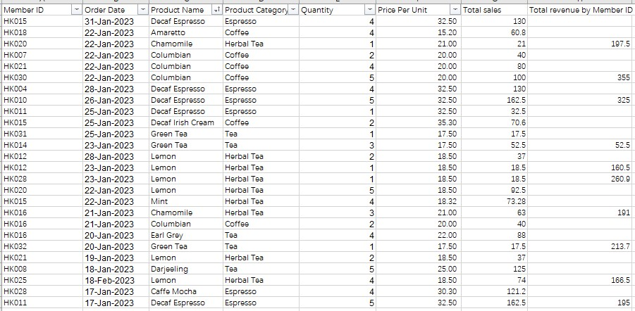
Pic 2 shows the sales record in Hong Kong Island. There are three worksheets which represent different region in this workbook. The member ID will be NTXXX (New Territories), HKXXX(Hong Kong Island) and KLXXX(Kowloon).（Add case to
other region）

Report generated

- Membership and Discount workbook (Workbook_Membership&discount) The officer needs to update the membership and discount workbook monthly to ensure giving correct discount to the customers.

In this workbook,
Officer needs to enter the column of
- Member ID,
- total amount spending,
- Birthday discount received,
- Valentine’s Day discount received,
- Membership level,
- Amount spent,
- Amount of discount received.

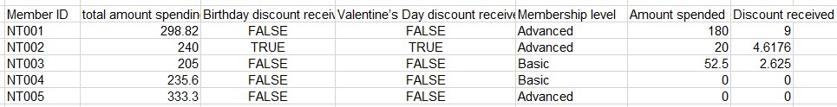

For example, the NT002 is having total spending of 240 which is extract for workbook_salesrecord in February. He had birthday in February and married. The valentine’s Day discount is depended on Marital status. He spent $20 at the 13-Feb. He can received discount of (20-20*0.92*0.88*0.95)=4.6176 in March.

In this workbook report, total amount spending need to be extract from the workbook_salesrecord first. Then birthday discount and Valentine’s Day discount need to be extracted from the workbook_MemberInformation because the birthday month and Marital status is the key of determining the discount is true or false.

- Sales report workbook (Workbook_sartm lesreport)
The first need to be done is weekly report worksheets, the weekly sales report have two parts, the first part is reporting the weekly unit sales of different region.

Pic3:
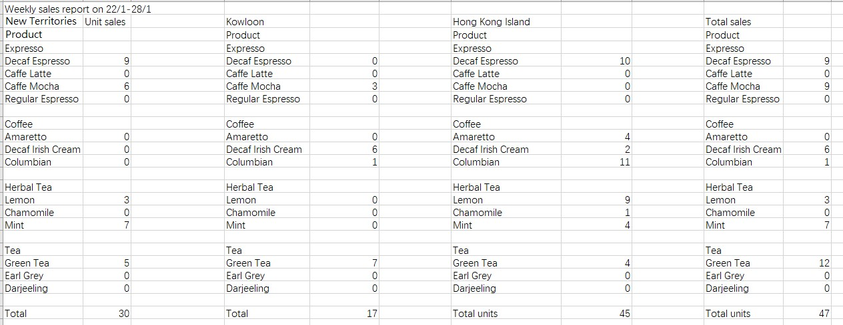
It show the number of products sold by different regions. It also generate the pie chart to visible the data. Pic 4:
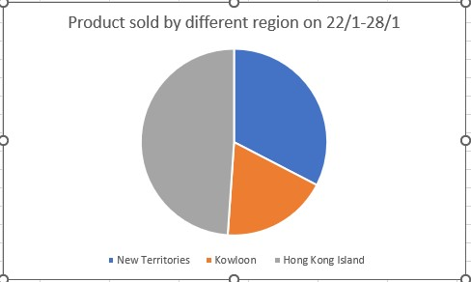
The second thing need to be done for weekly report is generate weekly profit report for different product. Pic 5:
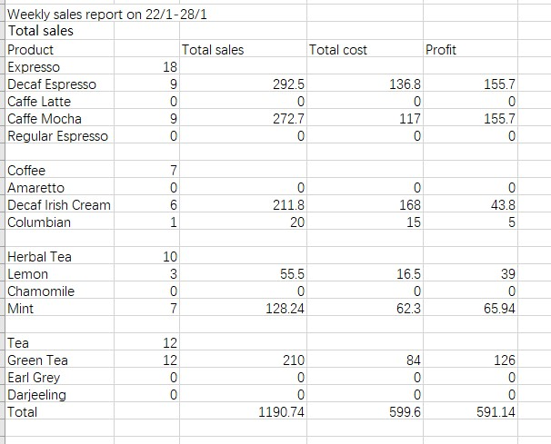
It shows the total number of products sold at that week.
Pic 6:
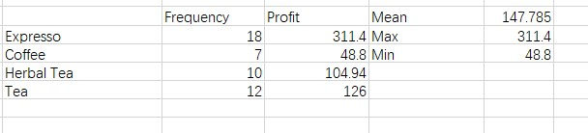
Also, the frequency table of type of product will be calculated and shown. Pic 7:
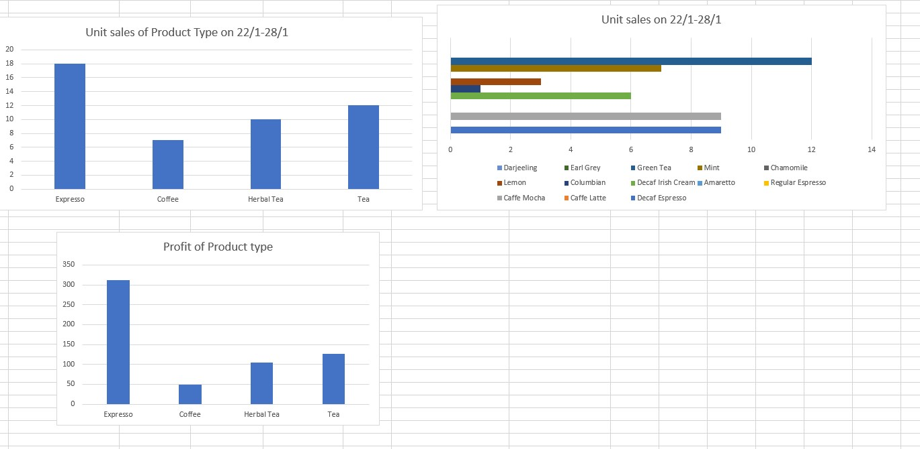

The data of weekly sales will be shown as chart in product type, unit sales and profit. The unit sales of product type can help company to know what customers would like to buy. The Unit sales in product can point out more specifically of what product the customer would like to buy. The profit chart shows the profit generated by that week. It may help company to adjust the inventory in next week.

Another report would be generated is Monthly sales and profit report.
Pic 7:
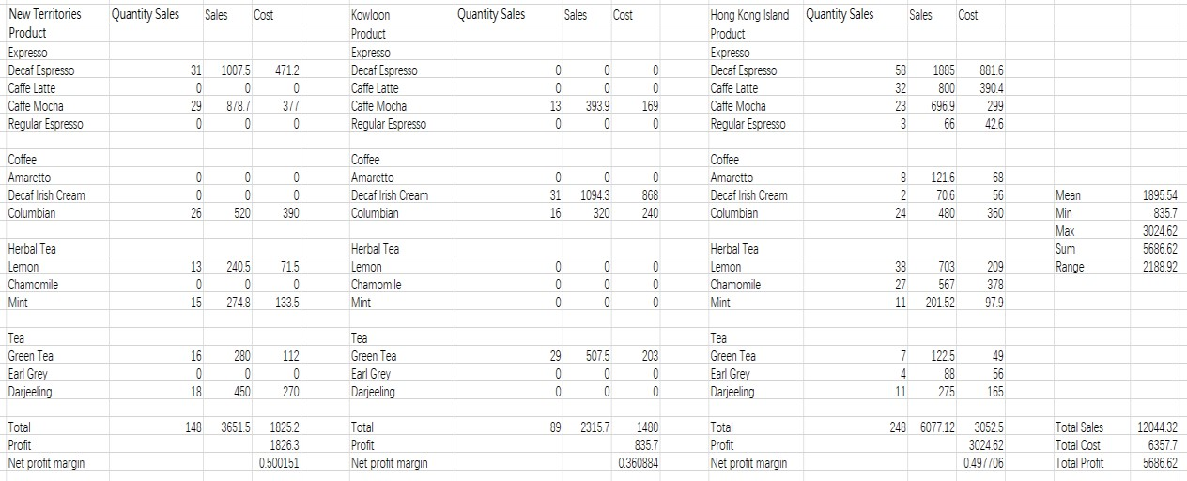
The report will generate the quantity sales, Revenue and Cost, and profit margin for different region respectively. It will also calculate the total profit and he summary statistic of the profit.
The data is extracted the source data Workbook_salesrecord. With analyzing the data, marketing strategies for different region can be suggested. Pic 8:
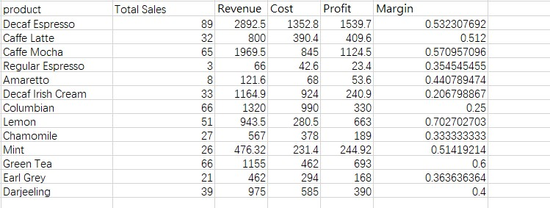
The second of Monthly report is Product analysis, by calculating and profit margin of each product. Company can know which product having a higher margin can generate higher profit in future. New variable Margin is calculated by (Profit/Revenue).

Pic 9:
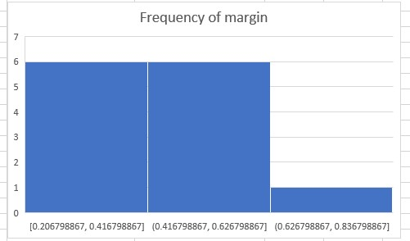
It shows only few products have a relatively high margin for selling.
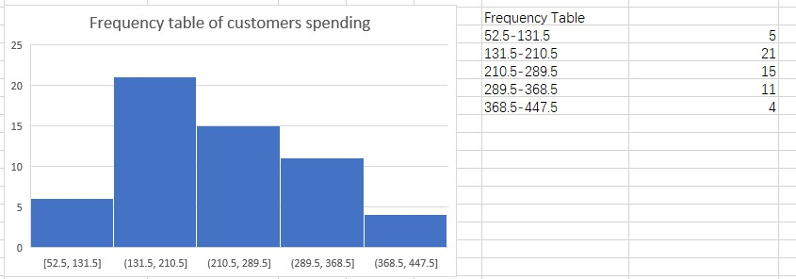
With acknowledging the Frequency of customers spending, company can know who is target customers, and adjust price in the future.

