SBA – Tic Tac Toe

Name: Joe, Anthony Kar Tong
Class: 6D
Class number: 9
Teacher: Mr Lee
Deadline:
Google link:
Content
1. Pre work 1
1.1 Problem analysis 3
1.2 Selection of programming language 2
1.3 Selection of Python IDE 2
1.4 CLI vs GUI 3
1.5 Tkinter vs Pygame vs PyQt 3
2. Programming (Tic Tac Toe) 4
2.1 Flowchart 5
2.2 Program(explanation + Variable/constant declaration) 6
2.3 Game logic 6
2.4 Modular approach 3
2.5 Scope of Variables and Parameter Passing 3
2.6 Program Interface Design 3
2.7 Data collections and, input and validation 3
2.8 Sorting and searching algorithms 3
2.9 Programing output 3
2.10 Error handling 3
2.11 Reusability and portability 3

3. Testing & Evaluation 4
3.1 Test data and test cases 3
3.2 Debugging Process 3
3.3 Unit Testing and System Testing 3
3.4 User Acceptance Testing 3
3.5 Pros and Cons of the Program 3
3.6 Modifications (during programming) 3
4. Further modifications 4
4.1 Numpy 3
4.2 AI implement 3
4.3 User Experience Enhancement 3

5. Conclusion 4
5.1 Summary of the program 3
5.2 Learning outcomes 3

6. References 4
4.1 Libraries and Tools used 3

  - Problem analysis
Before the start of the programming, brainstorming and define the workflow of the project is of importance to reduce error.

    - Understanding the problem
- Create a tic tac toe game includes two players
- Create a tic tac toe game includes players vs computer
- Including login functions (create player, change password and delete player)
- Including record results function
- Including display results function
Key aspects:
- How do user input?
- Game logic? (Computer part)
- Operating methods?
- Result display

    - Game rules
*Break down the rules into program elements
- Win = forming a row/column/diagonal
- Tie = board full but no row/column/diagonals is formed
- Player alternate turn

    - System of tic tac toe
A Standalone system should be used. That means the game does not require an internet connection after owning the program as long as database

    - Target audience
As tic tac toe is just a easy game with simple rules, target audience is supposed to be above 5 years old.

    - Functional requirements
- Allow players to input moves
- Refresh the game board after each move
- Check for the game condition

    - Non-functional requirements
- User-friendly
  - Outline drafts
Display record
Game over
username
login
password
Display name
Player 1 / Player 2 login
Change password
New password
username
Change password
exit
- Xxx win: 10 lose:1
- Yyy win:10 lose:2
- Zzz win:9 lose:1
- Aaa win:8 lose:2
- Bbb win:7 lose:6
Ranking list
  - Selection of programming language
With the meteoric advancement of technology, some parents would even like the first language of their children to be Java. Programming serves as a dominant role in the development of the world and already permeates into our daily life, it is ubiquitous anywhere, leading to the emergence of various programming languages over the past fifty years. Which is the best? Is there a big difference among those languages? Each programming language has its advantages and disadvantages. Each program is created to solve a specific problem and they all shine in different ways. But which one should be used? To answer the above queries, I am going to shed some light on several different programming languages and why I pick up “Python”.

    - C++
It evolved from C, it provides features like object-oriented programming capabilities without sacrificing speed or efficiency.
✓: Object-oriented features
✓: High performance
✕: Not beginner-friendly
✕: complex syntax

    - JavaScript
It is a versatile and high-level language primarily used for web development
✓: High flexible
✕: Flexible syntax can lead to inconsistencies

    - Java
It is a high-level object-oriented language designed to be cross platform.
✓: Strongly typed
✓: platform independent
✕: Flexible syntax confusing for beginners

    - Python
It is a high-level programming language known for its readability and simplicity
✓: Beginner-friendly and Easy to learn
✓: Extensive built-in functions and libraries
✕: poor web development

    - Why python?
- Beginner-Friendly
With simpler syntax, it’s easier to read and write and debugging.
- Rich libraries
There are lots of built-in functions. While making the game, I may try to use libraries like Tkinter for GUI or Pygame for game development. I may also use NumPy for sorting and searching.
- Strong Community support
There are extensive resources and abundant tutorials helping while programming.
- Cross platform
It allows running the program anywhere. It’s compatible with multiple operating systems.

  - Selection of Python IDE

    - IDLE
✓: beginner friendly with a distraction-free environment
✓: lightweight and fast, ideal for small projects
✕: limited debugging tools
✕: less customization
✕: lack advanced features for scaling projects

    - Jupyter
✓: Simple interface with markdown integration for documentation
✓: large community support
✕: Poor support for Tkinter GUIs; rendering often fails
✕: Minimal debugging tools, unsuitable for GUI development

    - PyCharm
✓: Contain advanced debugging tools
✓: Highly customizable
✕: Resource-intensive, heavy for small projects
✕: Steep learning curve for beginners

    - Thonny
✓: Designed for beginners and educators with a simple interface
✓: Lightweight and efficient for small projects
✕: Limited customization options
    - Visual studio Code
✓: Lightweight, fast, and easy to set up
✓: Excellent built-in debugging tools with breakpoints
✓: Highly customizable with a large library of extensions
✓: Suitable for developers of all skill levels
✕: Lacks advanced features of a full-fledged IDE like PyCharm

    - Summary
 | IDLE | Jupyter | PyCharm | Thonny | VS code
Best for | Beginners | Data science | Professionals | Beginners | All skill level
Ease of use | ✓✓✓ | ✕✕ | ✕ | ✓✓✓ | ✓✓✓
Resource Usage | ✕ | ✓ | ✓✓✓ | ✕ | ✓✓
Debugging | ✓ | ✓ | ✓✓✓ | ✓ | ✓✓
GUI support | ✓✓✓ | ✕ | ✓✓✓ | ✓✓✓ | ✓✓✓
To sum up, VS Code offers advantages like easy setup, syntax highlighting, debugging, modular organization, and broad extension support, making it ideal for GUI Tic Tac Toe. While PyCharm has stronger debugging tools, VS Code is more than sufficient for this project.

  - CLI vs GUI
For a game, there’s usually a lot of input and output, and monitor I/O is involved. Thus, there is command line interface and Graphical user interface.

So, CLI vs GUI, which is better?
CLI:  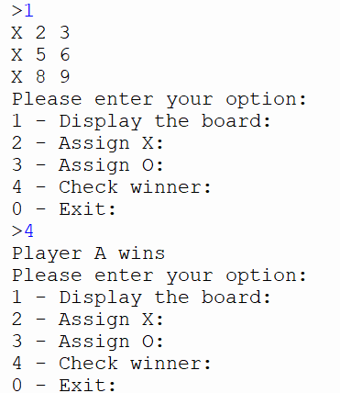 | GUI:  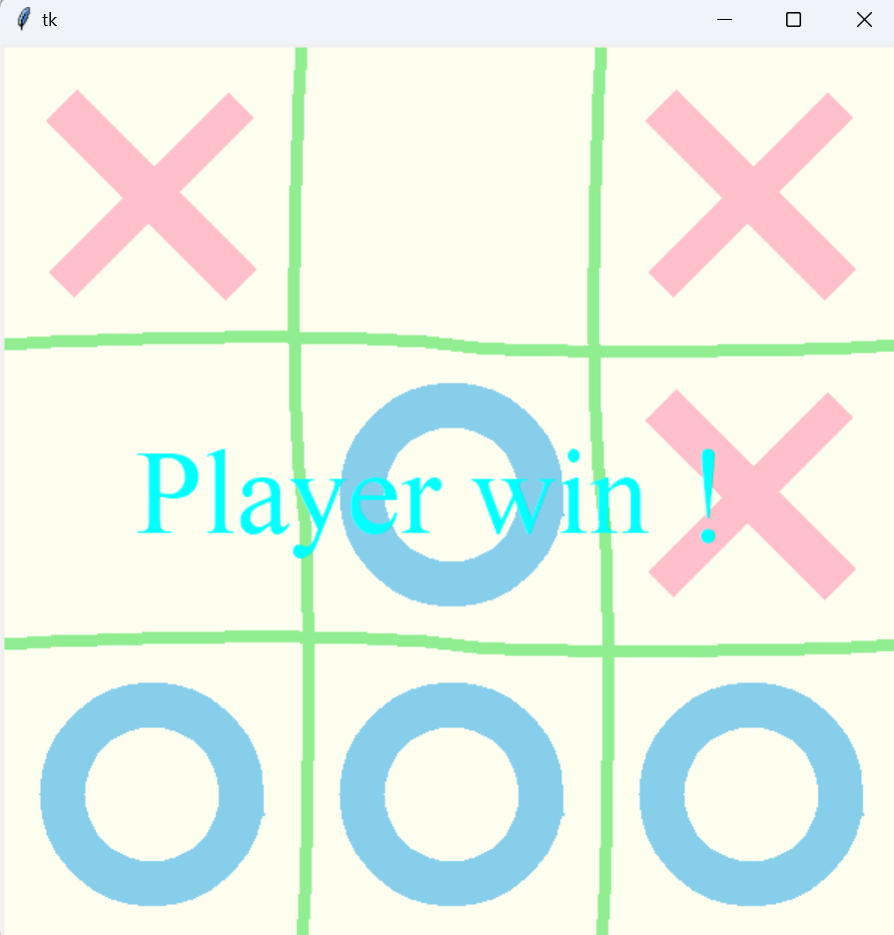
After making both cli and gui type tic tac toe, here comes a conclusion
Summary:
 | CLI | GUI
Interface | Text-based. Requires players type grid positions | Graphical board with clickable buttons and canvas
Libraries/Tools | Core Python or libraries like argparse | Libraries like Tkinter, Pyqt or Pygame and numpy
User Interaction | Input though text | Input though click buttons or cells to make moves
Development Complexity | Simple and minimal coding required | More complex as involved GUI layout design and event handling
Visual Appeal | Minimal and relies on formatted text like ASCII | Attractive and direct with graphical elements on the board
Feedback Mechanism | Displays updated board and messages in the terminal | moves visually and combine with colors or animations for feedback
Performance | Lightweight and fast execution in any terminal. | Slightly heavier due to graphical rendering
Storage size | Smaller as only text involved | Larger due to graphical handling and canvas
Learning Curve | Beginner-friendly; focuses on game logic | Steeper; involves learning a GUI library in addition to game logic
Deployment | Single script that is easy to run on any terminal | Requires additional dependencies and cross-platform testing
Audience | Suited for developers or technical users | Suited for general users including kids or non-technical people
Time to Build | Short and focus only on game logic. | Longer as it includes layout design and event handling

  - Tkinter vs Pygame vs PyQt
 | Tkinter | Pygame | PyQt
Ease to use | Easy to use | Moderate as it involves managing game loops | Difficult and requires the knowledge of  Qt framework
Built-in Widgets | Yes (buttons, labels, frames, etc) | None, manual creation is required | Yes, advanced widgets for complex GUIs
Setup and Dependencies | Comes preinstalled with Python | Requires installation and additional setup | Requires installation and heavier dependencies
Performance | Lightweight and efficient for tic tac toe | Optimized for games with better graphic | Heavy due to advanced features
Cross-Platform Support | Yes | Yes | Yes
Learning Curve | Low | Moderate | High
Customization | Moderate | High, support pixel-level control | Very high, support extensive styling
Animation Support | Limited but sufficient for tic tac toe | Good for animations and games | Yes, but requires implement
Resource Intensity | Low | Moderate | High
Community Support | Large and beginner-friendly | Large and focused on game development | Large, professional-focused
Use Case Suitability | Ideal for small to medium-scale applications | Best for game development with rich visuals | Best for large-scale and professional GUIs
Code Complexity | Simpler | Moderate, involves game-specific design | Complex and require structured programming
Deployment | Easy, no extra dependencies required | Moderate, requires bundling assets | Complex, needs Qt runtime and packaging
Target Audience | Beginners and general-purpose developers | Game developers | Professional developers and advanced users

    - Why tkinter?
- Minimal Setup
It is pre-installed, unlike Pygame and PyQt, which require additional dependencies.
- Ease of Use
Friendly for beginners, making it suitable for projects like a Tic Tac Toe game.
- Lightweight
Consumes fewer system resources, ensuring smooth performance on various devices.
- Versatile Widgets
Offers built-in tools like button, frame or messagebox and so on for quick GUI construction without extensive coding.
Tkinter stands out for its simplicity and efficiency in developing small-to-medium applications, balancing functionality and ease of development effectively.

2.3 Game Logic
Both PvPEngine(Player vs player) and PvCEngine(Player vs Computer) share the same basic logic, in this chapter, I would like to shed more light on PvCEngine, explaining the logic and how the whole engine works.
  - Canvas

  - Array

  - Player Input

  - Computer input logic*

  - Check win
  - 4. Further modifications
Python, being a powerful programming language, there are serval further modifications for my program. Here are some of the directions.
  - Numpy
Numpy (Numeric Python) is a library specifically supporting multi-dimension arrays and matrix, along with mathematical functions to operate on these arrays. It can perform complex operations on arrays with mineral code.

4.1.1 Numpy x Tic Tac Toe
- Using Numpy to represent the Tic Tac Toe board as a 3x3 ndarray will allow easier manipulation of the board state

- With numpy power array operation, which enables quickly check for winning conditions of (vertical, columns, diagonals) without using complex loops 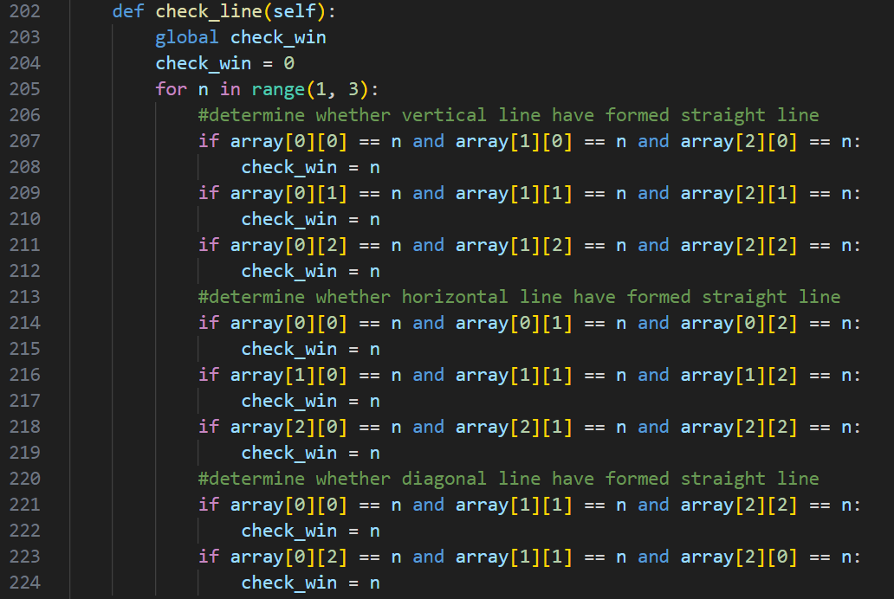^(inefficient example of my program in check winning) 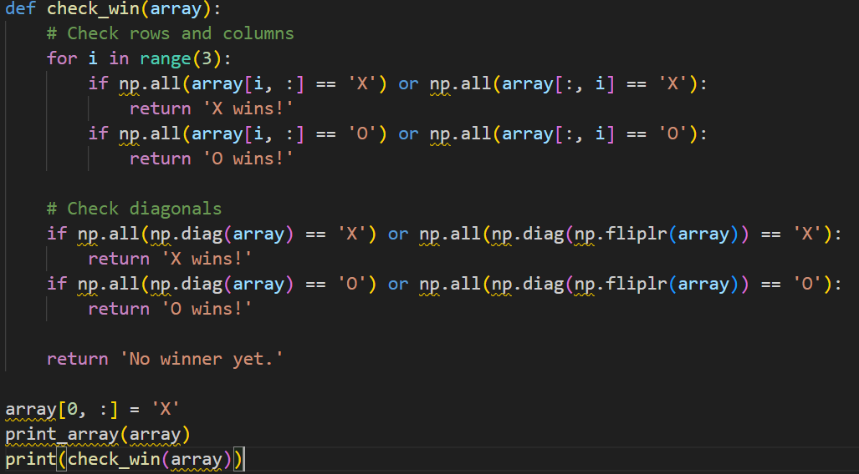^(much more efficient with less lines but same results, however this is just a cli example. It is slightly challenging to integrate into my program)

- Althought Tic tac toe doesn’t require extensive sorting or searching, numpy can be used for managing moves and analyze the game state. For instance, the computer could sort all possible move base on the current stragegic state.

    - Numpy x AI
NumPy enhances AI implementation in Tic Tac Toe by simplifying data handling and computations:
- Game State Management:
The board is represented as a 3x3 NumPy array, making updates and checks straightforward.
- Winning Condition Checks:
Win conditions (rows, columns, diagonals) are efficiently verified using array operations, reducing the reliance on nested loops.
- AI Integration:
NumPy supports Q-learning and other algorithms by handling large datasets and performing complex computations with ease.

  - AI implementation
    - Self-Learning
Using libraries like Gym, TensorFlow, or PyTorch, the AI can be trained to play Tic Tac Toe through self-learning by simulating games and learning from the outcomes. It develops strategies like blocking the opponent and prioritizing winning moves using reinforcement learning techniques.

    - Q-learning (Reinforcement Learning)
Q-learning trains the AI by assigning rewards to specific actions based on game outcomes.
- The board state is treated as input, and a Q-table stores the value of each move.
- After some time, AI learns to make decisions that maximize its chance of winning while avoiding losing moves.

    - Minimax Algorithm
The Minimax algorithm ensures the computer makes the best possible move by simulating all potential outcomes.
- It evaluates moves by assigning scores (positive for a win, negative for a loss, and zero for a tie).
- The AI chooses the move that maximizes its chances of winning or forces a tie when a win is impossible.
4.4 User Experience Enhancements
- Add sound effects (eg: clicks for moves, applause for a win).
- Allow theme customization (eg:change colors or board designs)
- Provide hints
- Add backward button which allows withdraw the moves
- Make more games

