

Tree Risk Management Portfolio (MR4005)
Author: Tammy, WC SUM
Introduction
Benefits generated from trees are uncountable. They contribute to a healthier and more sustainable environment in urban areas. Here are some of the key benefits of trees in urban areas.

- Tree is an air purifier which help to improve air quality and reduce pollution. They absorb carbon dioxide and release oxygen through photosynthesis, helping to improve air quality and reduce pollution.
- Tree also provides shade and help to cool the surrounding environment through evapotranspiration. This can help reduce the urban heat island effect (Wang & Hashem ,2016).
- Urban trees provide habitats for birds, insects, and other wildlife, promoting biodiversity in urban areas. They can create important green corridors and connect fragmented ecosystems.
- Trees enhance the visual appeal of urban areas, making them more attractive and inviting. Being around trees has been shown to reduce stress, improve mood, and promote overall mental well-being.

However, there's no needle with both ends pointed. As trees mature and grow in size, their likelihood of shedding branches or developing decay and other conditions that can lead to failure increases. Therefore, when evaluating and overseeing trees, it is important to find a middle ground between the potential risks they present and the advantages they offer to individuals and communities. By doing so, we can ensure a balanced approach to tree risk assessment and management.

This portfolio aims to examine and compare three cases of different tree defects and two contrasting cases of fungal decay in trees in the Arboriculture industry of Hong Kong. Additionally, it will introduce two tree defect detection systems, namely the Visual Tree Assessment and Sonic tomography. The portfolio will discuss the pros and cons of these methods and provide suggestions for potential improvements.

Tree Risk Cases

The significance of tree conflicts or failures varies depending on their location. In areas where the impact of tree failure would have minimal result such as non-urban or undeveloped areas, the need for tree inspections may be less critical. However, in urban and development zones where there is a higher risk of harm to people, property, and activities, the consequences of tree conflicts or failures can be significant or severe. Therefore, decisions regarding whether tree inspections are necessary, and the level of assessment required should be made by considering what is reasonable and proportionate to the specific condition and situation at hand. These considerations are crucial aspects of tree risk management. There are three cases will be discussed as coming page.

Tree Risk case – Case 1
In Case 1, we have a Casuarina equisetifolia (T1) planted in a tree pit measuring 2m x 2m. T1 has a diameter at breast height (DBH) of approximately 400mm and stands at a height of 14m. Its crown spread extends to about 6m.

T1 is situated in a significant location, adjacent to a public footpath and in close proximity to a high school entrance, a taxi stand, and a traffic road. This means that various vehicles, students, and residents frequently pass by or gather around T1. Due to its location, removing the target is not an option.

To provide a visual representation, a location map and a photo of T1 are included below.
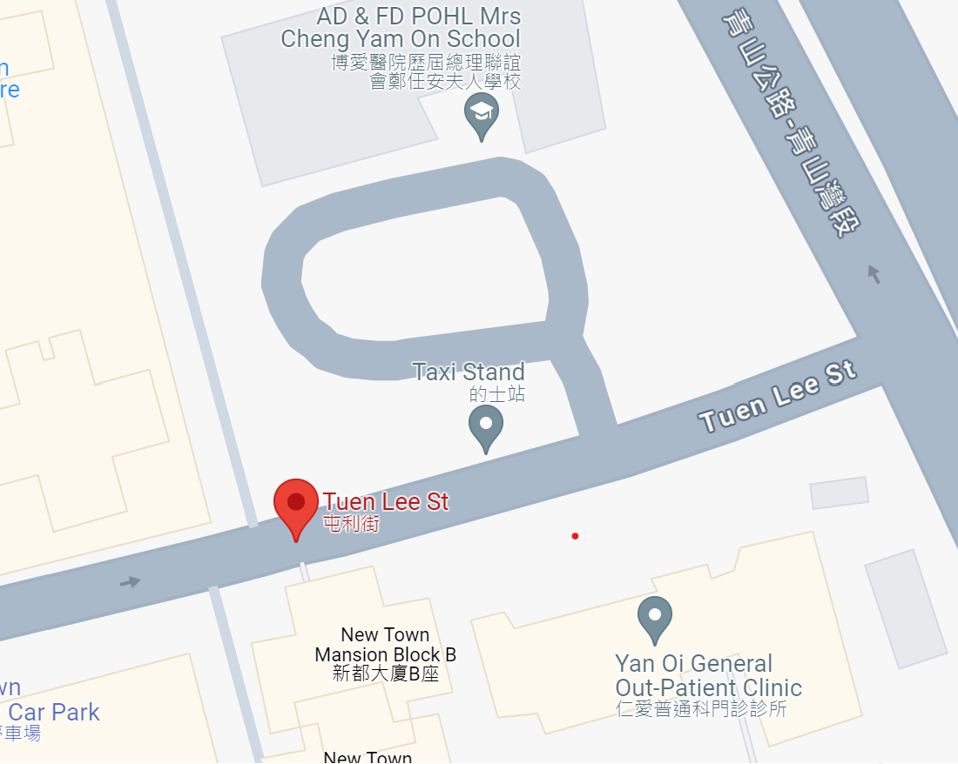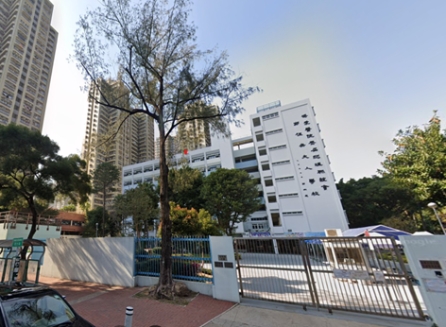
T1 Location

Considering the high traffic and potential risks associated with the area, it is crucial to conduct a tree inspection and risk assessment of T1.

Crown Condition: The comparative yellowing and smaller size of the foliage, along with a foliage density of around 75%, and the presence of died-back twigs, which indicate T1 is facing potential stress or health issues. These symptoms could be attributed to various factors, such as nutrient deficiencies, drought stress, pest infestation, disease, or root problems.

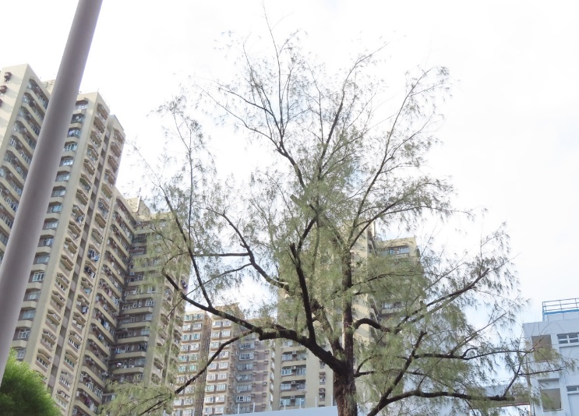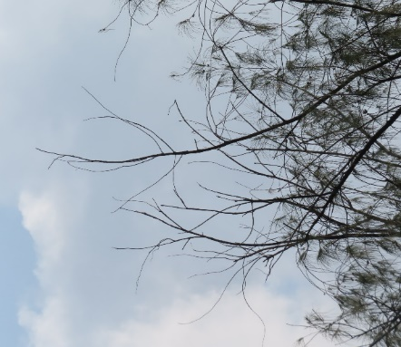

Trunk Condition: The presence of exposed dead wood and signs of termites at an old pruning wound on the upper trunk at 4m height, along with the discovery of a termite cavity measuring 120mm (height) x 30mm (width) x 300mm (depth) on the lower trunk at 1.3m height, indicates potential structural concerns and the possibility of decay or damage within the tree.

Photo of the upper trunk and the old wound
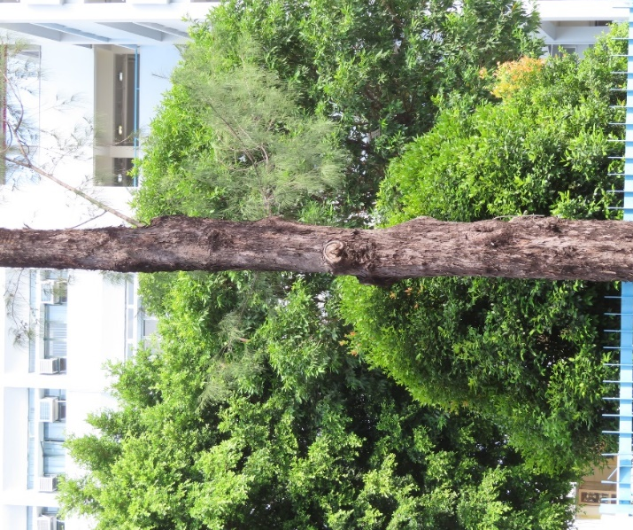 | 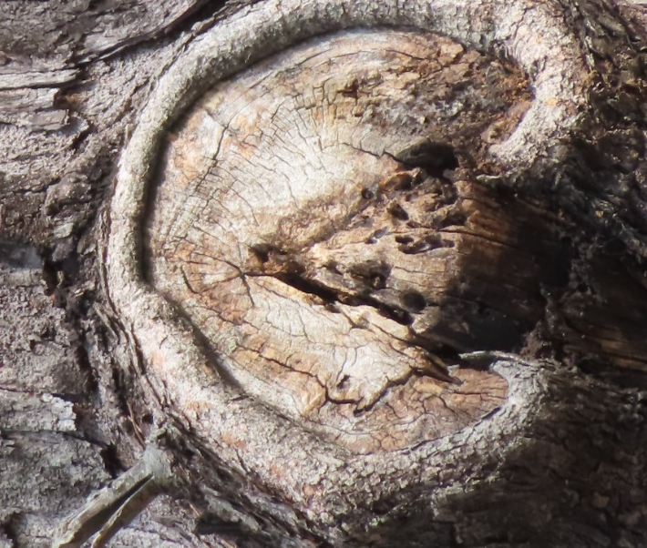

Photo of lower trunk and signs of termites
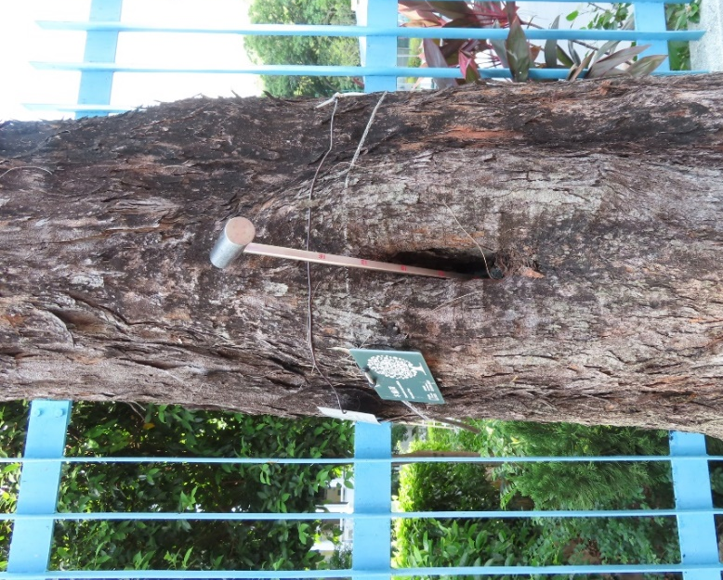 | 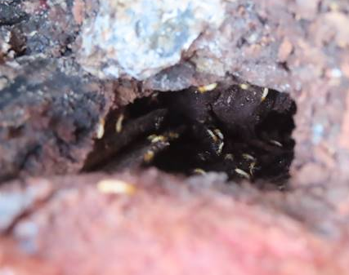

Exposed dead wood create entry points for pests (termites) which is increasing the risk of decay and compromising the structural integrity of the tree. The presence of termites is a cause for concern as they can further contribute to the decay and weakening of T1. Termites feed on wood, including dead wood, and can cause significant damage if left unchecked.

The presence of a termite cavity indicates that termites have created a void within the tree, potentially resulting in a loss of structural integrity. The size of the cavity suggests a significant amount of wood has been affected.

The results of the Sonic Tomography inspection as below indicate that the internal decay in the lower trunk is progressing and becoming more severe. The cross-sections inspection taken at various heights (170cm, 100cm, and 60cm from the ground) reveal a decreasing percentage of solid wood, ranging from 83% to 50%. This deterioration in the amount of solid wood suggests that the structural integrity of the tree is being compromised.

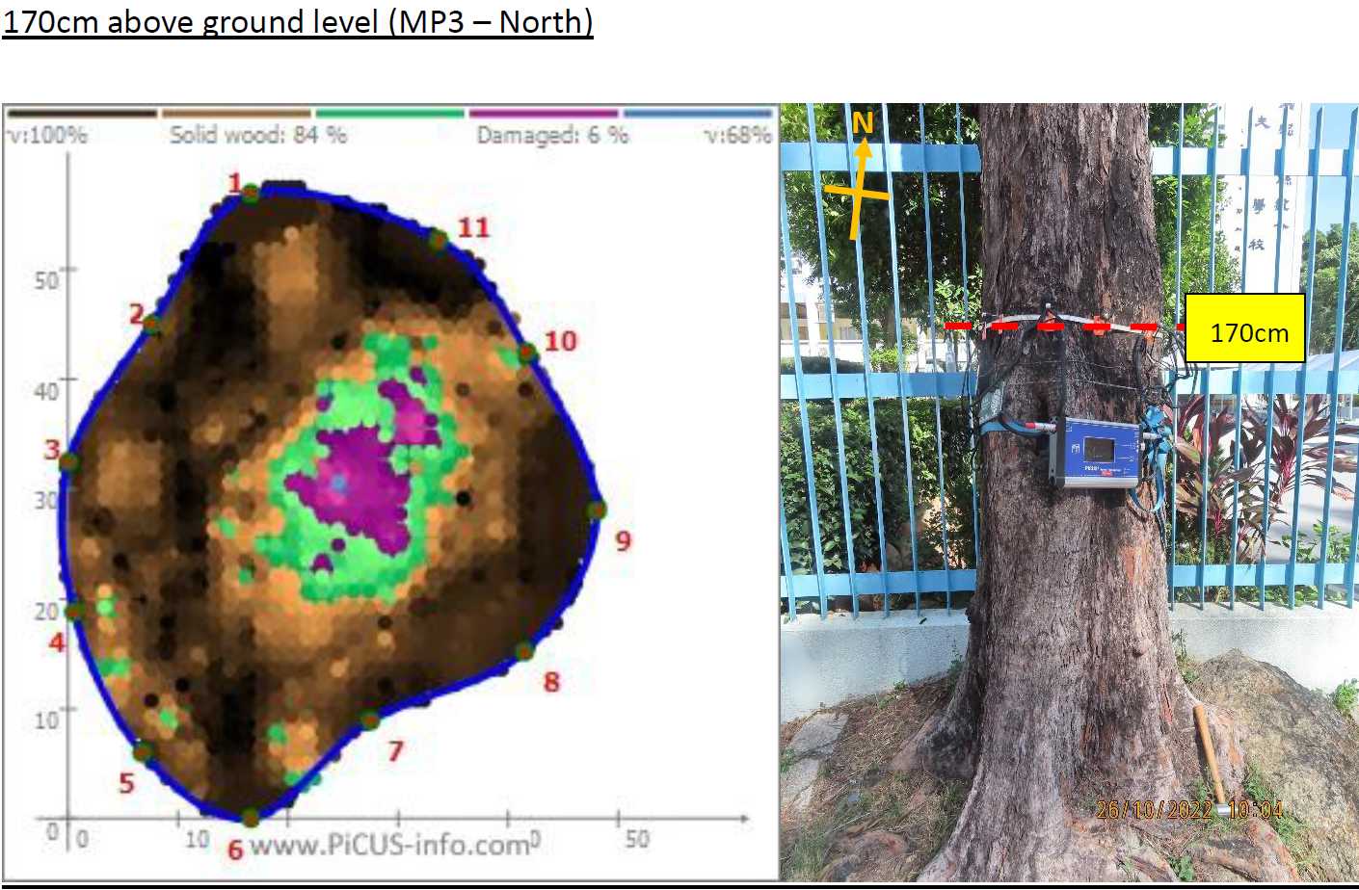
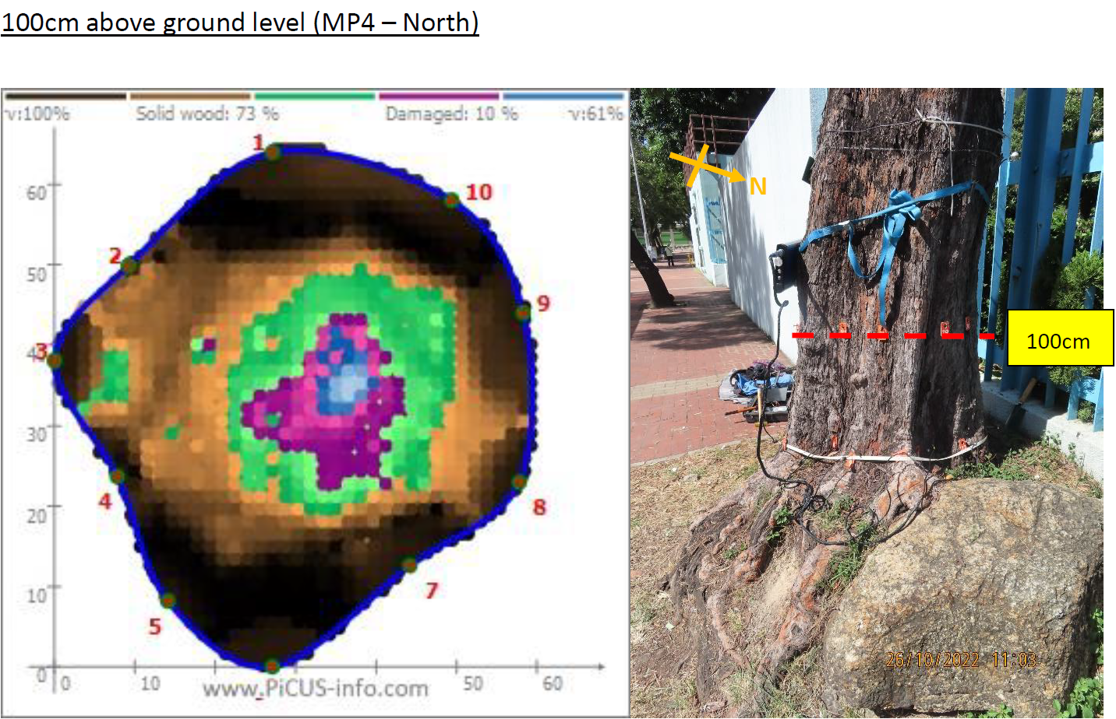
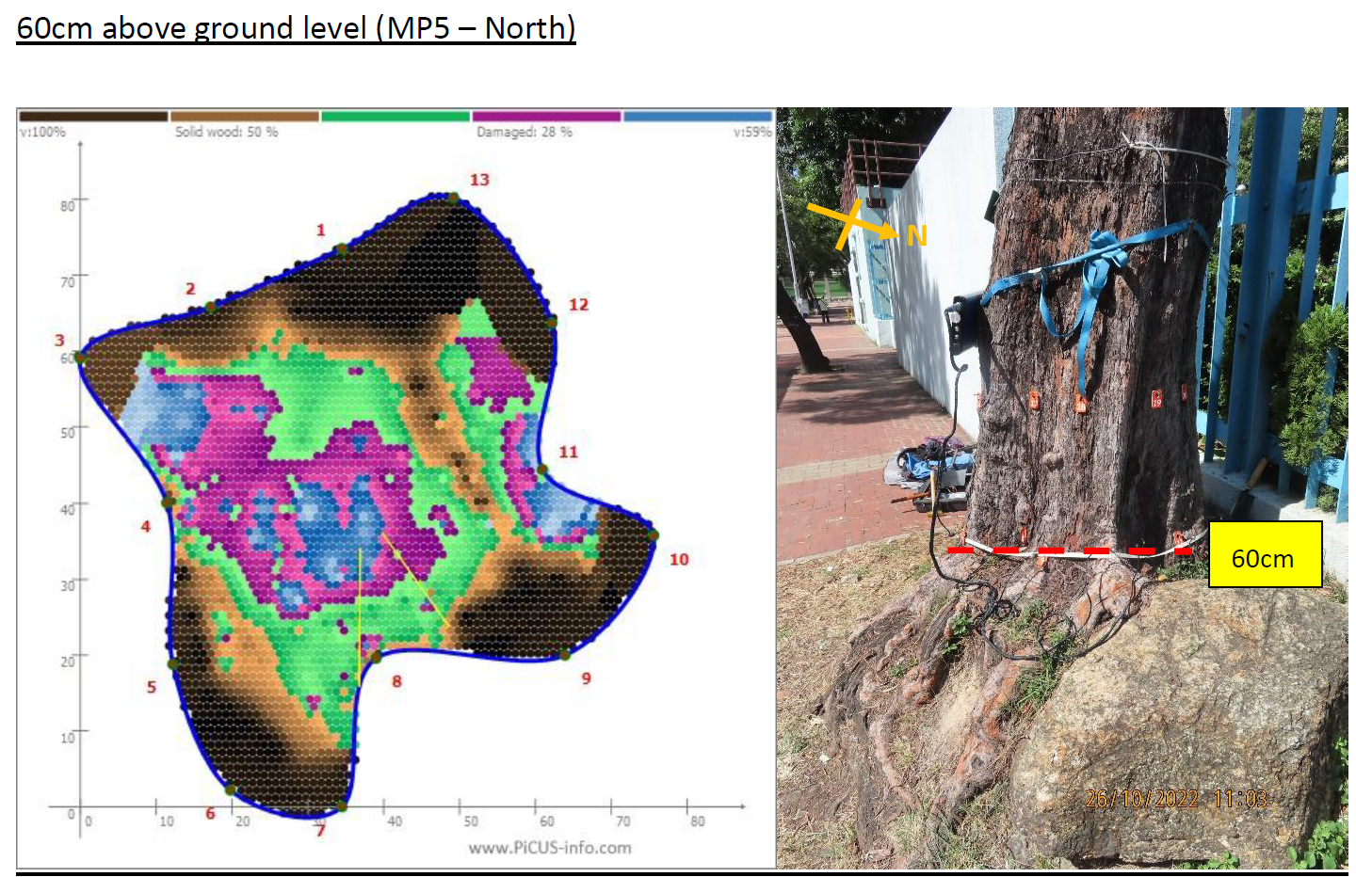

Root condition: The root development of the tree being restricted by the tree pit and structure wall, along with the presence of girdling roots, root cuts, and fungal fruiting bodies, indicates significant challenges and potential health issues for the tree.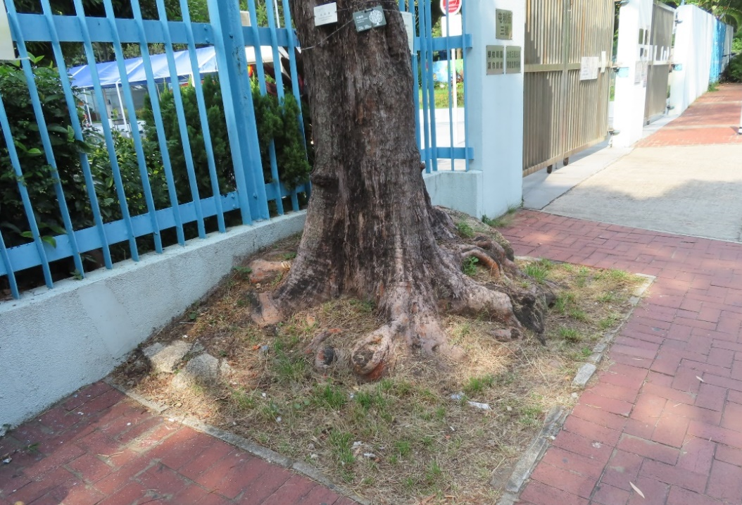

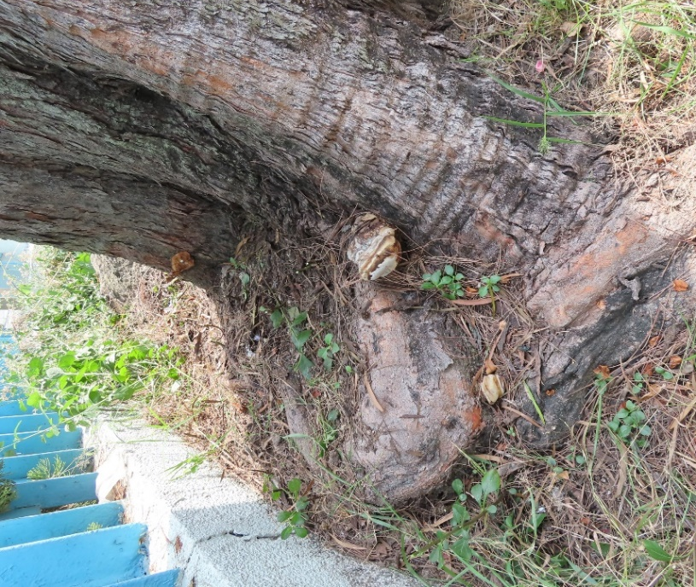  Girdling roots | 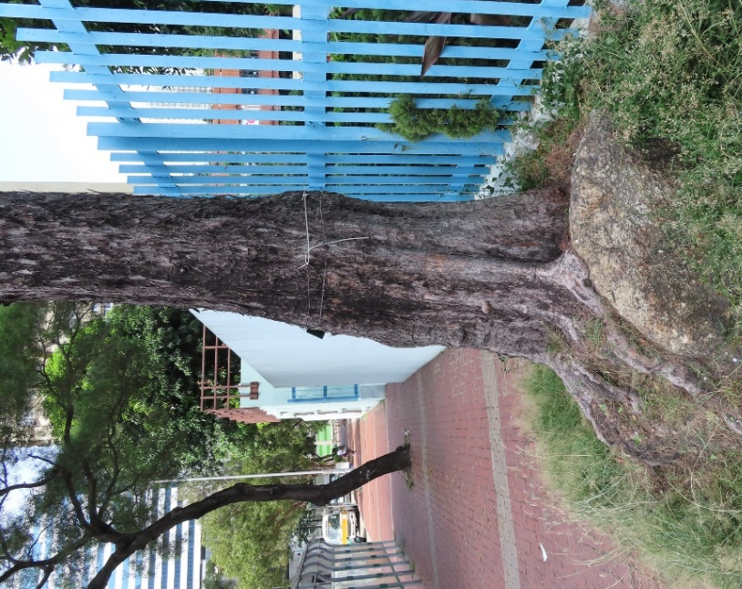
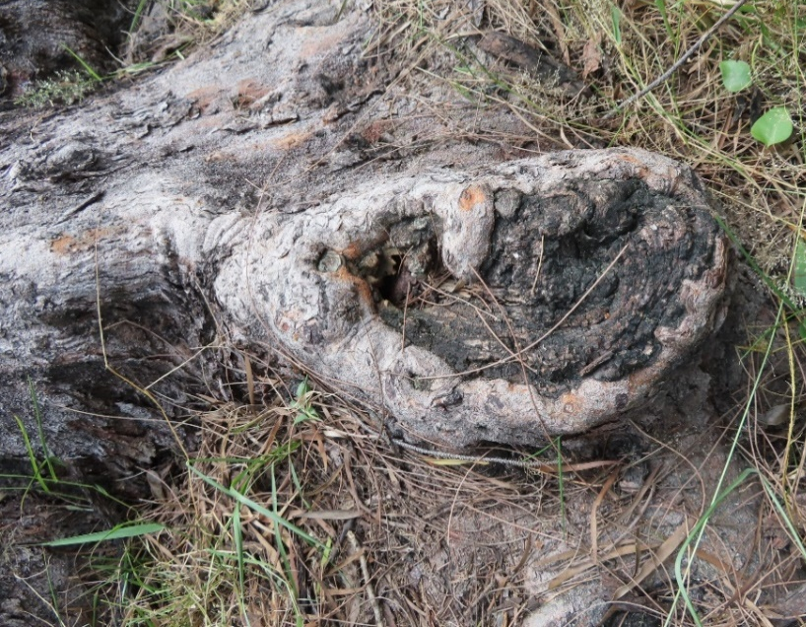  Root cut | 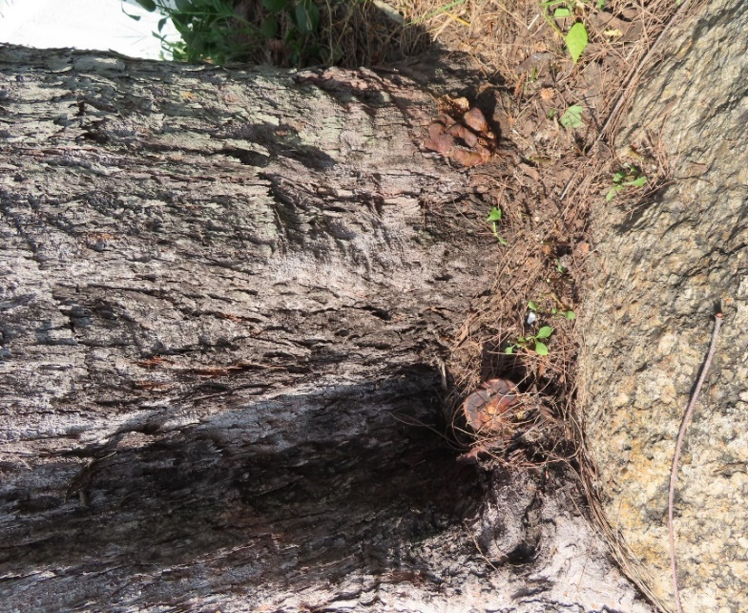  fungal fruiting bodies

Remedial measure: To summarize, The overall condition of T1 is moderate.

- Remove dead twigs and branches to improve the tree's appearance and reduce potential hazards.
- Implement appropriate treatments to control and eliminate termites, preventing further damage.
- Treat fungal infections with fungicide application or targeted removal of infected wood.
- Inspect the tree one month after treatment to assess the effectiveness of pest and fungal control measures.
- Conduct routine tree risk assessments every six months to evaluate health, stability, and potential risks.
Tree Risk case – Case 2
In Case 2, a Dimocarpus longan (T2) planted in a narrow amenity area measuring 1.5m(width) x 2m. T2 has a diameter at breast height (DBH) of approximately 600mm and stands at a height of 9m. Its crown spread extends to about 8m.

T2 is situated in a significant location, adjacent to a public footpath and in close proximity to a vehicle maintenance depot and pet garden and a traffic road. This means that various vehicles, residents, garden users with their pets frequently pass by or gather around T2. Due to its location, removing the target is not an option.

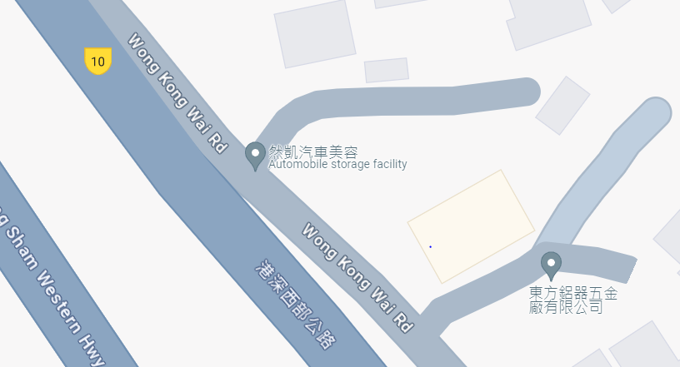
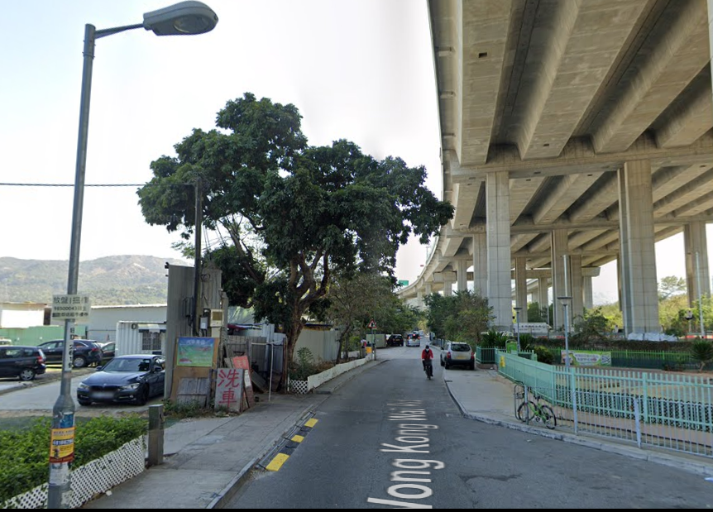
T2 Location

Crown Condition: While the color and density of the foliage appear normal, there is a noticeable difference in the size of the foliage, which is relatively smaller. Additionally, one of the branches has been broken due to inclement weather, and there is visible exposed dead wood.

Although the foliage color and density seem fine, the smaller foliage size could indicate possible issues such as nutrient deficiency, disease, insect infestation, or environmental stress. Furthermore, the broken branch and exposed dead wood pose potential risks, as they can weaken the tree's structure and potentially lead to further branch breakage or decay.

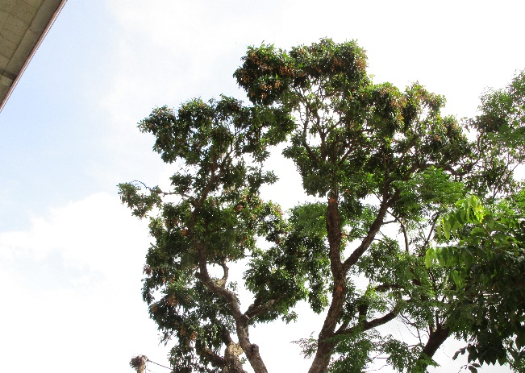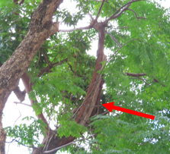

Trunk Condition: An extensive tearing wound, measuring 150mm wide and 600mm long, has been observed. Furthermore, there is a substantial opening wound on the broken stem, resulting in a single cavity that exceeds a depth of 500mm. Additionally, the lower trunk exhibits two cavities, both exceeding a depth of 500mm.
Photo of the upper trunk and the old wound
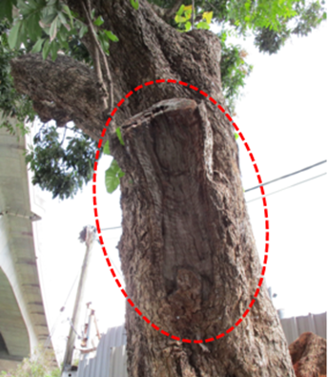  Case 2 Photo | 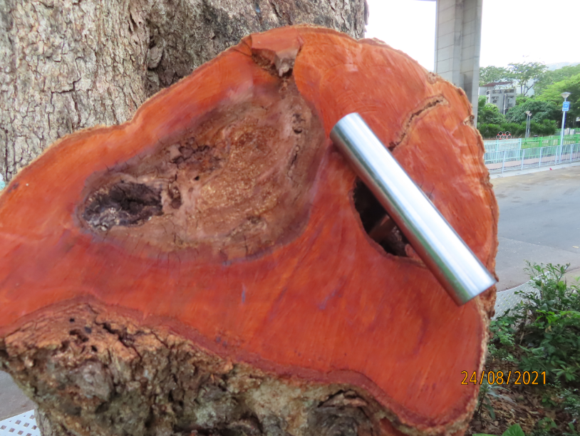
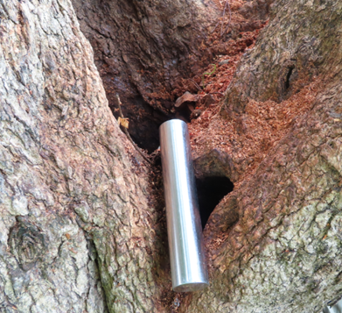 | 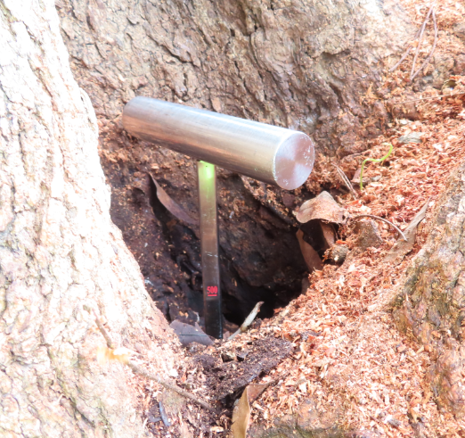

The tearing wound can compromise the tree's ability to heal and seal off the damaged area, making it more vulnerable to decay, disease, and insect infestation. The opening wound on the broken stem, along with the deep cavity, creates an entry point for pathogens and further weakens the structural stability of the tree.

The presence of cavities in the lower trunk suggests advanced decay or structural damage. These cavities can weaken the tree's support system, making it susceptible to branch failures or even complete failure of the tree itself.

The results of the Sonic Tomography inspection reveal that there is severe and progressing internal decay in the trunk of the tree. The cross-section inspections conducted at different heights, specifically 200cm and 140cm from the ground, indicate that the percentage of solid wood is only 20% and 22% respectively.
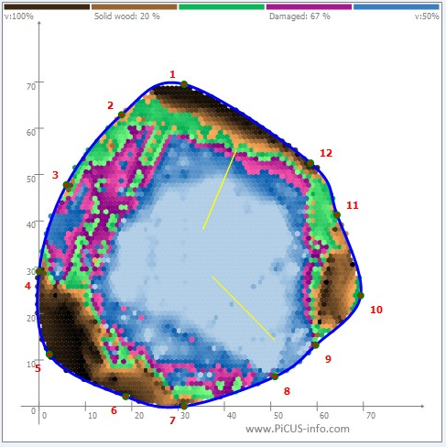  140cm above ground level | 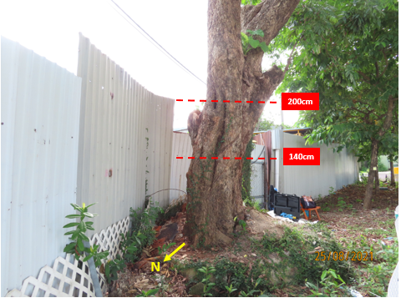
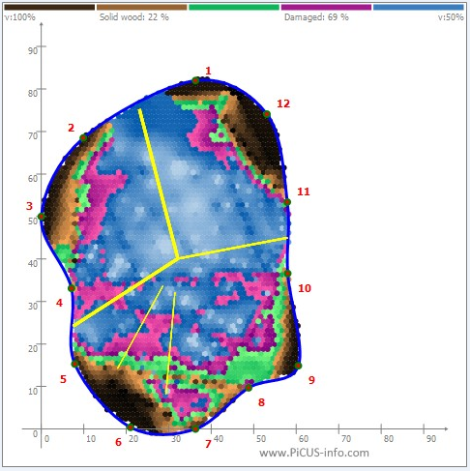
200cm above ground level

With a low percentage of solid wood in the cross-sections, the tree's ability to support its weight and withstand external forces is compromised. This increases the risk of branch or stem failures, which can pose a significant safety hazard to people and property in the vicinity.

Root condition: The root flare of the tree is not clearly visible, and the root zone is constrained by a metal plate and an old tree pit kerb.
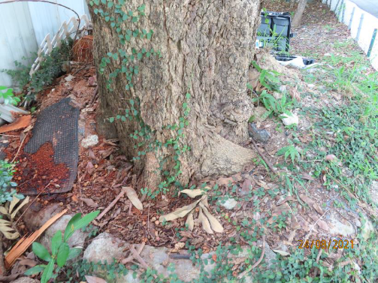
The lack of a noticeable root flare indicates that the base of the tree may be covered or obscured, potentially due to soil accumulation or other factors. The root flare is an important feature as it marks the transition between the trunk and the root system, allowing for proper nutrient absorption and stability.

The presence of a metal plate and an old tree pit kerb restricts the expansion and growth of the tree's root zone. This limitation can impede the tree's ability to access sufficient water, nutrients, and oxygen from the surrounding soil. It may also result in stunted root development and compromised stability.

Remedial measure: Based on the Sonic Tomography inspection results, the trunk of the tree exhibits a low percentage of solid wood, measuring only 20%. This indicates a significant decrease in trunk stability, which in turn affects the support provided to T2 (presumably a reference to a structure or object). The high risk of trunk failure or collapse is particularly concerning, especially during inclement weather conditions.

The potential consequences of such a failure are severe, including significant property damage and the risk of injuries. The presence of this problematic tree poses a direct threat to the safety of individuals and property within the tree canopy area.

Considering the above factors, it is highly recommended to remove T2. This course of action prioritizes public safety and mitigates the risk of accidents or damages caused by potential tree failure.

