係“BMF Adjustment”入面…
1. If “Raw Data”/ “BMF 1690 2680” tab嘅“NA” is 1690/ 2690 —> “Line type”填 Reversing
2. If “Raw Data”/ “BMF 1690 2680” tab嘅“NA” is 1020/2020/8601/8701 —> “Line type”填 Creation
3. Columns Highlight in yellow 填嘅資料都一樣, refer to following photo 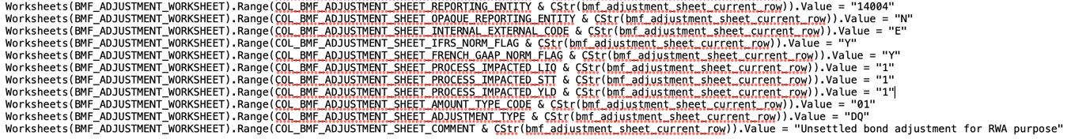
4. 係“BMF 1690 2690”入面…
Copy corresponding data in “BMF 1690 2690” to corresponding column in “BMF Adjustment”
“BMF 1690 2690” | To | “BMF Adjustment”
BMF ID (Column C) |  | BMF reference ID (Column A)
PCCO (Column E) |  | PCCO (Column G)
PCEC (Column F) |  | PCEC (Column H)
Amount in acct (Column M) |  | Amount in acct balance, Amount in funt (Column J, K)
NA (Column H) |  | Local Operational Account (Column BN) + 15130

