TEST plan

Test purpose

- Validation on the input data and display appropriate error messages
- Test Plan with test cases and test results.

Test #1

Test details
Test Case Name | Missing "Applicant Name"
Procedure | 1. leave "applicant name" field empty.  2. Click "Next" button
Expected Output | 1. The error MessageBox appears "name cannot empty."  2. The error MessageBox appears "Please fill the missing fields."
Result | Pass/Fail

Screen capture

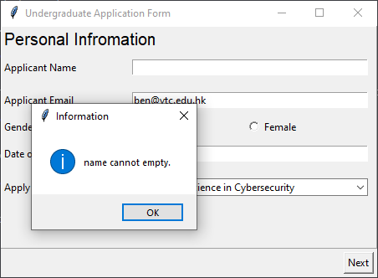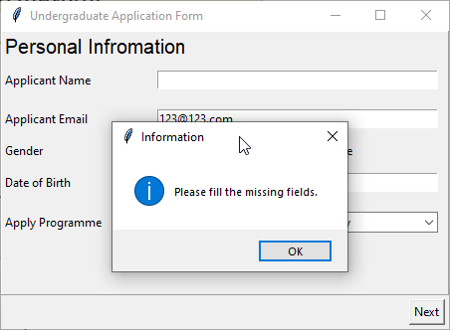

Test #2

Test details
Test Case Name | Missing "Applicant Email"
Procedure | 1. leave "applicant email" field empty.  2. Click "Next" button
Expected Output | 1. The error MessageBox appears "email field cannot empty."  2. The error MessageBox appears "Please fill the missing fields."
Result | Pass/Fail

Screen capture

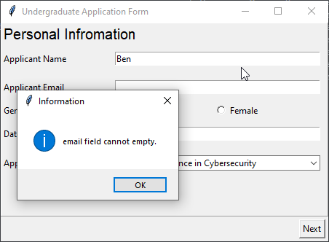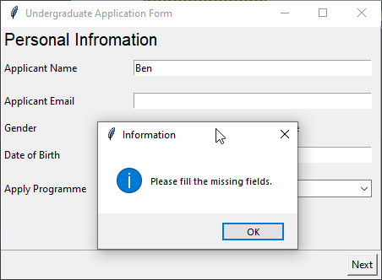

Test #3

Test details
Test Case Name | Missing "Date of Birth"
Procedure | 1. leave "date of birth" field empty.  2. Click "Next" button
Expected Output | 1. The error MessageBox appears "dob field cannot empty."  2. The error MessageBox appears "Please fill the missing fields."
Result | Pass/Fail

Screen capture

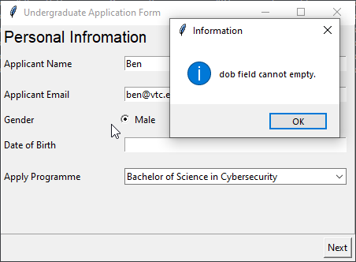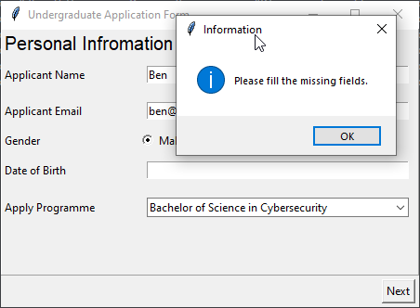

Test #4

Test details
Test Case Name | Missing Institution Name
Procedure | 1. finish “Personal information page”  2. leave "Institution Name" field empty  3. Click "Next" button
Expected Output | 1. The error MessageBox appears "institution name field cannot empty."  2. The error MessageBox appears "Please fill the missing fields."
Result | Pass/Fail

Screen capture

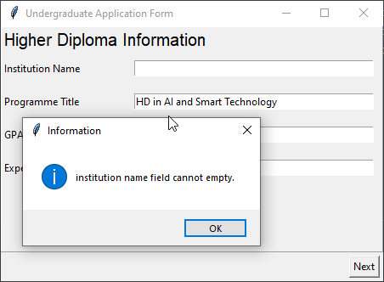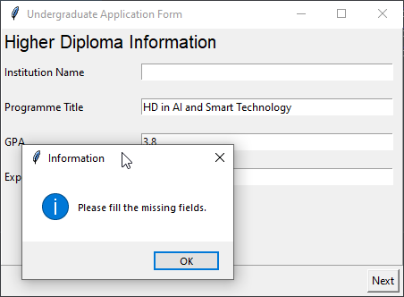

Test #5

Test details
Test Case Name | Missing Programme Title
Procedure | 1. finish “Personal information page”  2. leave "Programme Title" field empty  3. Click "Next" button
Expected Output | 1. The error MessageBox appears "programme title field cannot empty."  2. The error MessageBox appears "Please fill the missing fields."
Result | Pass/Fail

Screen capture

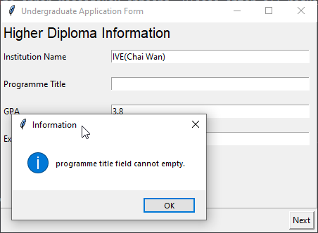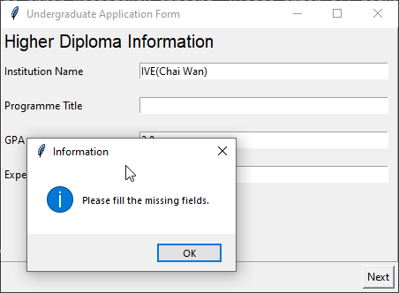

Test #6

Test details
Test Case Name | Missing GPA
Procedure | 1. finish “Personal information page”  2. leave "GPA" field empty  3. Click "Next" button
Expected Output | 1. The error MessageBox appears "GPA field cannot empty."  2. The error MessageBox appears "Please fill the missing fields."
Result | Pass/Fail

Screen capture

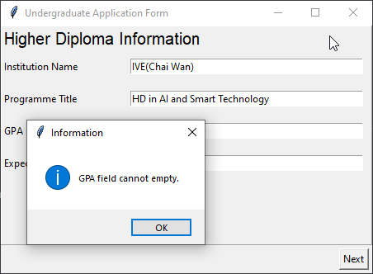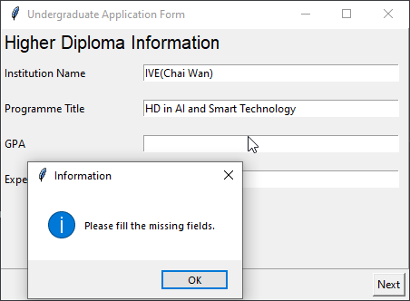

Test #7

Test details
Test Case Name | Missing Expected Graduation Year
Procedure | 1. finish “Personal information page”  2. leave "Expected Graduation Year" field empty  3. Click "Next" button
Expected Output | 1. The error MessageBox appears "Expected graduation year field cannot empty."  2. The error MessageBox appears "Please fill the missing fields."
Result | Pass/Fail

Screen capture

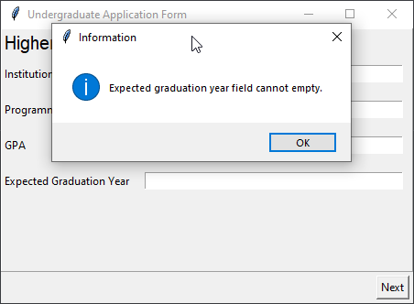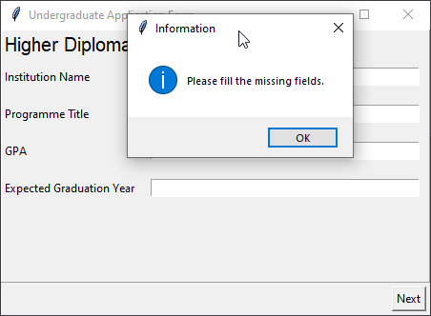

Test #8

Test details
Test Case Name | Showing summary if all input field fullfilled
Procedure | 1. filling all required information in "Personal Information"  2. click "Next" button  3. Filling all required information in"Higher Diploma Information" windows.  4. Click "Next" button  5. click "show" button to show summary
Expected Output | finally the summary window showing information in the page inputted before
Result | Pass/Fail

Screen capture

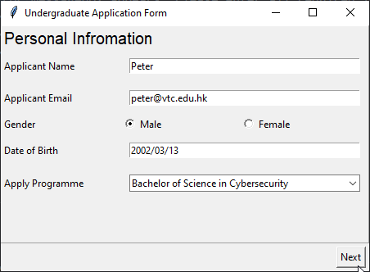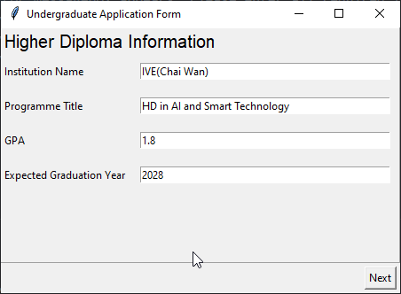

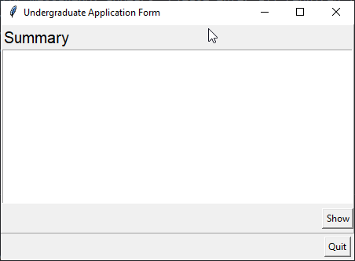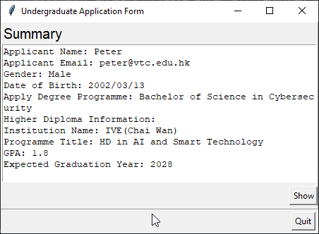

Test #9

Test details
Test Case Name | Date of birth should be in the past
Procedure | 1. enter a day after today to the "date of birth" field  2. click next button
Expected Output | 1. The error MessageBox appears "DOB: the day entered is latter than today."  2. The error MessageBox appears "Please fill the missing fields."
Result | Pass/Fail

Screen capture

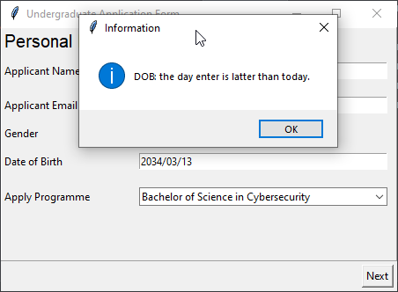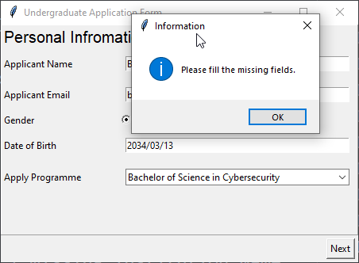

Test #10

Test details
Test Case Name | email entered should be valid
Procedure | 1. enter an invalid email e.g. "ankitrai326.com"  2. click "next" button
Expected Output | 1. The error MessageBox appears "email format error, it should be email."  2. The error MessageBox appears "Please fill the missing fields."
Result | Pass/Fail

Screen capture

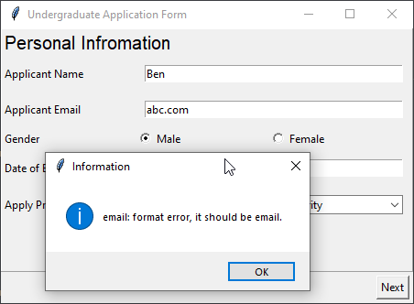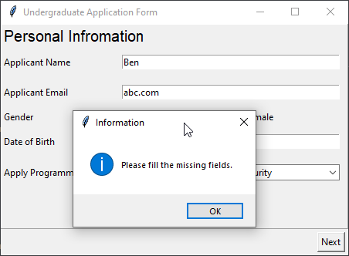

Test #11

Test details
Test Case Name | GPA should be a number / decimal
Procedure | 1. enter a non numeric value (e.g. a) into "GPA" field  2. Click "Next" button
Expected Output | 1. The error MessageBox appears "GPA field should be a number."  2. The error MessageBox appears "Please fill the missing fields."
Result | Pass/Fail

Screen capture

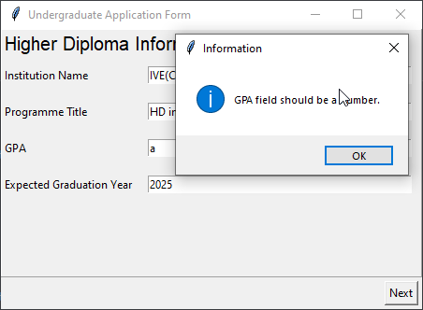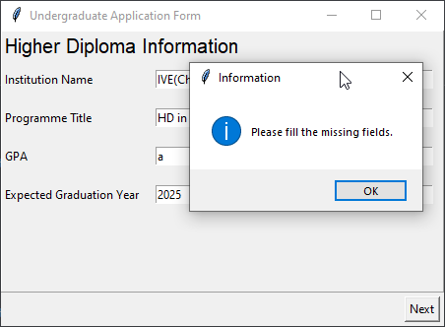

Test #12

Test details
Test Case Name | Expected graduation year should be in future
Procedure | 1. enter a day in the past (e.g. 2023) in "Graduation year" field  1. Click "Next" button
Expected Output | The error MessageBox appears "Expected graduation year should be after current year."  The error MessageBox appears "Please fill the missing fields."
Result | Pass/Fail

Screen capture

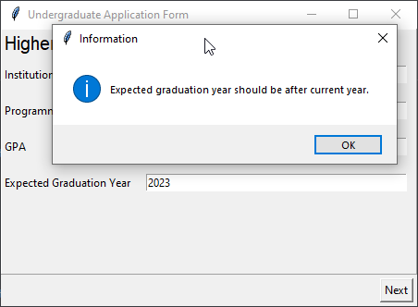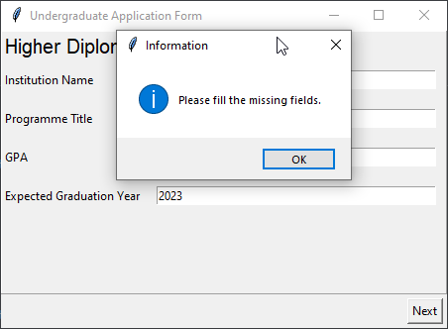

Test #13

Test details
Test Case Name | female appliciant
Procedure | 1. select female in applicant gender field  2. Click "Next" button
Expected Output | Summary shown in summary page
Result | Pass/Fail

Screen capture

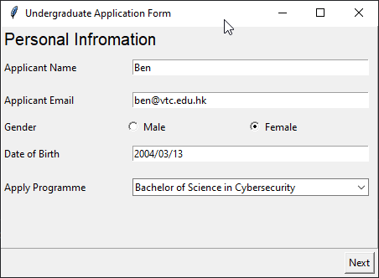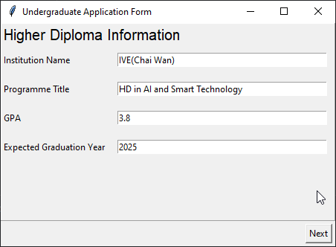

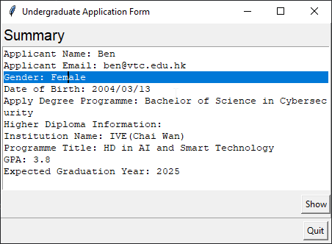

Test #14

Test details
Test Case Name | "Bachelor of Science in Computer Science and AI" in apply programme
Procedure | 1. select “Bachelor of Science in Computer Science and AI” in applicant apply programme field  2. Click "Next" button  3. complete Higher Diploma Information page
Expected Output | Summary shown in summary page
Result | Pass/Fail

Screen capture

