Recruitment Test (Health Solutions)
Time allowed: 60 minutes

Excel – Macro Test

Please complete the following questions by using the data in the excel file named “ACL – DATA”.

Part A (25 mins)
- Please write an Excel function using VBA which can:
  - Calculate the average scoring of each subject of all visible cells (i.e. hidden cells should not be included in calculation)
  - Be used in excel by typing the formula: =Average_Visible_Cells(B1:B101)
Please show our answer in the cells shaded in “Yellow”

Part B (35 mins)
Please answer Question No. 1 and 2 by referring to Demo A
- Create a UserForm with “OK” and “Cancel” Command Buttons to obtain the following data in ComboBox:
  - Class No.
  - Subject
- Insert a Click Button named “Get Score” to invoke the UserForm in Question No. 1

Demo A
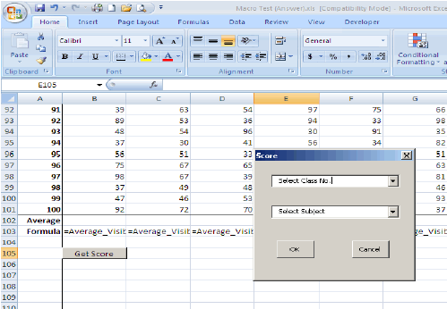

Please answer Question No. 3 by referring to Demo B
- Display students’ score of the respective subject in a Message Box as per below

Demo B
