ctensorflow don
pytorch jeff
flux johnny
abstract into and conclusion johnny
evaluation don
website jeff

Tensorflow

Preparation of Papers for GE2340 Project
(November 2023)

Author 1, Author 2, Ng Pui Chak Johnny (SID:57226313)

- Introdution

A. What is the MNIST classification?

One of the simplest works of classification is MNIST classification, a picture recognition of handwritten digits between 0 and 9. Deep learning is one type of machine learning. Hence, the MNIST classification problem is the “Hello ,World” in deep learning. The MNIST classification aims to teach the computer to recognize the handwritten digits.

B. What is the MNIST dataset?

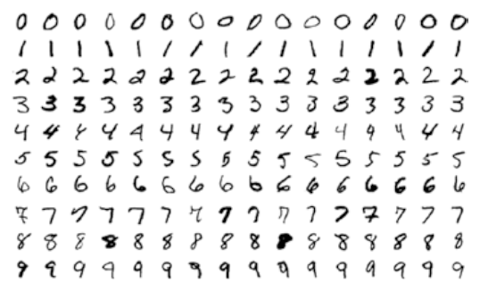
Figure 1. MNIST dataset examples

The MNIST dataset can be divided into 2 sets: training set and testing set. The training set contains 60,000 handwritten digits and the testing set contains 10,000 handwritten digits. Each digit is 28x28 pixels (represented as a matrix form) and gray color data. So the testing set is a 28x28x60,000 tensor form and the training set is a 28x28x10,000 tensor form.

- RELATED WORK & DESCRIPTION 1

About tensorflow
TensorFlow is an open-source machine learning framework developed by Google. It is designed to facilitate the development and deployment of machine learning models, particularly in deep learning applications. TensorFlow provides a comprehensive set of tools, libraries, and resources for building and training various types of neural networks.

It support functionality such as
- GPU and distributed processing
- high level API
- data visualization
- Automated differentiation
and more

Build a simple modal with Keras (the high level api of Tensorflow)
Set Up
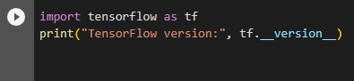
import the tensorflow packages to order to use the keras API

Load the preset dataset
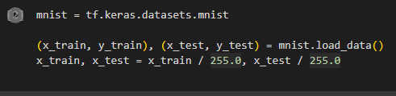
keras come with several preset dataset , one of them is MNIST dataset. A set of images of hand written numbers. The training data of the MNIST dataset are ranged from 0 to 255. Therefore we need to scale the number by divide 255

Build the machine learning model
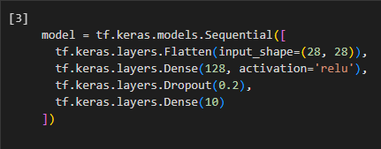

Here we build a keras Sequential model. It is a stacking layer with only one input and one output. Moreover, for most of the models in tensorflow ,they are composed of layers. Which means a model consists of different layers. This model we built used dense,dropout and flatten.
Dense layer used a activation function and compute the weight of each node with
Output = Activation(Weight * Input + Bias)
And create a fully connected layer. On the other hand, the dropout layer is a regularization method where it drops out neurons in the networks to prevent overfitting. The flatten layer simply flatten the data and does not affect the batch size.

The modal returns a vector of log-odds score for each class

training
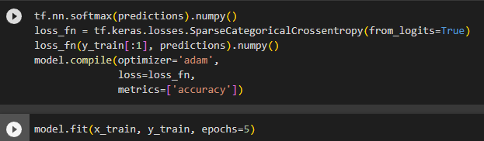
The softmax function turns the log odd score into proabilities. And we define the loss fucntion with SparseCategoricalCrossentropy.
Before actual training we need to compile the modal and set an optimizer, set the loss function to the loss function we define. The adam optimizer is a stochastic gradient descent method
Evaluation
To evaluate a model, we need to run model.evaluate. Then it will compute the functions loss and the accuracy of the modal

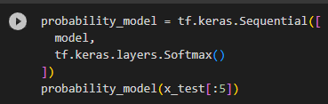
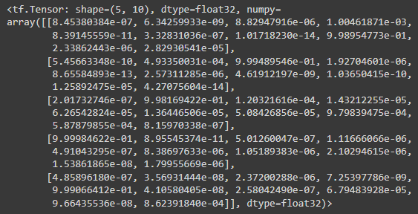
We can also turn the result into a probability matrix by applying the softmax function.

- RELATED WORK & DESCRIPTION 2

A. What is PyTorch?

PyTorch is an open-source software first developed by Meta AI in September 2017, after that it is governed by pytorch Foundation. PyTorch is mainly used in computer vision tasks and natural language processing, it is able to undergo tensor computing with GPU acceleration. PyTorch is supported by different OS such as Linux, Mac and Windows. Also the programming language supports Java and Python.

Traning

- RELATED WORK & DESCRIPTION 2

A. What is pytorch?

B.

C. Pre-processing data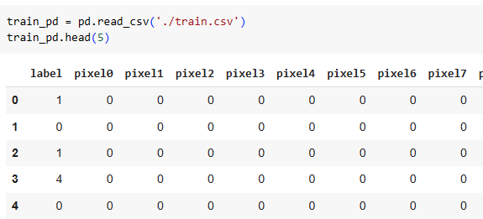

D.

E.

F. Summary

- RELATED WORK & DESCRIPTION 3

A. What is Flux.jl?
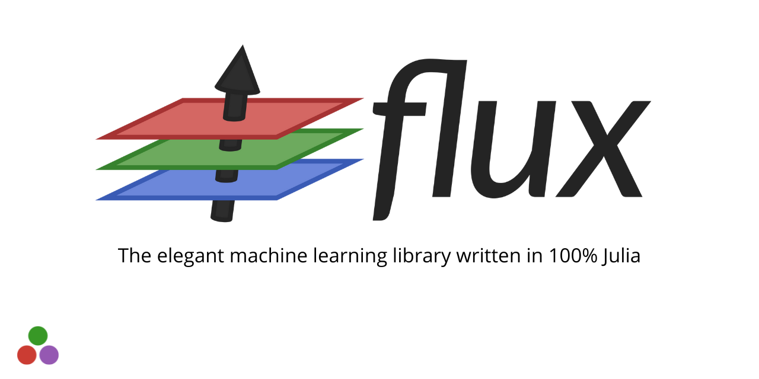

Flux.jl website
https://fluxml.ai/Flux.jl/previews/PR1613/

Since 2017, Mike Innes' team created Flux.jl which is one of the open source deep learning tools that provides functions (building blocks) for programmers to manipulate data and build artificial neural networks (ANN). The Flux.jl only supports writing in julia (programming language). The CUDA is the software system designed by NVIDIA to accelerate and improve the NVIDIA GPU performance.. The Flux.jl supports CUDA acceleration. Also, it supports multiple OS systems, including Windows, Linux and macOS. The software license is MIT license.

B. What is the Flux.jl package?

Flux.jl is a library with several deep learning toolkits to make the training process more easier. Programmers can call it in the namespace to load the Flux.jl package.

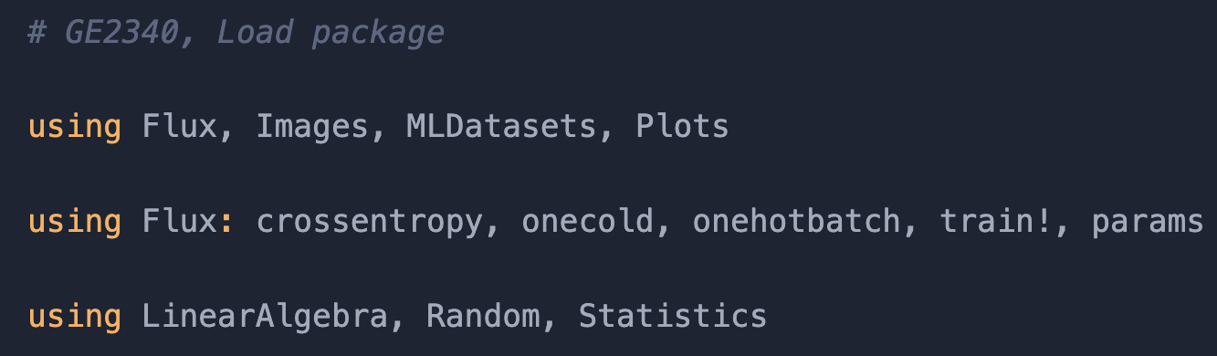
Figure. Flux.jl package

Figure. shows that in this project we are using crossemtropy(), onecold(), onehotbatch() and params() functions.

C. Pre-processing data

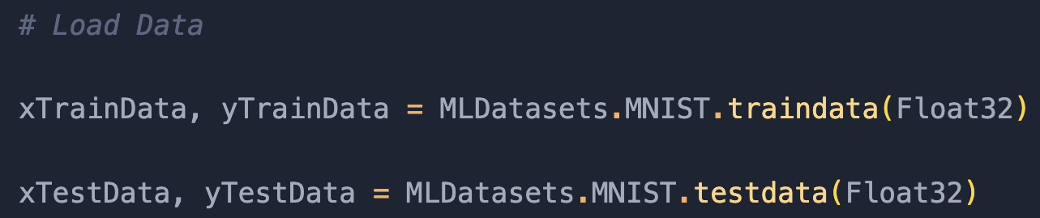
Figure. load MNIST dataset

We import the MNIST dataset which contains 60,000 training data and 10,000 testing data from the MLDatasets.

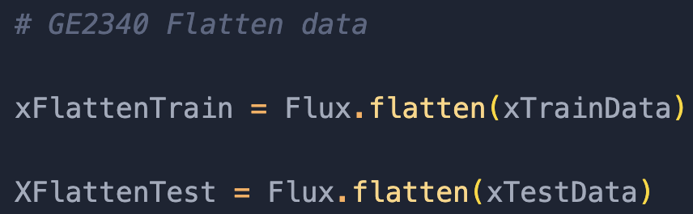
Figure. flatten() function

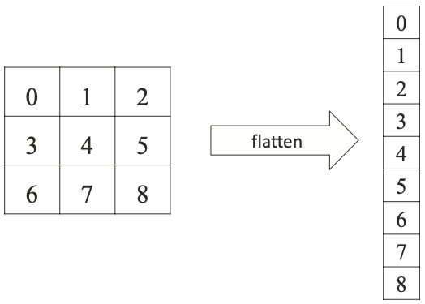
Figure. flatten concept

Since the model can only accept vectors, we use the flatten() function from the Flux.jl package to change the 28x28 matrix into a 784 column vector.

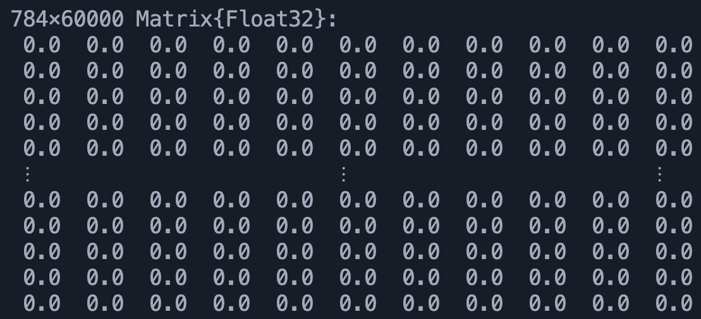
Figure. flatten training set result

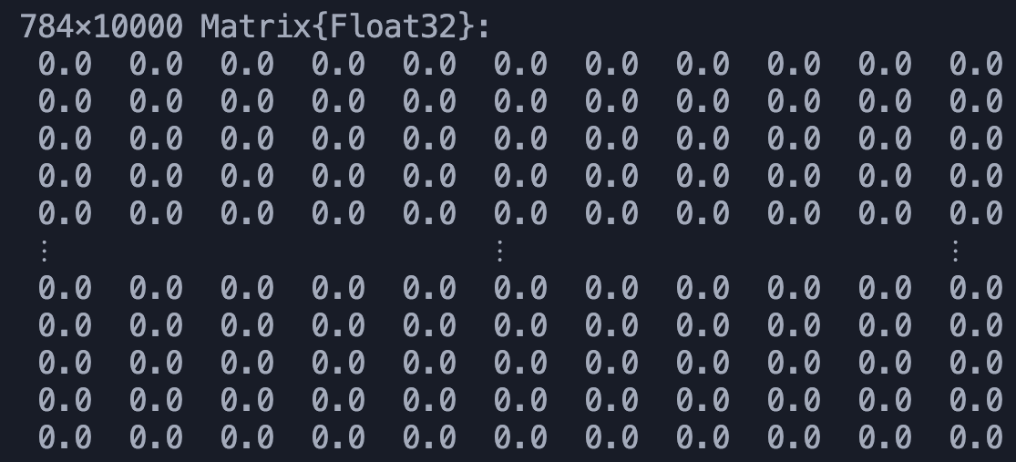
Figure. flatten testing set result

The result is the training set becomes a 784x60,000 matrix and the testing set becomes a 784x10,000 matrix.

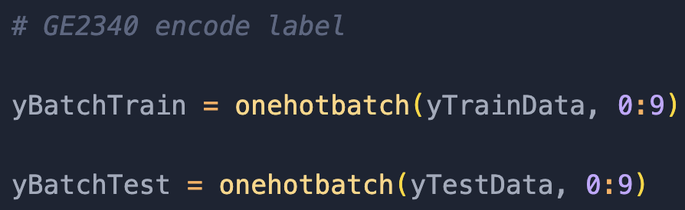
Figure. onehotbatch() function

There are 10 types of handwritten digits [0,9]. We use the onhotbatch() function to concatenate the i type elements into a 1x10 column vector, the i row is equal to 1, otherwise 0.

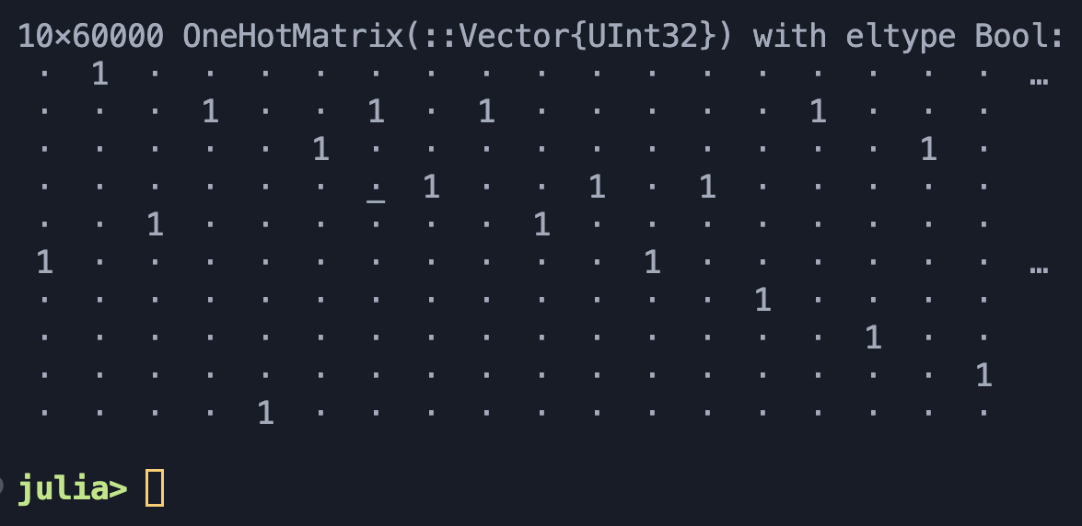
Figure. onehotbatch() function result

The result is a 10x60,000 one-hot matrix. For example the type of column vector 1x10 is 0, because the value of 1x2 =1.

C. Building Model using Flux.jl package

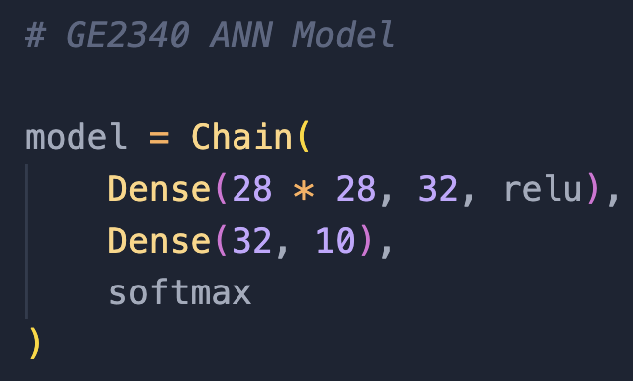
Figure. ANN model

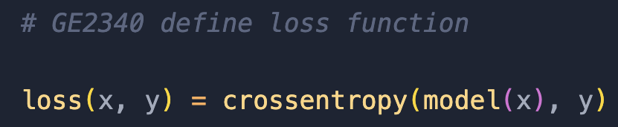
Figure. loss function (Cross Entropy)

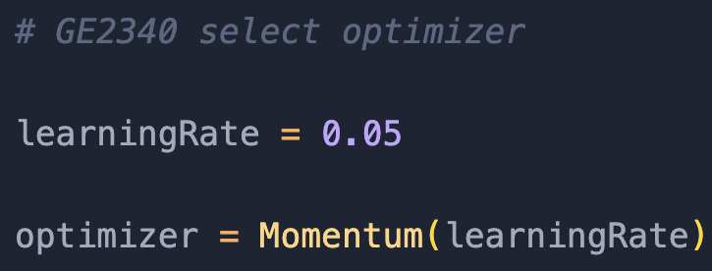
Figure. optimizer (Momentum)

The loss function of the model is cross entropy and the optimizer is the momentum. After selecting the loss function and optimizer, we have a 3 layers artificial neural network which contains 1 input layer, 1 hidden layer and 1 output layer.

D. Training

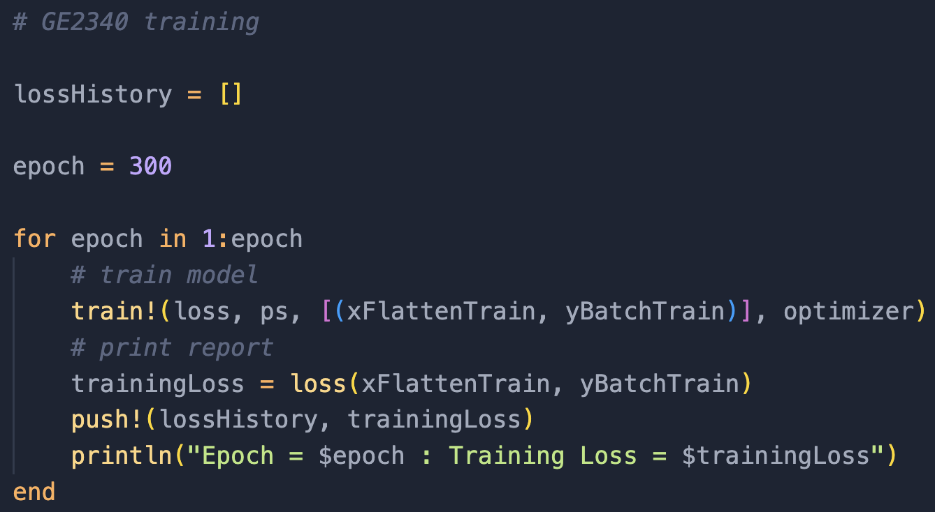
Figure. training

We use a for loop to train the model 300 times using the flatten training data that the value is between 0 and 1. When the epoch increases, the accuracy rate will increase. That is, the error between the flatten training data label and flatten testing label should be decreasing,

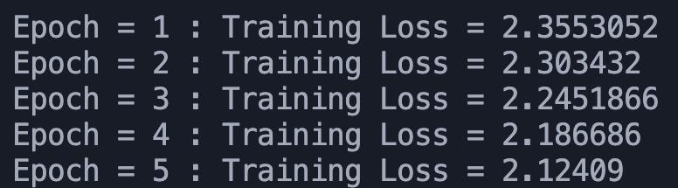
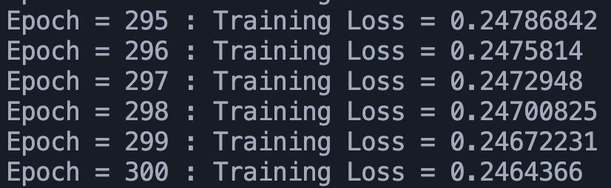
Figure. training loss result

At the beginning, the error rate was 235.53%. After the 300 times training, the error rate is 24.64%. The result is the error rate decreased 210.89%, and the parameters in the model were updated so that now the model can make a higher accuracy prediction.

E. Make prediction (accuracy score & learning curve)

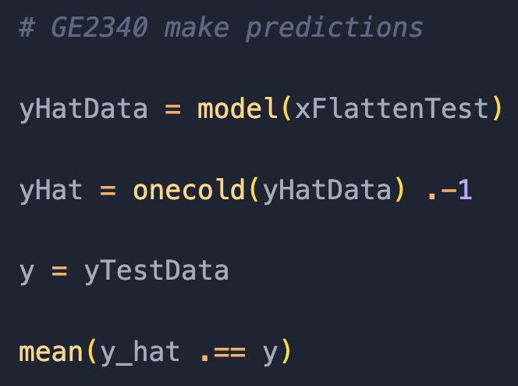
Figure. prediction

For the reduction, we use the predicted labels from the model to compare with the actual labels from the testing set. Again, the model only accepts vectors, so we use onecold() function to convert the matrix into a column vector like onehotbatch() function. The result is an accuracy score (93.22%).

F. Summary

Flux.jl provided powerful deep learning toolkits for programmers to write machine learning algorithms in julia. For example, in our experience we tried the flatten(), onehotbatch(), chain(), crossentropy(), momentum() and the onecold() function to successfully make a prediction on the handwritten digits label.

- EVALUATION

In this part, we evaluate three deep learning tools, PyTorch, TensorFlow, and Flux, and compare them regarding community, industry adoption, ease of use, and general performance. Nonetheless, we also look for the best use case of each tool based on its features.

- Ecosystem

First, all three of the tools are open source which means the ecosystem is highly relevant to the number of users since the users are the one contributing to the community. Regarding community size,Tensorflow has the most extensive user base and mature ecosystem among the three tools. Tensorflow was founded in 2015, which is the earliest of the three. Hence, it accumulates more users than the other two. Also, TensorFlow provides a wide range of tools and libraries. It attracts more developers by providing a comprehensive development platform.
On the other hand, PyTorch is the main contender with Tensorflow as researchers tend to use PyTorch(He, 2021). The figure below shows that a majority of papers are implemented in PyTorch.

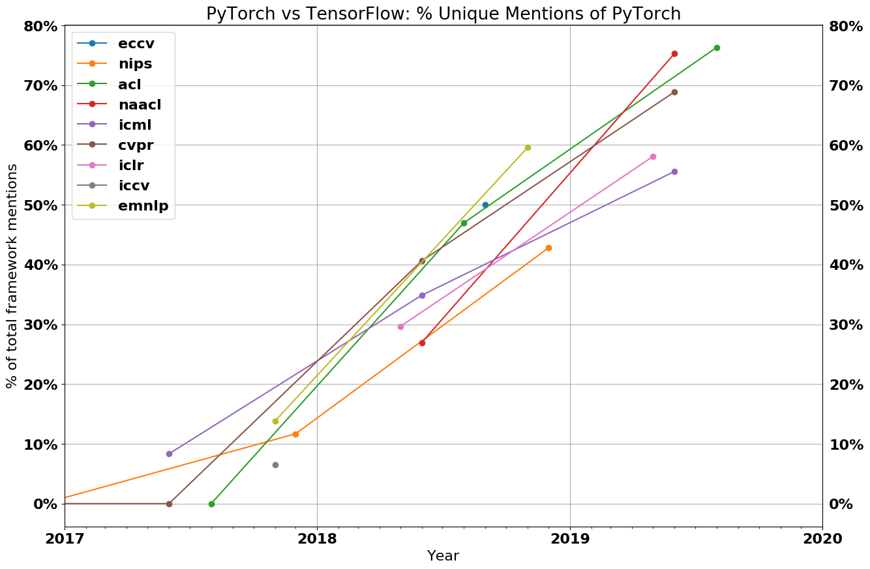

(He, 2021)
Moreover, Flux was created in 2017, which is the latest of the three, and it is designed for a programming language called Julia, in contrast to TensorFlow and PyTorch, which support multiple languages, including popular programming languages such as Python and C++. Flux has a smaller community size.

- Industry adoption

TensorFlow and PyTorch were both developed by tech giants. Google developed TensorFlow, and PyTorch was developed by Meta, formerly named Facebook. Hence, they have raised much attention in the industry since they were created. Companies favored them because they were more likely to be maintained and evolved. Moreover, TensorFlow provides an easy integration from deployment to production systems, which is essential in commercializing the Artificial Intelligence model. For example, Twitter uses Tensorflow to develop its tweet ranking system(Community, 2019). PyTorch is widely adopted in computer vision-related commercial applications due to its advantage in building machine learning models with convolutional neural networks(Novac et al., 2022).

In comparison, Flux has less industrial adoption. Flux has seen growing interest and adoption in academia and certain research domains where Julia is favored. However, there are fewer use cases of Flux in commercial applications. Also, companies are more afraid to use a new model since it usually means less support.

- Ease of use

The learning curve of using Flux depends on the user's familiarity with the Julia programming language. If the user is familiar with Julia, Flux's design and syntax are intuitive. However, Flux has less documentation and resources, which may make it more difficult for Flux's users to troubleshoot. Also, Flux emphasizes user customization and flexibility. However, these functions could be overwhelming for beginners as they require more experience in developing deep-learning projects.



On the other hand, TensorFlow developed a high-level API called Kera, which is straightforward to use. Moreover, it focuses on providing a user-friendly experience for beginners to develop deep learning projects. PyTorch also developed a user-friendly API to reduce beginners' learning curve. Nevertheless, Tensorflow and PyTorch are compatible with Python and integrated with popular libraries such as NumPy, making them accessible to many developers. Moreover, they both have a variety of documentation and official tutorials for beginners. An active and large community helps users to tackle various issues in their way of learning to use the tool.

- General performance

The performance of deep learning tools depends on their scalability, training speed, and hardware support. TensorFlow has a set of comprehensive tools for deploying large-scale machine learning models. It supports distributed computing, allowing users to train models on machine clusters. Pytorch also has features supporting distributed training, such as DistributedDataParallel(Li et al., 2020). Although PyTorch does not have the same scalability optimizations as TensorFlow, it supports integration with popular distributed frameworks that cover its lack of support on scalability.
On the other hand, Flux is designed to be scalable. Moreover, Julia, the programming language used in Flux, has built-in distributed and parallel computing features. However, Flux does not have much support for scalable solutions due to a relatively small community size. Therefore, Tensorflow is the most mature tool in terms of scalability.

The training speed of a machine learning model is a complicated topic with many variables. Here, we concentrate on the technical implementation of the tool that determines the three models' respective speeds. PyTorch facilitates automatic differentiation and effective GPU utilization. Distributed computing is another tool it can utilize to increase training speed. However, it used a dynamic model creation approach, leading to slower training rates. By contrast, Flux makes use of Julia's high-performance computing powers. The total training pace of Flux models is facilitated by Julia's just-in-time (JIT) compilation and effective mathematical operations.
On the other hand, TensorFlow is widely considered a performance-friendly tool (Dai et al., 2021). The core of TensorFlow is developed in C++, which is a strong indicator of its efficiency. It also utilizes various techniques to optimize its training speed in large-scale models. Overall, TensorFlow generally has a fast training speed.

Finally, all three models provide the functionality of hardware-specific optimizations such as Compute Unified Device Architecture(CUDA). It is vital for machine learning model training to have efficient GPU utilization performance-wise. However, TensorFlow and PyTorch have a more comprehensive range of hardware support and are also compatible with specialized accelerators like TPUs. The following table shows the performance ranking of three tools.

 | Scalability | Training speed | Hardware support
1st | TensorFlow | TensorFlow | TensorFlow
2nd | PyTorch | Flux | PyTorch
3rd | Flux | PyTorch | Flux

To conclude, TensorFlow has the best general performance of the three models.

- Optimal use cases

We conclude the optimal use cases for each model based on the previous comparison and evaluation.

TensorFlow

TensorFlow is excellent if you want to develop a commercial machine-learning application. It has the most extensive ecosystem and a high industry adoption. It provides an all-round development experience and supports a scalable solution for future improvement. It also has the best performance, which is vital in business use cases.

PyTorch

PyTorch is suitable in academic areas and great for researchers to build machine learning models since it has a smaller learning curve and a larger user community. Researchers can build their model with the smallest amount of time and resources.

Flux

Flux has a relatively small ecosystem, and compared to TensorFlow, it performs poorly. However, if the user knows Julia programming, Flux provides a user-friendly and customized experience in developing machine learning.
- CONCLUSION

In conclusion, this report used 3 deep learning tools, including tensorflow, PyTorch and Flux, to train and test the MNIST dataset.

This report also compared the 3 deep learning tools with the ecosystem, industry adoption, learning curve, general performance and the optimal use cases.

For the ecosystem, Flux has a smaller community than tensorflow and PyTorch.

For industry adoption, PyTorch and tensorflow are the major deep learning tools in the market.

For the learning curve of the deep learning tools, tensorflow has the Kera (high-level API) and PyTorch using Python (common programming language), so they are easier to use.

For the deep learning performance, PyTorch and tensor flow have hardware support such as CUDA which is supported by NVIDIA, so the deep learning result is usually faster and higher accuracy.

For the optimal case, tensorflow is a good choice for developing a commercial deep learning usage. PyTorch is commonly seen in the academic area. Flux can help users to customize deep learning.

Overall, tensorflow and PyTorch are the two popular deep learning tools in the machine learning area, because they have a larger community and better hardware support. If the user wants a customized deep learning experience, Flux would be a good choice.

REFERENCE

[1] Community, google. (2019). Ranking tweets with tensorflow. The TensorFlow Blog. https://blog.tensorflow.org/2019/03/ranking-tweets-with-tensorflow.html
[2] Dai, H., Peng, X., Shi, X., He, L., Xiong, Q., & Jin, H. (2021). Reveal training performance mystery between tensorflow and Pytorch in the single GPU environment. Science China Information Sciences, 65(1). https://doi.org/10.1007/s11432-020-3182-1
[3] He, H. (2021, December 5). The state of Machine Learning Frameworks in 2019. The Gradient. https://thegradient.pub/state-of-ml-frameworks-2019-pytorch-dominates-research-tensorflow-dominates-industry/
[4] Li, S., Zhao, Y., Varma, R., Salpekar, O., Noordhuis, P., Li, T., Paszke, A., Smith, J., Vaughan, B., Damania, P., & Chintala, S. (2020, June 28). Pytorch distributed: Experiences on accelerating data parallel training. arXiv.org. https://arxiv.org/abs/2006.15704
[5] Long, L., & Zeng, X. (2022). Beginning deep learning with TensorFlow : work with Keras, MNIST data sets, and advanced neural networks. Apress L. P. https://doi.org/10.1007/978-1-4842-7915-1

CONTRIBUTION LIST

 |  |  | 57226313
Introduction |  |  | X
Related Work1
Related Work2
Related Work3 |  |  | X
Evaluation
Conclusion |  |  | X
Website
Signature |  |  | Johnny

