Report:

Table of Contents
Purpose / Goals: 2
Assumption / Requirement: 2
Procedure / Terminology: 2
How to use: 3
Landing screen / Startup screen 3
1. User want to encrypt file: 4
2. User want to decrypt file? 5
3. How about the message is not long enough? 6
Background: 6
Data types / variable declaration and initialization 7
INTEGER: 7
STRING AND ARRAYS: 7
Terminology 8
Background: 8
Implementation: 9
- End - 18

Purpose / Goals:

Implement a “Shift Cipher Decrypter” using Python. User can decrypt a long enough (more than 200 words) message which was originally “shift cipher encrypted”. A bruce-forcing of k were also implemented and applied when the decrypted message is not readable.

For demonstration purpose, the remaining half "encryption" was also implemented. (which is the reverse process of decryption)

Assumption / Requirement:

Assuming a use case, for which message to be encrypted:
- Only contains upper case letters, space characters, punctuation marks
- Space characters remain unchanged during the encryption.
- punctuation marks remain unchanged during the encryption.
- message is longer than 200 words, alphabet distribution follows the general pattern

Procedure / Terminology:

Given that the encrypted message is long enough. A “shift cipher decrypter” can guess the message without knowing k (the original k). The letter that have the most frequent in the original message will be “E” which is also reflected in the “encryped” message as letter shifting of the whole message(`encrypted`) are the same.

How to use:

Landing screen / Startup screen

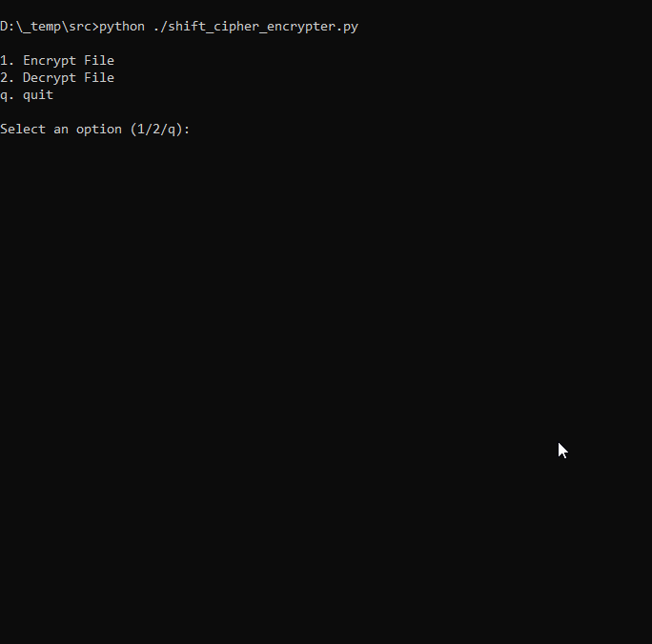
Start up screen

User want to encrypt file:

To encrypt file:
- select 1 to encrypt file
- select a k

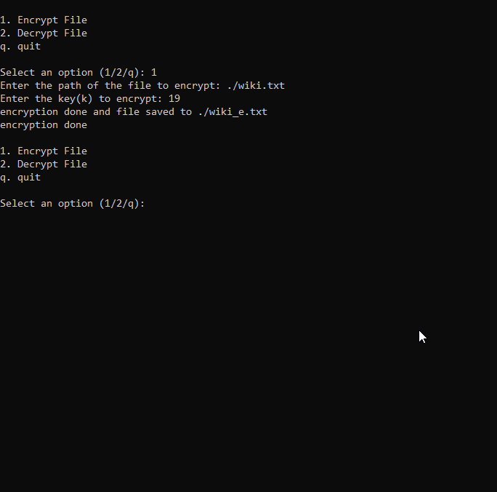
User encrypt file

2. User want to decrypt file?

To decrypt file:
- Press “2”
- Input the file want to decrypt

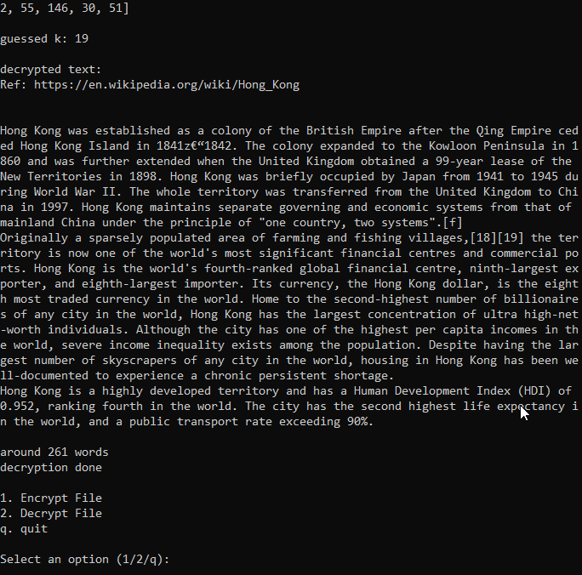
User decrypt file

3. How about the message is not long enough?

Background:

If the message is not long enough, the above terminology collapse. As such, using the same terminology cannot guess the k as the same with the message as shown in (2)

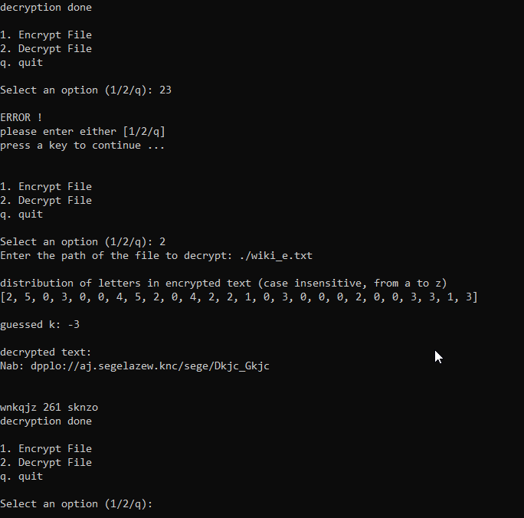
The decrypt message seems scrambled with incorrect k

Data types / variable declaration and initialization

INTEGER:

i.e.
…
ORD_a = ord('a') # 97
…

`ORD_a` is a variable storing `97` in integer format

STRING AND ARRAYS:

…
with open(file_path,'r') as fi:
# beginning of the process
# read file and join the lines all
lines = fi.readlines()
e_temp = ''.join(lines)
…

At here:
- `lines` is an array of string.
- `e_temp` is a single lined string.

Terminology

Letter occurrence:

Background:

The decryption algorithm implemented was k guessing (guessing the k with encrypted message long enough).

Letter E is counted to have the most occurrence in daily English. As the process of shift cipher encryption by whoever user is shifting letter by k (a unknown integer) times. Assuming the k used for the whole message are the same (or even in a regular pattern that already known). The letter occurrence will be reflected in the encrypted message (i.e. `E` -> k's shift -> `M` for this case) as well. That's why k can be guessed by counting the most occurrence letter and assuming that is the letter E in the original message.

Bruce-force:

Background:

While sometimes the letter occurrence may not work (i.e. word "apple" / "people") for irrational message (i.e. repeating of apple/people throughout whole message). Bruce forcing of k come in place.

The mechanism of shift cipher encryption restricts the key used (k) must be fallen into range in between 0 to 25 (as k was defined as the remainder of "some number" divided by 26). The bruce forcing will guarantee the worst chance to have the message decrypted by 26 try.

The mechanism of bruce forcing is simple. It will keep trying decrypt the message using k from 0 to 25 and perform dictionary lookup after each try. If the message decrypted matches one found in dictionary. The k tried will be considered as good one and terminate the try sequence. Otherwise, it will keep try with increasing k by 1 until 26 tries were made.

Constrains:

While each of them was the decryption of "shift cipher encryption". They both have constrains.

Letter occurrence/population:
As the mechanism relies on the accounting occurrence of letters in the message. Therefore, sometimes the mechanism won't work when some irrational message passed as an input.

Bruce forcing of k:
This mechanism relies on the calculation power of machine relatively as:
- more k (i.e. 25), more try,
- more words (i.e. words more than 250 in the message), more try

Therefore, the performance of this mechanism is lower compared to the letter population. However, this one may help decrypt those messages which failed by letter occurrence.

Implementation:

1. encryption (shift_cipher_encrypt)

def shift_cipher_encrypt(plaintext, key):
# apply encryption to text with given key

encrypted_message = ''

for char in plaintext:
if char.isalpha():
# change every character to upper case before enter to the loop to
# compare. (requirement)
char = char.upper()
# Determine ASCII offset based on uppercase or lowercase letter
ascii_offset = ORD_A

# the comment shown below are the pseudo code, it demonstrate the ideas only
# let say the input is 'the' // without quote
# find distance of target character with reference to A or a
# i.e. t - a = 19 , h - a = 7 , e - a = 4
distance = ord(char) - ascii_offset

# [19,7,4] + [8,8,8] (key) = [27, 15, 12]
# Shift the character by adding the key and taking modulo 26 to wrap around
# [27,15,12] % [26,26,26] = [1,15,12] // get modules
shifted_distance = (distance + key) % 26

# [1,15,12] + [97,97,97] = [98,112,109]
# chr(98) , chr(112) , chr(109) = 'bpm'
shifted_char = chr(shifted_distance + ascii_offset)

# so: the -> bpm
encrypted_message += shifted_char

else:
# consider integer case, retain
encrypted_message += char

return encrypted_message

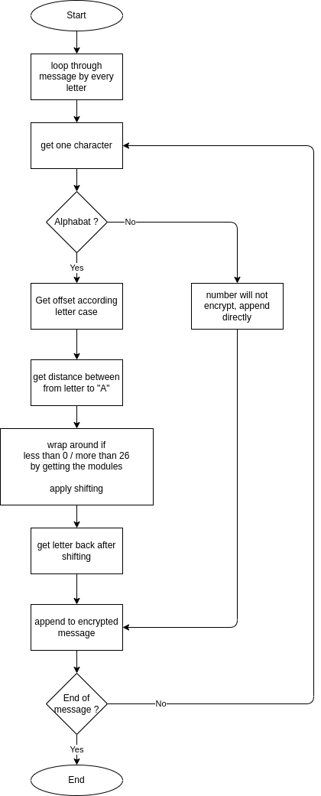
Diagram of shift_cipher_encrypt

2. encrypt file

def encrypt_file(file_path, key=8):
# open a file and apply encryption
output_file = file_path.replace('.txt','_e.txt')

# convert it to integer
key = int(key)

# open source file (plaintext)
with open(file_path,'r') as fi:
temp = ''.join(fi.readlines())

# open target file (encrypted text)
with open(output_file,'r+') as fo:
fo.truncate(0)
fo.writelines([shift_cipher_encrypt(temp, key)])

print(f'encryption done and file saved to {output_file}')
return

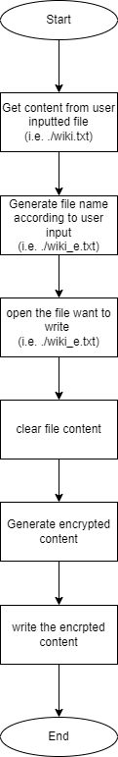
Diagram of encrypt file

3. Decryption

3.1 (Decrypt by letter occurrence)

def decrypt_by_letter_occurrence(enc_text, dictionary):
# 1. get the occurrence/population of letter from whole encrypted message
# 2. find the max occurrence
# 3. find the distance between max letter and letter "E" (denoted: "guessed k")
# 4. try decrypt using "guessed k"
# 5. lookup in dictionary (check_words_valid) and check if the decrypted valid.

print('decrypted by guessed k')
characters_population = count_most_occurrence_letter(enc_text)

print('')
print('population of letters in encrypted text (case insensitive, from a to z)')
print([chr(65 + i) for i in range(0, 26)])
print(['{:0>1}'.format(i) for i in characters_population])

print('')
guess_k = find_max_occurrence(characters_population)
print(f'try decrypt using guess_k -> guessed k: {guess_k}')

decrypted_text = shift_cipher_decrypt(enc_text, guess_k)
list_texts = decrypted_text.split(' ')
check_result_using_guess_k = check_words_valid(list_texts, dictionary, 0.8)

return [check_result_using_guess_k, decrypted_text]

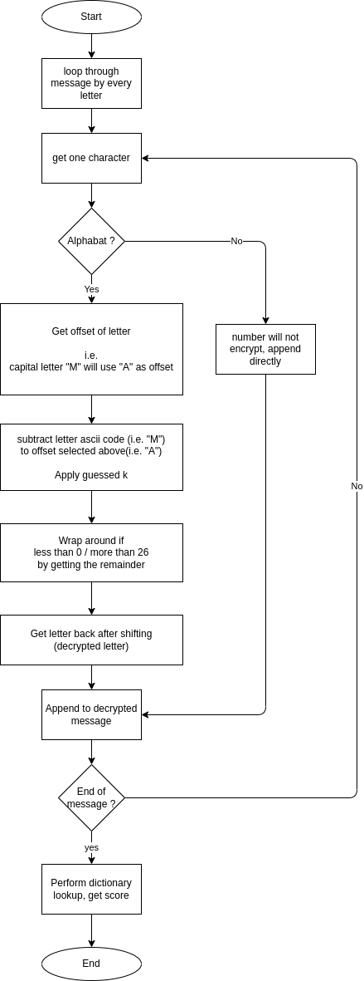
Diagram of decryption by letter occurrence

3.2 Decrypt by bruce forcing

def decrypt_by_bruce_force(encrypted_text, dictionary):
# 1. get the occurrence/population of letter from whole encrypted message
# 2. find the candidates of k (filter all zero answer in step 1)

# 3. find the distance between max letter and letter "E" -> "guessed k"
# 4. try decrypt using this "guessed k"
# 5. lookup in dictionary (check_words_valid) and check if the decrypted valid.

print()
print('try decrypt by bruce forcing k ...')
# will open an encrypted file and decrypt it by a guessed key
dictionary_match_found = False
characters_population = count_most_occurrence_letter(encrypted_text)

guess_k = bruce_force_k(characters_population, encrypted_text, dictionary)
# guess_k == -1 means the decrypted message failed in dictionary lookup,
# send the result directly
if (guess_k == -999):
return [False, '']

decrypted_text = shift_cipher_decrypt(encrypted_text, guess_k)
check_result_using_guess_k = check_words_valid(decrypted_text, dictionary, 0.8)

return [check_result_using_guess_k, decrypted_text]

s

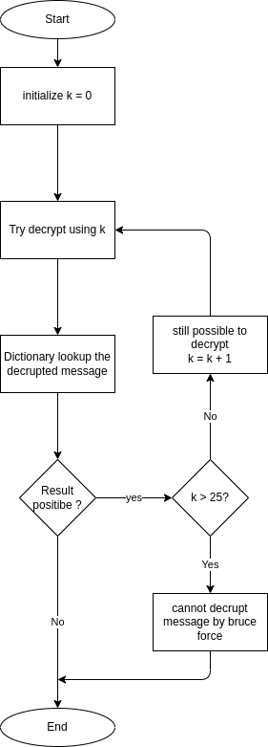
Diagram of bruce forcing

4. Flow of the whole program:

while True:
# show menu
print()
print("1. Encrypt File")
print("2. Decrypt File")
print("q. quit")
print()
option = input("Select an option (1/2/q): ")

if option == "1":
# run if user want to encrypt file
# check if user entered a file
user_not_enter_file = True
while user_not_enter_file:
file_path = input("Enter the path of the file to encrypt: ")
if len(file_path) > 0:
if os.path.exists(file_path):
user_not_enter_file = False
else:
print('sorry but the file not exist')
else:
print('please enter a file path')

# check if user entered a key
user_not_enter_key = True
while user_not_enter_key:
key = input("Enter the key(k) to encrypt: ")
if (len(key) > 0):
user_not_enter_key = False
else:
print('please enter a key(k)')

if os.path.exists(file_path):
encrypt_file(file_path, key)
print('encryption done')
else:
print("File does not exist.")

elif option == "2":
# run if user want to decrypt file
file_path = input("Enter the path of the file to decrypt: ")
if os.path.exists(file_path):
decrypt_file(file_path, load_dictionary())
print('decryption done')
else:
print("File does not exist.")

elif option.lower() == "q":
print('quitting bye ...')
break
else:
print('')
print('ERROR !')
print('please enter either [1/2/q]')
input("press a key to continue ...")
print('')

print("Exiting…")

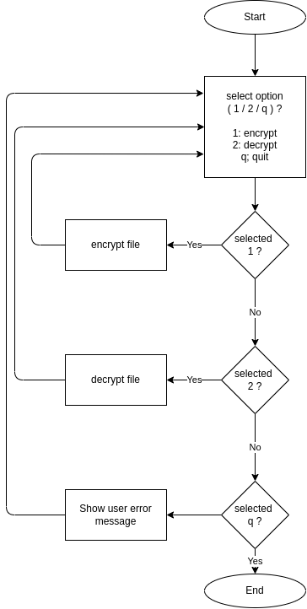
Diagram of whole system

- End -

