2023 Lancaster University
CSS 201 Lab Week 1

Instructions:
This week you will gain hands-on experience with reading/writing Entity-Relationship diagrams (ER diagrams for short).

There are some examples for you to read and reinforce your learning. These are followed by exercises you need to solve. You are free to discuss your answers with your classmates.
TASK 1: Getting familiar with draw.io.(The expected time of work is 20 mins)
Follow the steps:
- Write Draw.io in the search bar and then press enter.

- Click on the Entity Relationship Diagram button and then press Create.
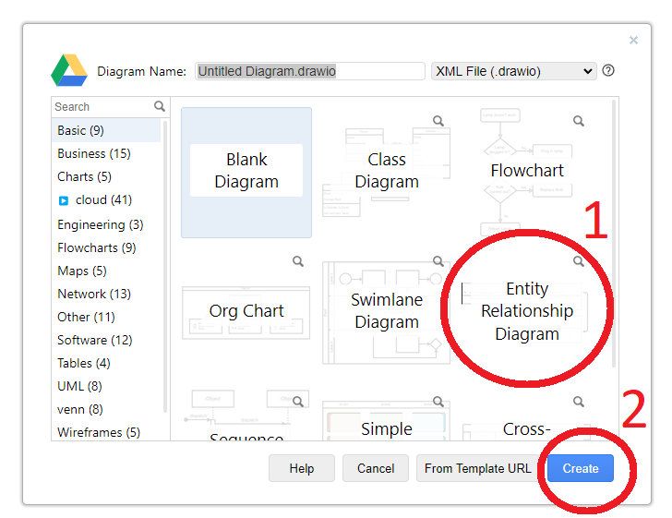
- Use the root folder or create a new folder.

- You will see a page like the following.
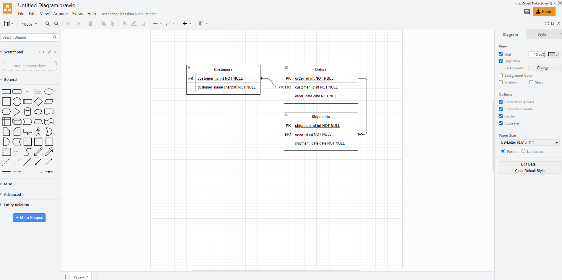
- Press CTRL + A and then press Delete. This will clear the screen for you (or create a new page.).
- Click the Entity Relation tab to see the built-in images.


- Familiarise yourself by drawing the below ER diagrams
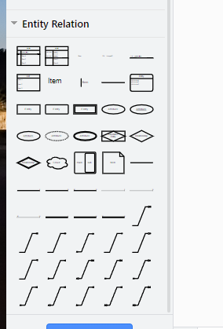

Expression 1: “A customer has a name, SSN, Account No, balance.”
Explanation:
The account number is selected as a primary key for a customer to keep more than one account.
The ER diagram:

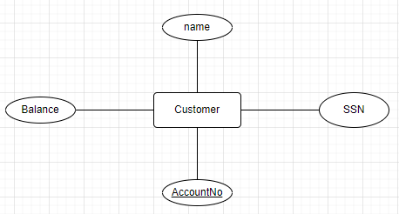

Expression 2: “A fish has weight (in KG.), and price per gram value, its type”
Explanation:
The type is selected as a primary key to identify the fish type. Please note that not having a primary key for this entity set is okay. Moreover, you can also introduce a derived attribute (price).
The ER diagram:

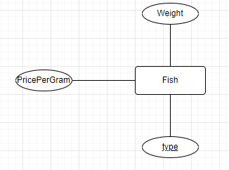
Expression 3: “There are football teams and players. Each football player has a name, surname, age, and role. You may assume that football players have distinct name-surname combinations. Teams have names, coaches, and sponsors. Names of the teams are unique.“
Explanation:
The name and surname of the player are the primary key (composite keys), as suggested by the text.
The attributes of coaches and sponsors are multivalued, so drawn using double-lined ellipses.

The ER diagram:

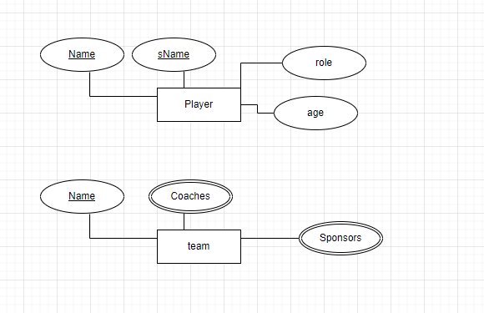

Expression 4: “Car has colours”
Explanation:
This defines an entity called Car, which has an attribute called colours. Clearly, this is a multivalued attribute, as a car may be associated with several colours during its lifetime.
The ER diagram:

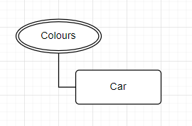

Expression 5: “A computer game has Name, Year, System Reqs, Pictures, Developers, Programming Language, Owner ID”
Explanation:
This defines an entity called Computer Game, which has an attribute called Name, Year (probably the year of publication), Systems Reqs., Pictures, Developers, Programming Language, and Owner ID. System Reqs., Pictures, and Developers are multi-valued attributes. Since this is a computer game, the Name is a key for this Entity set. It is also OK to have Owner ID as a multivalued attribute as many owners may own a game.
The ER diagram:
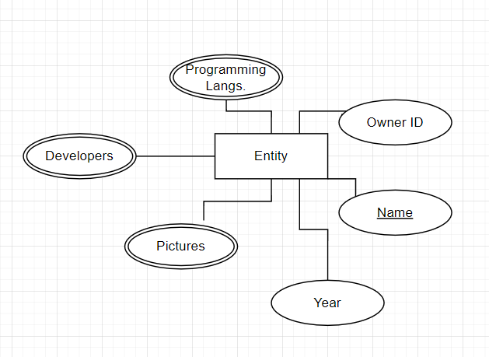

ER Diagram to text

For the following ER diagrams, write their English explanations.

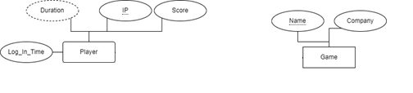
The player has a unique IP address, score, and log_in_time. The duration of the play can be derived and represented as a derived attribute, “Duration”.
A game has a unique name (the primary key) and company attribute.
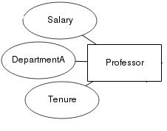
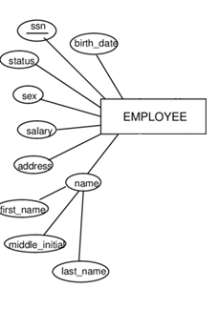
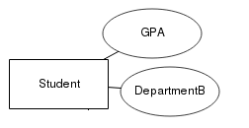
Professor has a salary, Tenure, and DepartmentA values. No primary key has been given.

A student has a GPA and DepartmentB values, but a primary key has not been given.

Employee has a unique SSN value (the primary key), and several attributes. The attribute “name” has three parts, first_name, middle_name, and last_name.

