ER and attributes for combat

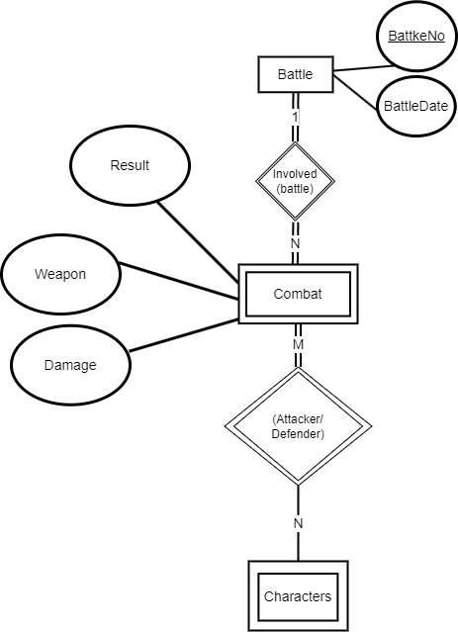
ER diagram of combat and battle

Entity
A Battle has a Battle Number (the primary key) and Date(BattleDate) attribute.
A Combat has a Damage, Weapon and a Result attribute.

Relationship: Involved (battle)
A combat must have battle involved.
A battle will contain at least one combat.

Relationship: Involved (Attacker / Defender)
A combat must have at least 1 characters involved.
A Characters may contain many combat history

ER and attributes for characters

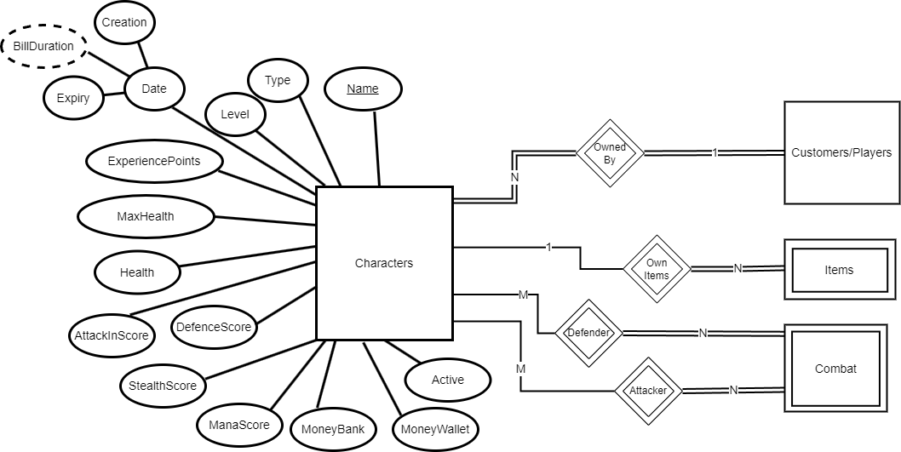
ER diagram of characters

Entity
A Characters has a Name(key)​, Type, Level, ExperiencePoints, MaxHealth, Health, AttackInScore, DefenceScore, StealthScore, ManaScore, MoneyBank MoneyWallet attribute.

The field Creation ,Expiry and the existence of the character will help to get bill for the player. BillDuration will help get the character for billing period.
Newly added field Active will store the state (activated/deactivated) of character.

Relationship: OwnedBy
A character must owned by one player
A player may have many characters

Relationship: OwnItems
An Items must owned by one character
A character may have many Items
If a character is deleted from the game server, the items will be deleted

Relationship: Attacker and Defender
A Combat (either attacker/defender) must owned by one character
A character may involved in many combats

If a character is deleted from the game server, the combat will be deleted

ER and attributes for customers/players

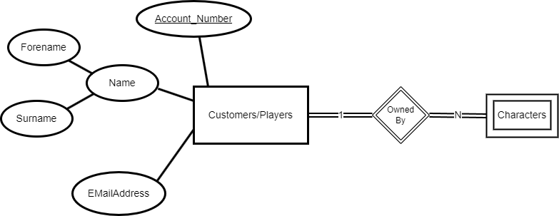
ER diagram of Customers/Players

Entity set
A customers has a AccountNumber(key)​, Name and EMailAddress attribute.

Name is a Multi-valued attribute containing Forename and Surname.

Relationship Owned By
A Characters must owned by one character
A customers/player may have many character
If a customer/player is deleted from the game server, the characters will be deleted

ER and attributes for items/inventory

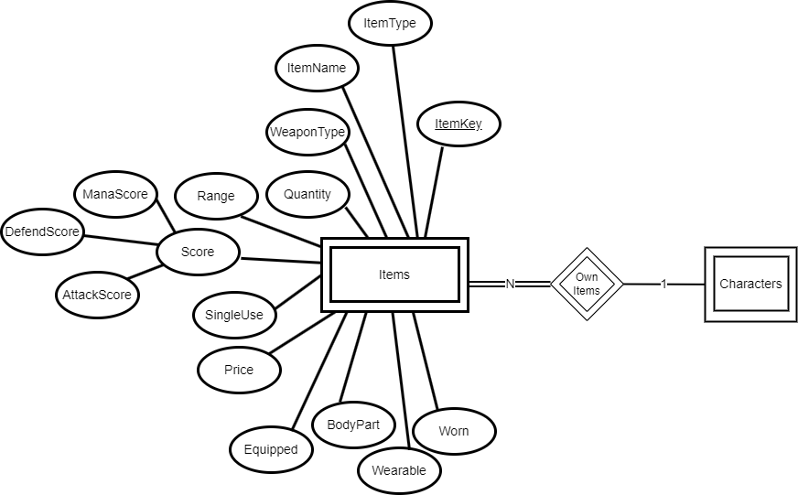
ER diagram of Items

Entity set
A Items has a ItemName, ItemType, WeaponType, Quantity, Range, SingleUse, Price, Equipped, BodyPart, Wearable, Worn attribute

A Score is a Multi-valued attribute containing ManaScore, DefendScore and AttackScore.

A ItemKey is an key to indicate the specific item

The field BodyPart, Worn, Wearable and Equipped will help handle the state of the items:
- If the items is equipped.
- If the items is target to the body part (e.g. arms, legs, body…)
- If the items is wearable.
- If the items is worn.

Relationship OwnedItems
A Items must owned by one character
A character may have many items
If a character is deleted from the game server, the Items will be deleted
This relation will help to manage the inventories owned by characters

