Analysis of 3D scanners on Additive Manufacturing and its application for Aircraft Maintenance Repair and Overhaul
Final Year Project
[Interim Report]

Student Name: Pun Jazz
Student Number: 200296381
Supervised by: Dr Frank Tat Yuen

Technological and Higher Education Institute of Hong Kong
Faculty of Science and Technology
Aircraft Engineering Programme
[AY 2023/24]


Table of Contents

- Project Title....................................................................................1
- Abstract and Introduction...............................................................3
- Literature Review...........................................................................6
- Objectives.......................................................................................7
- Methodology...................................................................................8
- Plan for the project........................................................................21
- Reference......................................................................................22

[Abstract. The rising innovation of 3D printing and scanning technology has transformed Aircraft Maintenance and Overhaul (MRO) in numerous ways. Yet to be complete!]

1 Introduction

Additive Manufacturing

To meet the demands of rapid prototyping and various structural production, Charles Hull invented three-dimensional (3D) printing, which is also known as Additive Manufacturing in 1986. A 3D physical object or component could be created using 3D printing technology through the 3D CAD model with precision [1,2]. Agility, rapid design, and manufacturing of mass goods are characteristics of this technology that suit customers' demands. High production rate of complex products with design flexibility, predictable time schedules and recyclability are other key features of this technology [3]. An additive manufacturing is a method of producing models though layering materials to meet the requirements of quality control with the aid of automation by sensor mechanism, which allows for fault identification and transfer in the manufacturing process [4].

1.2 3-D Scanners

Digital 3D scanning is a modern calibration technology that can digitally rebuild the landscape of surfaces with high precision and accuracy. It can ensure high-quality goods through computerized monitoring and management, thus converting traditional manufacturing processes to an intelligent integrated manufacturing approach [5].
Therefore, by supplying 3D coordinate to cloud data to assess structural and volumetric through sets of sensors, 3D surface geography data of component can be obtained and overthrow conventional direct measurements [6-8]. The 3D topography data consists of crucial quality information, including dimensions, surface texture, dents, alterations, and other faults [9].
But, as it utilizes automation, the process consists of remote procedural controls and surveillance is restricted. Therefore, the problems that will occur are primarily due to the limited structural resolution and poor scan rate of current three-dimensional technology growth [10,11].
Numerous aircraft companies demand reduced prices, high production rate, production of complex component capabilities and efficient control on scanners and 3D printers [5,12]. As technology advances, 3D scanners and printers are certain to develop certain characteristics and improvements especially in scan and printing rate, resolution, and production of precise models.

Reverse engineering is essential for developing new components that incorporate older designs that are unobtainable through the original CAD design. Reverse-engineering techniques can combine complex surfaces from current objects into 3D-printed jigs, which are effective in mass-modifying manufactured and handcrafted goods. The size of an attribute in solid CAD could change while the entire model is updated to reflect the change [13].

1.3 Maintenance Repair and Overhaul

Maintenance, repair, and overhaul (MRO) often refers to the daily maintenance operation activities performed in a company; it is essential for all personnels to follow the guidelines and procedures carefully when performing overhaul.
Aircraft critical devices must go through the MRO process at predetermined intervals for continuous use, thus tighter periods for overhaul activities. Regardless, to maintain the safety of personnel and operations of the aircraft, MRO must be strictly regulated and applied in the aviation sector.
Due to the importance of MRO in the aviation industry, it is the root of the second highest pricing element for airlines to pay for. Airlines must maintain quality and safety regulations while cutting MRO costs to exceed other competitors in aviation. However, this limits worker’s availability due to heavy reliance on human labor and overhaul capacity to perform MRO activities [14].
So, to overcome the issues in MRO, 3D scanners are a viable solution. 3D scanners consist of high accuracy and feature rapid and efficient measurements which can assist in quick reporting and damage assessments. Meanwhile, the traditional approach to defects in the structural repair manual (SRM), in which length, width, and depth are the sole measurements. Moreover, the current approach is comparable to describing an issue in the same way that a 'box' is, discards all details regarding the exact shape. Resulting in a considerable scale of uncertainty, with various forms (and associated fatigue life) classified as the same when compared to the excellent precision of 3D scanners, the effort of acquiring a large amount of information is negated [15].
This study aims to investigate the effects of 3D scanners and digital manufacturing on MRO. Specifically, to provide the functions, types and feasibility of 3D scanners and printers, along with their limitations and capabilities regarding challenges a company would encounter with comparison to the traditional repair methods.

2 Literature review

This literature review investigates recent studies and academic articles on how 3D scanners and additive manufacturing can be used in aircraft maintenance, repair, and overhaul (MRO).
A thorough grasp of knowledge and information is required to be studied on 3D scanners and printers to recognize advantages, difficulties, and limitations to administer this advanced technology in real time aviation overhaul processes.
An important subject that occurs when discussing modern technologies in the aircraft maintenance, repair, and overhaul (MRO) would be the possible advantages and benefits these technologies provide. Several studies have demonstrated the improved accuracy, precision, and capabilities to provide precise measurements and examination of aircraft components.
For example, 3D scanning technology gave more accurate and consistent measurements over the traditional measurements being performed currently with depth gauges and rulers. The 3D scanning technology provided 95% accuracy while only requiring 25-33% of inspection time [16].
Moreover, efficient repairs and maintenance would be provided by the aid of 3D scanners. Another case study has noticed that 3D scanners could provide accurate cloud coordinates to identify complex shaped objects, allowing this technology to capture detailed free-form images of an object being inspected on [17-19].
3D scanners for aircraft inspection follow along numerous benefits, but its issues are highlighted with fixes being required. For example, a major problem that may prove difficult to release current technology would be the certifications and regulations that this technology would have to overcome before proceeding. An example of a regulation process and obligation would be airworthiness, it comprises of all technical and non-technical tasks necessary for design safety, certification, maintenance, and operation of an aircraft over its lifespan [20]. Challenges and delays could be met when facing standard and guidelines for 3D scanners in MRO operations.
Overall, this literature review has shown that 3D scanners provide high efficiency and accuracy in aircraft component inspection on defects such as wear, damage, and defective issues. On the other hand, to effectively apply this technology in the aviation industry, regulations and guidelines must be strictly met and adhered to.
In addition to emphasizing the possible advantages and challenges associated with the use of 3D scanners in aircraft maintenance and repair, the purpose of this study of the literature is to gain an understanding of the present state of knowledge.

3 Objective
The objective of this project is to figure out several types, capabilities and features of 3D scanning and printing technology to aid the overhaul process in aircraft maintenance, repair, and overhaul (MRO). The following states the aim of this project.
1. Differentiate the distinct types of 3D scanners and additive manufacturing
Investigate the several types of 3D scanners and printers suitable for MRO in terms of efficiency, cost, trend and potential and figure out challenges and issues that could arise during the MRO process.
2. Comparison of traditional scan and repair and current technology
Investigate the difference and provide benefits of using 3D scanners and printers over visual inspection, rulers, and gauges to observe damage, give factors including time efficiency, performance, and accuracy.
3. Integrations of 3D scanners to additive manufacturing
Figure out how a scanner could be incorporated to additive manufacturing and work with data transfer to create accurate rapid prototypes for specific aircraft parts. Aim to replace defective aircraft components using the prototypes created using additive manufacturing, to increase efficiency in the MRO process.
4. Recommendations and guidelines for modern technologies
Suggest ideas on implementing 3D scanners and printers in MRO industry and identify issues and future research directions on adopting these technologies. When these ideas are adopted, they must go through multiple guidelines before being implemented in the industry for daily tasks.
These objectives aim to build a foundation on the body of this literature around the use of 3D scanners and additive manufacturing in aviation MRO, with the characteristics of increasing efficiency, accuracy and reliability while lowering cost and time for repair procedures.

4 Methodology

This research paper’s objective is to investigate the use of 3D scanners and additive manufacturing for aircraft maintenance, repair, and overhaul (MRO). The following paragraphs represent the various methods to gather data and relevant information for this research paper.

4.1 Research Design and Approach

Quantitative and qualitative methods will be implemented to analyze the effectiveness of using scanners and printers for MRO. The quantitative analysis will be used as a comparison between traditional repair methods and 3D scanners to assess accuracy and efficiency, statistics will be employed to provide differences between the two approaches. The qualitative method will consist of interviews to dive into participants’ experiences, perspectives and issues or challenges related to scanners and additive manufacturing in MRO. By integration of the two methods, this mixed approach will provide the benefits, limitations and challenges for the scanners and printers in the process of applicability of the technology in MRO for daily use.

4.1.1 Quantitative analysis: Visual inspection

Even to this day, visual inspection by airport ground crew is still the most widely used approach for aircraft skin inspection [21].

Table 1 provides a breakdown regarding the study's layout, research sample, study population, demographics, and technical comparative partner, which will be discussed further below.
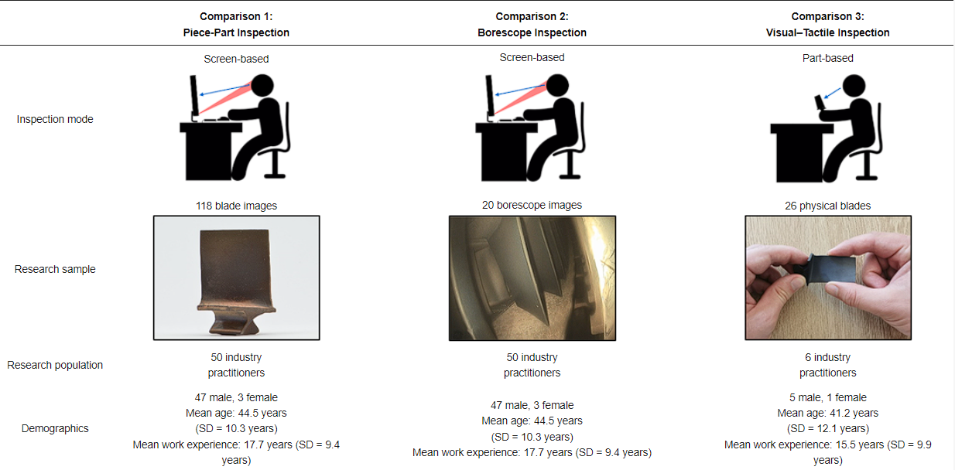
Table 1. Overview of research design on visual inspection
A screen-based examination, full vision inspection and visual-tactile inspection methods were done in this research. In the first trial, the participants were shown photographs; in the second, they were shown the actual blade; and in the third, they were given the blade. The inspection results were documented, subjected to statistical and semi-qualitative analysis, and then compared with one another [22].

4.1.2 Quantitative analysis: 3-D scanners
There are several approaches available for digitally capturing the shape of a 3D object. A well-established categorization splits them into two distinct categories: contact and non-contact 3D scanners [23].
Contact Scanners:
A probe is frequently seen at the end of an articulated mechanical arm in 3D contact scanners calibrated to function on a stationary platform. Across the surface of the part, the arm can be moved manually or by robot. By measuring the armature's position as its tip contacts object's surface, the scanner captures the probe's X, Y, and Z positions. A 3D mesh can be computed using the point cloud formed by the recorded coordinates. The manufacturing sector frequently uses a type of extremely precise 3D scanner known as a Coordinate Measuring Machine (CMM) to examine components for early signs of assembly issues.
Non-Contact 3D scanners:
Non-contact 3D scanners do not have physical contact with the component being scanned on, as it scans an object using active or passive approaches. An extremely precise cloud of points is produced which can be utilized for rapid prototyping, reverse engineering, engineering analysis, virtual assembly, features, and surface inspection [24].
For examining objects or surroundings, active scanners generate radiation or light and detect reflections. Streams of light, ultrasound, and x-ray are among the types used [23]. Time of flight, phase shift, and laser triangulation are the three primary categories into which 3D laser scanners adhere. While each of these laser-scanning methods is normally applied separately, they can also be combined to produce a more customizable scanning technology. Fig.1 shows the major category of 3D Scanning technology, distinguished by contact and its output dimensions.

Fig. 1 Different categories of 3D scanners
In this project, an Atos Q 3D scanner manufactured by GOM was used (Figure 2). This scanner employs a technique called structural light where multiple light patterns are projected onto an object and the resulting distortion is measured when these patterns reflect off the surface. By capturing images of these patterns and using triangulation stereoscopic cameras can generate point clouds that accurately represent the area by calculating millions of data points. As a result, 3D scanning allows us to identify any irregularities, in the blades shape to how an operator would do, with their hands [25].
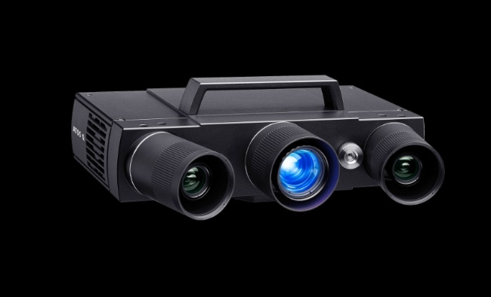
Fig. 2 Atos Q 3D scanner

4.2 Participants and sampling size

For this study, 50 industry professionals were recruited. More specifically, there were 18 inspectors who conducted visual inspections every day. An additional 16 engineers inspected parts on occasion, during failure analysis. The remaining 16 assembly operators were responsible for verifying the parts for internal damage. As a result, all participants had prior inspection experience. Overall, participants had 1.5 to 35 years of actual experience in engine maintenance, repair, and overhaul.
The research sample was designed to include a wide range of defect forms and severity levels, with emphasis on difficult threshold challenges. In the investigation, high-pressure compressor (HPC) blades from V2500 gas turbines (Figure 1), that had airfoil dents, bends, dents, nicks, tears, tip curls, and tip rubs were studied. There were other non-defective blades included.
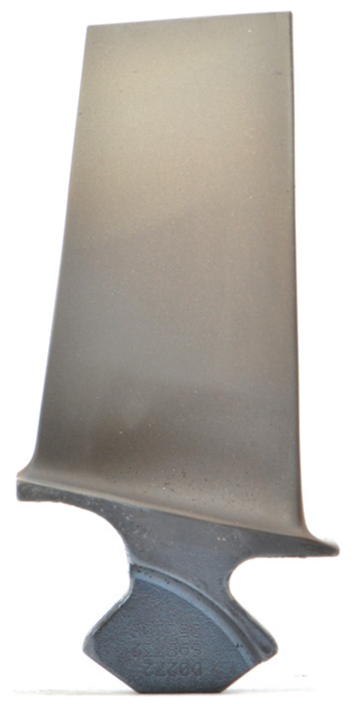
Fig. 3 High-pressure compressor (HPC) blade.

To conduct piece-part, borescope, and visual-tactile inspections, the sample sizes for each comparison diversified and consisted of 118 blade images, 20 borescope images, and 26 physical components. Both the technical inspection agent and the human operator observed the exact same set of blades for each comparison [22].
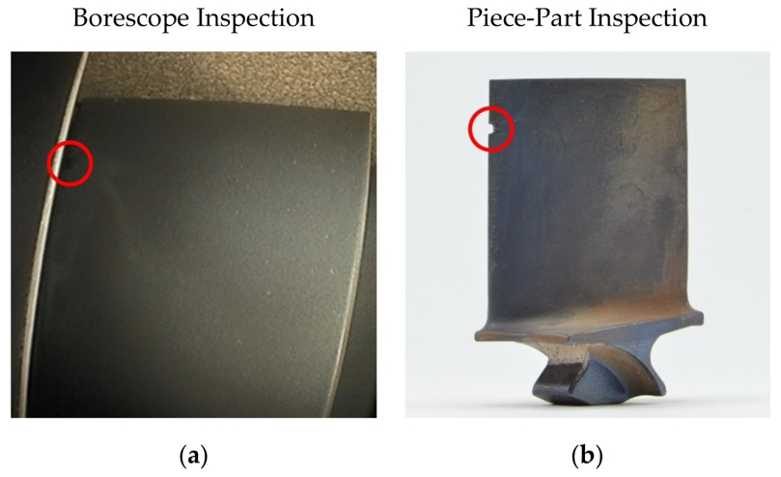
Fig. 4 Two types of inspections: (a) in situ borescope inspection, (b) piece part inspection.
The situation for a borescope inspection is different and exhibits a noticeable degree of variability (Figure 2a), whereas in a piece-part inspection the blades are fully exposed and could be examined individually (Figure 2b). The inbuilt borescope LED diode is the only source of illumination, and how it is absorbed varies according to coating and cleanliness. Furthermore, the engine design and the overlapping of adjacent blades limit the perspective [26].

4.3 Data Analysis

Human operators were instructed to mark a circle around the flaw on the computer screen to indicate their discoveries. The visual-tactile study was the sole exception, as participants were requested to express their conclusions verbally rather than by marking them on the actual blade.
Two distinct measures, inspection accuracy and examination time, were used to gauge the inspection's effectiveness. These represented the study's dependent variables, all of which are given additional detail in Table 2. Along with the variables which formed up the base in the confusion matrix.
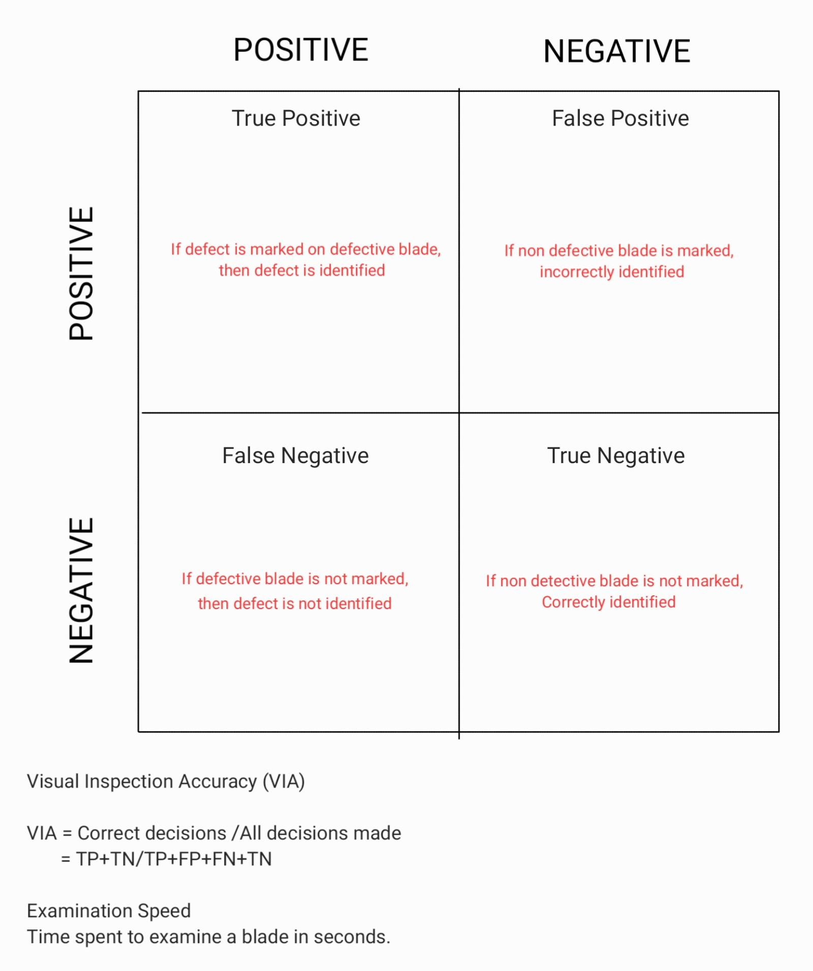
Table 2. Visual Inspection performance interpretation using confusion matrix.

Any discrepancy found by the system during 3D scanning was indicated by the red color in the output file. The confusion matrix performance indicators were used to interpret all the data gathered, indicated in Table 2. Regardless of whether a finding was color-coded in the 3D scanning files, manually marked by a human operator, or highlighted by software, all inspection results are subject to the same interpretation rules. The results of the operator were compared analytically to 3D scanners using the hypothesis (as shown in Table 3) testing whether there is difference between the two subjects.

Table 3. Research hypothesis.

4.4 Limitations
The Atos Q scanner was made to scan objects within a certain size range. Despite its primary design, it still faces difficulty in accurately capturing the geometry of objects. This is because of the way its hardware is set up and the limitations of its scanning range. So, when the Atos Q scanner tries to measure an object, the scanner may not be able to capture some details or dimensions the object. An inaccurate measurement could lead to missing data required, reducing accuracy.
The field of view of Atos Q scanner is another limitation, it refers to the area of object where the component is scanned and captured. The field of view of the scanner is often enough to scan area in a go, however when measuring it may not be the case. A scan obtained from different angles of component is required to obtain a complete measurement and representation of the model. This procedure will provide detailed errors and complexities in obtaining accurate measurements of model.

Inaccurate measurements could be caused by the distance, obstruction or the size of the component. For example, a trembling scan would prove difficult for the scanner to capture the three dimensions of a component. This would result in inaccurate recorded data, reduction of reliability and loss of time.

The object being scanned is optimised to be captured within a controlled environment. However, this would diminish the efficacy of the scanner and its ability to be flexible as the scanner would have to be constantly constrained to a point.
On the other hand, the scanner would be positioned in an optimal position and manoeuvred in a pattern to capture all angles of the object. But the fixed placement of the object may pose an issue to irregular shaped objects.

It is important to acknowledge that the group of people being interviewed is restricted, as it is the representation of a company and the participants do not reflect on the company whole due to subjective bias. The findings of this report will not represent the entirety of aircraft professionals.

The process in which selected professionals in this report for testing can result in bias, participants chosen are based on volunteers and self-nominations and are likely to be inclined in their skills and ability and expect outcome. Therefore, resulting in potential skew based on participants' judgments.

It is important to understand that the professionals tested will possess a level of expertise and experience and will have a specialised area of expertise, while others may have no clue simply because the person is new to the industry. Such variety of competence and knowledge amongst participants could affect the accuracy of inspection results and reports.

To counter the issues of bias and test results, each case would have to be examined carefully by aircraft professionals to inspect defects. However, due to limited time, budget and resources, all aircraft personnel will not be able to participate and the defect types to be inspected will also be restricted. Testing will be prone to a focused subset of professionals and a limited number of aircraft components will be evaluated.

The test will focus on areas of defect but not the type of defect, overlooking the critical aspects in aircraft inspection.
The chosen defects may not be found commonly in everyday aircraft inspection practices, limiting reliability testing of 3D scanners in daily practices.

The test is done under controlled conditions, it does not replicate operational challenges faced by aircraft personnel in the hangar. Challenges such as weather conditions and operational demands on site will not be tested, therefore will affect the defect detection rate.

5 Projected Timeline
Project initial Phase  - Define Objective and scope.  - Research on 3D scanners and printers.  - Identify research participants and establish connections. | October 2023-November 2023
Literature Review and Data collection Phase  - Research on articles of 3D scanners and printers to provide case studies on reason to implement this technology.  - Collection of data and adjust. | November 2023-December 2023
3D scanner and printer analysis  - Figure out diverse types of scanners and printers  - Research their benefits and limitations  - Choose a type from both scanners and printers and provide reasons | January 2024-February 2024
Figure out on integrating/merging scanners and printers  - Find ideas to allow scanned 3D images to be sent through cloud to printers  - Find challenges and difficulties for the process | February 2024-March 2024
Testing and Validation  - Conduct tests and provide prototypes on the model  - Do test runs  - Find inaccuracies and mention them in the results  - Adjust to the issues and retest until the process is valid | March 2024-May 2024
Presentation  - Prepare presentation and outline main key points such as case studies, aims and limitations  - Use publications to back up findings | May 2024-June 2024
Report and Documentation  - Draft a report based on the findings and summarize  - Examine and review report | June 2024- July 2024

6 References

[1] Wang, X., Jiang, M., Zhou, Z., Gou, J., and Hui, D. “3D Printing of Polymer Matrix Composites: A Review and Prospective.” Composites Part B: Engineering, Vol. 110, 2017, pp. 442–458. https://doi.org/10.1016/j.compositesb.2016.11.034.
[2] Chen, Z., Li, Z., Li, J., Liu, C., Lao, C., Fu, Y., Liu, C., Li, Y., Wang, P., and He, Y. “3D Printing of Ceramics: A Review.” Journal of the European Ceramic Society, Vol. 39, No. 4, 2019, pp. 661–687. https://doi.org/10.1016/j.jeurceramsoc.2018.11.013.
[3] Mostafaei, A., Elliott, A. M., Barnes, J. E., Li, F., Tan, W., Cramer, C. L., Nandwana, P., and Chmielus, M. “Binder Jet 3D Printing—Process Parameters, Materials, Properties, Modeling, and Challenges.” Progress in Materials Science, Vol. 119, 2021, p. 100707. https://doi.org/10.1016/j.pmatsci.2020.100707.
[4] Frazier, W. E. “Metal Additive Manufacturing: A Review.” Journal of Materials Engineering and Performance, Vol. 23, No. 6, 2014, pp. 1917–1928. https://doi.org/10.1007/s11665-014-0958-z.
[5] Wang, R., Law, A. C., Garcia, D., Yang, S., and Kong, Z. “Development of Structured Light 3D-Scanner with High Spatial Resolution and Its Applications for Additive Manufacturing Quality Assurance.” The International Journal of Advanced Manufacturing Technology, Vol. 117, Nos. 3–4, 2021, pp. 845–862. https://doi.org/10.1007/s00170-021-07780-2.
[6] Parry, L., Ashcroft, I., Bracket, D., and Wildman, R. D. “Investigation of Residual Stresses in Selective Laser Melting.” Key Engineering Materials, Vol. 627, 2014, pp. 129–132. https://doi.org/10.4028/www.scientific.net/kem.627.129.
[7] Fröhlich, C., and Mettenleiter, M. Terrestrial Laser Scanning-New Perspectives in 3D Surveying. ResearchGate. https://www.researchgate.net/publication/238081866_Terrestrial_laser_scanning-new_perspectives_in_3D_surveying.
[8] Boehnen, C., and Flynn, P. J. Accuracy of 3D Scanning Technologies in a Face Scanning Scenario. https://doi.org/10.1109/3dim.2005.13.
[9] Haleem, A., and Javaid, Mohd. “3D Scanning Applications in Medical Field: A Literature-Based Review.” Clinical Epidemiology and Global Health, Vol. 7, No. 2, 2019, pp. 199–210. https://doi.org/10.1016/j.cegh.2018.05.006.
[10] Huang, P. S. “Novel Method for Structured Light System Calibration.” Optical Engineering, Vol. 45, No. 8, 2006, p. 083601. https://doi.org/10.1117/1.2336196.
[11] Wyant, J. C. "White light interferometry." Proc. SPIE 4737, Holography: A Tribute to Yuri Denisyuk and Emmett Leith, 9 July 2002, https://doi.org/10.1117/12.474947.
[12] Shahrubudin, N., Lee, T. C., and Ramlan, R. “An Overview on 3D Printing Technology: Technological, Materials, and Applications.” Procedia Manufacturing, Vol. 35, 2019, pp. 1286–1296. https://doi.org/10.1016/j.promfg.2019.06.089.
[13] Haleem, A., Javaid, M., Singh, R. P., Rab, S., Suman, R., Kumar, L., and Khan, I. H. “Exploring the Potential of 3D Scanning in Industry 4.0: An Overview.” International Journal of Cognitive Computing in Engineering, Vol. 3, 2022, pp. 161–171. https://doi.org/10.1016/j.ijcce.2022.08.003.
[14] Ertogral, K., and Öztürk, F. S. “An Integrated Production Scheduling and Workforce Capacity Planning Model for the Maintenance and Repair Operations in Airline Industry.” Computers & Industrial Engineering, Vol. 127, 2019, pp. 832–840. https://doi.org/10.1016/j.cie.2018.11.022.
[15] Lafiosca, P., Fan, I.-S., and Avdelidis, N. P. “Aircraft Skin Inspections: Towards a New Model for Dent Evaluation.” Insight - Non-Destructive Testing and Condition Monitoring, Vol. 65, No. 7, 2023, pp. 378–383. https://doi.org/10.1784/insi.2023.65.7.378.
[16] Hughes, R., Rahman, A. A., Lin, C., and Rahman, A . A. A., “Implementation of a 3D Scanning System for Quality Inspection in Manufacturing,” ResearchGate, 2023. https://www.researchgate.net/publication/373555629_Implementation_of_a_3D_scanning_system_for_quality_inspection_in_manufacturing

[17] Kang, K. W., Pereda, M. D., Canafoglia, M. E., Bilmes, P., Llorente, C., and Bonetto, R. “Uncertainty Studies of Topographical Measurements on Steel Surface Corrosion by 3D Scanning Electron Microscopy.” Micron, Vol. 43, Nos. 2–3, 2012, pp. 387–395. https://doi.org/10.1016/j.micron.2011.10.005.
[18] Larue, J.-F., Brown, D. R. L., and Viala, M. How Optical CMMs and 3D Scanning Will Revolutionize the 3D Metrology World. Advances in computer vision and pattern recognition. Volume 141–176. https://doi.org/10.1007/978-1-4471-6741-9_5.
[19] Panjvani, K., Dinh, A. V., and Wahid, K. A. “LiDARPheno – A Low-Cost LiDAR-Based 3D Scanning System for Leaf Morphological Trait Extraction.” Frontiers in Plant Science, Vol. 10, 2019. https://doi.org/10.3389/fpls.2019.00147.
[20] Kourousis, K. I. “Special Issue: Civil and Military Airworthiness: Recent Developments and Challenges.” Aerospace, Vol. 7, No. 4, 2020, p. 37. https://doi.org/10.3390/aerospace7040037.
[21] Ding, M., Wu, B., Xu, J., Kasule, A. N., and Zuo, H., “Visual Inspection of Aircraft Skin:
Automated Pixel-Level Defect Detection by Instance Segmentation,” Chinese Journal of
Aeronautics, Vol. 35, No. 10, 2022, pp. 254–264. https://doi.org/10.1016/j.cja.2022.05.002.

[22] Aust, J., and Pons, D. J., “Comparative Analysis of Human Operators and Advanced Technologies in the Visual Inspection of Aero Engine Blades,” Applied Sciences, Vol. 12, No. 4, 2022, p. 2250. https://doi.org/10.3390/app12042250

[23] Wikipedia contributors, “3D Scanning,” Wikipedia, Jan 05, 2024.
https://en.wikipedia.org/wiki/3D_scanning

[24] Mostafa, A.-B., and Ebrahim, M. A., “3D Laser Scanners’ Techniques Overview,”
ResearchGate, 2015.
https://www.researchgate.net/publication/282753883_3D_Laser_Scanners'_Techniques_Overview

[25] “3D Scanning with ATOS | Flexible, Reliable.”
https://www.gom.com/en/products/3dscanning

[26] Aust, J., Pons, D. J., and Mitrović, A., “Evaluation of Influence Factors on the Visual
Inspection Performance of Aircraft Engine Blades,” Aerospace, Vol. 9, No. 1, 2021, p. 18.
https://doi.org/10.3390/aerospace9010018

Table 1. [22] Aust, J., and Pons, D. J., “Comparative Analysis of Human Operators and Advanced Technologies in the Visual Inspection of Aero Engine Blades,” Applied Sciences, Vol. 12, No. 4, 2022, p. 2250. https://doi.org/10.3390/app12042250
Fig 1. Pérez-Cortés, J.-C., Pérez, A., Sáez, S., Guardiola, J.-L., and Salvador, I., “A System for In-Line 3D Inspection without Hidden Surfaces,” Sensors, Vol. 18, No. 9, 2018, p. 2993. https://doi.org/10.3390/s18092993

Fig 2. Admin, “ATOS Q,” HandsOnMetrology, Nov 14 2023. https://www.handsonmetrology.com/products/atos-q/?gad_source=1&gclid=Cj0KCQiAqsitBhDlARIsAGMR1RhIsAdB33hOTceACv9N0t4bLIeo158QS8YwiMnQ1dW5Bf3Ck85HI9IaAl2LEALw_wcB

Fig 3. Aust, J., Mitrović, A., and Pons, D. J., “Comparison of Visual and Visual–Tactile Inspection of Aircraft Engine Blades,” Aerospace, Vol. 8, No. 11, 2021, p. 313. https://doi.org/10.3390/aerospace8110313

Fig 4. Aust, J., Pons, D. J., and Mitrović, A., “Evaluation of Influence Factors on the Visual Inspection Performance of Aircraft Engine Blades,” Aerospace, Vol. 9, No. 1, 2021, p. 18. https://doi.org/10.3390/aerospace9010018

