Report:

Purpose / Goals:

Implement a “Shift Cipher Decrypter” using Python. User can decrypt a long enough (more than 200 words) message which was originally `shift cipher encrypted`.

For demonstration purpose, the remaining half "encryption" was also implemented. (which is the reverse process of decryption)

Assumption / Requirement:

Assuming a use case, for which message to be encrypted:
- Only contains upper case letters, space characters, punctuation marks
- Space characters remain unchanged during the encryption.
- punctuation marks remain unchanged during the encryption.
- message is longer than 200 words, alphabet distribution follows the general pattern

Procedure / Terminology:

Given that the encrypted message is long enough. A “shift cipher decrypter” can guess the message without knowing k (the original k). The letter that have the most frequent in the original message will be “E” which is also reflected in the “encryped” message as letter shifting of the whole message(`encrypted`) are the same.

How to use:

Landing screen / Startup screen

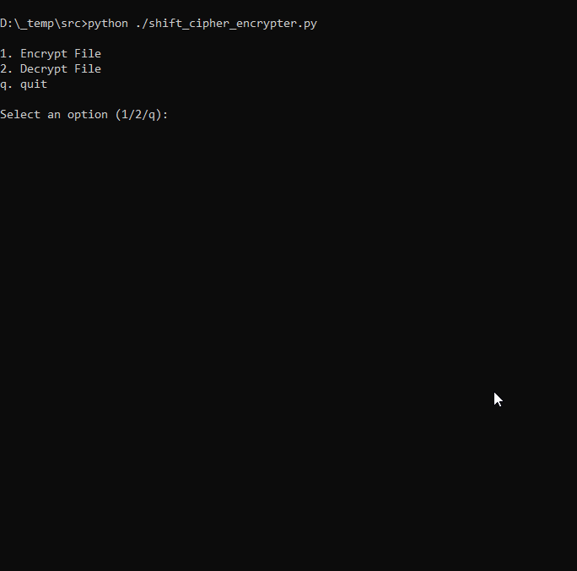
Start up screen

User want to encrypt file:

To encrypt file:
- select 1 to encrypt file
- select a k

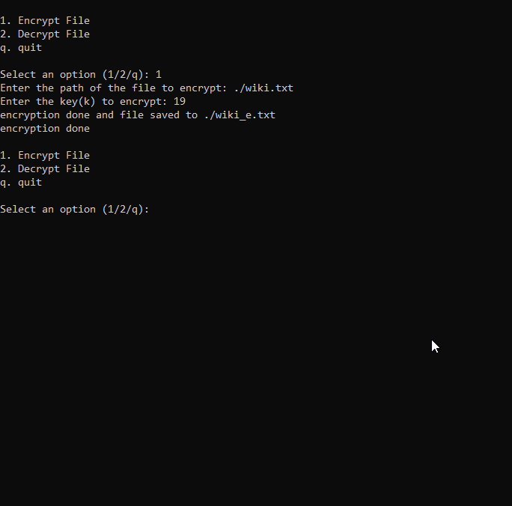
User encrypt file

2. User want to decrypt file?

To decrypt file:
- Press “2”
- Input the file want to decrypt

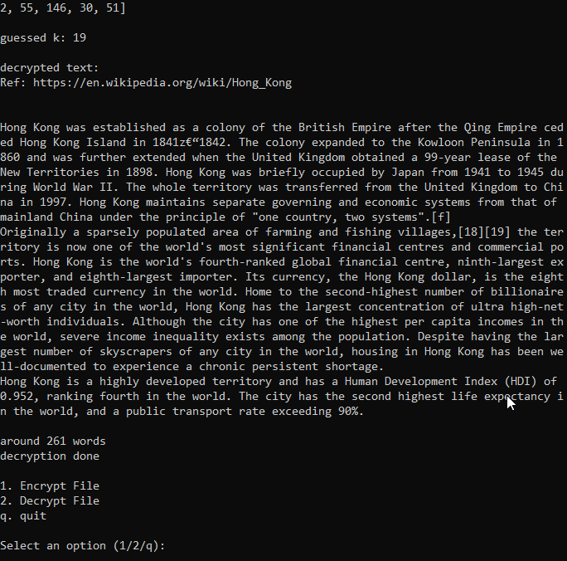
User decrypt file

3. How about the message is not long enough?

Background:

If the message is not long enough, the above terminology collapse. As such, using the same terminology cannot guess the k as the same with the message as shown in (2)

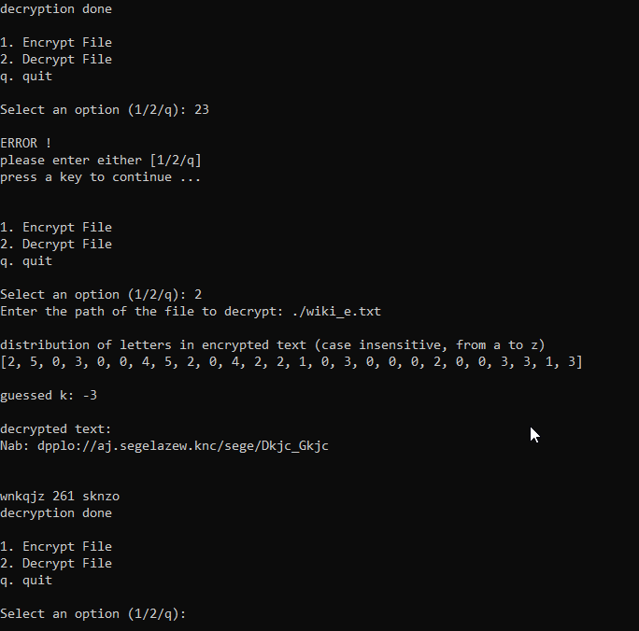
The decrypt message seems scrambled with incorrect k

Data types / variable declaration and initialization

INTEGER:

i.e.
…
ORD_a = ord('a') # 97
…

`ORA_a` is a variable storing `97` in integer format

STRING AND ARRAYS:

…
with open(file_path,'r') as fi:
# beginning of the process
# read file and join the lines all
lines = fi.readlines()
e_temp = ''.join(lines)
…

At here:
- `lines` is an array of string.
- `e_temp` is a single lined string.

Terminology

Background:

The decryption algorithm implemented was k guessing (guessing the k with encrypted message long enough).

Letter e is counted to have the most occurrence in daily English. As the process of shift cipher encryption by whoever user is shifting letter by k (a unknown integer) times. Assuming the k used for the whole message are the same (or even in a regular pattern that already known). The letter occurrence will be reflected in the encrypted message (i.e. `e` -> k's shift -> `m` for this case) as well. That's why k can be guessed by counting the most occurrence letter and assuming that is the letter e in the original message.

Implementation:

1. encryption

def shift_cipher_encrypt(plaintext, key):
# apply encryption to text with given key
encrypted_message = ''

for char in plaintext:
if char.isalpha():
ascii_offset = ORD_A if char.isupper() else ORD_a # Determine ASCII offset based on uppercase or lowercase letter

# the comment shown below are the pseudo code, it demonstrate the ideas only
# let say the input is 'the' // without quote
# find distance of target character with reference to A or a
# i.e. t - a = 19 , h - a = 7 , e - a = 4
distance = ord(char) - ascii_offset

# [19,7,4] + [8,8,8] (key) = [27, 15, 12]
# Shift the character by adding the key and taking modulo 26 to wrap around
# [27,15,12] % [26,26,26] = [1,15,12] // get modules
shifted_distance = (distance + key) % 26

# [1,15,12] + [97,97,97] = [98,112,109]
# chr(98) , chr(112) , chr(109) = 'bpm'
shifted_char = chr(shifted_distance + ascii_offset)

# so: the -> bpm
encrypted_message += shifted_char

else:
# consider integer case, retain
encrypted_message += char

return encrypted_message
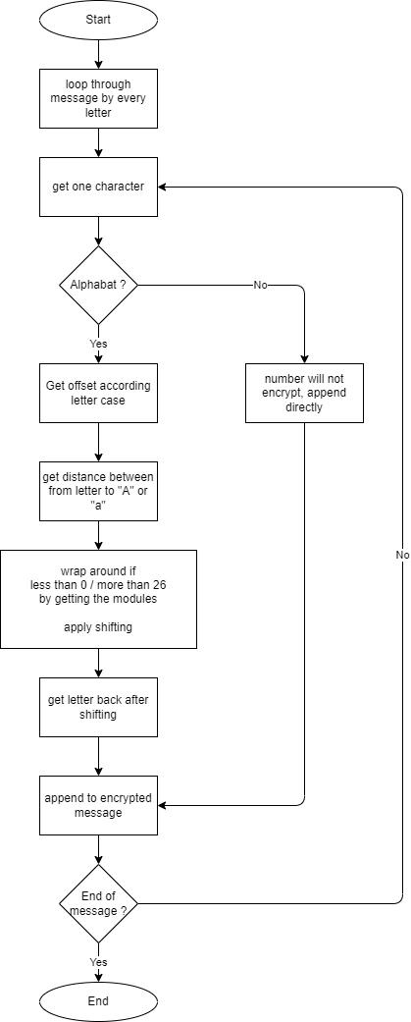
Diagram of encryption

2. encrypt file

def encrypt_file(file_path, key=8):
# open a file and apply encryption
output_file = file_path.replace('.txt','_e.txt')

# convert it to integer
key = int(key)

# open source file (plaintext)
with open(file_path,'r') as fi:
temp = ''.join(fi.readlines())

# open target file (encrypted text)
with open(output_file,'r+') as fo:
fo.truncate(0)
fo.writelines([shift_cipher_encrypt(temp, key)])

print(f'encryption done and file saved to {output_file}')
return

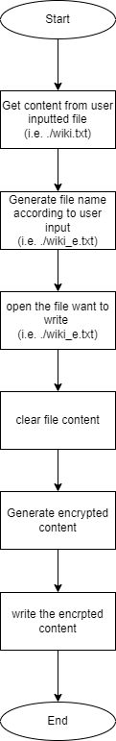
Diagram of encrypt file

3. Guess k value

def find_max_occurrence(char_occurrences):
# get the letter of the most occurrences. i.e. m
# by subtract between this letter to e, k can be guess

# find max occurrence and its index
max_idx = char_occurrences.index(max(char_occurrences))

# subtract it with index of e -> 4
return max_idx - 4

def count_most_occurrence_letter(txt_in):
# letter e, as stated have the most occurrence in the message by statistics.
# as 'Shift Cipher' is a encryption by letter shifting, the letters have good chance
# to have the most occurrence too in the encrypted text.
output = [0] * 26 # bucket for 26 letters

for char in txt_in:
if char.isalpha():
output[ord(char.lower()) - ORD_a] += 1

# output contains the statistics of paragraph letter by letter
return output

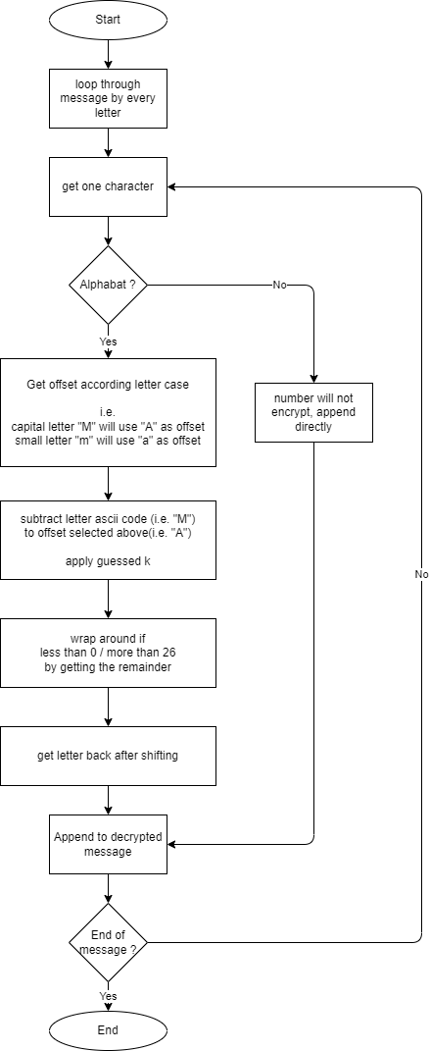
Diagram of guessing k

4. decrypt file

def decrypt_file(file_path):
# will open an encrypted file and decrypt it by a guessed key

with open(file_path,'r') as fi:
# beginning of the process
# read file and join the lines all
lines = fi.readlines()
e_temp = ''.join(lines)

characters_distribution = count_most_occurrence_letter(e_temp)

print('')
print('distribution of letters in encrypted text (case insensitive, from a to z)')
print(characters_distribution)

print('')
guess_k = find_k_dist(characters_distribution)
print(f'guessed k: {guess_k}')

print('')
print('decrypted text:')
decrypted_text = shift_cipher_decrypt(e_temp, guess_k)
print(decrypted_text)

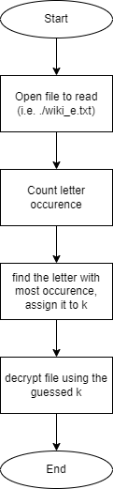
Diagram of decrypt file

5. decryption

def shift_cipher_decrypt(ciphertext, key):
plaintext = ""

for char in ciphertext:
if char.isalpha():
ascii_offset = ORD_a if char.islower() else ORD_A # Determine ASCII offset based on lowercase or uppercase letter

# Calculate the distance of the target character from a or A
distance = ord(char) - ascii_offset

# apply shift, get the remainder of 26
shifted_distance = (distance - key) % 26

# Convert back to ASCII
decrypted_char = chr(shifted_distance + ascii_offset)

plaintext += decrypted_char
else:
# If it is not an alphabetic character, retain as is.
plaintext += char

return plaintext

Diagram of decryption

- End -

