Hong Kong Institute of Vocational Education (Lee Wai Lee) Department of Information Technology

Higher Diploma in Information and Communications Technology (IT524110)

Final Year Project - Information and Communications Technology (ITP4108M) –
Project Proposal
Academic Year 20XX/XX

Date: Refer to Moodle
Project Title

Supervisor:
Industrial Mentor:

Students:

We declare that this is a group project and that no part of this submission has been copied from any other student’s work or from any other source except where due acknowledgement is made explicitly in the text, nor has any part been written for us by another person.

Student | Contribution to the project (%) | Signature

ACKNOWLEDGEMENT

- Mr. _________ as our Final Year Project Supervisors.

- Provide information and opinion

- _________ as our EIA/IA company

- provide real environment for learning

TABLE OF CONTENTS

Page

1. Introduction 1
1.1 Statement of the problem 1
1.2 Background of the problem 1
2. Outline of Proposed Solution 2
2.1 Approaches 2
2.2 Scope of the proposed solution 3
3. Explanation of why proposed solution is appropriate. 4
4. Main Stages 5
5. Main deliverables 5
5.1 Feature1 5
5.2 Feature2 5
5.3 Feature3 5
6. The responsibilities of each member 6

- Introduction

- Statement of the problem
# describe the services provided by the proposed system.
(Example)
In Hong Kong,
……………………………………………………………………………………………………………………………………………………………………………………………………………………………………………………………………………………………………………….. Therefore, our project is a solution to this problem.

- Background of the problem
# describe the environments or domains in which the proposed system will be used.
(Example)
The purpose of this project is to …
……………………………………………………………………………………………………………………………………………………………………………………………………………………………………………………………………………………………………………………. User can ……………...

In our project …..
………………………………………………………………………………………………………………………………………………………………………………………………………………………………………………………………………………………………………………..

- Outline of Proposed Solution

  - Approaches
#Explain what approaches you will use to develop the proposed system. You should explain the issues of the solution, for example, the system architecture, the algorithms (e.g. shortest path algorithm), software architectures (e.g. client-server), development methodology (e.g. Object-oriented approach)

- System Architecture (Example)
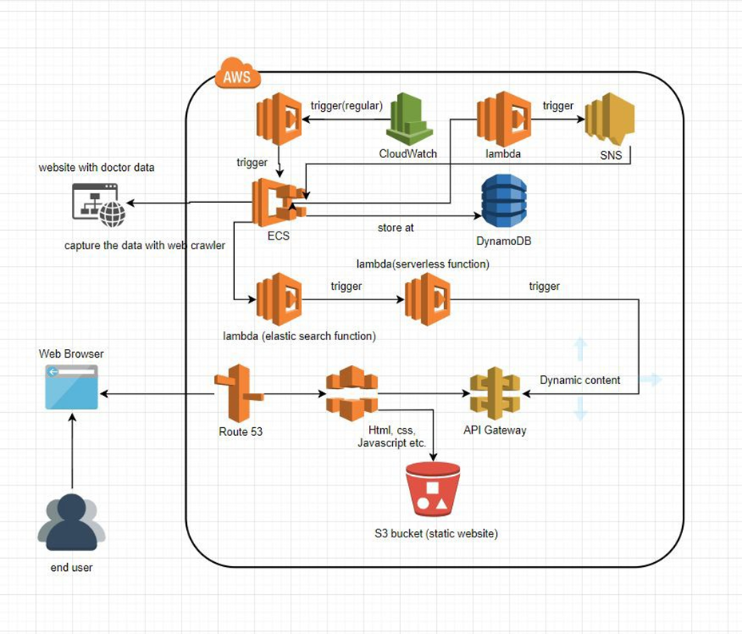
- Development methodology

  - Scope of the proposed solution

- Functions
# describe all functions to be provided by the system
- Data
# describe data handled by the system;

- Non-functional requirements
# describe all non-functional requirements, e.g. performance, usability, software platform, interfaces with existing systems, reliability, etc.;
(Example)
Hardware List:
PC / Laptop

Software/platform List:
Flask | A micro web framework
Boto3 | AWS SDK for Python
PyCharm | An integrated development environment
GitHub | For version control using Git
Cloud Service List:
Amazon DynamoDB | For our database
Amazon Elasticsearch Service | For our search engine
Amazon Elastic Container Service | For docker container
Amazon Elastic Container Registry | For docker container registry
Amazon Lambda | For serverless application
Amazon S3 | For object storage
Amazon CloudFormation | For provision all the infrastructure resources Amazon Cognito For authentication
Amazon CloudFront | A content delivery network (CDN) service
Amazon Route 53 | DNS service
Amazon Cloud9 | An integrated development environment
Amazon CloudWatch | A monitoring and management service

- Explanation of why proposed solution is appropriate.
# Explain how your system can meet the requirements of the users
Advantages
…..

- Main Stages
# Outline your project plan by describing the system development life cycle with deadlines of tasks
Task List
Gantt Chat
Your Gantt Chart here

- Main deliverables
# describe the things that you will deliver
- Deliverable1 / Feature1

- Deliverable2 / Feature2

- Deliverable3 / Feature3

- The responsibilities of each member
#Explain the allocation of work to individual member.

