Introduction to Game of Life and pS.js
You have learned enough fundamental knowledge to attempt your first personal project. We are going to attempt the game of Conway's Game of Life with the help of a library called ps. j s.

Conway's Game of Life
Conway's game of life is a that is created by the English Computer Scientist and Mathematician John Horton Conway . It is very typical programming problem because of the simplicity, beauty and inherent complexity of this problem.
Let's look at what Game of Life looks like. Here is one famous example called Gasper's Glider Gun.
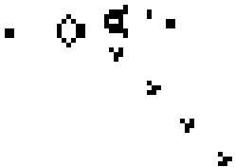

What is happening here ? It seems that we are having a form of life spitting something crawling to the corner. You may assume that the above animation is based on a very complex rule to generate such pattern. Surprisingly, the rules of game of life is very simple.

Rules of Game of Life
Game of Life runs on a 2-dimensional grid plane with square grid. On each grid, there could be with life (colored) or no life(white). So it looks like the following.
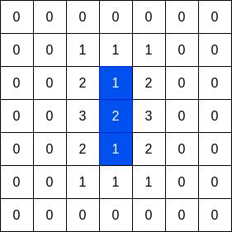

What are all those numbers? It is the neighbor of the grid. We call it the Moore neighborhood which includes all neighboring grids. We would hide the number of neighbors of all box with O neighbors

since it is trivial.
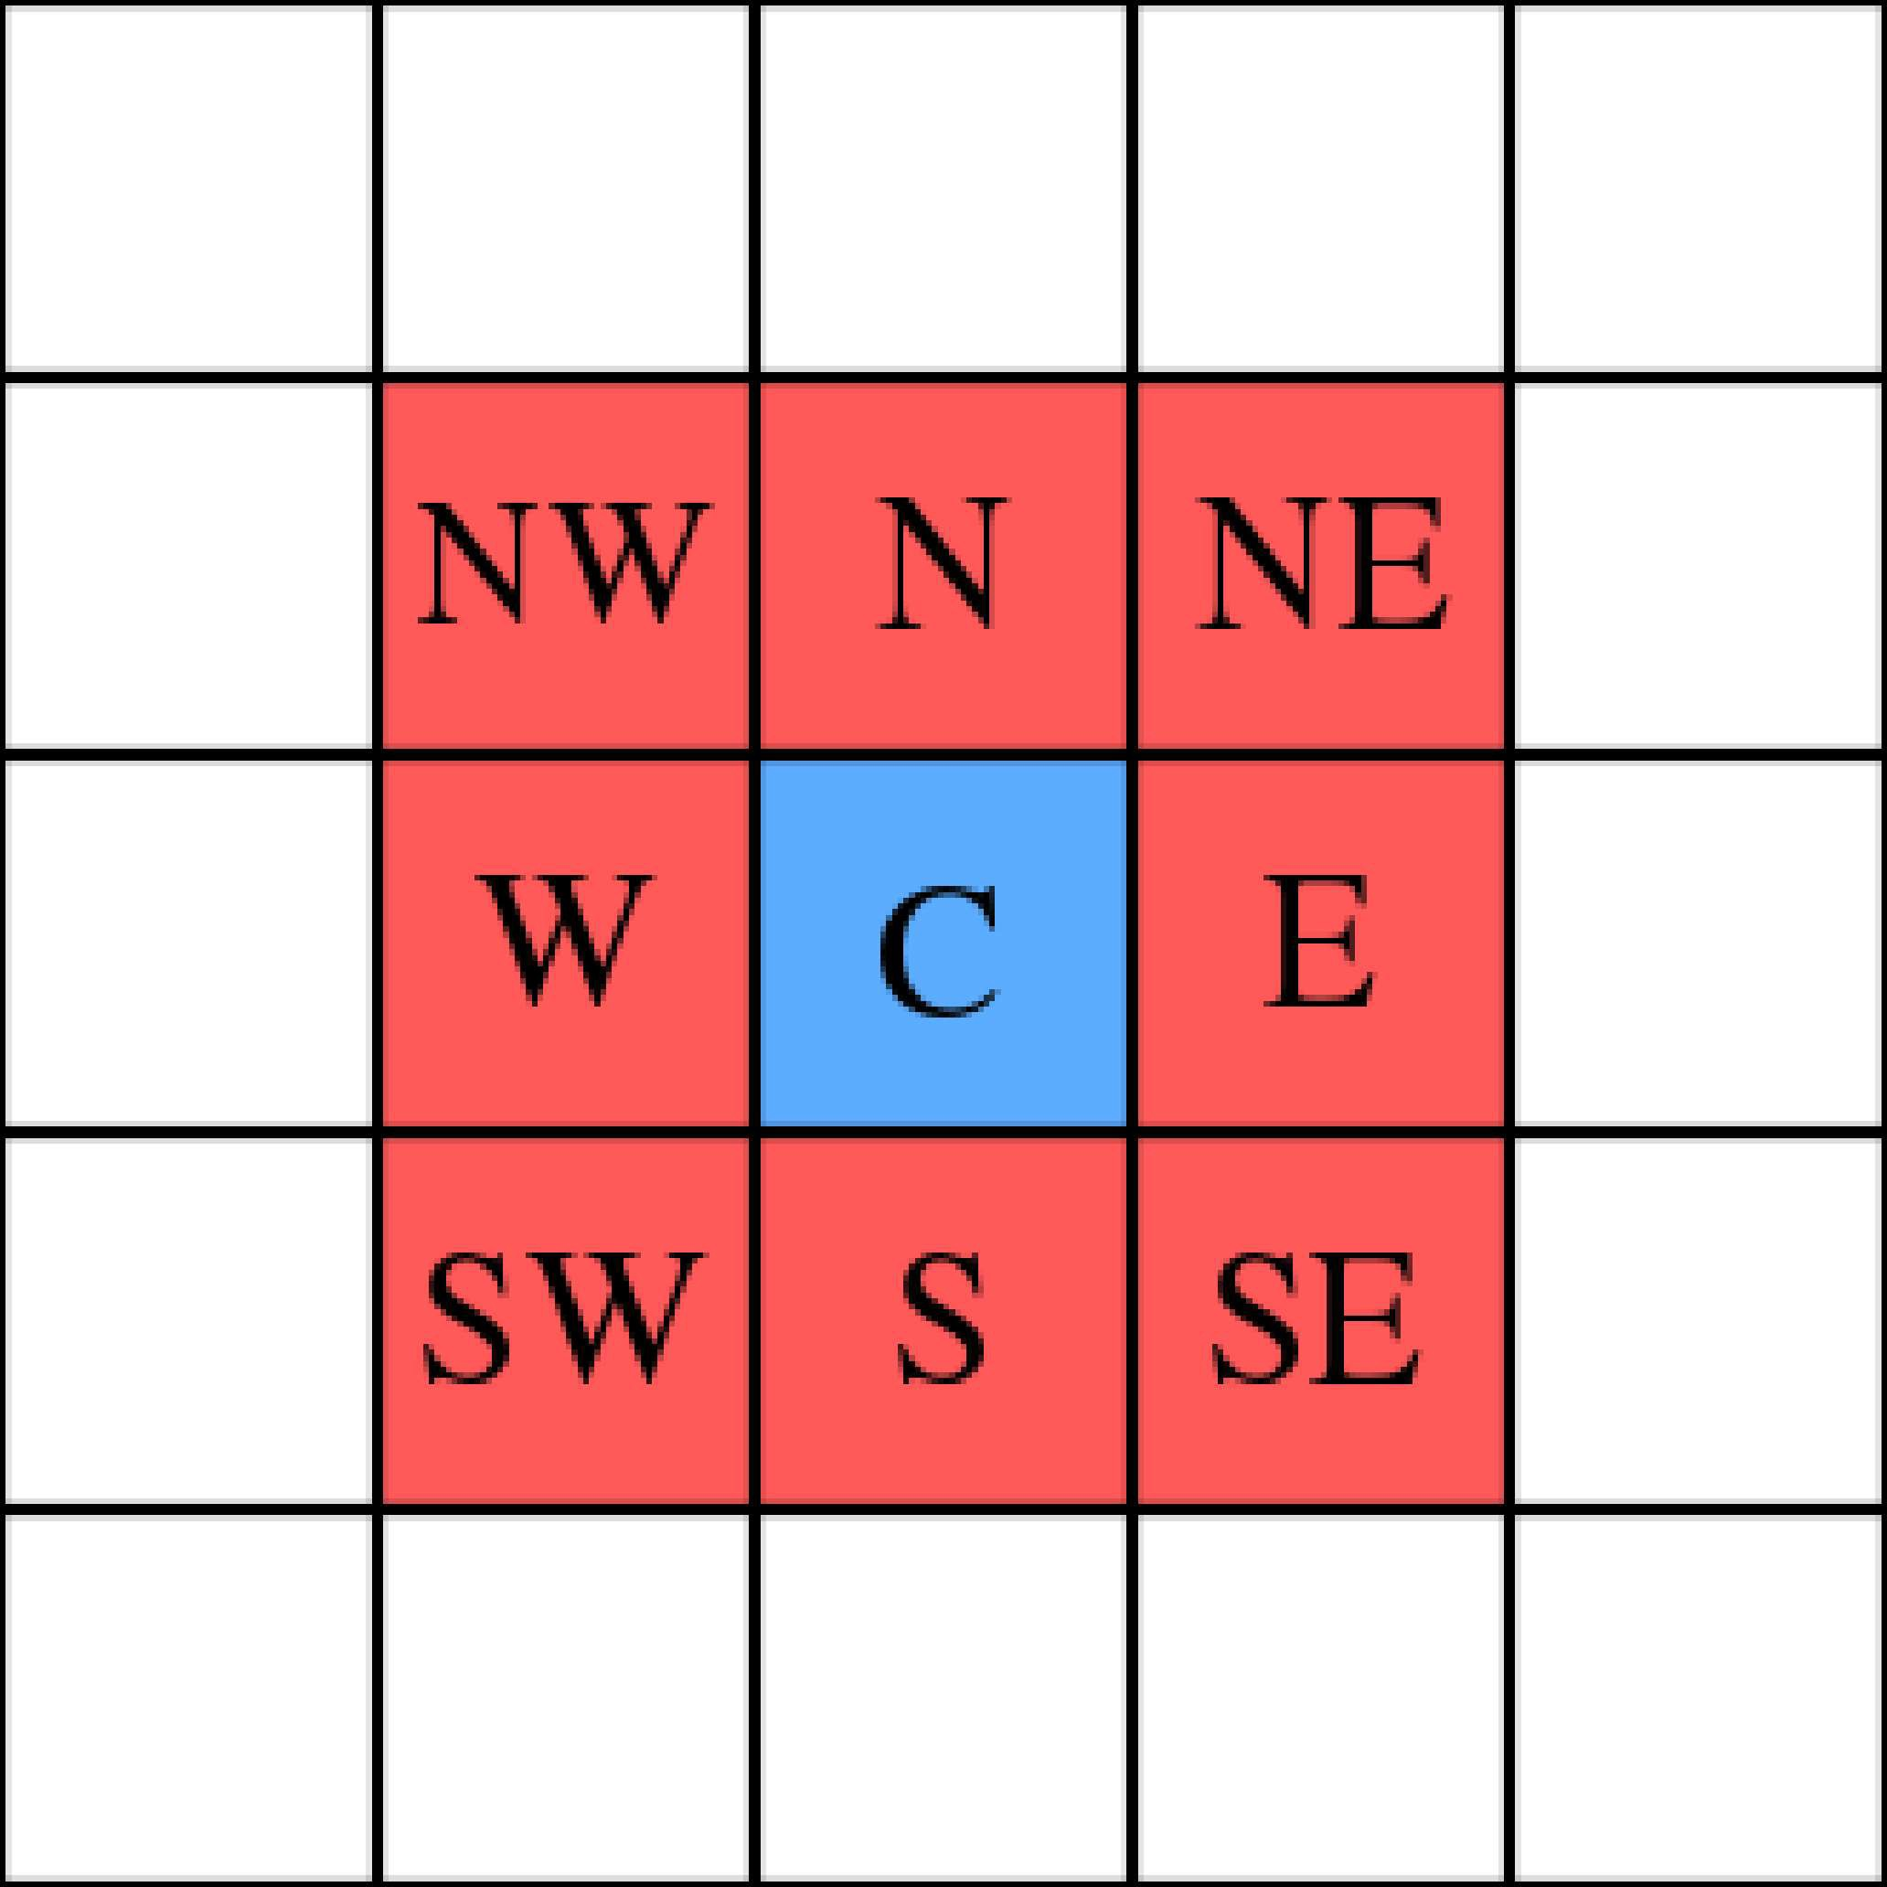
Here are the rules of Game of life:

- If a box has life and it has less than 2 neighbors. It dies of loneliness. The box becomes lifeless next generation.
- If a box has life and it has more than 3 neighbors. It dies of overpopulation. The box becomes
lifeless next generation.
- If a box has life and it has 2 to 3 neighbors. Nothing changes for this box.
- If a box has no life and it has 3 neighbors, the box in next generation fills with life because of reproduction.

It seems pretty simple rule. But it gives unexpectedly complex behavior. Here are some common patterns:

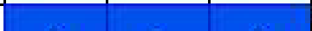

-
 |  | 1 | 1 | 1
 |  | 2 |  | 2 |  |  |  |  | 1 | 2 | 3 | 2 | 1
 |  | 3 |  | 3 |  |  | Next Generation |  | 1 |  |  |  | 1
 |  | 2 |  | 2 |  |  |  |  | 1 | 2 | 3 | 2 | 1
 |  | 1 | 1 | 1

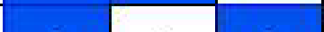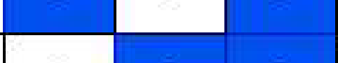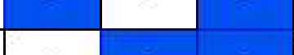Next Generation
2
2
1
2
1
2
2
1
2
1
2
2
2
2
1
2
1
2
2
1
2
1
2
2
-


Next Generation
1
2
2
1
1
2
2
2
2
1
1
2
1
1
-
 |  |  |  |  | 1
 | 1 | 1 | 2 | 1 | 1
 | 1 |  |  |  | 1
 | 2 |  |  |  | 2
 |  |  |  |  | 1
 | 1 |  |  |  | 1
 | 1 | 1 | 2 | 1 | 1

As you can see from these examples, the first one changes from a vertical three-box pattern to a horizontal three-box pattern. It is going to oscillate between these two patterns forever if there is no other box interfering.
The second one is a pattern just like Tecky Logo. It is stable because of the life-box has 2-3 neighbors.

The third one is much more populate and it becomes four separated box with O neighbors. So the third pattern would disappear completely after two generations.
That is the game we need to implement. It seems pretty difficult to implement all these boxes by ourselves. Hence we are going to make use of a very useful library called ps. j s.
Here is a demonstration that showcase how the neighbors are calculated.

pS.js
p5. j s is a library that makes use of the canvas element in web. It aims at making coding easier for designer, artist and programming beginners. Hence it is a very nice library for us to build our Game of life with this library.

Installation of pS.js
Installation of pS.js is very simple. You can just put the following CDN link to your index. html.

<script src="https://cdnjs.cloudflare.com/ajax/libs/pS.js/1.2.0/pS.js"></script>

Our resulting index.html would look like the following with bootstrap installed as well.

<html>
<head>
<meta charset="utf-8">
<meta name="viewport" content="width=device-width, initial-scale=1, shrink-to-fit
<linkhref="https://cdn.jsdelivr.net/npm/bootstrap@S.0.2/dist/css/bootstrap.min.ci rel="stylesheet" integrity="sha384-EVSTQN3/azprG1Anm3QDgpJLim9Nao0Yz1ztcQTwFspd3yl crossorigin="anonymous">
<link rel="stylesheet" href="index.css"/>
</head>
<body>
<div id='canvas'></div>
<script src="https://cdn.jsdelivr.net/npm/bootstrap@S.0.2/dist/js/bootstrap.bundli integrity="sha384-MrcW6ZMFYlzcLA8Nl+NtUVF0sA7MsXsP1UyJoMp4YLEuNSfAP+JcXn/tWtiaxVXI crossorigin="anonymous"></script>
<script src="https://cdnjs.cloudflare.com/ajax/libs/p5.js/1.2.0/p5.js"></script>
<script src="index.js"></script>
</body>
</html>

Usage
Using ps. j s is very straight forward, there are two functions that you can put inside your index. j s
to start with. They are the functions setup() and draw().

function setup(){
// Setup logic here

I

function draw(){
// draw logic here

I

setup() function is for setting up the initial values. It is going to run . draw() is going to run many times. It is going to run . If you have a frame rate of 30 frames per second, then draw() runs 30 times per second!

p5.j s makes writing canvas related code easier because it simplifies the common flow of drawing animations into functions like setup() and draw().They also have different functions in their Reference. We would utilize many of them in the next section.

