Aim of the project:
- 該項目的目標是開發一個學習管理系統(LMS)，允許教育機構和組織創建和管理在線課程、跟踪學習者的進度並在課程完成後頒發證書。

Objectives of the project:
- 開發用戶友好的學習管理系統，使教師和學習者都易於使用。
- 提供各種課程創建和管理工具，包括課程材料創建、測驗、作業和評分。
- 為學習者提供一系列功能，包括課程註冊、進度跟踪和證書頒發，
- 確保整個系統用戶數據的安全和隱私。
AWS
AWS for hosting and cloud services(用於託管和雲服務的AWS)

Lambda for serverless computing(用於無服務器計算的 Lambda)

Can you make them of the Laravel LMS project?

LMS Function
can not work the student change password and forgot password function:
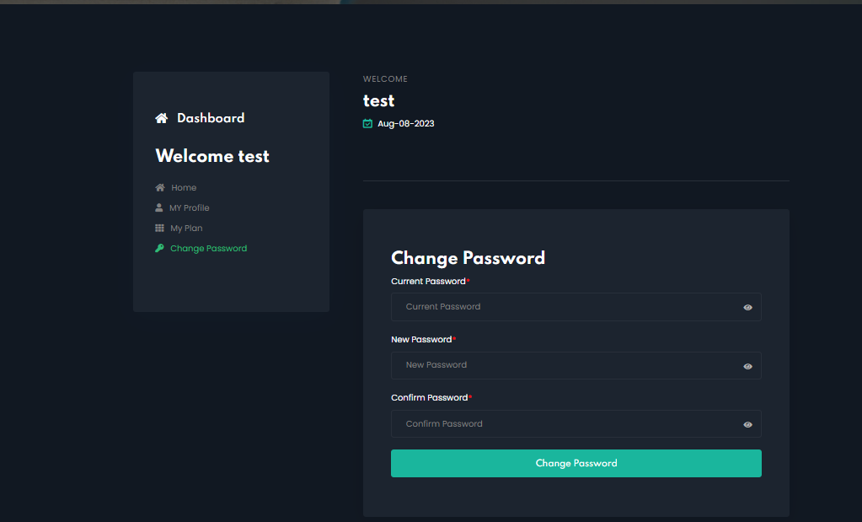
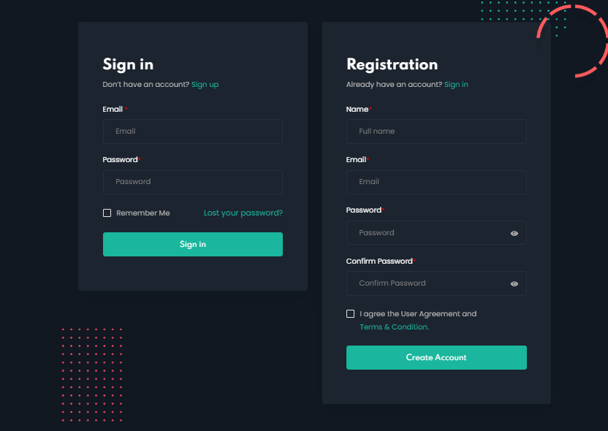
1.提供各種課程創建和管理工具，包括課程材料創建、測驗、作業和評分。
done for original template (LMS-Project-Laravel/resources/views
/admin/…….[country/exam/examcategory/plan/state/subject/test/test_question]
but the original template is not provide the admin account so that I can not to debug the admin function and access the admin dashboard
can you made to the admin function to work?

Controllers:
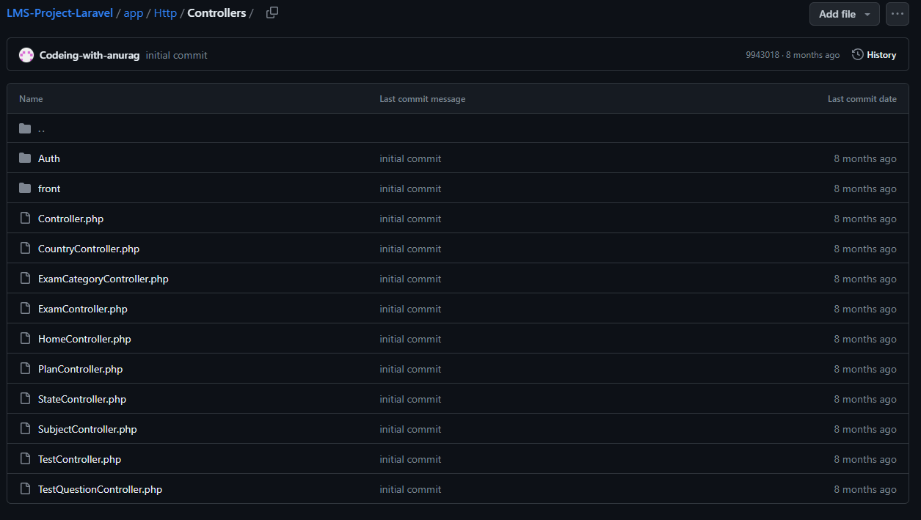
Auth:
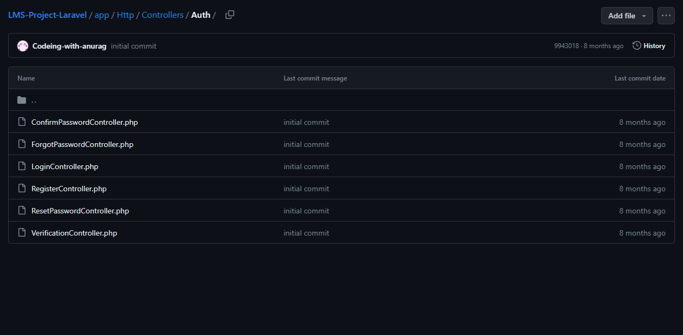
2.為學習者提供一系列功能，包括課程註冊、進度跟踪和證書頒發。
課程註冊:
I'm not sure if it's possible to register for the course, can you do this? (adding database related records and showing admin roles can see which courses students choose on the admin roles dashboard)?
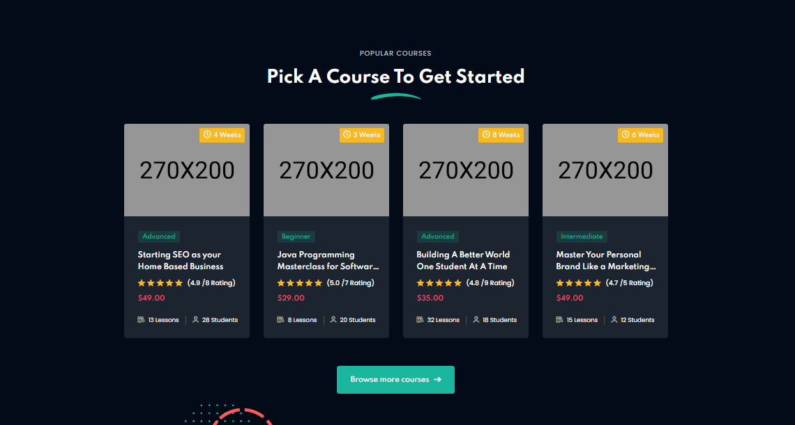
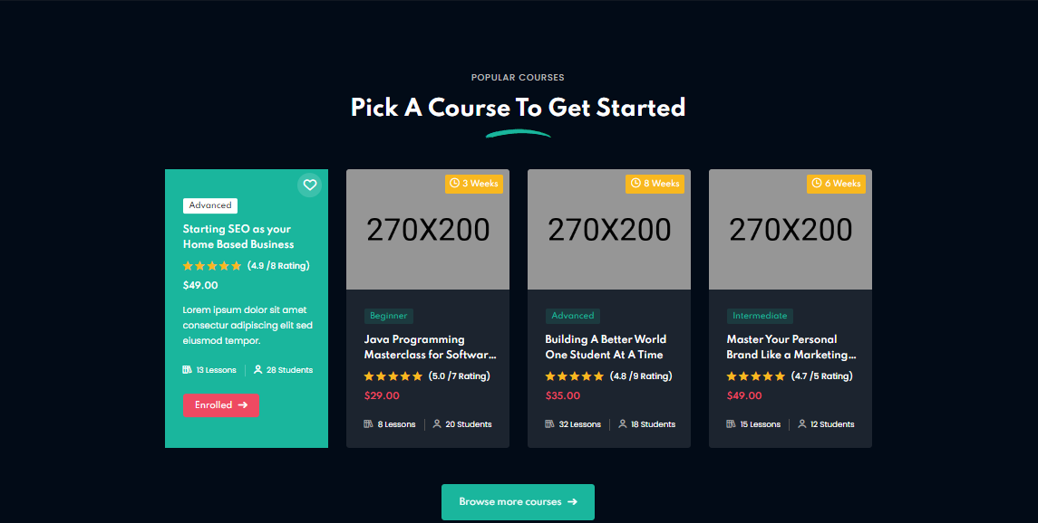

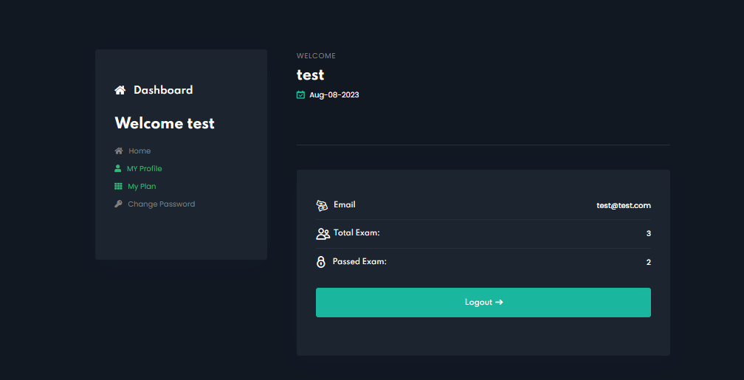
進度跟踪:
student view myself done the total exam number and admin view student course process

證書頒發:
I don’t know this project template should be have this function,
if it’s not, just given up this.
if its exist, just not to modify this.
Website front page layout:
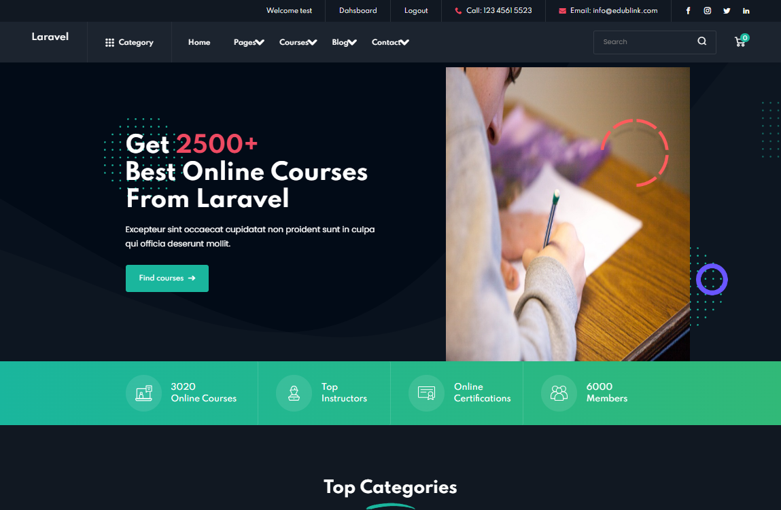

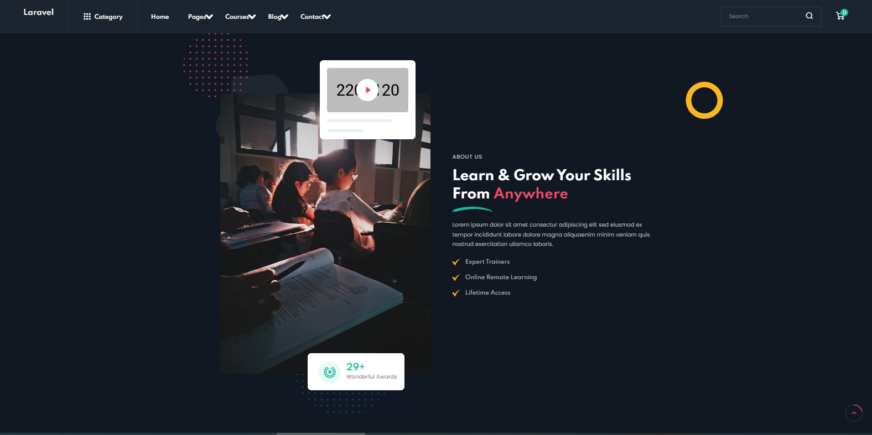
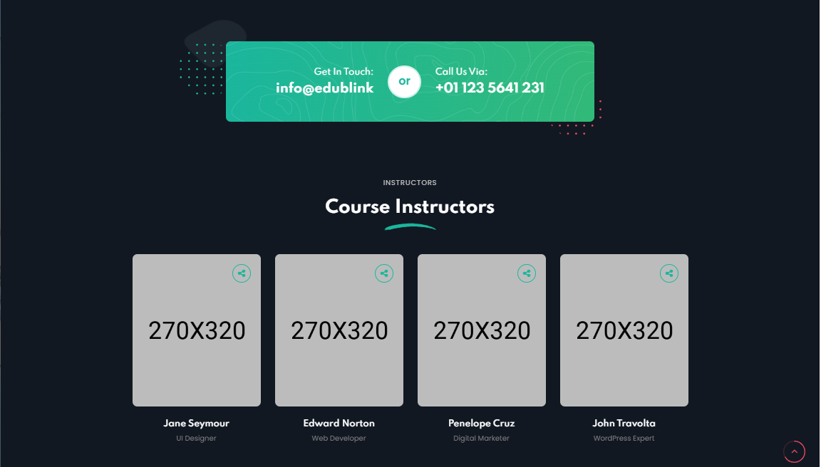

404 NOT FOUND(nav bar all function pages):
its can still show the 404 error cause we can not create them


