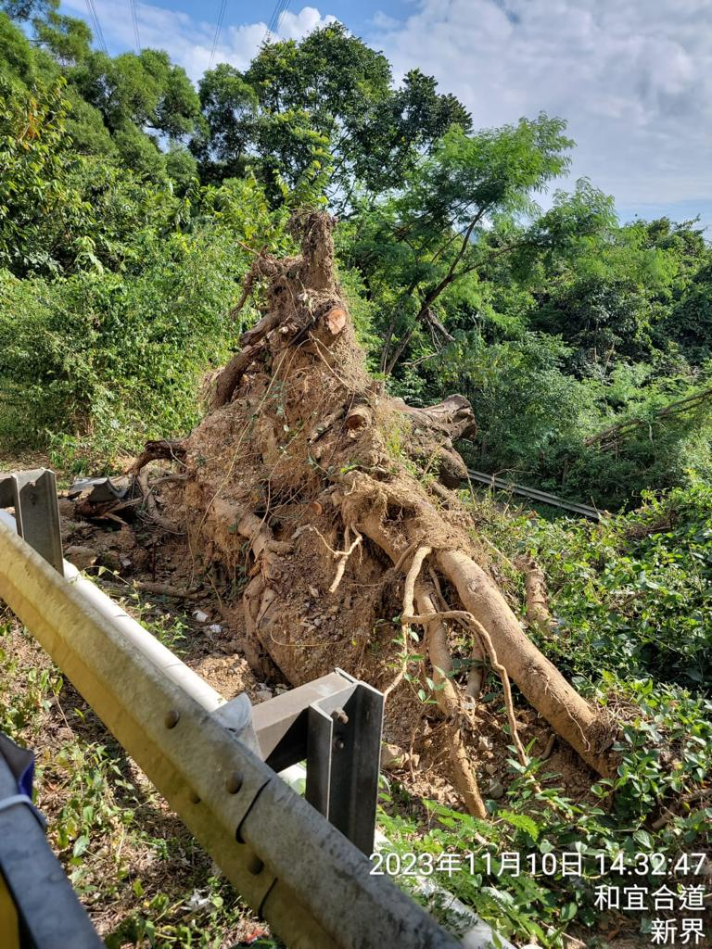
( Banner Photo)

Introduction

( Caption)

( Web page content)

Welcome to the tree risk management portfolio, created to share the role of good tree risk management in urban forestry in Hong Kong.

This portfolio is going to introduce and discuss on the urban forestry development in Hong Kong

In Hong Kong, it is renowned for its iconic skyline and bustling urban landscape, is also home to a remarkable array of trees and green spaces. The city's commitment to preserving and enhancing its natural environment is evident in its extensive urban forestry initiatives. However, as with any urban setting, the management of tree risks is crucial to ensure the safety and well-being of residents and visitors alike.

Tree risk management in Hong Kong encompasses a multidimensional approach that combines scientific knowledge, careful assessment, and proactive measures. With its unique geographical and climatic characteristics, Hong Kong faces various challenges in maintaining healthy and safe urban trees. These challenges include typhoons, heavy rainfall, soil erosion, and the urban heat island effect.

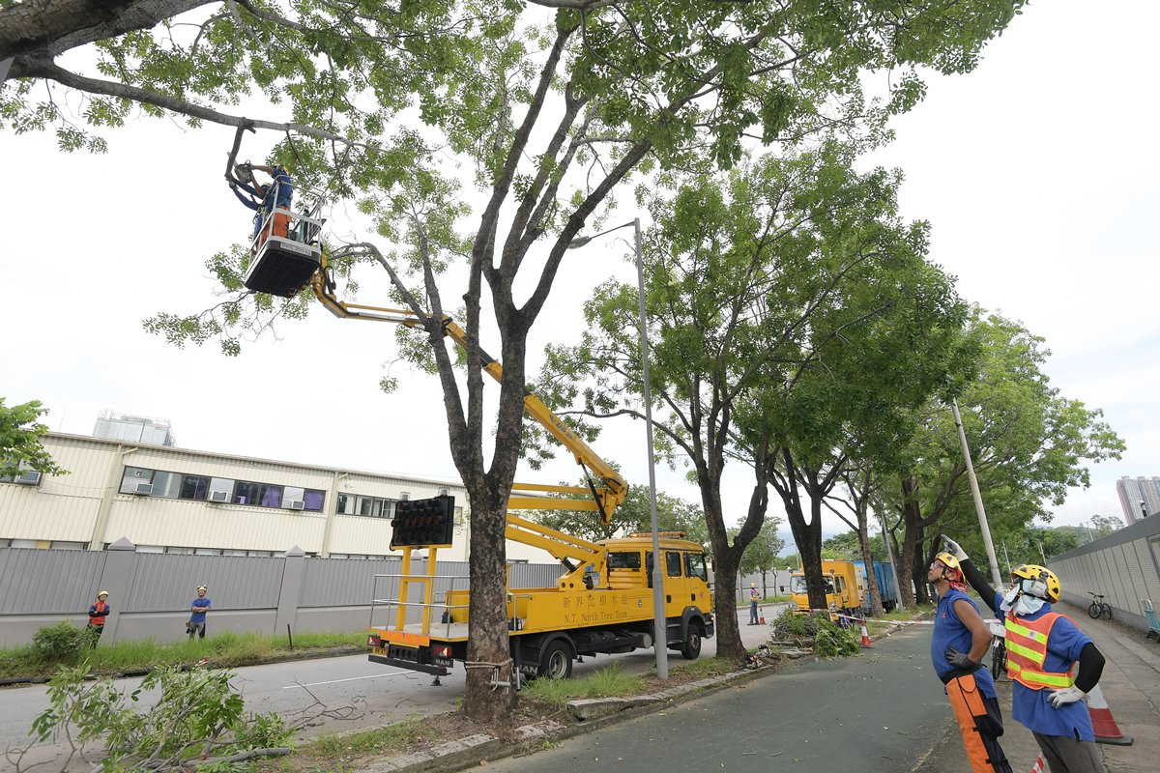

The government, in collaboration with environmental agencies and arboricultural experts, has developed comprehensive strategies to address these challenges. A key aspect of tree risk management involves regular inspections and assessments of urban trees to identify potential hazards such as decay, disease, or structural instability. By utilizing advanced technologies like tree risk assessment systems and aerial surveys, authorities can efficiently evaluate the condition of trees and prioritize risk mitigation efforts.

Additionally, public awareness and engagement play a vital role in tree risk management. The government and relevant organizations actively promote education campaigns to enhance understanding among citizens about the importance of tree maintenance and risk prevention. Community involvement in reporting tree-related concerns and participating in tree planting initiatives further strengthens the overall management framework.

In conclusion, tree risk management in Hong Kong is an essential endeavor to safeguard the city's urban greenery while ensuring public safety. Combining scientific expertise, innovative technologies, and community participation, Hong Kong strives to strike a delicate balance between urban development and the preservation of its natural heritage. By implementing proactive measures, the city aims to maintain a harmonious coexistence between its thriving urban landscape and the vital role played by trees in enhancing the quality of life for its residents.

In the following pages, I would like to provide the portfolio and share my observations and opinions during the tree inspection at my daily work basis.

In this portfolio, the trees in Hong Kong were inspected. Cases were selected to illustrated and evaluated the highlights topics in risk management as following :

Fungal decay in standing trees with assessment
3 nos.of Tree Case Study showing the tree risk with mitigation measures.
Evaluate defect detection systems in current arboricultural industry and potential improvements.

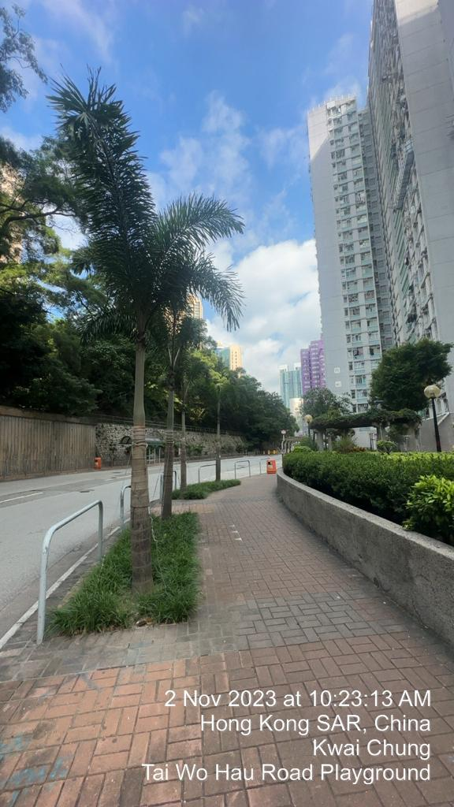

Finally, a conclusion will be provided from the portfolio in assessing the case studies and evaluations. A full reference list is appended.

