TEST plan

Test purpose

- Validation on the input data and display appropriate error messages
- Test Plan with test cases and test results.

Test #1

del me | del me
Test Case Name | Missing "Applicant Name"
Procedure | 1. leave "applicant name" field empty.  2. Click "Next" button
Expected Output | 1. The error MessageBox appears "name cannot empty."  2. The error MessageBox appears "Please enter all required information."
Result | Pass/Fail

Screen capture

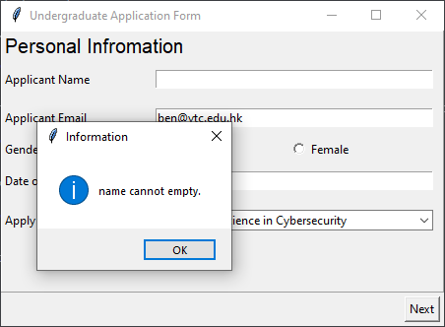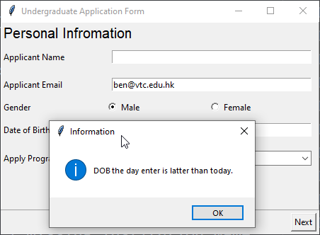

Test #2

del me | del me
Test Case Name | Missing "Applicant Email"
Procedure | 1. leave "applicant email" field empty.  2. Click "Next" button
Expected Output | 1. The error MessageBox appears "email field cannot empty."  2. The error MessageBox appears "Please enter all required information."
Result | Pass/Fail

Screen capture

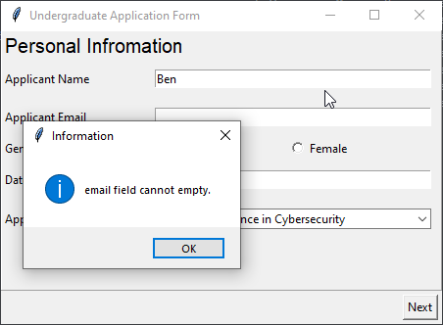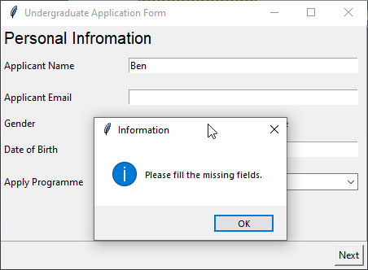

Test #3

del me | del me
Test Case Name | Missing "Date of Birth"
Procedure | 1. leave "date of birth" field empty.  2. Click "Next" button
Expected Output | 1. The error MessageBox appears "dob field cannot empty."  2. The error MessageBox appears "Please enter all required information."
Result | Pass/Fail

Screen capture

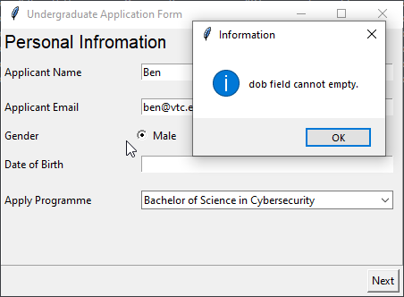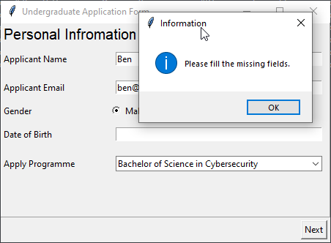

Test #4

del me | del me
Test Case Name | Missing Institution Name
Procedure | 1. leave "Institution Name" field empty  1. Click "Next" button
Expected Output | The error MessageBox appears "Please enter all required information."  The error MessageBox appears "Please enter all required information."
Result | Pass/Fail

Screen capture

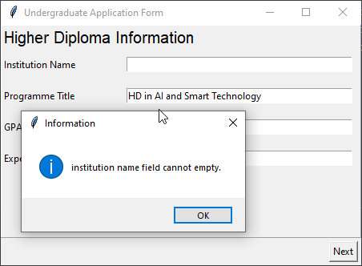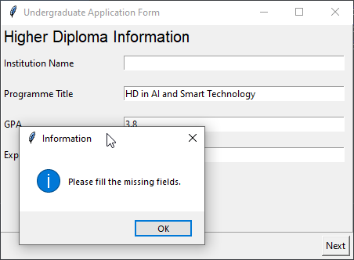

Test #5

del me | del me
Test Case Name | Missing Programme Title
Procedure | 1. leave "Programme Title" field empty  1. Click "Next" button
Expected Output | The error MessageBox appears "Please enter all required information."  The error MessageBox appears "Please enter all required information."
Result | Pass/Fail

Screen capture

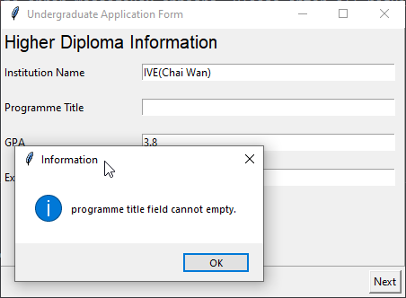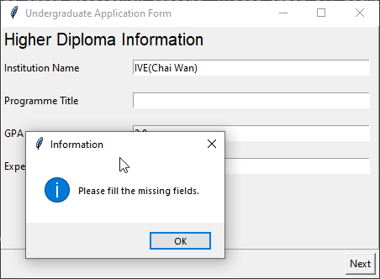

Test #6

del me | del me
Test Case Name | Missing GPA
Procedure | 1. leave "GPA" field empty  1. Click "Next" button
Expected Output | The error MessageBox appears "Please enter all required information."  The error MessageBox appears "Please enter all required information."
Result | Pass/Fail

Screen capture

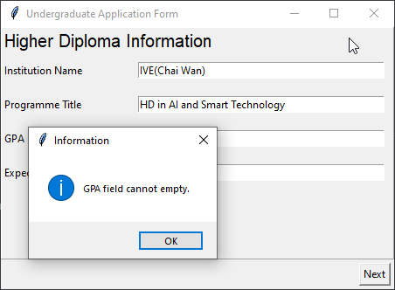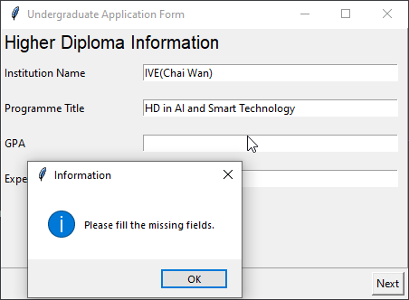

Test #7

del me | del me
Test Case Name | Missing Expected Graduation Year
Procedure | 1. leave "Expected Graduation Year" field empty  1. Click "Next" button
Expected Output | The error MessageBox appears "Please enter all required information."  The error MessageBox appears "Please enter all required information."
Result | Pass/Fail

Screen capture

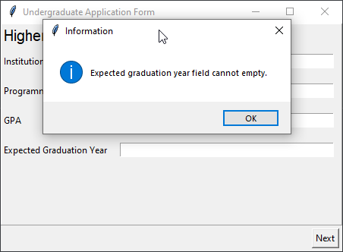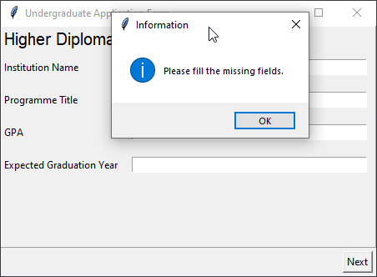

Test #8

del me | del me
Test Case Name | Showing summary if all input field fullfilled
Procedure | 1. filling all required information in "Personal Information"  1. clici "Next" button  1. Filling all required information in"Higher Diploma Information" windows.  1. Click "Next" button  1. click "show" button to show summary
Expected Output | finally the summary window showing information in the page inputted before
Result | Pass/Fail

Screen capture

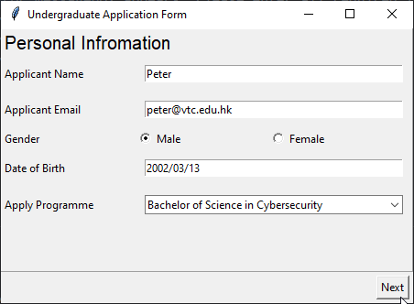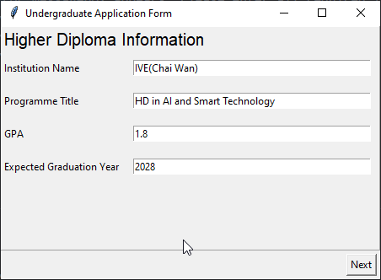

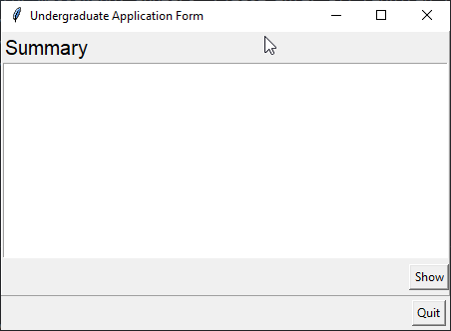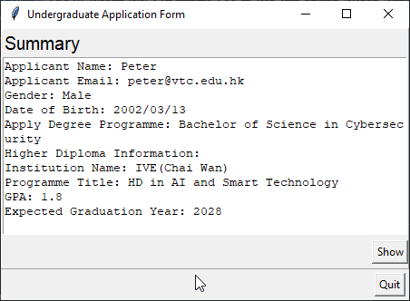

Test #9

del me | del me
Test Case Name | Date of birth should be in the past
Procedure | 1. enter a day after today to the "date of birth" field  1. click next button
Expected Output | The error MessageBox appears "DOB: the day entered is latter than today."  The error MessageBox appears "Please enter all required information."
Result | Pass/Fail

Screen capture

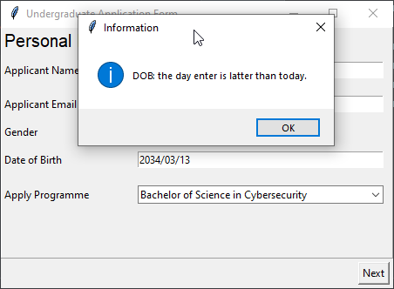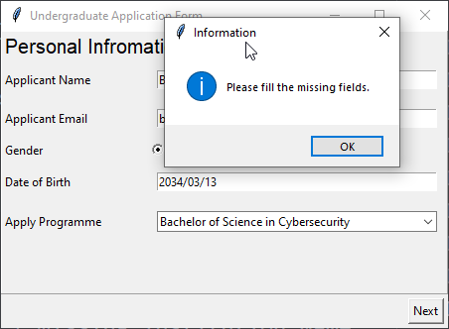

Test #10

del me | del me
Test Case Name | email entered should be valid
Procedure | 1. enter an invalid email e.g. "ankitrai326.com"  1. click "next" button
Expected Output | The error MessageBox appears "email format error
Result | it should be email."  The error MessageBox appears "Please enter all required information."

Screen capture

Test #11

del me | del me
Test Case Name | GPA should be a number / decimal
Procedure | 1. enter a non numeric value into "GPA" field  1. Click "Next" button
Expected Output | The error MessageBox appears "GPA field should be a number."  The error MessageBox appears "Please enter all required information."
Result | Pass/Fail

Screen capture

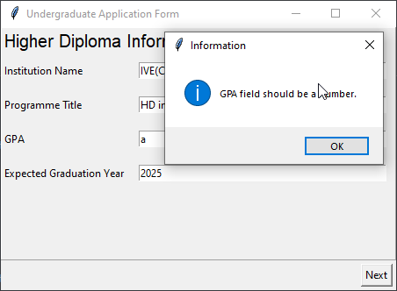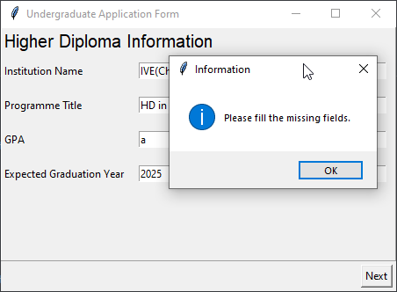

Test #12

del me | del me
Test Case Name | Expected graduation year should be in future
Procedure | 1. enter a day in the past in "Graduation year" field  1. Click "Next" button
Expected Output | The error MessageBox appears "Expected graduation year should be after current year."  The error MessageBox appears "Please enter all required information."
Result | Pass/Fail

Screen capture

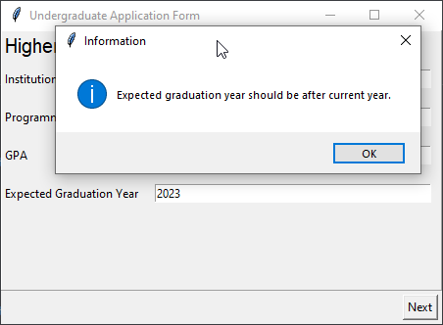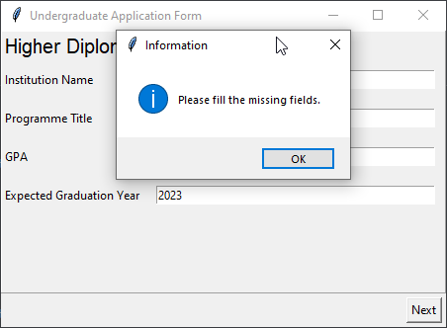

Test #13

del me | del me
Test Case Name | female appliciant
Procedure | 1. select female in applicant gender field  1. Click "Next" button
Expected Output | The error MessageBox appears "Expected graduation year should be after current year."  The error MessageBox appears "Please enter all required information."
Result | Pass/Fail

Screen capture

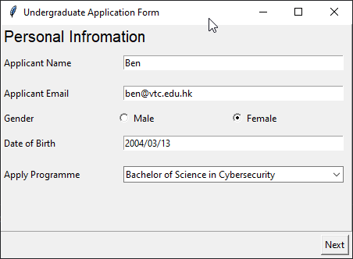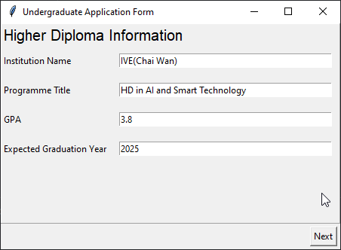

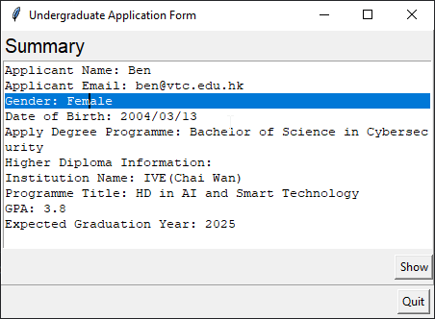

Test #14

del me | del me
Test Case Name | "Bachelor of Science in Computer Science and AI" in apply programme
Procedure | 1. select female in applicant gender field  1. Click "Next" button
Expected Output | The error MessageBox appears "Expected graduation year should be after current year."  The error MessageBox appears "Please enter all required information."
Result | Pass/Fail

Screen capture

