2023 Lancaster University
SCC 201 Lab Week 4

Instructions:
This week you will continue to work on the relational model.
Task 1:
(Windows)
Download sqlite3.exe Version 3.26.0 from Moodle page.
Go to the terminal and run sqlite3.exe
(Linux)
Goto the terminal and type sqlite3 and then press enter.
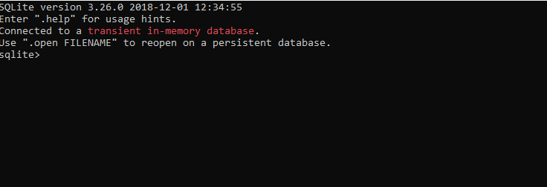

- Execute the following DDL code.
CREATE TABLE Department(DName TEXT NOT NULL, HoD TEXT, NoOfEmp INTEGER, PRIMARY KEY(DName));
CREATE TABLE StudentsEnrol(firstName TEXT, lastName TEXT, RegNumber INTEGER NOT NULL, Address TEXT, BDate TEXT, Gender TEXT, DepName TEXT, PRIMARY KEY (RegNumber), FOREIGN KEY(DepName) REFERENCES Department(DName) ON DELETE SET NULL);
CREATE TABLE CourseRuns(CName TEXT NOT NULL, Desc TEXT, DepName TEXT, PRIMARY KEY (CName), FOREIGN KEY(DepName) REFERENCES Department(DName) ON DELETE SET NULL);
CREATE TABLE StTakesCourse(CName TEXT NOT NULL, RegNumber INTEGER NOT NULL, PRIMARY KEY(CNAME,RegNumber), FOREIGN KEY (CName) REFERENCES CourseRuns(CName), FOREIGN KEY (RegNumber) REFERENCES StudentsEnrol(RegNumber));
pragma table_info('StTakesCourse');

You should see a similar console as given:
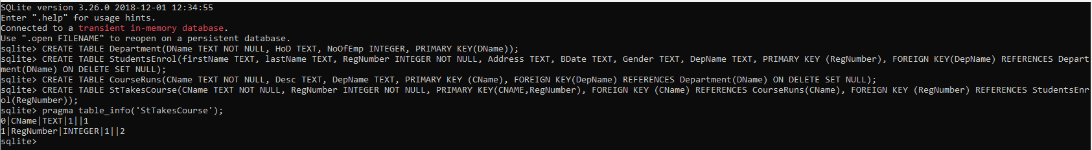

- Insert some values of your choice to the tables using INSERT INTO <tableName> (AttributeName) VALUES (values); e.g.

INSERT INTO Department(DName,HoD,NoOfEmp) VALUES ("SCC","Nigel Davies",219);

- Print the content of your tables using SELECT command; e.g.

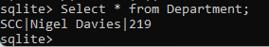

- Draw the ER diagram for the Database.

SEE SLIDE NO 23 of WEEK 3 (Only one student recognised I asked the question and solved it during the lecture a week ago!)

- Execute the following code to remove tables
drop table StudentsEnrol;
drop table CourseRuns;
drop table Department;
drop table StTakesCourse;

Task 2: Create the ER Diagram, write the Relational Schema with ICs and create the database for the Stagecoach:
Stagecoach has several buses. Each Bus has a unique chassis number, capacity, a Boolean value indicating the bus has wheel-chair support (1 for yes, 0 for no), and range (in km’s). Stagecoach has bus drivers. Each driver has a unique driver’s licence code, age, name, and phone number. Stagecoach has several routes; each has a unique route_id, distance (in km), and a total number of stops.
A bus, a route and a driver can SERVE for a given time denoted with START_TIME. A driver can SERVE on one route with one bus at a given time. Likewise, a bus can SERVE on one route with one driver at a given time. A bus cannot SERVE with 0 or more than one driver (exactly one driver), and a driver can SERVE with one bus.

