用戶註冊後免費vip 72小時

VIP
- 解鎖參與者名單
- 專屬vip標誌
- 查看訪客
- 訊息已讀提示
- 語音及圖片傳送
- 每24小時置頂到附近的人（每次停留45分鐘，以訂閱開始時間計）
- 無限聊天 (非vip用戶每日限制發言傳送20次)
- 過濾已驗證的用戶

活動報名流程
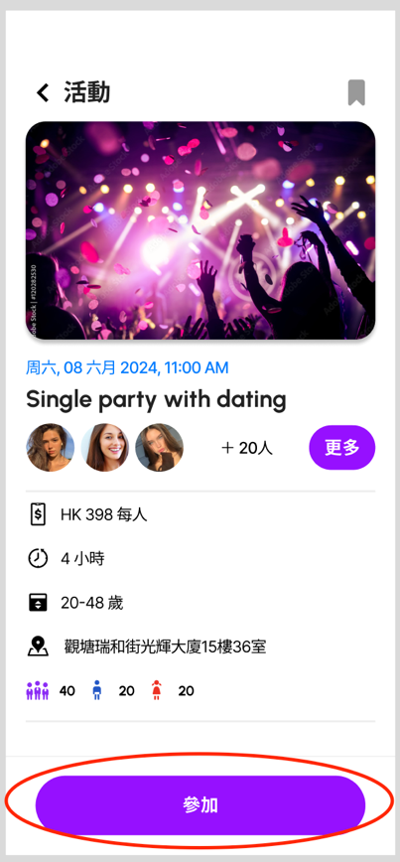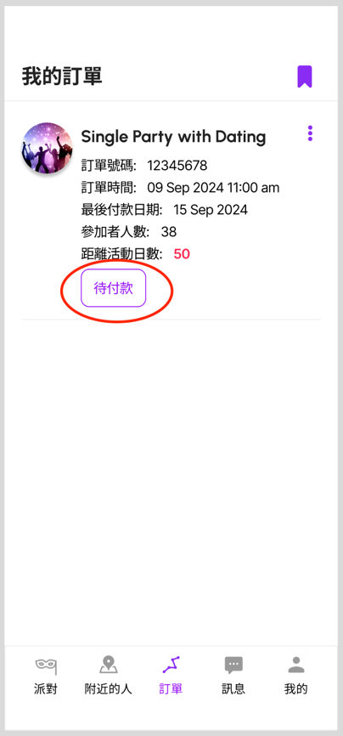

未報名
活動頁面顯示：
- 報名
- 截止報名（系統設置）
- 活動取消（系統設置）

1. Sign up
2. Deadline for registration
3. Event cancellation

已報名
活動頁面顯示:
- 已報名
- 活動取消

1. Already registered
2. Event cancellation

訂單顯示：
- 待支付（報名後未付款）（可取消報名）
- 已支付（報名後已經付款）（不可取消報名，不退款）
- 限期未付（報名後3天未付款，管理者系統未有手動設置為「已支付」或其他選項，則將移出報名名單，活動頁面顯示「報名」，並不在參加者名單中出現）
- 拒收款（未付款但活動取消，活動頁面顯示：活動取消）
- 安排退款（已付款但活動取消）
- 退款中（已付款但活動取消）
- 已退款（已付款但活動取消）

1. Pending payment
2. Paid
3. Overdue payment
4. Rejection of payment
5. Arrange a refund
6. Refund in progress
7. Refunded

簡介Profiles

職業
醫生，護士，醫護人員， 藥劑師，律師，法官，律政人員， 演員，導演，作家，編劇，攝影師，銀行家， 會計師，金融服務業， 投資家，司機，飛機師， 物流交通， 保險業，資訊科技， 編程師，項目經理，政府機構，服務性行業，廚師，老師，校長，教育人員， 企業家，創業人士，建築業，電器維修員，設計師，畫師，行政人員， 文員，人力資源部，社工，心理學家， YouTuber，船員，警務人員，消防員，自僱人士，記者， 導遊，售貨員，測量師，地產經紀，美容師，美甲師，騎師，保安，其他

Career
Doctors, nurses, medical staff, pharmacists, lawyers, judges, legal personnel, actors, directors, writers, screenwriters, photographers, bankers, accountants, financial services, investors, drivers, pilots, logistics and transportation, insurance Industry, information technology, programmer, project manager, government agency, service industry, chef, teacher, principal, educator, entrepreneur, entrepreneur, construction industry, electrical appliance repairman, designer, painter, administrator, clerk, Human resources department, social worker, psychologist, YouTuber, crew, police officer, firefighter, self-employed, journalist, tour guide, salesperson, surveyor, real estate agent, beautician, manicurist, jockey, security guard, others

興趣
捉棋，冥想，做手工，閱讀，投資， 飼養寵物，唱歌，夜晚散步，觀星，塔羅牌，編程，砌積木，集郵，模型收藏，古玩收藏， 玩音樂樂器， 彈鋼琴， 彈結他， 拉小提琴， 烹飪，整甜品，去博物館，上興趣班， 做義工，酒吧飲酒，聽音樂，園藝，雕塑，手鏈製作

Interest
Playing chess, Meditating, doing crafts, Reading, investing, raising pets, singing, walking at night, stargazing, tarot cards, programming, building blocks, collecting stamps, collecting models, collecting antiques, playing musical instruments, playing piano, playing guitar, playing the violin, cooking, making desserts, going to museums, taking interest classes, volunteering, drinking in bars, listening to music, gardening, sculpture, bracelet making

性格
內向，外向，佛系，搞笑，幽默，細心，責任心，重家庭，重友情， 宅， 工作狂， 嚴肅， 喜愛社交， 有耐性，有目標，忍耐力強，好動，社交能力強，不善交際，會聊天，喜歡挑戰，怕陌生人，情緒化，愛自由

Character
Introvert, extrovert, Buddhist, funny, humorous, careful, responsible, family-oriented, friendship-oriented, homebody, workaholic, serious, social-loving, patient, goal-oriented, tolerant, active, strong social skills, not good at Sociable, good at chatting, likes challenges, is afraid of strangers, emotional, loves freedom

生活習慣
夜貓，規律作息， 彈性上班時間， 經常社交， 工作生活不協調，工作狂，懶散，順其自然， 朝九晚六，朝九晚五，必食早餐

Living habit
Night owl, regular schedule, flexible working hours, frequent social interaction, uncoordinated work and life, workaholic, lazy, let nature take its course, 9 to 6, 9 to 5, must eat breakfast

運動
跑步， 保齡球， 釣魚， 羽毛球，乒乓波， 壁球， 桌球， 踩單車，英式足球，美式足球，籃球，跳繩，健身，瑜伽，攀爬，滑浪， 跳舞，划艇，行山，游泳，慢跑，跳遠

Sport
Running, bowling, fishing, badminton, table tennis, squash, billiards, cycling, soccer, American football, basketball, rope skipping, fitness, yoga, climbing, surfing, dancing, rowing, hiking, swimming, jogging ,long jump

書藉
鬼怪，哲學，心理學，小說，歷史，旅行，家庭，愛情，漫畫，教育，靈修，醫學， 經濟學，散文，天文地理， 星相命理， 被討厭的勇氣， 人性的弱點

Book
Ghosts, philosophy, psychology, novels, history, travel, family, love, comics, education, spirituality, medicine, economics, essays, astronomy and geography, astrology, the courage to be hated, human weakness
影視
動作電影，武俠，科幻電影，恐怖電影，懸疑電影，戰爭電影，搞笑電影，紀錄片，卡通電影，動漫， 古裝電視劇，災難片，喪屍片，綜藝節目，警匪片，鐵達尼號，蠟筆小新，多啦A夢，櫻桃小丸子，周星馳電影

Film and television
Action movies, martial arts, science fiction movies, horror movies, suspense movies, war movies, funny movies, documentaries, cartoon movies, animation, costume TV series, disaster movies, zombie movies, variety shows, police movies, Titanic, Crayon Shin-chan, Doraemon, Chibi Maruko-chan, Stephen Chow movies

旅遊
背包客， 東京，大阪，濟州島，首爾，紐約， 台北，台南，台中，馬來西亞，吉隆坡，泰國，越南，法國，美國，英國，土耳其，巴黎，北京，上海，中國，畢業旅行，俄羅斯，澳洲，紐西蘭，洛杉磯，舊金山，波士頓，西雅圖，羅馬，意大利， 馬爾代夫，米蘭， 歐洲，倫敦，愛丁堡，北海道，福岡，沖繩，曼谷，東南亞，檳城，廣州，澳門，新加坡，德國

Travel
Backpackers, Tokyo, Osaka, Jeju Island, Seoul, New York, Taipei, Tainan, Taichung, Malaysia, Kuala Lumpur, Thailand, Vietnam, France, the United States, the United Kingdom, Turkey, Paris, Beijing, Shanghai, China, graduation travel, Russia, Australia , New Zealand, Los Angeles, San Francisco, Boston, Seattle, Rome, Italy, Maldives, Milan, Europe, London, Edinburgh, Hokkaido, Fukuoka, Okinawa, Bangkok, Southeast Asia, Penang, Guangzhou, Macau, Singapore, Germany

美食
甜品，西餐，中式美食，日式美食，自助餐，打邊爐，燒烤，肉醬意粉，海鮮，壽司，拉麵，刺身，薄餅，麥當勞，炸雞，泡菜，法式美食，意大利菜， 粵菜，四川菜，湖南菜，客家菜，芝士蛋糕，馬卡龍，波子汽水，雪糕，叉燒飯，泰式美食，越式美食， 韓國年糕， 泡芙，零食，薯片， 檸檬茶，可樂

food
Dessert, Western food, Chinese food, Japanese food, buffet, grill, barbecue, spaghetti with meat sauce, seafood, sushi, ramen, sashimi, pizza, McDonald's, fried chicken, pickles, French food, Italian food, Cantonese food, Sichuan food Food, Hunan food, Hakka food, cheesecake, macarons, soda pop, ice cream, barbecued pork rice, Thai food, Vietnamese food, Korean rice cakes, puffs, snacks, potato chips, lemon tea, cola

隱私保護政策

歡迎使用Hong Kong Single party。我們深知隱私對您的重要性，並承諾採取一切合理措施保護您的個人信息。本隱私保護政策旨在向您說明我們如何收集、使用、儲存和保護您的個人信息，以及您對自己信息所擁有的權利。

1. 個人信息的收集
為了提供最佳的社交體驗，我們可能會在您使用Hong Kong Single party時收集以下類型的個人信息：

- 基本信息：如您的姓名、性别、出生日期、電話號碼和電子郵件地址等。
- 位置信息：當您開啟位置服務時，我們可能會收集您的設備位置信息，以便向您推薦附近的活動和朋友。
- 使用信息：包括您使用Hong Kong Single party的時間、頻率、偏好設定和交互數據。
- 活動參與信息：當您參與我們的線下活動時，我們可能會收集您的活動參與情況和反饋。

2. 個人信息的使用
我們使用您的個人信息主要用於以下目的：

- 提供和改進服務：確保Hong Kong Single party能夠正常運行，並不斷進行優化和改進。
- 個性化體驗：根據您的偏好和使用習慣，為您提供更加個性化的服務和推薦。
- 活動組織：組織和安排您感興趣的線下活動，包括遊戲配對和社交聚會。
- 溝通交流：向您發送重要通知，如活動更新、新功能或客戶服務相關信息。
- 安全保障：保護您的帳戶安全，預防和調查潛在的安全問題。

3. 個人信息的儲存和保護
我們將採取適當的技術和組織措施來保護您的個人信息，防止未經授權的訪問、披露、篡改或損壞。我們會將您的個人信息儲存在安全的服務器上，並限制員工對這些信息的訪問。

4. 個人信息的共享和轉移
我們不會將您的個人信息出售或提供給第三方，除非：

- 獲得您的明確同意。
- 為了提供您要求的服務或功能，需要與可信賴的第三方合作夥伴共享信息。
- 根據法律法規的要求或為了遵守法律程序。

5. 您的權利
您對自己的個人信息擁有以下權利：

- 訪問權：您有權訪問我們持有的您的個人信息。
- 更正權：如果您發現我們持有的信息有誤，您有權要求更正。
- 刪除權：在某些情況下，您有權要求我們刪除您的個人信息。

6. 政策更新
我們可能會不時更新本隱私保護政策。所有更新將在[友緣圈]應用程序內公佈，並在更新後的隱私保護政策中標明新的生效日期。

7. 聯繫我們
如果您對本隱私保護政策有任何疑問或擔憂，或者希望行使上述權利，請通過在Hong Kong single party中的聯絡我們，我們團隊會以最快速度回覆，請耐心等候。

感謝您對Hong Kong Single party 的信任和支持。我們將持續努力，為您提供更安全、更可靠的社交體驗。

Privacy Policy

Welcome to Hong Kong Single Party. We understand the importance of privacy to you and are committed to taking all reasonable measures to protect your personal information. This Privacy Policy aims to explain how we collect, use, store, and protect your personal information, as well as the rights you have regarding your information.

1. Collection of Personal Information
To provide the best social experience, we may collect the following types of personal information when you use [Friend Circle]:

- Basic Information: Such as your name, gender, date of birth, phone number, and email address.
- Location Information: When you enable location services, we may collect information about the location of your device to recommend nearby activities and friends.
- Usage Information: Including the time, frequency, preference settings, and interaction data of your use of [Friend Circle].
- Activity Participation Information: When you participate in our offline activities, we may collect information about your participation and feedback.

2. Use of Personal Information
We use your personal information mainly for the following purposes:

- Service Provision and Improvement: To ensure that [Friend Circle] functions properly and to continuously optimize and improve it.
- Personalized Experience: To provide you with a more personalized service and recommendations based on your preferences and usage habits.
- Activity Organization: To organize and arrange offline activities that interest you, including game matching and social gatherings.
- Communication: To send you important notifications, such as activity updates, new features, or customer service-related information.
- Security: To protect the security of your account and to prevent and investigate potential security issues.

3. Storage and Protection of Personal Information
We will take appropriate technical and organizational measures to protect your personal information against unauthorized access, disclosure, alteration, or destruction. We will store your personal information on secure servers and restrict employee access to this information.

4. Sharing and Transfer of Personal Information
We will not sell or provide your personal information to third parties unless:

- We have your explicit consent.
- It is necessary to share information with trusted third-party partners to provide a service or feature you have requested.
- Required by law or to comply with legal processes.

5. Your Rights
You have the following rights regarding your personal information:

- Right to Access: You have the right to access the personal information we hold about you.
- Right to Rectification: You have the right to request corrections if you find any inaccuracies in the information we hold.
- Right to Erasure: Under certain circumstances, you have the right to request the deletion of your personal information.

6. Policy Updates
We may update this Privacy Policy from time to time. All updates will be published within the [Friend Circle] application and will be reflected in the new effective date of the updated Privacy Policy.

7. Contact Us
If you have any questions or concerns about this Privacy Policy, or if you wish to exercise any of the above rights, please contact us using “Contact us”of Hong Kong Single party. Our team will respond as soon as possible. Please wait.

Hong Kong Single Party. We will continue to strive to provide you with a safer and more reliable social experience.

服務協議及社區規範

歡迎使用香港單身派對！本服務協議及社區規範（以下簡稱“協議”）旨在規範您使用香港單身派對（以下簡稱“平台”）的行為，確保平台的健康運營和用戶的良好體驗。請在使用平台前仔細閱讀並遵守本協議。

1. 服務內容
香港單身派對提供以下服務：
(a) 附近的人交友：使用地理定位功能幫助您認識附近的用戶。
(b) 線上活動參與：平台不定期舉辦各類線上活動，包括但不限於遊戲配對、主題討論和社交聚會。

2. 用戶權利與義務
(a) 用戶有權使用平台提供的服務，並參與平台組織的活動。
(b) 用戶應確保其在平台上發布的個人照片及資料真實且屬於本人，不得使用他人的照片或虛假信息。
(c) 用戶應遵守相關法律法規，不得利用平台進行任何非法活動。
(d) 用戶應尊重其他用戶的隱私權和個人信息安全，不得收集、使用或披露其他用戶的信息。
(e) 用戶應維護良好的社區環境，不得發布任何違背公序良俗、含有歧視、騷擾、暴力或色情等內容的信息。
(f) 用戶不得抄襲、模仿或以其他方式侵犯平台的知識產權，包括但不限於應用程序的界面設計、功能實現和內容創作。
(g) 本平台僅限於18歲以上的用戶使用。未滿18歲的用戶不得使用平台，一旦發現，其帳號將被終止。

3. 社區規範
(a) 禁止發布任何形式的廣告、垃圾信息或欺詐信息。
(b) 用戶應保持友好互動，避免使用侮辱性、攻擊性的語言。
(c) 用戶不得發布、傳播任何侵犯他人知識產權或其他合法權益的信息。
(d) 用戶應遵守平台的操作規範，不得進行任何破壞平台正常運行的行為。

4. 隱私保護
平台將採取合理措施保護用戶的個人信息，並遵守相關隱私保護法律法規。用戶同意平台在提供服務過程中收集和使用其個人信息。

5. 違規處理
用戶違反本協議時，平台將視情節輕重給予警告或終止其帳號的使用權。嚴重違反者將被永久禁止使用平台服務。

6. 協議的變更與終止
(a) 平台有權根據需要對本協議進行修改，並在平台上公佈最新版本。
(b) 如用戶違反本協議，平台有權限制或終止其使用平台的權利。

7. 爭議解決
因本協議引起的任何爭議，雙方應首先嘗試友好協商解決；協商不成時，任何一方可直接提出訴訟。

8. 其他
(a) 本平台保留對所有情況的最終決定權和解釋權。
(b) 本協議的附件是協議不可分割的一部分，與協議具有同等法律效力。

用戶在使用平台服務時，即表示已閱讀、理解並同意遵守本協議。

Service Agreement and Community Guidelines

Welcome to the Hong Kong Single Party. This Service Agreement and Community Guidelines (hereinafter referred to as the "Agreement") is designed to regulate your use of the Hong Kong Single Party (hereinafter referred to as the "Platform"), ensuring the healthy operation of the platform and a positive user experience. Please read and comply with this Agreement before using the Platform.

1. Service Content
Hong Kong Single Party provides the following services:
(a) Nearby Person Dating: Use of geolocation features to help you meet users nearby.
(b) Online Event Participation: The platform regularly hosts various online events, including but not limited to game matching, thematic discussions, and social gatherings.

2. User Rights and Obligations
(a) Users have the right to use the services provided by the platform and participate in events organized by the platform.
(b) Users must ensure that the personal photos and information posted on the platform are true and belong to themselves, and must not use photos of others or false information.
(c) Users must comply with relevant laws and regulations and must not use the platform for any illegal activities.
(d) Users must respect the privacy and personal information security of other users and must not collect, use, or disclose information about other users.
(e) Users must maintain a good community environment and must not post any content that violates public order and good customs, contains discrimination, harassment, violence, or pornography.
(f) Users must not plagiarize, imitate, or otherwise infringe upon the intellectual property rights of the platform, including but not limited to the app's interface design, functional implementation, and content creation.
(g) The platform is intended for users aged 18 and above. Users under the age of 18 are not permitted to use the platform, and if discovered, their accounts will be terminated.
3. Community Guidelines
(a) Posting any form of advertising, spam, or fraudulent information is prohibited.
(b) Users should maintain friendly interactions and avoid using insulting or offensive language.
(c) Users must not post or disseminate any information that infringes upon the intellectual property rights or other legal rights of others.
(d) Users must comply with the platform's operational guidelines and must not engage in any behavior that disrupts the normal operation of the platform.

4. Privacy Protection
The platform will take reasonable measures to protect users' personal information and comply with relevant privacy protection laws and regulations. Users agree to the collection and use of their personal information by the platform during the provision of services.

5. Handling of Violations
When users violate this Agreement, the platform will issue warnings or terminate their account usage rights depending on the severity of the violation. Serious violators will be permanently banned from using the platform services.

6. Agreement Modification and Termination
(a) The platform reserves the right to modify this Agreement as needed and to publish the latest version on the platform.
(b) If a user violates this Agreement, the platform reserves the right to restrict or terminate their right to use the platform.

7. Dispute Resolution
Any disputes arising from this Agreement should first be attempted to be resolved amicably between the parties; if negotiation fails, either party may directly initiate legal proceedings.
8. Other
(a) The platform reserves the right to make final decisions and interpretations in all situations.
(b) The annexes to this Agreement are an integral part of the Agreement and have the same legal effect as the Agreement.

By using the platform's services, users acknowledge that they have read, understood, and agreed to comply with this Agreement.

